Object-Oriented Programming with PHP

Introduction

01_Welcome: This course will demonstrate practical examples of Object Oriented PHP. We will look at classes, objects. Abstraction, scope, and design patterns. We will be looking at a real world problem in storing addresses. By doing so, we will gain a fundamental understanding of object orientation.

Introduction to Object-Oriented Programming

01_01_What is an object: A primitive example include booleans, floating point numbers -fractional values, integers, and strings.

An object contains complex data structures, attributes, behaviors, and contain multiple data types.
We can see the difference below:
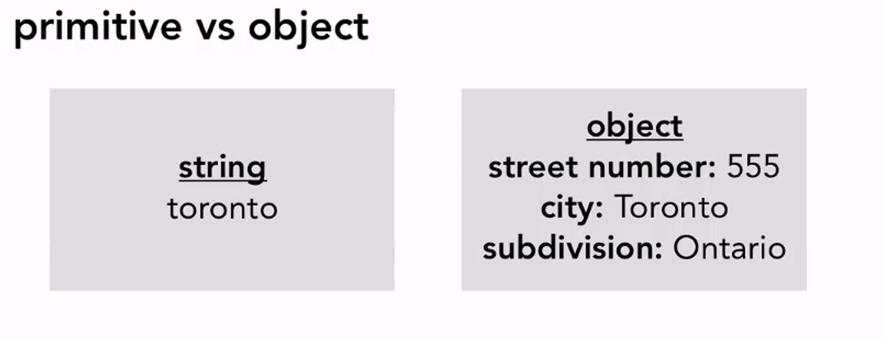

01_02_What is a class: A class is a blueprint that defines the attributes and behaviors. Objects are instances of a class -instances have attributes and behaviors of class. Classes modularize program functions by separating features without overlap.
A class address can have different attributes and behavior. But instances of an address can contain both particular formats in order to access them correctly. Instances, again, are objects that share a class attributes and behaviors but are unique in the information that is passed and assigned:
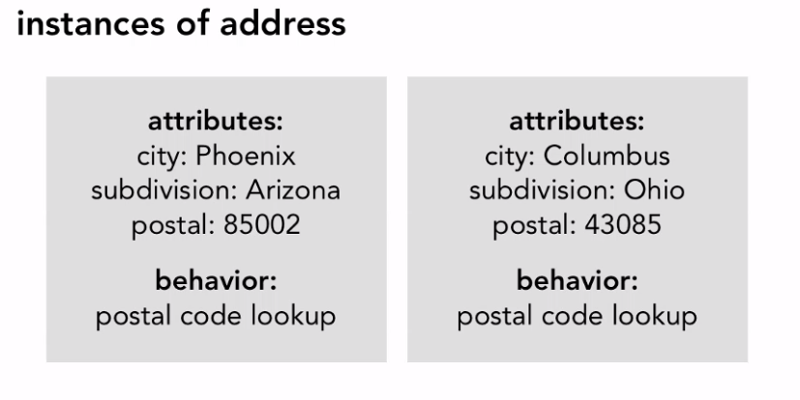

01_03_Why should you use object-oriented programming: Organize large project into manageable pieces. In comparison, procedural language is step by step instructions and thus is linear. Linear comes from when you scale up. You may find yourself passing large number of data to buggy scripts that are hard to find.
Object oriented programming allows the developer to mitigate problems that may occur and define features that are solution to structures and principles. These included
- Abstraction defines data and structures while hiding implementation.
- Encapsulation exposes functionality, restricts access to low level data.
- Hierarchy allows inherited attributes and behavior for incremental development
- modularity allows functionality to be broken into task specific pieces.
- Polymorphism allows interaction with classes without knowing which class it is.

01_04_The history of Object-Oriented PHP: object oriented programming started in the 1960s.
- PHP3 (1998) introduced object-oriented features
- PHP4 (2000) added functionality, but it was non-intuitive object referencing and copied whole objects over head (obvious performance issue :S)
- PHP5 (2004) extensive rewrite of object handling with Zend Engine 2 and full object modeling.

Creating Your First Object

02_01_Defining a class: Naming collections start with letter or underscore. The remaining characters must be letters or underscores. There is no length. The use of upper camel casing naming means Class. This helps differentiate between an instance and an object. We have curly braces that define standards of properties and methods.
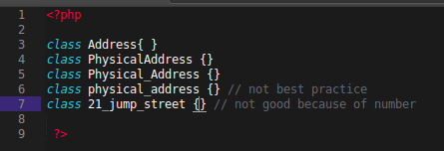

02_02_ Defining class properties: In this example, we demonstrate a few rules of writing class properties that follow best practices. In this example, we set items for a class of Address that allows us to easily assign characteristics to our class.
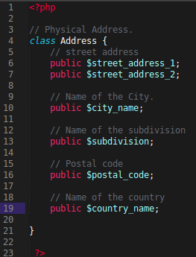

02_03_Creating a method and exploring object context with $this variable: In this video, we added a method called display that builds the output of our information -of course, we would want to sanitize the information for proper use and security. We use the $this variable to grab variables from within the objects context. We can then use it to build an output that we can then return.

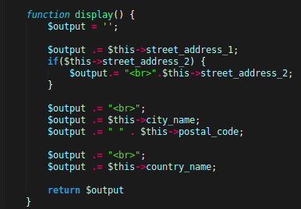

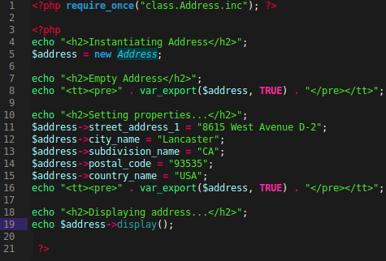
02_04_Instantiating an object and accessing its contents: In this example, we use index.php to include our demo.php. We create three sections in which we display through a var_export of our object. The first is instantiated but is empty. The second is set with values and is again exported. Our last method is displaying the address through the outputted address:

02_05_Specifying the visibility scope: We have different visibility scopes:
Public is accessed by all files that can refer to the class and it's properties.
Protected can only be accessed with the class or it's inherited sub classes.
Private can only be accessed within the class itself and by methods within it.

We tried accessing a protected method directly and came with an error, we need magic methods to fix this problem.

Overloading with Magic Methods

03_01_What is magic method, and do I need one: PHP overloading is dynamically create property or method that has not been declared or is not visible. Dynamic entities processed using “magic methods.”

Magic methods have special naming conventions are executed in response to a PHP event. Name perpended with two underscores that contain about a dozen PHP magic methods.
We can have a __construct() and __toString() for examples.

Magic Methods can be very useful by attempting to access missing properties, missing methods, customize object creation, and defaults like current time.

Why might we not use magic methods?
Magic methods can be 3-20 times slower during method call, they ignore scope -meaning expose property or method that is hidden. They can break IDE code completion.

Decide for yourself. It may be worth warnings to be a contextually responsive code. The performance difference is negligible outside of benchmarking. Customize scope controls.

03_02_Overloading property access: PHP overloading is important in accessing missing properties. We take advantage of get and set.

We first create a __get method that takes one parameter -that is of course the name. We then check to see if a value is set within the postal code. If not, then we will assign the postal code value to a method lookup. At the same time, __set() magic method will be called in which will get the name and the value. The name will be checked to see if it is named postal_code. Next, we then assign the name to the value provided to then return. Returning back to our get magic method, we then assign the protected property name with an underscore as that is ignored during the name calling. We then check to see if a property exists within the object, if it it does, then we return that value back to whereever it was called. In a way, this is a simple get and set magic method but it does cause issues with readibility. Make sure you provide thorough documentation.

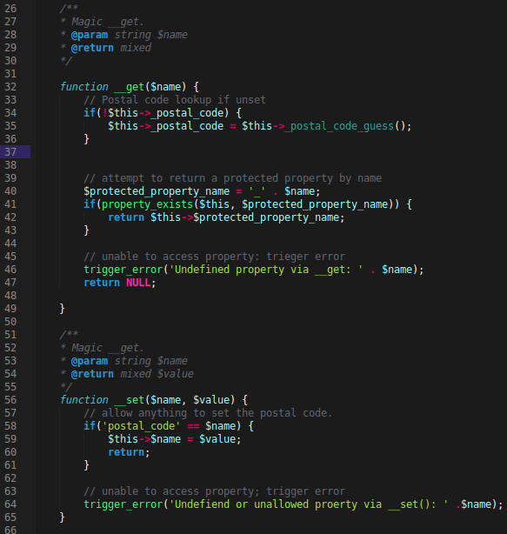

03_03_Customizing object construction: As of PHP 5, you can call a magic method that can be use to initialize an object before it is used -also known as a constructor method. In our demo, we send an associative array that will handle all our construction for the properties from within our class. We send in a full mailing address and echo display.

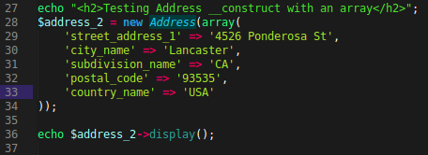

Next, within our constructor, we automatically default to an empty array. If no array is provided, we error with the name of the class. The difference between an object and a class, is that an instance of a class is an object. We then check to see if at least one bit of data is contained in the array. If so, we go through a loop assigning the name of the object in association to the class value.

Another thing that I learned was that $this->$name means $this->name_within_class. By using two dollar signs, we are saying to call the property variable of that class. If we called $this->name, we would look for the property variable of name! There's a difference -be sure you understand.

Now we assign all the values within the constructor. If in the instance either time or time updated is provided, this is where we use a calling of that value and assign it to the class variable. The reason being is because both time and updated are protected values and thus require a preceding underscore.
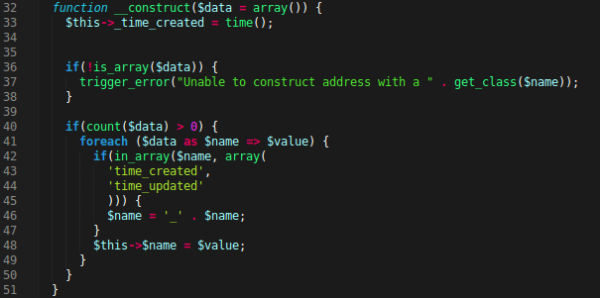

03_04_Standardizing object rendering a string: Polymorphism is an important feature from within PHP Object Orientation. We can take advantage of this by calling an object that must be converted to a string and thus initiate default behavior. In our demo.php, we are calling out an echo of an object. We can then activate the magic method of __toString() with will act as a form of polymorphism.
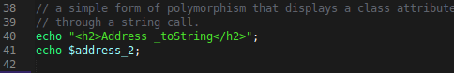

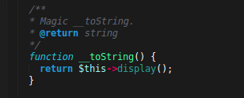

Accessing Classes without Instatiation

04_01_Using the static keyword : Sometimes you may need to access a property of a class without having to instantiate it. Single connections for databases or services are for static callings. It avoids meed for global scope. Lastly, we have single instances of class. There is no need to instantiate member class thus properties are stored at a class level. Thus we can keep track number of instantiated objects.

In the address example, we will limit a domain that an address can be a business, park, or a residence. We can assign numbers for defining differences between attributes. However, there is no need to instantiate an object for access.

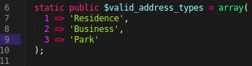
We can create a static variable with the keyword by calling:

04_02_Leveraging scope resolution: Or in other words, the double colon -allows us to access constants and properties or methods. All you need is:
class:method() or class:$variable.

Will allow us to display a static array.

04_03_Setting constant values: A class constant is like a property that never changes. This is useful for defining error codes and data structure names. Best practices dictate all caps and should contain simple values. To define a a constant, we use the constant variable call. We can define these values through the calling of constant and then full caps value. We set a few constant for each of the address types by number and then call these constants statically within our array. There is no performance difference between this and before, but having this allows the constant to be accessed throughout the entire Class.
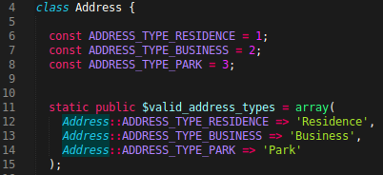

04_04_Avoiding static method pitfalls: static methods are similar to regular methods because of naming conventions, scope and return values.
You cannot use $this keyword because this will result in a fatal error.
Use self for scopes within the Class.
You can be explicit by using self::$property.
In this example, we use a static array to validate an already set variable with the object. By using static variables, we can can reference the static values all over the class.

In our Address instance, we set the class variable of address_type_id to one. When we call the variable export a couple things are going to happen:

In our magic set method, we included the condition to check if that set name matches the address_type_id -remember, the actual variable of address_type_id is protected! Therefore, the value needs to be set through the magic set method and other static methods in order to protect scope. When we write those if conditions, we are checking the class instance references in the demo.php. Because we are calling a value that doesn't exist directly in the class, we set a setter in order to find that the set variable is indeed referring to the protected variable -make sense?

After the if condition in the set method, we call the protected setAddressType. This will take the value of the setter -one -and then call the self static of the validation method in which in turn will validate that the key exist in the static array. It returns true or false and thus will assign the actual address type id to the value indicated in the demo page. Lastly, we return back.

This entire process helps us appreciate how we could call a protected variable and have magic methods assign the correct value to our protected value through a public file. This saves the paradigm of scope and Object Orientation.

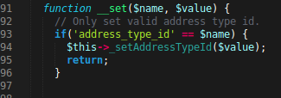

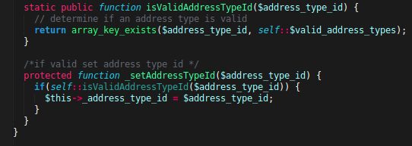

// remember that we are calling, in demo.php, $address->address_type_id = 1;

04_05_Creating database class: MySQL improved extension is MySQLi which is both object-oriented and procedural API. We first created a new class of Database. Database will, by instantiation, automatically construct a database connection and check for errors. If no errors exist it will assign the connection and be ready to go. We provided a static reference to the instance inside Database so that only one connection is necessary for opening -this will increase performance. Next, we write a clone method that returns nothing -this further prevents the ability to clone the Database class. We provide a get connection which will return a reference to the connection.

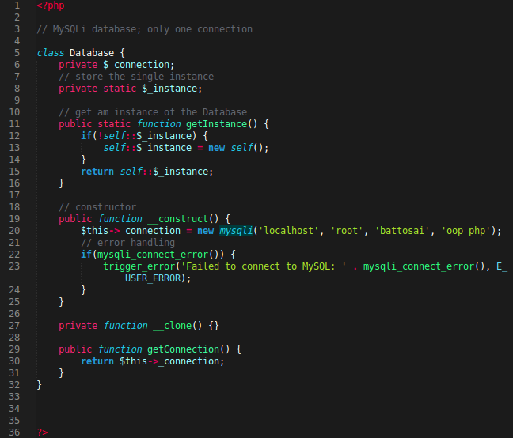

Only when we get the variable for use, that we do a postal code lookup if it doesn't exist. Therefore, within our postal code lookup, we get an instance of the connection and run a SQL connection that will select from the postal code where the city name matches the current city name and the sub division name matches the current sub division name. We then call a fetch associative array on the query call to then return the row that contains the postal code -this is of course one that matches the result.

// within our demo, we don't include an assignment of postal code but of course is assigned during display. Display method in address class calls a get on the variable that is empty.

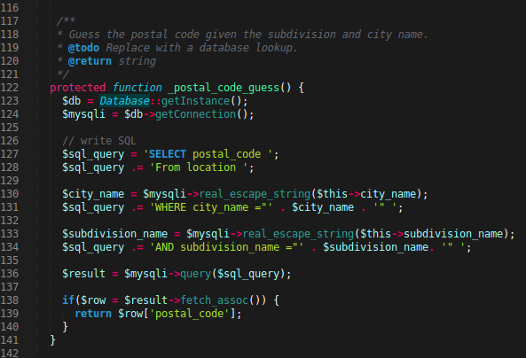

Class Relationships and Interactions

05_01_Extending your class: inheritance is a fundamental object-oriented principle. A relationship between classes and instances. Subclasses of another class. Children and Parents. This is useful for common functionality without having to copy and paste same methods uses. Child extends Parent.

Auto loading can be used to include missing class definitions. The auto load magic function will take the class name requested and then include it within the page reference once.

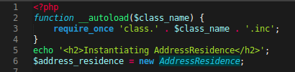

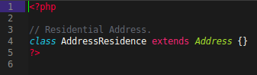
Extending can only be used by one class methods or properties at a time. You cannot specify multiple classes at a time. You can extend the class using the extends keyword. You can extend a class as following:

By doing so, you can call a new instance from the Address Residence and inherit all the Parent properties of Address. This allow us to gain the same access from Address Residence as we would from Address. All through extension.

05_02_Abstracting classes: PHP 5 introduces abstract classes and methods. Abstract classes cannot be instantiated. When extending, abstract methods must also be abstract -if a class has an abstract method, then the class must be abstract.

When using initialization for abstract classes. The construct magic method is fragile and unwieldy. However, the abstract magic method init, can be called each time from a constructor and therefore assign variables associated with an objects instantiation. We first write abstract in front of our Address class in order to use abstract variables and methods. We can then use the abstract protected method of init inside:

Now within our constructor, we include a calling to the init method.
The secret lies in writing the body of the init method for specific extensions of the classes that inherit from the Address. Address Residence is one of them. In it we define the init method and setting the address type id directly in the static calling. By doing so, each instantiation of a class of Address that extends, will assign a variable dependent value based on which class was called:

all of this adds together to abstracting our methods away from our main data, we will look at a step further of this in the next video.

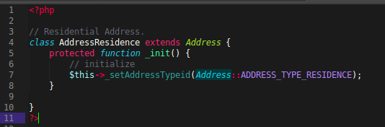

05_03_Sharing interfaces polymorphism: When developing an application, you are working with different types of data with needs. Using names, or spaghetti code is impossibly complex and unable to decode.
Object interface can specify methods that a class must implement but now how.
Is similar to abstract class
every method is abstract and public.
Interfaces can have constants that are available to any implementation. An interface can extend another interface.
Sharing common API is polymorphism is a common practice in implementing polymorphism.

To create an interface we use the key word interface with the name of model. We include two functions with no body. The bodies will be defined in the class that implements it.
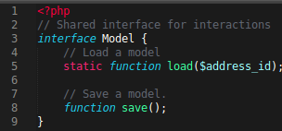

To implement a interface, we say that the class implements the model:

We then call a final public static function of those models in our implementation. We will be providing bodies inside these methods later on. Remember, if a class implements a model, it must use the defined interface.

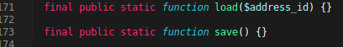

05_04_Overriding methods, properties, and constants: Overriding a method means redeclaring a method, or property, or constant
We can define a new or altered behavior and we cannot specify stricter.

Overriding constants is just a redeclare, methods must have same number of arguments and exceptions are constructors. You can call parent class methods and properties as well. In our example, we want to overwrite the default display in order to show a green background for park address. We alter the extended class of Address Park to write a public function of display. We can also call our parent display in order to include the content from a normal display but overwrite the display with a styling by a simple concatenation. In other words, we are not only defining an overwrite for the method but we are including details from the original to give a new feature that is specific to the Address Park class.

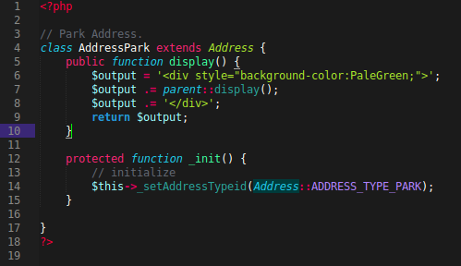

05_05_Cloning and comparing objects: Sometimes, you want to make a copy of an object to make a backup or a shortcut. We can clone an object through the simple clone keyword. When we compare both objects, they will refer to as a copy. A triple equal sign will ensure that both objects are the same instance of a class. We only use a double equals to show that they are indeed a clone.
Interesting side note, this example demonstrates how to include a ternary operator in a string concatenation.
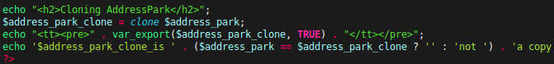
What if we wanted to indicate a new time of creation. Because, the time creation is copied over but that doesn't necessarily reflect the right results. The results are not true because the clone will create the object and thus copy it over -it should reflect this.
We can do this through another magic method called clone. Clone will set new definitions if an object copies a value over.

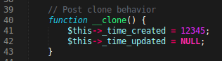

05_06_Referencing objects: References are aliases. Meaning multiple variables write to the same value. Our object variables do NOT contain object itself.

In this example, we copy references over to other variables that reference classes. We first copy address business into address business copy -we use the ampersand to indicate that we want the variable of address business copy to point to the address business. This means that any changes made to business copy will reflect onto address business because they are both pointing to the same area of data. If we didn't use the (=&) we would merely make a copy of the object but not the same reference in memory.

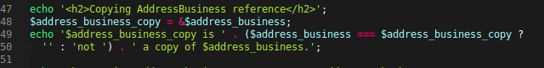
Now when we make a new instance and assign Address Park to the address business, we are also effecting the address business copy. Because of reference. We display this by indicating that both are indeed a copy. We then display the class of address business which would be 'park.' Next we see the instance of the address business copy and see if it is an instance of address business. Because we referenced the park, it is not an instance of the address business.

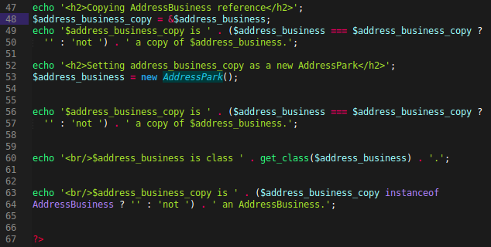

Built-in PHP Objects

06_01_Leveraging standard class objects: standard classes include a type cast to an object. They have no methods but does have values.

If you cast type an object to object, nothing will happen.
If you type cast an array to an object, then the keys will be properties. Values are array values.

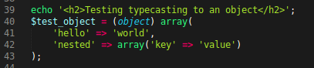
We can type cast by using the object cast and then array assignment. The array's keys will be objects and the values the properties. Strict data structures, shorthand, and mock-up instances encourage standard class

06_02_Retrieving objects from the database: To retrieve an object from a database without having to directly construct it, we can call a static method of load to get an objects from the database.
We first load in a header for loading from the database. We then call the static public final method of load with the parameter of one.
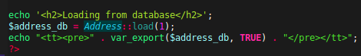

Now jump to the class.Addresss.inc. We now will write our method from our interface -load. Load will take the address id and first grab an instance of the connection to the database. Next, we reassign the connection to the mysqli. Next we build a query string that selects an address matching an id. We then grab the data and convert it into an associative array. We then assign that to a row. If data returned, then we call get an instance of that data or an object.
In the get instance, we take two arguments. One is the address type id we submitted and was processed. And the data of the associative array. We ten return the class name -in this instance it would be AddressResidence. Next, we then return the new class with the associative data.
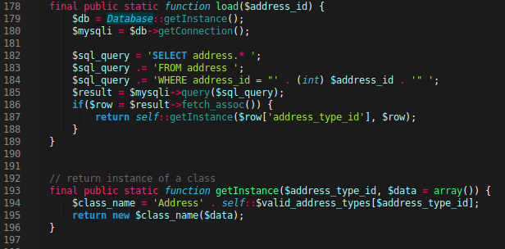

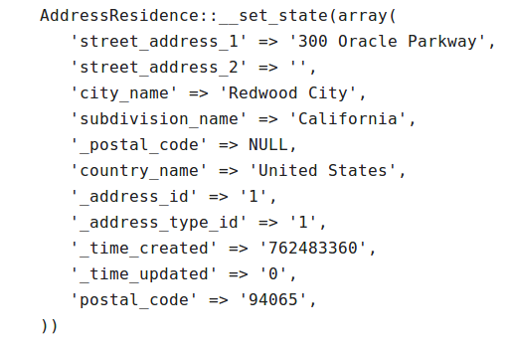
As a result, when we export our object, we get the following:

06_03_Error handling with Exceptions: Exception handling is the response to problems that change execution. They are thrown, then caught. To catch: use try. If thrown, throw new exception('paraemeter').

In this example, we provide an error handling for an event that may make a request that may not exist. We can do so simply by throwing a new exception with a message. This allows us to display the message that actually occurred. In this example, we try to load a address id of 0 -which doesn't exist.
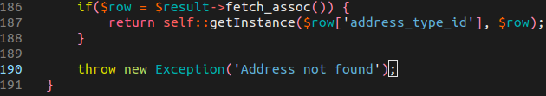

06_04_Customizing PHP exceptions: To customize our error handling, we can write a separate Exception class that extends the Extension class. This will deal with Exception Address specifically. We write a magic method of to string which will display the class, the error code, and the message thrown by the catch.
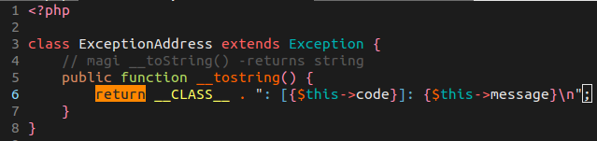

Next, within our throw call, we tell throw to use the Exception Address and report a message and code.
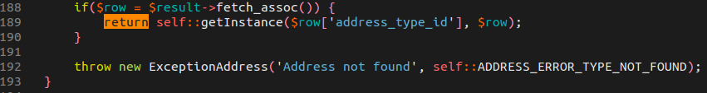

Lastly, in our demo, we use a try and catch method which will catch the error and use the exception address e message. By echoing out the variable of e, we use the magic method of to string to display the message:

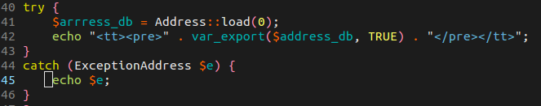

Design Patterns

07_01_Identifying the singleton Leveraging standard class objects: OOP offers the solution of design patters which are reusable solutions to common problem.
A singleton pattern restricts instantiation to one object -the database class is one example.
We can identify this through a quick example. We create a class of lazy init that calls get property. That property then checks if a property exists or is null. If it is, then we assign a new property of init -which will instantiate the class reference. It returns that property reference.
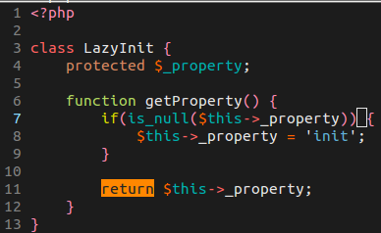

07_02_Using factory method pattern: The factory method pattern creates objects without specifying an exact class.
We create an instance of a class by calling get instance of address type residence:
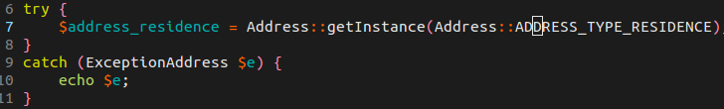

Within our get instance method, we will try and get a class name, if no class name exists, then we can report and error
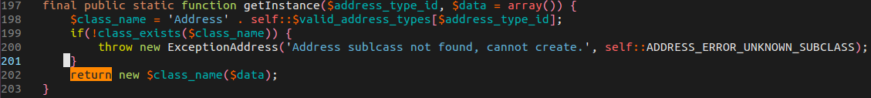
07_03_Implementation a strategy pattern: The strategy pattern is a family of algorithms to perform a task. Mechanisms to determine which algorithm to use is important. When choosing a shirt to wear in the morning you go through a process of steps, choices, and solutions -no clean shirts results in a problem.

Strategy patterns in this course include:
- class.AddressDisplay.inc
- class.AddressDisplayNoCountry.inc
- class.AddressDispayFull.inc
- class.AddressDisplayPark.inc
In this example we have an interface of Address Display that requires an is available method and display method for each specific display that implements it.

We re-wrote our display to strategically use an interface class for display. We first check if the _display_strategy is null. It will be if we instantiated a new display. What will happen, in the init which is called during instantiation, is within the display, each display strategy will be consider as a strategy class name. If we consider a strategy class name that checks if the class that was called indeed is an instance of the correct available strategy name, then we will assign the display strategy to that strategy class name. We add an error exception catch for no display strategy found.
We then assign display strategy to the global instance of display strategy. We ten return the display strategy calling the static method of display. This will return an appropriate strategy of display. This is a creative as well as a strategic pattern for implementation. We can take advantage of this through out our code as it is a great instance of implementing class based interfaces and strategies.

// display method will use AddressDisplay interface -for example AddressDisplay -if no country, then use the display of Address Display No Country.

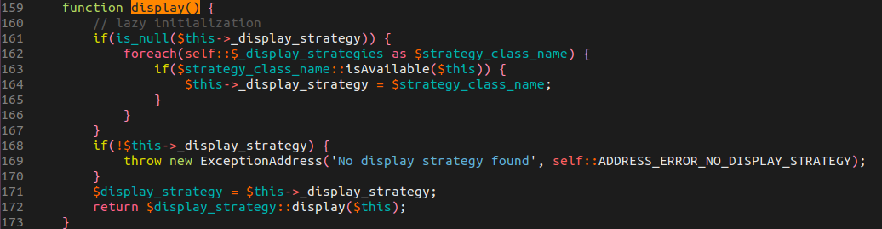
Conclusion

08_01_Looking forward to name space: Is PHP the technical plateau of OOP? Absolutely not. Name spaces can encapsulate classes, functions, and constants. It solves reusable code problems with naming collisions and ability to alias long names. Check out PHP Fundamentals for use of name space.

08_02_Next steps: MVC Frameworks.

