ACMG Classification Rules Specified for PALB2

Summary of ACMG-AMP Criteria for PALB2 associated with hereditary breast and pancreatic cancer
Green writing is HBOP VCEP Expert opinion on PALB2 Rules
MONDO:0700272 (PALB2-related cancer predisposition)  MONDO:0012565 (Fanconi Anemia Complementation Group N) |  | RefSeq: NM_024675.3  Ensembl: ENST00000261584.9
PATHOGENIC CRITERIA
Criteria | Criteria Description |  | Specification
VERY STRONG CRITERIA
PVS1_Variable  PVS1_Variable(RNA) | Null variant in a gene where loss of function is a known mechanism of disease.  - Per PALB2 Exon Map and PALB2 PVS1 Guide  - PVS1_Variable: Predicted splice defect  - PVS1_Variable(RNA): Observed splice defect  - In the event that RNA data are available and they reflect a substantial variant-specific impact, do not use both PVS1(RNA) and PP3 or BP4. However, in the event that RNA data are available and they reflect no variant-specific impacts, PP3 or BP4 may be applied in conjunction with BP7(RNA). |  | Gene-Specific
STRONG CRITERIA
PS1_Variable | Same amino acid or splice change as a previously established pathogenic variant regardless of nucleotide change.  - Missense: Do not use. Missense changes are not yet confirmed as a mechanism of disease for PALB2.  - Splicing (use as PS1_ Variable): Use PALB2 PS1 Splicing table for splicing variants with similar predictions or observations of splice defect. (PMID: 36865205) |  | General
PS2 | De novo (paternity confirmed) in a patient with the disease and no family history.  - Do not use for AD or AR disease: Informative de novo occurrences have not yet been observed and de novo AR conditions are unlikely to be informed by phase |  | N/A
PS3_Variable | Well-established in vitro or in vivo functional studies supportive of a damaging effect  - Protein: Do not use: Lack of known positive controls  - RNA: Do not use: See code PVS1_Variable(RNA) |  | Gene-Specific
PS4 | The prevalence of the variant in affected individuals is significantly increased compared with the prevalence in controls.  - Case-control studies; p-value ≤.05 AND (Odds ratio, hazard ratio, or relative risk ≥3 OR lower 95% CI ≥1.5).  - Do not use for proband-counting studies (PS4_Moderate): Proband counting for genes causing a common disorder need to be calibrated in a population-specific way before use |  | Disease-Specific
MODERATE CRITERIA
PM1 | Located in a mutational hot spot and/or critical and well-established functional domain.  - Do not use: Missense is not yet confirmed as a mechanism of disease for PALB2 |  | N/A
PM2_Supporting | Absent/rare from controls in an ethnically-matched cohort population sample.  - Frequency ≤ 1/300,000 (0.000333%) in gnomAD v4 dataset  - EXCEPTION: under-represented sub-populations with n=1 but frequency >.0003%  - Not considered a conflicting piece of evidence for variants that otherwise are likely benign/benign  - Use as PM2_Supporting (not moderate) |  | Gene-Specific: Strength
PM3_Variable | For recessive disorders, detected in trans with a pathogenic variant.  - Per Fanconi Anemia PM3 tables |  | Disease-Specific: Strength
PM4 | Protein length changes due to in-frame deletions/insertions in a non-repeat region or stop-loss variants.  - Do not use for in frame insertions and deletions as no data are available for this rule at this time  - Do not use for stop-loss variants. |  | N/A
PM5_Supporting | Missense change at an amino acid residue where a different missense change determined to be pathogenic has been seen before.  - For missense: do not use-missense changes are not yet confirmed as a mechanism of disease for PALB2.  - Apply as PM5_Supporting to frameshifting or truncating variants with premature termination codons upstream of p.Tyr1183, based on location of the most C-terminal known pathogenic variant, p.Tyr1183*. Apply as PM5_Supporting to splice variants with premature termination codons upstream of p.Tyr1183 where PVS1_VS[RNA] is applied based on high quality observed splicing impact and must be NMD prone. |  | Gene-specific: Strength
PM6 | Confirmed de novo without confirmation of paternity and maternity.  - Do not use for AD or AR disease: Informative de novo occurrences have not yet been observed and de novo AR conditions are unlikely to be informed by phase |  | N/A
SUPPORTING CRITERIA
PP1_Variable | Co-segregation with disease in multiple affected family members  - AD Condition: use as per Co-Segregation Guidelines  - AR Condition:  - PP1_Strong: Segregation in ≥3 affected relatives  - PP1_Moderate: Segregation in 2 affected relatives  - PP1: Segregation in 1 affected relative  - Note: Affected relatives must have both variants identified in proband. |  | Gene-Specific
PP2 | Missense variant in a gene that has a low rate of benign missense variation and where missense variants are a common mechanism of disease.  - Do not use. Missense is not yet confirmed or refuted as a mechanism of disease |  | N/A
PP3 | Multiple lines of computational evidence support a deleterious effect on the gene or gene product  - Missense: Do not use. So far, published predictors have yet to achieve functional outcome for PALB2 missense variants  - Splicing: Predicted impact via splicing (SpliceAI ≥0.2)  - NOTE: Splice analysis needs to be considered for all variant types (including missense, frameshift, nonsense, etc. as any variant has the potential to impact splicing which may preclude any expected protein effects)  - NOTE: PP3 for splice predictions may not be applied in addition to PVS1 or PVS1_Variable[RNA] codes.  - Use caution in applying the wrong type of computational evidence (protein vs. RNA) towards the cumulative body of evidence for the opposite mechanism.  The VCEP uses SpliceAI as a sole predictor due to its ability to accurately predict loss of native splice sites and creation of cryptic sites (Jaganathan et al., 2019). This VCEP recommends SpliceAI thresholds set forth by the SVI in applying PP3 and BP4 to non-canonical splice variants: Apply PP3 for SpliceAI scores ≥0.2 and apply BP4 for SpliceAI scores ≤0.1 (Walker et al., 2023).  In the event that RNA data are available and they reflect a substantial variant-specific impact, do not use both PVS1(RNA) and PP3 or BP4. However, in the event that RNA data are available and they reflect no variant-specific impacts, PP3 or BP4 may be applied in conjunction with BP7(RNA). |  | Gene-Specific (protein)  General (RNA)
PP4 | Phenotype specific for disease with single genetic etiology.  - Autosomal Dominant: do not use as breast cancer is a disease with multiple genetic etiology (genetic heterogeneity) and there are no features that can readily distinguish hereditary from sporadic causes.  - Autosomal Recessive: do not use as a separate line of evidence. Such evidence is built into the Fanconi Anemia PM3|BS2 table |  | N/A
PP5 | Reputable source recently reports variant as pathogenic but the evidence is not available to the laboratory to perform an independent evaluation |  | N/A-discontinued

BENIGN CRITERIA
Criteria | Criteria Description | Specification
STAND ALONE CRITERIA
BA1 | GnomAD Filtering Allele Frequency Allele frequency  - >0.1% in gnomAD v4 dataset | Gene/Disease-Specific
STRONG CRITERIA
BS1 | GnomAD Filtering Allele Frequency greater than expected for disease  - >.01% in gnomAD v4 dataset | Gene/Disease-Specific
BS2 | Observed in a healthy adult individual for a dominant (heterozygous) disorder with full penetrance expected at an early age.  - Per Fanconi Anemia BS2 tables | Gene/Disease-Specific
BS3_Variable | Well-established in vitro or in vivo functional studies shows no damaging effect on protein function  - Protein: Do not use: Lack of known positive controls  - RNA: Do not use: See code BP7_Variable(RNA) | N/A
BS4 | Lack of segregation in affected members of a family.  - AD Condition: use as per Co-Segregation Guidelines  - AR Condition: informative instances of co-segregation in FANCN families are too rare to be considered for weight at this time and can also be considered for BS2 if biallelic unaffected patients are observed in a Fanconi Amenia family. | Gene-Specific
SUPPORTING CRITERIA
BP1 | Missense variant in gene where only LOF causes disease  - Apply to all missense variants. | Gene-Specific
BP2_Variable | Observed in trans with a pathogenic variant for a fully penetrant dominant gene/disorder.  - Do not use: See Fanconi Anemia BS2 table | N/A
BP3 | In-frame deletions/insertions in a repetitive region without a known function  - No data at this time | N/A
BP4 | Multiple lines of computational evidence suggest no impact on gene or gene product  - Missense: Do not use. So far, published predictors have yet to achieve functional outcome for PALB2 missense variants  - Splicing: No predicted impact via splicing (SpliceAI ≤0.1)  - NOTE: Splice analysis needs to be considered for all variant types (including missense, frameshift, nonsense, etc. as any variant has the potential to impact splicing which may preclude any expected protein effects)  - NOTE: BP4 for splice predictions may not be applied in conjunction with BP7_Variable[RNA] (a lack of observed RNA defect)  - Use caution in applying the wrong type of computational evidence (protein vs. RNA) towards the cumulative body of evidence for the opposite mechanism.  The VCEP uses SpliceAI as a sole predictor due to its ability to accurately predict loss of native splice sites and creation of cryptic sites (Jaganathan et al., 2019). This VCEP recommends SpliceAI thresholds set forth by the SVI in applying PP3 and BP4 to non-canonical splice variants: Apply PP3 for SpliceAI scores ≥0.2 and apply BP4 for SpliceAI scores ≤0.1 (Walker et al., 2023).  In the event that RNA data are available and they reflect a substantial variant-specific impact, do not use both PVS1(RNA) and PP3 or BP4. However, in the event that RNA data are available and they reflect no variant-specific impacts, PP3 or BP4 may be applied in conjunction with BP7(RNA). | General
BP5 | Variant found in a case with an alternate molecular basis for disease  - Do not use | N/A
BP6 | Reputable source recently reports variant as benign but the evidence is not available to the laboratory to perform an independent evaluation  - Do not use | N/A - discontinued
BP7  BP7_ Variable(RNA) | A synonymous (silent) variant  - BP7: Can be used for deep intronic variants further than (but not including) +7 (donor) and -21 (acceptor)  - Can be used in conjunction with BP4 to achieve likely benign in the absence of conflicting data  - Is not considered a conflicting piece of evidence against a body of evidence supporting a pathogenic splice defect  - BP7_Variable(RNA): Observed Lack of aberrant RNA defect with variable weight applied depending on assay quality (see text)  - NOTE: BP4 splice predictions may not be used in conjunction with BP7_Variable(RNA) | General

Key: Disease-Specific: Disease-specific modifications based on what is known about PALB2-related diseases; Gene-Specific: Gene-specific modifications based on what is known about PALB2; Strength: Increasing or decreasing strength of criteria based on the amount of evidence; N/A: not applicable for PALB2; General: Using the baseline ACMG guideline but may also expounding on some of the details.

VERY STRONG EVIDENCE OF PATHOGENICITY
PVS1 | Null variant (nonsense, frameshift, canonical +/-1 or 2 splice sites, initiation codon, single or multi-exon deletion) in a gene where loss of function (LOF) is a known mechanism of disease  Caveats:  - Use caution interpreting LOF variants at the extreme 3’ end of a gene  - Use caution with splice variants that are predicted to lead to exon skipping but leave the remainder of the protein intact  Notes  - The default RefSeq transcript for nucleotide (c.) annotation is NM_024675.3/ENST00000261584.8. Several naturally occurring alternate splicing isoforms have been described1. Yet, after careful examination, none of them is considered a candidate rescue transcript (very low contribution to overall expression, not coding proteins predicted functional, or both). In keeping with that, we have considered that all presumed LoF events (PVS1 decision tree specifications) occur in biologically relevant transcript(s). (Lopez-Perolio 2019 PMID 30890586).  - WD40 beta propeller and Coiled-coil domain (CC) are considered indispensable for PALB2 protein function. PVS1 alterations that are predicted to escape NMD, but that adversely affect the WD40 domain can be granted PVS1 (as opposed to PVS1_Strong as the recommended baseline (Tayoun 2018 PMID 30192042). The following evidence supports this strength change:  - The WD40 domain interacts with many different protein partners that are involved in the double strand break repair pathway (Reviewed in Ducy 2019 PMID 30638972)  - Two different C-terminal truncating mutations (c.3549C>A and c.3549C>G) resulting in loss of the last 3 amino acids [p.(Tyr1183Ter)], were identified in trans with PALB2 stop-gain variants in three unrelated FA (FA-N) patients (Reid 2007 PMID 17200671)  - The PALB2 WD40 toroidal structure is “sealed” in the seventh blade by interaction of the C-terminal strand with the incomplete N-terminal blade. The last four residues of PALB2 (Y1183, H1184, Y1185, and S1186) are directly involved in this interaction (molecular Velcro hydrogen bonding) (Oliver 2009 PMID: 28673926). This is the rationale for the clinical relevance of the last 4 amino acids of the protein.  - Alterations predicted to lead to in frame losses adversely affecting the WD40 structure/function are found in trans with LoF PALB2 alterations in Fanconi Anemia patients (Reid 2007 PMID 17200671)  - Exon 10 donor: c.3113+5G>C (biallelic with c.395delT)  - Exon 12 donor: c.3350+4A>G (biallelic with c.2393_2394insCT)  - LoF alterations are rare in GnomAD in all exons  - GnomAD v2.1 accessed 5/30/2019  - Total Variants (includes splice acceptor/donor-conservative)  - 1418 variants  - 336,349 carriers  - LoF Flag (excludes splice acceptor/donor-conservative)  - 95 variants (6.7%)  - 239 carriers (.07%)
PALB2 Exon Map and Domain Map: Use for Single- and Multi-Cassette Exon Losses
- Number above exon represents the coding exon number
- Overhang on top: a two-nt overhang
- Overhang on bottom: a one-nt overhang
- Parallel lines represent in-frame changes (e.g. EX6_7del is in-frame [5’ of exon 6 and 3’ of exon 7 are parallel]; however EX6_8del is out-of-frame [5’ of exon 6 and 3’ of exon 8 are not parallel])
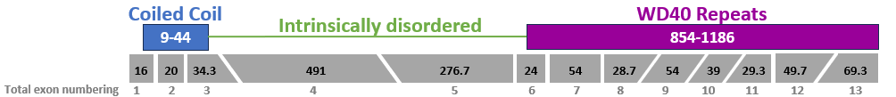
- BRCA1 binds the coiled coil domain
- BRCA2 and RAD51 bind the WD40 domain

PVS1 can be applied as per the below decision tree.

PVS1_Variable[RNA] shall be used for observed splice defects, whether from canonical +/-1,2 positions or other spliceogenic regions (including mid-exonic missense/synonymous variants that cause splice defects) with baseline weight as per the below decision tree. Weight can be further modified based on the quality of the RNA study including consideration of concepts such as:
- Starting material (where patient material is preferable to in vitro minigene)
- Use of NMD inhibitors where translation does occur such as cell lines (Thermann 1998 PMID 9628884, Cater 1995 PMID 7499432)
- Primer design (to make sure it’s comprehensive to capture possible multicassette events)
- Method of quantification
  - where e.g. capillary electrophoresis is preferable to estimation by gel band density
  - where SNP analysis is most preferred (where analysis of exonic SNPs and their relative presence in aberrant and WT transcripts is informative)
- Quantification (where complete effects should have increased weight over incomplete effects)
- Specific guidance on the use of RNA evidence in variant assessment is not a gene-specific consideration for PALB2 at this time, therefore discretion is left to assessors until further guidance is provided for this general concept from the Sequence Variant Interpretation group.
PALB2 PVS1/ PVS1_Variable[RNA] Guide (Adapted from PMID 30192042)
1. PVS1 decision tree, based on ACMG/AMP rationale (Tayoun et al, 2018), introducing some code strength modifications (upgrades and downgrades as indicated), and a few instances not addressed by Tayoun et al. Specifically: (i) GT-AG variants not affecting coding exons, (ii) +2T>C variants predicted to create de novo functional GC sites, (iii) +2C>T variants targeting native GC sites and, (iv) considering the relevance of the protein domain targeted by ≥1 exon duplications in deciding the PVS1 evidence strength

2. We have considered NM_024675.3 the clinically relevant reference transcript (13 exons, 13 coding exons, start codon located in exon 1, encoding a 1186aa protein-UniProtKB Q86Yc2)

3. We are not aware of any potential rescue transcripts (i.e. for the sake of simplicity, in the decision tree we will not refer to “exon is absent from biologically-relevant transcripts”) Lopez-Perolio et al, 2019.

4. We define two clinically relevant domains (Figure 1): (i) a Coiled-coil (CC) domain spanning residues 10-40 (Song et al, 2018) and (ii) a WD40 domain spanning residues 856-1186 (Oliver et al, 2009).

5. Based on clinical, functional and structural data, we have considered in-frame alterations targeting the CC and WD40 domains as PVS1 (see footnote G for an exception)

6. Based on clinical and structural data, we have considered in-frame alterations targeting FATKIN as PVS1, the only exception being very small in-frame alterations with PROVEAN score suggesting pathogenic, that were considered PVS1_Supporting

7. As far as we know, p.Tyr1183Ter is the last PTC variant known to be pathogenic (Reid et al, 2007)

8. p.Tyr1183Ter pathogenicity suggests that the last four residues (YHYS) of PALB2, or at least some of them, as critical for PALB2 function. This is supported by structural considerations (Oliver et al, 2009).

9. The existence of experimental data (literature and/or personal communication from HBOP VCEP members) supporting the PVS1 weight are denoted by red-underline in the PVS1 decision tree.
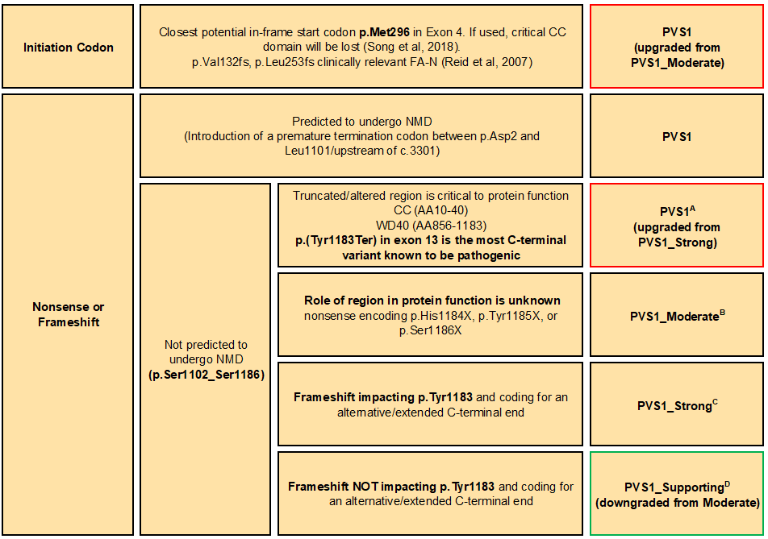
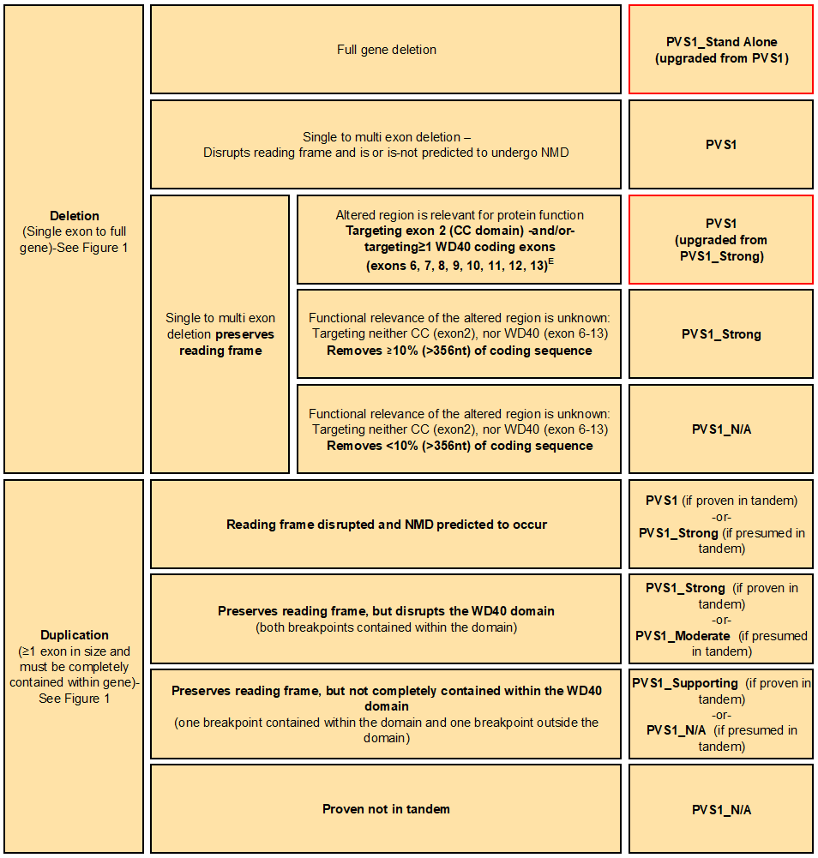
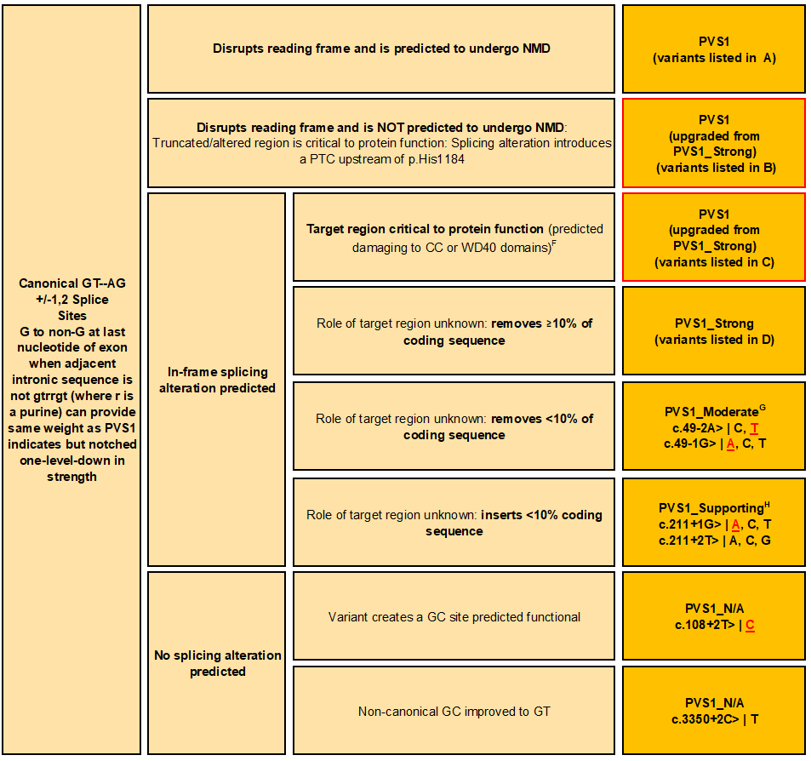
A) Two different C-terminal truncating mutations (c.3549C>A, c.3549C>G) introducing the same stop codon [p.(Tyr1183Ter)] were identified in trans with PALB2 stop-gain variants in three unrelated FA (FA-N) patients (Reid 2007). For that reason, variants introducing stop gains upstream of His1184 are considered PVS1, regardless of NMD status. Pathogenicity of p.(Tyr1183Ter) points to last four residues (YHYS), or at least some of them, as critical for PALB2 function. Probably, this critical role has a structural basis, as WD40 C-terminal residues interacting with WD40 N-terminal residues seal the toroidal structure in a “molecular Velcro” interaction, and lack of residues YHYS (is predicted to) prevent the closure of the WD40 ring (Oliver et al, 2009). Note that, at present, we do not know if all four residues or only a subset are structurally critical.

B) Depending on the location, these variant will preserve one, two, or three residues at the C-terminal YHYS end. The role of deleted residues is not necessarily critical (i.e. the preserved residues might be sufficient to seal the toroidal structure), and <10% protein removed, qualifying for moderate.

C) These variants will encode proteins with alternative C-terminal ends. We expect these alternative C-terminal ends being unable to recapitulate the “molecular Velcro” interaction with WD40 N-terminal residues, but we cannot discard the possibility of an alternative C-terminal end (partially) mimicking the critical role of the native C-terminal end in WD40 folding. A similar mechanism has been proposed at the N-terminal end of the WD40 domain (upstream sequence mimicking 7D β-strand) to explain the apparent hypomorphic nature of exon 6 skipping (Byrd et al, 2016)

D) Depending on the location, these variants will preserve one, two or three residues at the C-terminal YHYS end (as per B). Compare with B, these variant will code additional residues. We cannot discard the possibility of an alternative C-terminal end mimicking the critical role of YHYS in WD40 folding

E) Exon 6 codes for WD40 β-strand 7D that is critical for WD-40 toroidal folding (Oliver et al, 2009). Yet, Byrd et al 2016 suggests that exon 6 deletion might be to some extent hypomorphic due to some ability of exon 5 residues to mimic WD40 β-strand 7D.

F) Predicted damaging to CC (exon 2) -or- WD40 (exons 6 to 13) domains if ≥1 coding exon skipped

G) For variants targeting the exon 2 acceptor site, the predicted/observed outcome ∆(E2p6) skips two residues located at the CC domain p.(Leu17_Lys18del). p.Lys18Arg has no impact on HR efficiency (Boonen et al, 2020). p.Leu17Pro shows HR efficiency reduced >50%. Yet, we do not consider the latter result a formal proof that Leu 17 is critical for HR activity, as proline is a well establish α-helix breaker (Li et al, 1996)

H) For variants targeting the exon 3 donor site, the predicted/observed outcome ▼(E3q48) introduces 17 novel residues in the protein p.E71delinsGKSRPFTYACFIIHFPE. Supporting strength is based on bioinformatics (PROVEAN score -15.84)

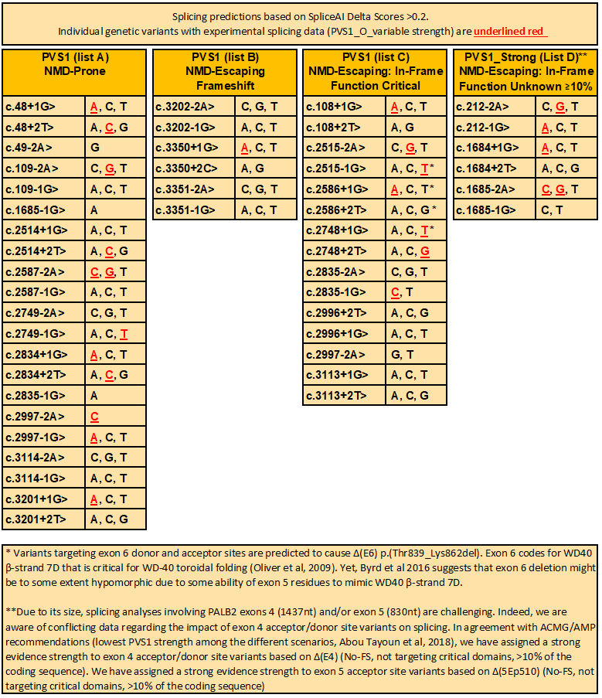
STRONG EVIDENCE OF PATHOGENICITY
PS1 | Same amino acid change as a previously established pathogenic variant regardless of nucleotide change  - Missense: Do not use. Missense changes are not yet confirmed as a mechanism of disease for PALB2.  - Splicing: See PALB2 PS1 Table for splicing variants with similar predictions or observations of splice defect. (PMID: 36865205)
  PS1 code weights for variants with the same predicted splicing event as a known (likely) pathogenic variant *
  Variant Under Assessment (VUA) | Baseline computational/ predictive code applicable to VUA | Position of reference variant compared to VUA | PS1(Splicing) code applicable to VUA
  Variant Under Assessment (VUA) | Baseline computational/ predictive code applicable to VUA | Position of reference variant compared to VUA | with P reference variant | with LP reference variant
  Located outside donor/acceptor ±1,2 dinucleotide positions | PP3 | Same nucleotide | PS1 | PS1_Moderate
  Located outside donor/acceptor ±1,2 dinucleotide positions | PP3 | Within same donor/acceptor motif (including at ±1,2 positions) | PS1_Moderate | PS1_Supporting
  Located at donor/acceptor ±1,2 dinucleotide positions | PVS1 | Within the same donor/acceptor dinucleotide | PS1_Supporting | N/A
  Located at donor/acceptor ±1,2 dinucleotide positions | PVS1 | Within same donor/acceptor motif, but outside dinucleotide# | PS1_Supporting | PS1_Supporting
  Located at donor/acceptor ±1,2 dinucleotide positions | PVS1_Strong, PVS1_Moderate, or PVS1_Supporting | Within the same donor/acceptor dinucleotide | PS1 | N/A
  Located at donor/acceptor ±1,2 dinucleotide positions | PVS1_Strong, PVS1_Moderate, or PVS1_Supporting | Within same donor/acceptor motif, but outside dinucleotide# | PS1_Moderate | PS1_Supporting
  * Prerequisite for all: The predicted event of the VUA must precisely match the predicted event of the known (likely) pathogenic variant (e.g. both predicted to lead to exon A skipping, or both to enhanced use of cryptic site B), AND the strength of the prediction for the VUA must be of similar or higher strength than the strength of the prediction for the known (likely) pathogenic variant. (Likely) pathogenic variant should be assigned classification using VCEP specifications. For an exonic variant, predicted or proven functional effect of missense substitution/s encoded by the VUA and (likely) pathogenic variant should also be considered before application of this code. Donor/acceptor dinucleotide refers to donor and acceptor ±1,2 dinucleotides in reference transcript/s used for curation. Designated donor and acceptor motif ranges should be based on position weight matrices for intron category. For GT-AG introns these are defined as follows: the donor motif, last 3 bases of the exon and 6 nucleotides of intronic sequence adjacent to the exon; acceptor motif, first base of the exon and 20 nucleotides upstream from the exon boundary. Consider other motif ranges for non GT-AG introns.
  # If relevant, splicing data for a pathogenic variant outside the donor/acceptor ±1,2 dinucleotide positions may be used to update a PVS1 decision tree, and hence the applicable PVS1 code for a donor/acceptor dinucleotide variant.
PS2 | De novo (both maternity and paternity confirmed) in a patient with the disease and no family history  Note: Confirmation of paternity only is insufficient. Egg donation, surrogate motherhood, errors in embryo transfer, etc. can contribute to non-maternity  - Autosomal Dominant Disease: Do not use-Informative de novo occurrences have not yet been observed for autosomal dominant disease. As breast cancer is relatively common and occurs frequently as an apparently sporadic event, de novo is unlikely to ever be informative unless specific features of PALB2-related-breast cancer are identified.  - Autosomal Recessive Disease: Do not use- de novo occurrences are too rare to be informative at this time. In addition, in a biallelic state de novo occurrences have an exceedingly low probability of being able to be confirmed as in trans because parental testing (and identification of one variant in each parent) is typically required without the use of long-range technologies.
PS3 | Well-established in vitro or in vivo functional studies supportive of a damaging effect on the gene or gene product.  - Protein: Do not use- Due to a lack of known positive controls, do not apply functional criteria at this time.  - RNA functional studies shall be coded as PVS1(RNA) (where RNA is for Observed RNA data). Please see PVS1(RNA) section (above) for guidance on baseline weights and modifications of weight based on quality
PS4 | The prevalence of the variant in affected individuals is significantly increased compared to the prevalence in controls  - PS4 Case-control studies with p-value ≤.05 AND (Odds ratio, hazard ratio, or relative risk ≥3 OR lower 95% CI ≥1.5).  - PS4_Moderate: Do not use-Proband counting for genes causing a common disorder need to be calibrated in a population-specific way before use.

MODERATE EVIDENCE OF PATHOGENICITY
PM1 | Located in a mutational hot spot and/or critical and well-established functional domain (e.g. active site of an enzyme) without benign variation  - Do not use: Missense pathogenic variation in PALB2 is not yet confirmed as a mechanism of disease.
PM2 | Absent from controls (or at extremely low frequency if recessive) in GnomAD  - PM2_Supporting  - Frequency ≤ 1/300,000 (0.000333%) in gnomAD v4 dataset  - EXCEPTION: under-represented sub-populations with n=1 but frequency >.0003%  - There must be sufficient coverage at the locus (>30X, PMID 33600021)  - Is not considered a conflicting piece of evidence for variants that otherwise are likely benign/benign
PM3 | For recessive disorders, detected in trans with a pathogenic variant  - Fanconi Anemia (FA) of any subtype is generally considered an exceedingly rare, severe, early-onset disease with variable features. In the case of BRCA2, hypomorphic FA patients have been described who are diagnosed at older ages with less severe phenotypes. The criteria set forth in the tables below are designed to accommodate such hypomorphs and are recommended to be applied to all FA-associated genes which may not be as well described due to the extreme infrequency of their identification, and due to ascertainment bias (for severe phenotype) in the literature.  - General Considerations  - Variant may not exceed general population frequency >0.01%.  - Consider other gene panel test results as potential explanation for phenotype.  - Multiple unrelated cases are additive.  - Phenotype consistent:  - Chromosomal breakage with 1 clinical feature OR  - Ex. Chromosomal breakage testing + microcephaly / triangular face  - At least 2 of 3 clinical features from separate categories without chromosomal breakage studies  - Ex. (Without chromosomal breakage): Myelodysplastic Syndrome and microcephaly / triangular face.  - Positive for chromosome breakage test:  - Increased chromosome breakage and/or radial forms on cytogenetic testing of lymphocytes with diepoxybutane (DEB) or mitomycin C (MMC)  - Clinical features indicative of FA, including  - Physical features (in ~75% of affected persons), include:  - prenatal and/or postnatal short stature  - abnormal skin pigmentation (e.g., café au lait macules, hypo- pigmentation)  - Skeletal malformations (e.g., hypoplastic thumb, hypoplastic radius)  - Microcephaly, triangular face  - Ophthalmic anomalies  - Genitourinary tract anomalies.  - See Orphanet for full list of >100 HPO terms (and their reported frequency).  - Pathology findings and laboratory findings (non-cancer related) include  - progressive bone marrow failure (unrelated to cancer treatment)  - aplastic anemia  - Myelodysplastic syndrome  - Inordinate toxicities from chemotherapy or radiation  - macrocytosis  - cytopenia (especially thrombocytopenia, leukopenia, and neutropenia)  - increased fetal hemoglobin (often precedes anemia).  - Cancer diagnosis ≤5yr, particularly  - Blood cancers (AML)  - Brain cancers (medulloblastoma, neuroblastoma)  - Wilms Tumor  - Specifications are adapted from GeneReviews (last revision June 3, 2021)  Fanconi Anemia PM3|BS2 tables:
  Points per unrelated PALB2-related (FANCN) Fanconi Anemia Proband (PM3)
  Phenotype and Classification/ Zygosity of other variant¹ |  | Confirmed in trans or homozygote² |  |  |  | Phase unknown
  Phenotype consistent with PALB2-related FA |  | 2.0 |  |  |  | 1.0
  Points per proband meeting age/cancer diagnosis criteria (BS2)
  Phenotype and Classification/ Zygosity of other variant |  | VUA in trans with P or LP variant³ |  | Homozygote⁴ |  | Phase unknown, VUA co-occurs with P or LP variant
  Patient first cancer onset >50y or cancer-unaffected at age at last follow up of >50y |  | 4.0 |  | 2.0 |  | 1.0
  Patient first cancer onset 40-50y or unaffected at age of last follow up of 40-50y |  | 2.0 |  | 1.0 |  | 0.5
  ¹Variant under assessment (VUA) must be sufficiently rare (not meeting a benign population evidence code). Consider other gene panel test results as potential explanation for phenotype.
  ²Co-occurrent P or LP variant should be assigned classification using VCEP specifications. Stipulation for in trans can be met by genotyping of at least one parent or assumed if VUA is seen with at least 2 different P/LP variants. If there are multiple phase unknown co-occurrences with different P/LP variants, at least one should be weighed as phase unknown to allow for the probability of one co-occurrence in cis and the remaining can be weighed as in trans. Further, co-occurrence in trans can be inferred in the case of a homozygote FA-affected patient due to a consanguineous union, or if both maternal and paternal lineages present with family history of cancer consistent with PALB2 related cancers. Maximum of 2 homozygous individuals.
  ³VUA should not be bioinformatically predicted (or experimentally proven) to have a clinically important effect on protein or mRNA splicing. Co-occurrent P or LP variant should be assigned classification using VCEP specifications. See footnote 2 for stipulation for in trans.
  ⁴Apply only for phenotyped individuals from clinical or research cohorts. NOT to be applied for data used to assign frequency-based codes; we have observed that variants observed as ≥2 homozygotes in gnomAD data (assumed unaffected adults of unspecified age) are already captured by the BA1 or BS1 frequency codes.
  Do not use observations in cis
   | Supporting | Moderate | Strong |  | Very Strong
   | PM3_
   | 1.0 | 2.0 | 4.0 |  | 8.0
   | BS2_
   | 1.0 | 2.0 | ≥4.0 |  | N/A
PM4 | Protein length changes due to in-frame deletions/insertions in a non-repeat region or stop-loss variants  - Do not use for in-frame deletions/insertions that are not already PVS1-eligible as no information is available to justify the application of this rule. In addition, missense and small in-frame indels are not yet confirmed as a mechanism of disease for PALB2.  - Do not use for stop-loss due to lack of data on stop-loss variants.
PM5 | Missense change at an amino acid residue where a different missense change determined to be pathogenic has been seen before  - Do not use for missense/hotspot - Multiple amino acid substitutions at the same residue can be pathogenic or benign and bioinformatic tools cannot yet confidently distinguish them. In addition, missense is not yet confirmed as a mechanism of disease for PALB2.  - Apply as PM5_Supporting to frameshifting or truncating variants with premature termination codons upstream of p.Tyr1183, based on location of the most C-terminal known pathogenic variant, p.Tyr1183*  - Apply to splice variants as PM5_supporting for splice variants can only be applied for variants premature termination codons upstream of p.Tyr1183 where PVS1_VS[RNA] is applied based on high quality observed splicing impact and must be NMD prone
PM6 | Assumed de novo, but without confirmation of paternity and maternity  - Do not use: See PS2 for justification

SUPPORTING EVIDENCE OF PATHOGENICITY
PP1 | Co-segregation with disease in multiple affected family members in a gene definitively  known to cause the disease  AD Co-Segregation Guidelines  - Quantitative co-segregation analysis is mandated for more accurate assessment of causality for PALB2 alterations. It is strongly preferred that biocurators use a quantitative method that accommodates both pathologies of AD PALB2: breast cancer, ovarian cancer and pancreatic cancer. These methods may be conducted by biostatisticians, particularly if they are able to compute LR scores using multiple phenotypes. LR thresholds are derived from Tavtigian 2018 PMID 29300386 as follows:  - PP1_Very Strong: LOD ≥2.54 or Bayes Factor (LR) ≥350:1  - PP1_Strong: LOD ≥1.26 or Bayes Factor (LR) ≥18:1  - PP1_Moderate: LOD ≥.60 or Bayes Factor (LR) ≥4:1  - PP1: LOD ≥0.3 or Bayes Factor (LR) ≥2:1  - BS4_Supporting: LOD ≤-.32 or Bayes Factor (LR) ≤.48  - BS4_Moderate: LOD ≤ -.64 or Bayes Factor (LR) ≤.23  - BS4: LOD ≤ -1.28 or Bayes Factor (LR) LR≤.053:1  A freely available tool, COOL (COsegregation OnLine) from Bing-Jian Feng’s laboratory can be used to calculate LoD scores for co-segregation analysis  - Navigate to https://fengbj-laboratory.org/cool2/server.uu.html  - Input ‘PALB2’ into the ‘Input a Gene Symbol’ field (the PALB2 defaults are approved by this VCEP)  - Upload your Pedigree File (see https://fengbj-laboratory.org/cool2/manual.html for formatting)  - Leave all defaults as is. Select ‘Submit’ to obtain LR based on Full Likelihood Bayes (FLB)  AR Condition  - PP1_Strong: Segregation in ≥3 affected relatives  - PP1_Moderate: Segregation in 2 affected relatives  - PP1: Segregation in 1 affected relative  - Note: Affected relatives must have both variants identified in proband.
PP2 | Missense variant in a gene that has a low rate of benign missense variation and where missense variants are a common mechanism of disease  - Do not use: Missense is not yet confirmed or refuted as a mechanism of disease for PALB2.
PP3 | Multiple lines of computational evidence support a deleterious effect on the gene or  gene product (conservation, evolutionary, splicing impact, etc)  - Missense: Do not use. So far, published predictors have yet to achieve functional outcome for PALB2 missense variants  - Splicing: Predicted impact via splicing (SpliceAI ≥0.2) for silent, missense/in-frame and for intronic variants outside of donor and acceptor 1,2 sites.  - NOTE: Splice analysis needs to be considered for all variant types (including missense, frameshift, nonsense, etc. as any variant has the potential to impact splicing which may preclude any expected protein effects) o  - NOTE: PP3 for splice predictions may not be applied in addition to PVS1 or PVS1_Variable[RNA] codes.  - Use caution in applying the wrong type of computational evidence (protein vs. RNA) towards the cumulative body of evidence for the opposite mechanism.  - The VCEP uses SpliceAI as a sole predictor due to its ability to accurately predict loss of native splice sites and creation of cryptic sites (Jaganathan et al., 2019). This VCEP recommends SpliceAI thresholds set forth by the SVI in applying PP3 and BP4 to non-canonical splice variants: Apply PP3 for SpliceAI scores ≥0.2 and apply BP4 for SpliceAI scores ≤0.1 (Walker et al., 2023).  - In the event that RNA data are available and they reflect a substantial variant-specific impact, do not use both PVS1(RNA) and PP3 or BP4. However, in the event that RNA data are available and they reflect no variant-specific impacts, PP3 or BP4 may be applied in conjunction with BP7(RNA).
PP4 | Patient’s phenotype or family history is highly specific for a disease with a single genetic etiology.  - Do not use for AD disorder as breast cancer is a disease with multiple genetic etiology (genetic heterogeneity) and there are no features that can readily distinguish hereditary from sporadic causes.  - For AR disorder, see PM3 for specific phenotype considerations
PP5 | Reputable source recently reports variant as pathogenic but the evidence is not available  to the laboratory to perform an independent evaluation  N/A Discontinued by ACMG/AMP

STAND ALONE EVIDENCE OF BENIGN IMPACT
BA1 | Grpmax Filtering AF >.1% in gnomAD v4 dataset  Rounded from .118% using Whiffin calculator http://cardiodb.org/allelefrequencyapp/  - Prevalence (breast cancer): 1:8  - Allelic Heterogeneity: 1 (differs from BS1)  - Genetic Heterogeneity: .01  - Penetrance: .53

STRONG EVIDENCE OF BENIGN IMPACT
BS1 | Grpmax Filtering AF >.01% in gnomAD v4 dataset  Rounded from .0118% using Whiffin calculator http://cardiodb.org/allelefrequencyapp/  - Prevalence (breast cancer): 8  - Allelic Heterogeneity: 0.1 (differs from BA1)  - Genetic Heterogeneity: .01  - Penetrance: .53
BS2 | Observed in a healthy adult individual for a recessive (homozygous), dominant  (heterozygous), or X-linked (hemizygous) disorder with full penetrance expected at an early age.  - See Fanconi Anemia BS2 tables (above)  - Do not use for individuals in population-based cohorts, such as gnomAD  - Consider multiple instances of co-occurrence with the same variant are more likely to be in cis in unrelated individuals when assessing BS2 application
BS3 | Well-established in vitro or in vivo functional studies show no damaging effect on protein function or splicing.  - Protein functional studies (BS3): Do not use  - See PS3 for details  - RNA functional studies (Use BP7_Variable[RNA])
BS4 | Lack of segregation in affected members of a family  - See PP1

SUPPORTING EVIDENCE FOR BENIGN IMPACT
BP1 | Missense variant in a gene for which primarily truncating variants are known to cause disease  - Based on published and unpublished functional studies, PALB2 has a low rate of missense variants that are non-functional in relevant assays. True missense pathogenic variants are not yet confirmed or refuted but are thought to be exceedingly rare. Given the very low likelihood that missense variants are pathogenic, this rule applies to all missense variants in PALB2.
BP2 | Observed in trans with a pathogenic variant for a fully penetrant dominant  gene/disorder; or observed in cis with a pathogenic variant in any inheritance pattern  - Do not use: See Fanconi Anemia PM3|BS2 table (above)
BP3 | In-frame deletions/insertions in a repetitive region without a known function  - Do not use: small in-frame losses are neither confirmed nor refuted as a mechanism of pathogenicity for PALB2. In addition, PALB2 is not considered to have repetitive regions without known function.
BP4 | Multiple lines of computational evidence suggest no impact on gene or gene product (conservation, evolutionary, splicing impact, etc.)  - Missense: Do not use. So far, published predictors have yet to achieve functional outcome for PALB2 missense variants  - Splicing: No predicted impact via splicing (SpliceAI ≤0.1).  - NOTE: Splice analysis needs to be considered for all variant types (including missense, frameshift, nonsense, etc. as any variant has the potential to impact splicing which may preclude any expected protein effects)  - NOTE: BP4 for splice predictions may not be applied in conjunction with BP7_Variable[RNA] (a lack of observed RNA defect)  - Use caution in applying the wrong type of computational evidence (protein vs. RNA) towards the cumulative body of evidence for the opposite mechanism.  - The VCEP uses SpliceAI as a sole predictor due to its ability to accurately predict loss of native splice sites and creation of cryptic sites (Jaganathan et al., 2019). This VCEP recommends SpliceAI thresholds set forth by the SVI in applying PP3 and BP4 to non-canonical splice variants: Apply PP3 for SpliceAI scores ≥0.2 and apply BP4 for SpliceAI scores ≤0.1 (Walker et al., 2023).  - In the event that RNA data are available and they reflect a substantial variant-specific impact, do not use both PVS1(RNA) and PP3 or BP4. However, in the event that RNA data are available and they reflect no variant-specific impacts, PP3 or BP4 may be applied in conjunction with BP7(RNA).
BP5 | Variant found in a case with an alternate molecular basis for disease  - Do not use: Cases with multiple pathogenic variants have been observed with no noticeable difference in phenotype (e.g. BRCA1 and BRCA2). In addition, PALB2 has moderate penetrance and will naturally occur with other pathogenic variants more frequently due to higher tolerance/presence in the general population.
BP6 | Reputable source recently reports variant as benign but the evidence is not available to the laboratory to perform an independent evaluation  N/A Discontinued by ACMG/AMP
BP7 | A synonymous (silent) variant  - BP7: Synonymous and deep intronic  - Can be used for deep intronic variants beyond (but not including) +7 (donor) and -21 (acceptor)  - May also apply BP4 to achieve Likely Benign  - Is not considered a conflicting piece of evidence against a body of evidence supporting a pathogenic splice defect  - BP7_Variable[RNA]: RNA functional studies  - Lack of aberrant splice defect: Please see PVS1_Variable[RNA] section (above) for guidance on baseline weights and modifications of weight based on quality for RNA assays  - NOTE: BP4 splice predictions may not be used in conjunction with BP7_Variable(RNA)  - In the event that RNA data are available and they reflect a substantial variant-specific impact, do not use both PVS1(RNA) and PP3 or BP4. However, in the event that RNA data are available and they reflect no variant-specific impacts, PP3 or BP4 may be applied in conjunction with BP7(RNA).

RULES FOR COMBINING PATHOGENIC CRITERIA

Pathogenic
- 1 Very Strong (PVS1, PVS1_Variable[RNA], PM3_VeryStrong) AND
  - ≥1 Strong (PS1‐PS4, PM3_Strong, PP1_Strong) OR
  - ≥2 Moderate (PM3, PM5, PS1 _Moderate, PP1_Moderate) OR
  - 1 Moderate (PM3, PM5, PS1 _Moderate, PP1_Moderate) and 1 Supporting (PP1‐PP3, PM2_Supporting, PM3_Supporting, PM5_Supporting) OR
  - ≥2 Supporting (PP1‐PP5, PM2_Supporting, PM3_Supporting, PM5_Supporting)
- ≥2 Strong (PS1‐PS4, PM3_Strong, PP1_Strong) OR
- 1 Strong (PS1‐PS4, PM3_Strong, PP1_Strong) AND
  - ≥3 Moderate (PM3, PM5, PS1 _Moderate, PP1_Moderate) OR
  - 2 Moderate (PM3, PM5, PS1 _Moderate, PP1_Moderate) AND ≥2 Supporting (PP1‐PP3, PM2_Supporting, PM3_Supporting, PM5_Supporting) OR
  - 1 Moderate (PM3, PM5, PS1_Moderate, PP1_Moderate) AND ≥4 Supporting (PP1‐PP3, PM2_Supporting, PM3_Supporting, PM5_Supporting)

Likely Pathogenic
- 1 Very Strong (PVS1, PVS1_Variable[RNA], PM3_VeryStrong) AND 1 Moderate (PM3, PM5, PS1 _Moderate, PP1_Moderate) OR
- 1 Very Strong (PVS1, PVS1_Variable[RNA], PM3_VeryStrong) AND 1 Supporting (PM2_Supporting, PM5_Supporting) OR
- 1 Strong (PS1‐PS4, PM3_Strong, PP1_Strong) AND 1‐2 Moderate (PM3, PM5, PS1 _Moderate, PP1_Moderate) OR
- 1 Strong (PS1‐PS4, PM3_Strong, PP1_Strong) AND ≥2 Supporting (PP1‐PP3, PM2_Supporting, PM3_Supporting) OR
- ≥3 Moderate (PM3, PM5, PS1 _Moderate, PP1_Moderate) OR
- 2 Moderate (PM3, PM5, PS1 _Moderate, PP1_Moderate) AND ≥2 Supporting (PP1‐PP3, PM2_Supporting, PM3_Supporting, PM5_Supporting) OR
- 1 Moderate (PM3, PM5, PS1 _Moderate, PP1_Moderate) AND ≥4 Supporting (PP1‐PP3, PM2_Supporting, PM3_Supporting, PM5_Supporting)

RULES FOR COMBINING BENIGN CRITERIA

Benign
- 1 Stand‐Alone (BA1) OR
- ≥2 Strong (BS1‐BS4)

Likely Benign
- 1 Strong OR
- 1 Strong (BS1-BS4) and 1 Supporting (BP1‐BP7, BP7_Supporting[RNA]) OR
- ≥2 Supporting (BP1–BP7, BP7_Supporting[RNA])

