GP1BA, GP1BB, GP9 Rules for Combining Codes with Conflicting Criteria
For GP1BA, GP1BB or GP9 variants where criteria codes for benign and pathogenic evidence apply, these variants are not subjected to an automatic variant of uncertain significance (VUS) classification. Instead, we recommend application of the rule combination point system described by Tavtigian, et al. 2020 (PMID: 32720330).
Use the Tavtigian, et al. Table 2 below to determine how many points that each evidence code is worth and sum those point values:
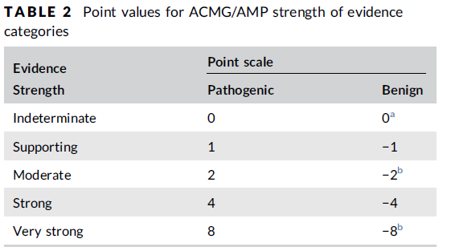
Then, use the Tavtigian, et al. Table 3 below to determine which variant classification corresponds to the summed point value.
