ClinGen SVI Recommendations for Applying Variant in trans Evidence (PM3)
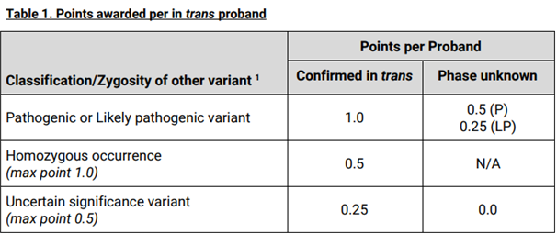
¹ In trans variants classified as a variants of uncertain significance, as per the Bernard Soulier syndrome (BSS) rule specifications, must meet PM2_supporting to be scored. Conversely, in trans variants that meet a pathogenic or likely pathogenic classification using the BSS rule specifications do not have to meet PM2_supporting criteria; however, they cannot meet BS1 or BA1 criteria; P – Pathogenic; LP – Likely pathogenic

