Rule Specifications for Type 2 VWD: Instructions for use

The following rule specifications can be used for VWF variants associated with a type 2 clinical diagnosis of VWD and/or for variants with no known association with disease. If the variant being curated has not been previously associated with VWD type 2 or if the proband with this variant does not clearly have a VWD type 2 phenotype, do not use this rule set. Phenotyping for type 2 VWD is complex. If the variant has not been previously associated with a specific type 2 diagnosis (e.g., 2A, 2M, 2B or 2N) and the proband’s type 2 diagnosis is unclear, we recommend not using this rule set. Due to the complexity of the VWD phenotype, we also recommend not using this rule set if there is uncertainty on how to apply the type 2 VWD guidelines. A general VWD rule set agnostic of type of VWD will be developed in the future. Rule specifications specific to VWD types 1 and 3 are also currently under development. These rule specifications are also not recommended for variants that have only been associated with a clinical diagnosis of Types 1 and/or 3 VWD or no clinical diagnosis/proband.

VWD type 2 can be further broken down into four specific diagnoses: VWD type 2A, 2B, 2M and 2N. Types 2A, 2B, and 2M are generally inherited in an autosomal dominant fashion, and therefore, have a separate rule set from VWD 2N, which is inherited in an autosomal recessive fashion. Additionally, the rule specifications have slight differences between types 2A, 2B and 2M. Therefore, it is advisable that the specific type of VWD that the variant has been associated with be established before further variant curation can begin (see Figure 1). It is also important to note that there are some variants that have been associated with more than one type of VWD. For those variants, it may be warranted to curate for more than one type of VWD, separating the probands that fall under each type and only applying them under a single phenotype. For instance, if a VWF variant has been associated with type 2A and type 2M phenotypes, you would curate the variant twice, once for the 2A phenotype using that proband(s) and once for the 2M phenotype using that proband(s). If the variant has not been associated with a specific type of VWD and there is no proband with sufficient laboratory results available for use in the PP4 rule code, we would recommend that these rule specifications not be used. These rule specifications are specifically for variants that have been associated or are suspected to be associated with VWD type 2 disease. We plan to develop a more general rule specification set in the future.

Use the flow chart below to decide which set of rules to use for a particular variant. Additional laboratory results not referred to below could support a diagnosis of the condition. The purpose of this flow chart is to simply guide which rule set might be most appropriate before starting a detailed variant curation.

Figure 1 – Flow chart to guide choice of rule specifications for VWD Type 2 variant curation
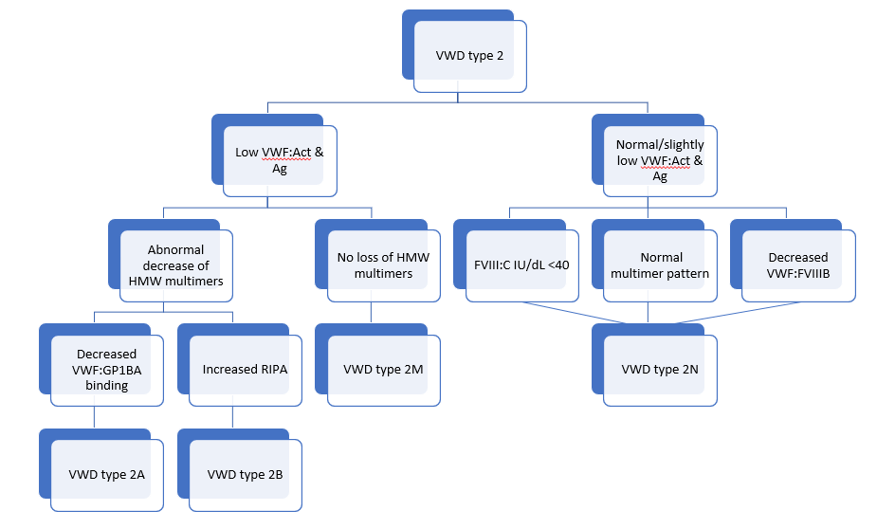
VWF: von Willebrand factor; Act: activity; Ag: antigen; HMW: high molecular weight; RIPA: ristocetin-induced platelet aggregation; FVIII:C: factor VIII clotting assay; VWF:FVIIIB: VWF binding to factor VIII protein assay

