SERPINC1 Rules for Combining Codes with Conflicting Criteria
For SERPINC1 variants where criteria codes for benign and pathogenic evidence apply, these variants are not subjected to a variant of uncertain significance (VUS) classification. Instead, we recommend application of the rule combination point system described by Tavtigian, et al. 2020 (PMID: 32720330).
Use the Tavtigian, et al. Table 2 below to determine how many points that each evidence code is worth and sum those point values:
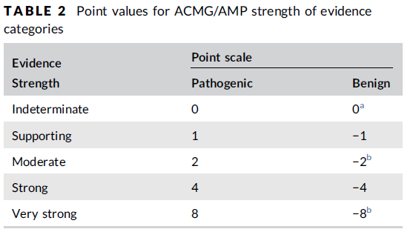
Then, use the Tavtigian, et al. Table 3 below to determine which variant classification corresponds to the summed point value.
