Classification/Zygosity of other variant | Points per Proband-Family*
Classification/Zygosity of other variant | Confirmed in trans | Phase unknown
Pathogenic or Likely pathogenic variant | 1.0 | 0.5 (P)  0.25 (LP)
Homozygous occurrence  Non-consanguineous** (no max) | 1.0 | 1.0
Homozygous occurrence  Consanguineous** (no max) | 0.5 | 0.5
Uncertain significance variant  (max point 0.5) | 0.25 | 0
* Multiple probands from separate nuclear families that are later found to have identity-by-descent should only be counted once.
** When consanguinity is not known or reported: if family IS NOT from a bottlenecked population (as defined by gnomAD), assume non-consanguinity; otherwise, assume consanguinity. If genetic ancestry of the family cannot be determined, assume consanguinity.

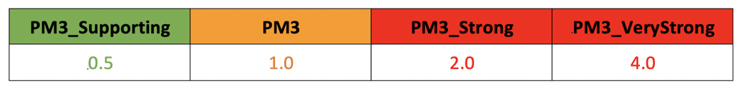

SVI Comments:
- Prefer N/A to repeating the 1.0 and 0.5

The SCID VCEP deliberated this point. Our geneticists pointed out that apparent homozygous variants could result from hemizygosity, which may be undetected if the parents are not sequenced (i.e., “Phase unknown”). Because of the likelihood that authors may not bother to sequence the parents in homozygous situations, especially in older publications, the VCEP experts preferred to leave the numbers in place.

- Update “max point 0.5 per family” to “max point 0.5” as in original specs
- Please replace “max point 0.5 per family” from the Homozygous Consanguineous and indicate “no max”. Rationale:
  - “per proband” is a rule for the whole table in general (per the table title)
  - Multiple cases per family will inherently be counted as PP1 instead of multiple PM3s

The SCID VCEP agreed and made the changes to the table. To minimize confusion for biocurators and experts as much as possible between proper application of PM3 vs. PP1 (which we have definitely observed, even in sustained curations), we changed “Proband” to “Proband-Family”.

- What to do if you don’t know about consanguinity

The VCEP decided to use gnomAD definitions to specify assumption of non-consanguinity for families from non-bottlenecked populations and assumption of consanguinity otherwise. A footnote was added to the Table.

- If the VCEP wishes, they can provide an asterisk footnote that supports the notion that “multiple probands from separate nuclear families that are later found to have identity-by-descent should only be counted once.”

We added this footnote to the Table.

