Data and citations related to PM1
Amino acid residues in BMPR2 indispensable to function
Extracellular domain
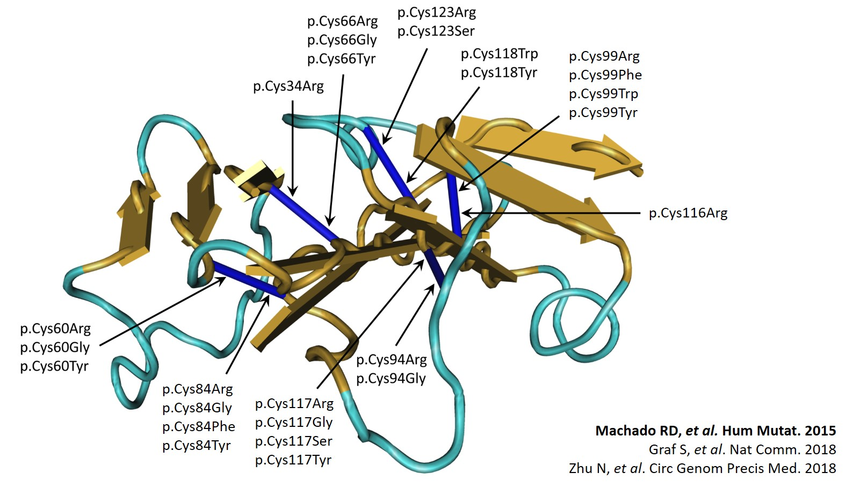

These are the 10 invariant cysteine residues in the BMPR2 ECD required for correct folding. ‘In vitro mutagenesis and X-crystallography studies identified 10 cysteine residues conserved across the related type II BMP, MIS, and activin receptors, each of which is necessary for receptor ligand protein folding of the ligand domain’ [Greenwald et al., 1999, Machado et al., 2006]. FPAH-causing missense mutations have now been identified for all of the 10 cysteine residues, and of those studied by transient transfection of GFP- or myc-tagged BMPR2 constructs, each appears to lead to significant protein misfolding and/or cytoplasmic retention [Nishihara et al. 2002, Rudarakanchana et al., 2002].

Kinase domain
Structural and functional data have effectively demonstrated the critical role these amino acids play in receptor activity. For example, the invariant arginine at position 491 in BMPR-II is indispensable for signaling, since it forms an ion pair with a highly conserved glutamic acid at position 386 [Zhang et al., 1994; Hanks and hunter, 1995]. Substitution at this codon is the most frequently observed missense mutation in FPAH. The following sections provide additional critical residues of the kinase domain based on comparative evolutionary alignment and structural analyses.

Invariant and nearly invariant residues by comparative evolutionary EUK sequence alignment
Method:
Sequences from 60 aligned eukaryotic kinases (EUKs), [Hanks and Hunter] were assessed with reference to BMPR2. An example of KD subdomain I-V is shown below where invariant residues are in capital letter above the sequence, the 12 invariant and near invariant residues are defined as being conserved in >95% of 370 EUK species:

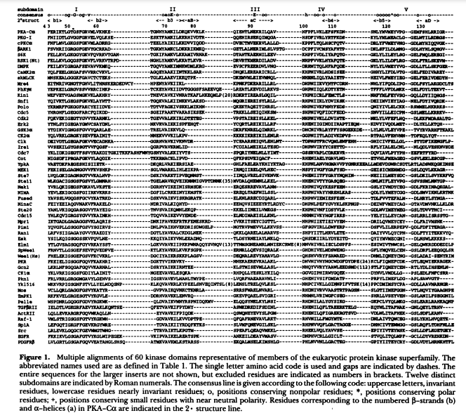

Next, the two closest evolutionary relatives to BMPR2, namely ACTR2 and TGFβR2 were aligned to BMPR2 to determine the corresponding residue position (red arrows indicate invariant residues, blue indicate nearly invariant).

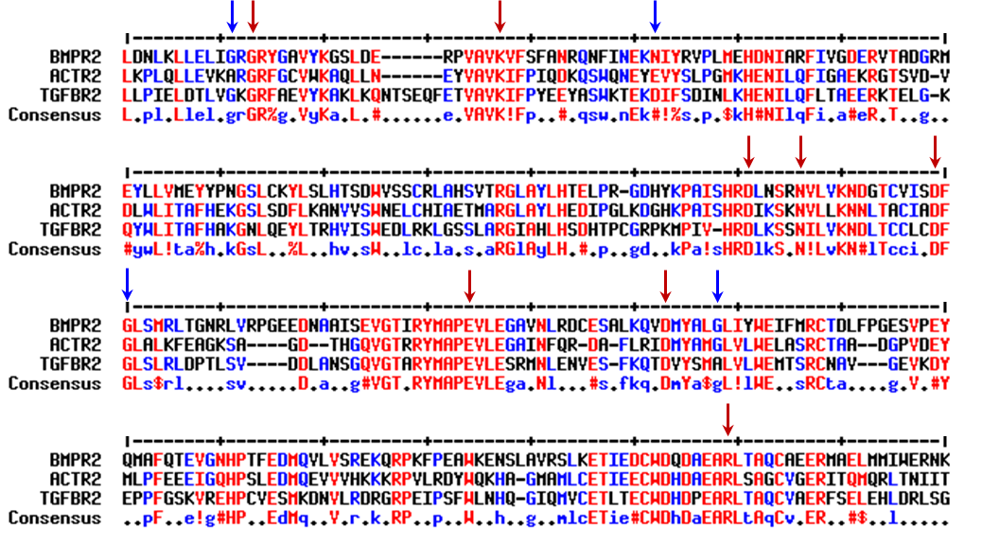

Results:
Invariant residues in BMPR2: G212, K230, D333, N338, D351, E386, D405, R491.
Nearly invariant residues: G210, E/N245, G353, G410

Reference: Hanks SK, Hunter T. Protein kinases 6. The eukaryotic protein kinase superfamily: kinase (catalytic) domain structure and classification. FASEB J. 1995 May;9(8):576-96. PMID: 7768349.

Indispensable residues in the KD for heterodimerisation – structural analysis
- Hydrogen deuterium exchange mass spectrometry (HDX-MS), small angle X-ray scattering (SAXS) and molecular dynamics (MD) simulations

Fig. 3: The ALK2^{KD}/BMPR2^{KD} heterodimer interface localizes to the kinase C-lobes.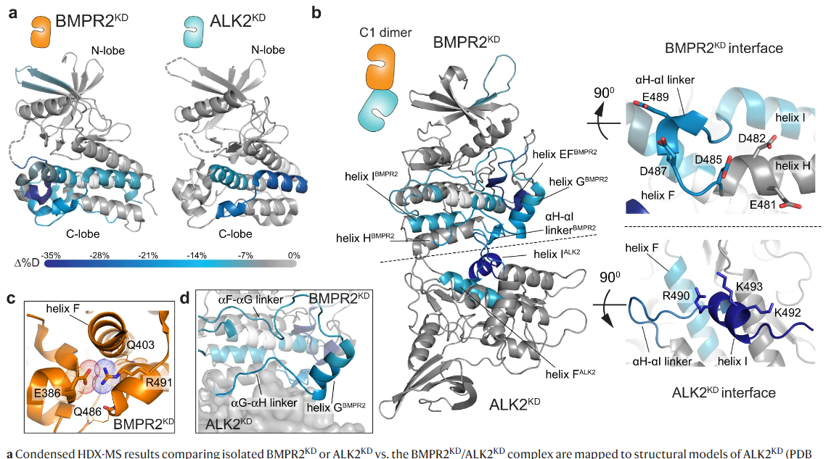

The structure of the C-lobe of BMPR2KD also undergoes stabilization upon dimerization with the ALK2KD (Fig. 3a, b, Supplementary Fig. 4). One of the protected regions encompasses the αH-αI linker (residues 485–492), a surface displaying and bordering acidic residues, including E481, D482, D485, D487, and E489. This region is in direct contact with helix I on ALK2 in the C1 dimer model (Fig. 3b). Boxed in red. In the crystal structure of the BMPR2 kinase domain, the αH-αI linker forms a partial helix and is mostly surface accessible, except for the highly conserved R491 that packs into the C-lobe core where it forms an electrostatic interaction with the sidechain of E386 and with the backbone carbonyl oxygens of Q403 and Q486 (Fig. 3c).
The BMPR2 C-lobe dimer interface is disrupted in PAH
Heterozygous loss-of-function or expression mutations in BMPR2 account for ~80% of familial and ~20% of idiopathic PAH27. Some of these mutations introduce insertions, cause deletions or frameshifts in the BMPR2 kinase domain, likely compromising its structure and hence enzymatic activity. The mechanisms of action of missense mutations commonly found on the surface of the BMPR2 kinase are more difficult to rationalize28,29,30,31. Remarkably, several of these mutations (C483R, D485G, D487V, A490D/V, and R491W/Q) cluster to the C1 dimer interface in the BMPR2 kinase domain, specifically at the αH-αI linker (Fig. 6a). Boxed in red. As shown in Figs. 4c and 5c, mutations of the residues within the αH-αI linker disrupt ALK2/BMPR2 kinase dimerization and downstream SMAD signaling by the full-length ALK2/BMPR2 receptor complex (Figs. 4c and 5c). Two sites of PAH mutations—D487 and D485—stand out because they make direct interactions with residues in ALK2 in the C1 dimer model (Fig. 6b). D487 was included in the BMPR2KD-EDE mutant which failed to dimerize with ALK2KD (Fig. 4c). D485 was not included in our initial mutagenesis and was of particular interest. The D485G mutation is highly penetrant in PAH, and previous studies have shown its dominant-negative effect on BMPR2 signaling in complex with other type I receptors (ALK3 and ALK6) in cells30,32,33.
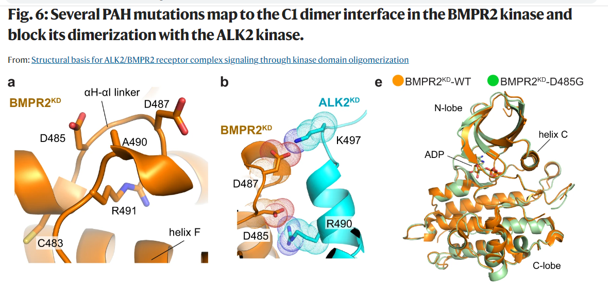

Results:
Residues need for type I dimerization: 485 -492
Reference: Structural basis for ALK2/BMPR2 receptor complex signaling through kinase domain oligomerization. Christopher Agnew, Pelin Ayaz, Risa Kashima, Hanna S. Loving, Prajakta Ghatpande, Jennifer E. Kung, Eric S. Underbakke, Yibing Shan, David E. Shaw, Akiko Hata & Natalia Jura Nature Communications volume 12, Article number: 4950 (2021).

Example of a kinase variant that retains kinase activity
- Luciferase assays
Not all kinase reisidue variants are functionally equal (red arrow indicates KD variant p.E503D}. Equivalent to WT when co-transfected with type I receptors (panel F) in marked contrast to p.D485G.
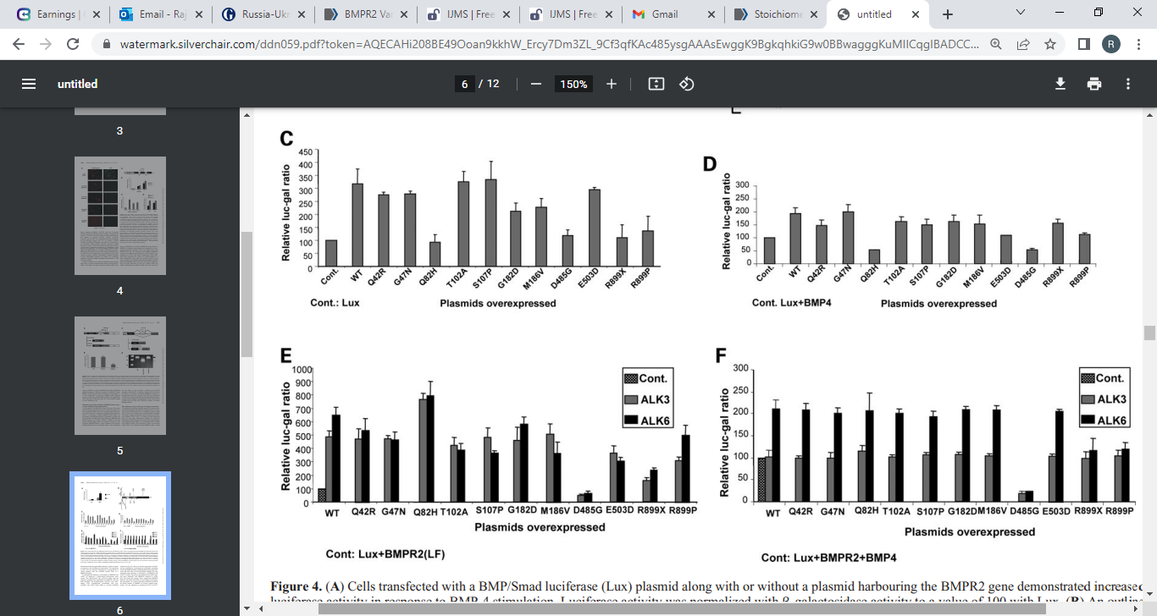
Cells were stimulated with BMP-4. Plasmids encoding wild-type and mutant BMPR2 activated reporter activity but mutation at position p.D485G had severely abolished the activity. BMP-4 and BMPR-II stimulated normalized value was set as 100.

Results:
Not all residues in the kinase domain are critical.
Reference: Nasim MT, Ghouri A, Patel B, James V, et al. Stoichiometric imbalance in the receptor complex contributes to dysfunctional BMPR-II mediated signalling in pulmonary arterial hypertension. Hum Mol Genet. 2008 Jun 1;17(11):1683-94.

References:
- Greenwald J, Fischer WH, Vale WW, Choe S. 1999. Three-finger toxin fold for the extracellular ligand-binding domain of the type II activin receptor serine kinase. Nat Struct Biol 6:18–22. PMID: 9886286
- Nishihara A, Watabe T, Imamura T, Miyazono K. 2002. Functional heterogeneity of bone morphogenetic protein receptor-II mutants found in patients with primary pulmonary hypertension. Mol Biol Cell 13:3055–3063. PMID: 12221115
- Rudarakanchana N, Flanagan JA, Chen H, Upton PD, Machado R, Patel D, Trembath RC, Morrell NW. 2002. Functional analysis of bone morphogenetic protein type II receptor mutations underlying primary pulmonary hypertension. Hum Mol Genet 11:1517–1525. PMID: 12045205
- Hanks SK, Hunter T. 1995. The eukaryotic protein kinase superfamily: kinase (catalytic) domain structure and classification. FASEB J 9:576–596. PMID: 7768349
- Southgate L, Machado RD, Gräf S, Morrell NW. Molecular genetic framework underlying pulmonary arterial hypertension. Nat Rev Cardiol. 2020 Feb;17(2):85-95. doi: 10.1038/s41569-019-0242-x. Epub 2019 Aug 12. PMID: 31406341
- Machado RD, Southgate L, Eichstaedt CA, Aldred MA, Austin ED, Best DH, Chung WK, Benjamin N, Elliott CG, Eyries M, Fischer C, Gräf S, Hinderhofer K, Humbert M, Keiles SB, Loyd JE, Morrell NW, Newman JH, Soubrier F, Trembath RC, Viales RR, Grünig E. Pulmonary Arterial Hypertension: A Current Perspective on Established and Emerging Molecular Genetic Defects. Hum Mutat. 2015 Dec;36(12):1113-27. doi: 10.1002/humu.22904. Epub 2015 Oct 12. PMID: 26387786
- Machado RD, Aldred MA, James V, Harrison RE, Patel B, Schwalbe EC, Gruenig E, Janssen B, Koehler R, Seeger W, Eickelberg O, Olschewski H, Elliott CG, Glissmeyer E, Carlquist J, Kim M, Torbicki A, Fijalkowska A, Szewczyk G, Parma J, Abramowicz MJ, Galie N, Morisaki H, Kyotani S, Nakanishi N, Morisaki T, Humbert M, Simonneau G, Sitbon O, Soubrier F, Coulet F, Morrell NW, Trembath RC. Mutations of the TGF-beta type II receptor BMPR2 in pulmonary arterial hypertension. Hum Mutat. 2006 Feb;27(2):121-32. doi: 10.1002/humu.20285. PMID: 16429395.

