PM3_Moderate for GALT:
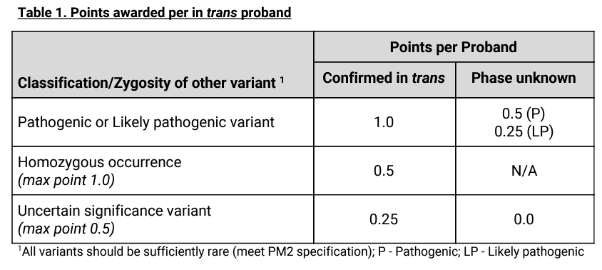
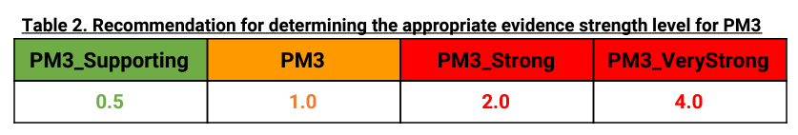
Tables from ClinGen Sequence Variant Interpretation Recommendation for in trans Criterion (PM3) - Version 1.0 accessed October 2023
- Variant under investigation must meet PM2
- Identified individuals must meet PP4
- Pathogenic of variant in trans must be determined using VCEP guidelines

