ClinGen SVI Recommendations for Applying the PM3 Code
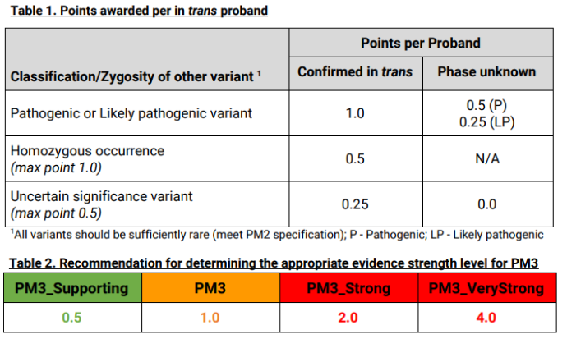
¹Variant must not meet BS1 or BA1 criteria.

