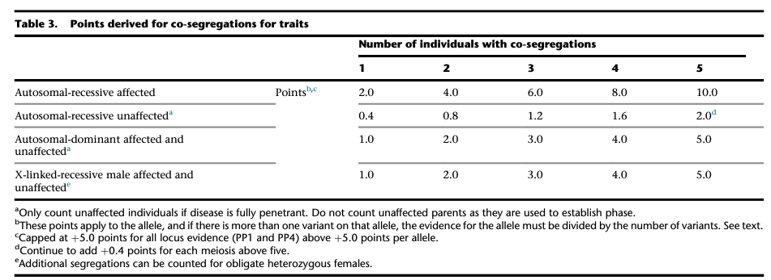

This guidance is from Biesecker et al 2023. For full information, please see the article:
https://pubmed.ncbi.nlm.nih.gov/38103548/

