PART 1 — Install SQLite

Windows installation:
- Go to the SQLite Download Page (sqlite.org/download.html)
- Search and download the latest windows binary. Under Precompiled Binaries for Windows, search for:
“sqlite-tools-win-x64”
Download the highlighted file as shown below:
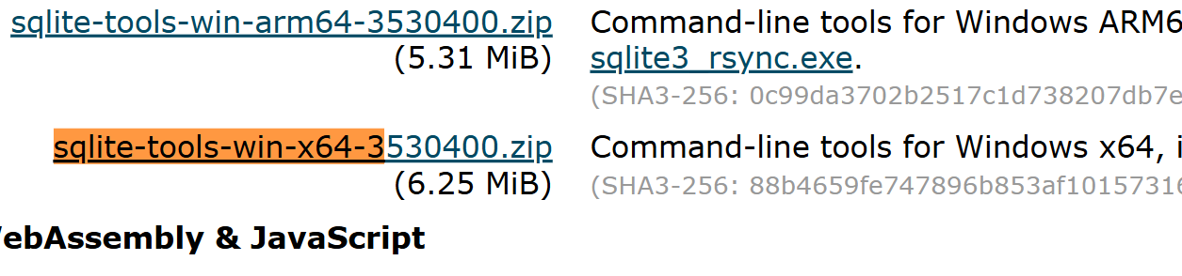
- Extract the zip file.
- Create a folder “Assignment6” in your repository assignments folder.
- Move the extracted folder to: Assignment6
- Right click in the folder and click “Open in Power Shell”
- Type:
.\sqlite3
Add a screenshot of your output below if you are using windows:
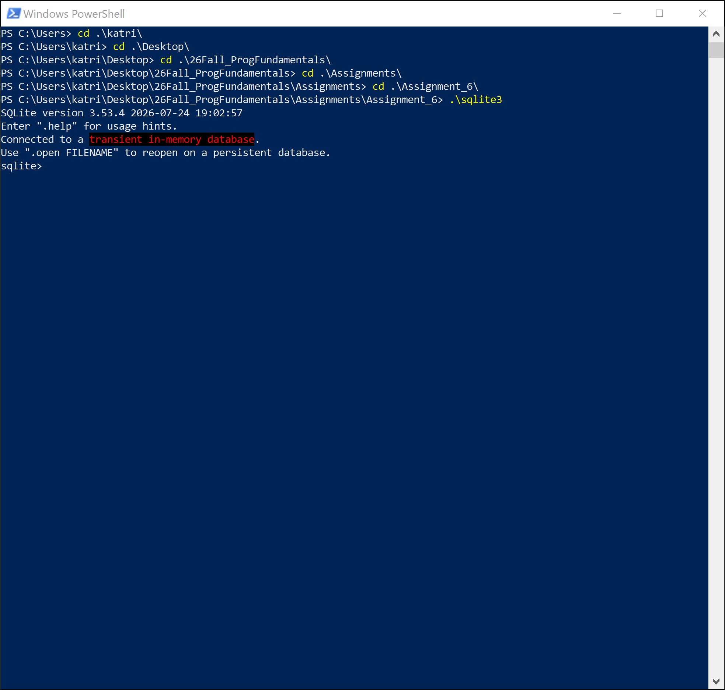
- Type:
.exit

macOS Installation:
macOS already includes SQLite.
Create a folder “Assignment6” in the repository folder.
Open Terminal and type:
sqlite3
Add a screenshot of your output below if you are using mac:
If not installed, use: brew install sqlite

Install SQLite Extension in VS Code
- Open VS Code
- Click Extensions (left panel)
- Search: SQLite
- Install:
  - SQLite (by alexcvzz)
Add a screenshot showing the extension installed
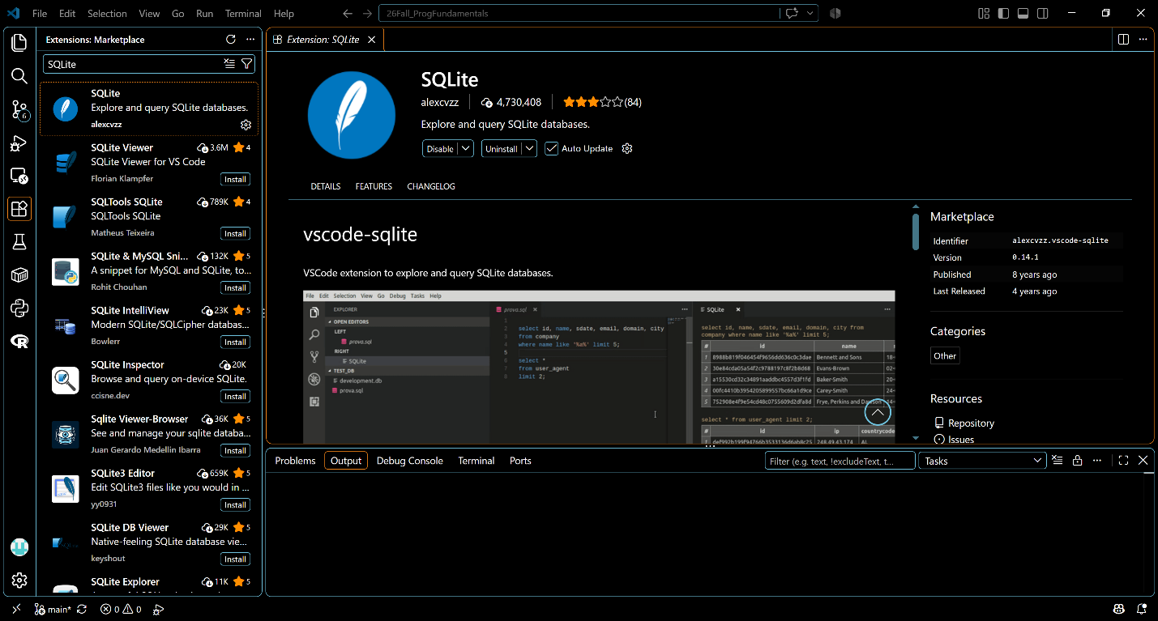

Create Your First Database
Open Visual Studio Code and click on Open Folder:
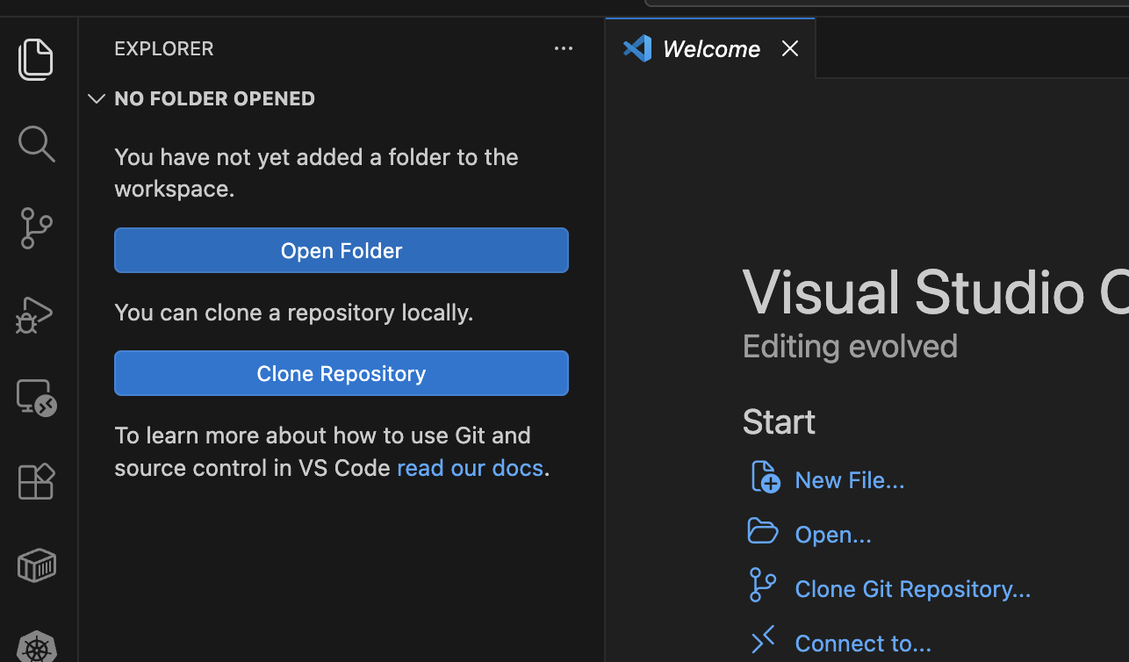
Navigate to your sql_labs folder and open it in the workspace.
Click on Terminal, then New Terminal:
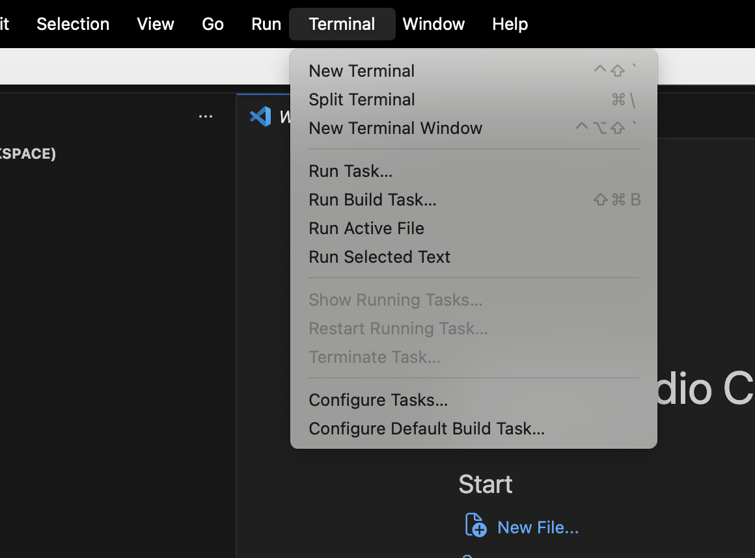
If you are using windows, please make sure you have sqlite3.exe in the same folder “sql_labs”
Type: sqlite3 school.db in the terminal.
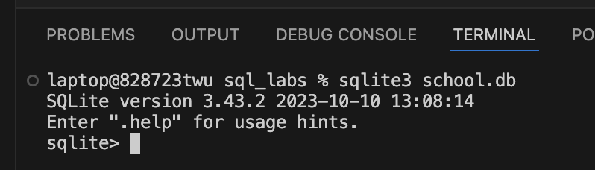
Inside the sqlite terminal, type the following:
CREATE TABLE students (
id INTEGER PRIMARY KEY,
name TEXT,
major TEXT
);
Add a screenshot of your folders section. You will see a database file in the left side pane:
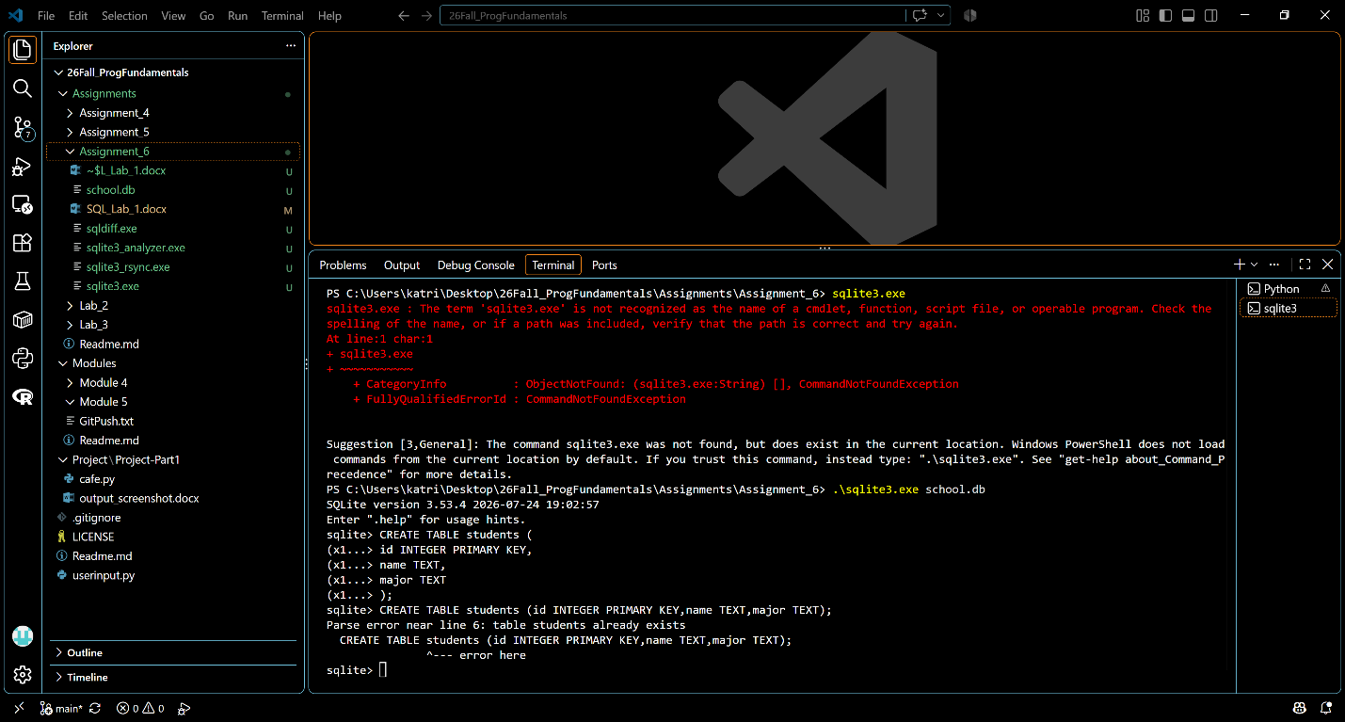
Now let us insert some data into the tables:
Type the following:
INSERT INTO students VALUES (1, 'Alice', 'Biology');
INSERT INTO students VALUES (2, 'Bob', 'Business');
INSERT INTO students VALUES (3, 'Clara', 'Psychology');
Now this data is added to the database. To see the data that is newly added to the table, run the following query:
SELECT * FROM students;
Add a screenshot of your terminal output:
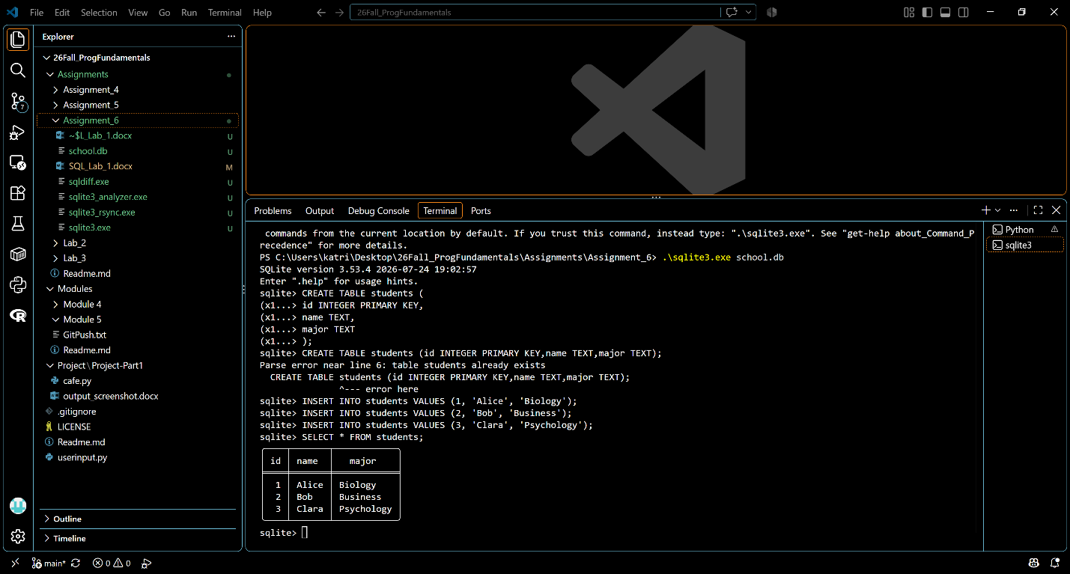
If you are using windows, press “ctrl+shift+p”
If you are on mac, press “command+shift+p”
Search for sqlite: Open Database:
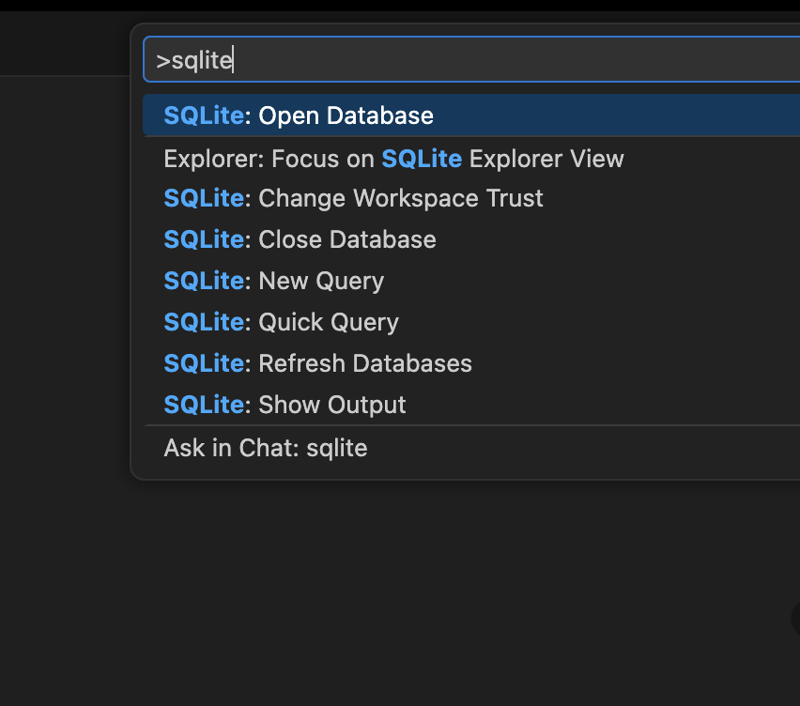
It will ask you to select the database. Select the one you just created, school.db
Click on Create New File in the explorer pane:
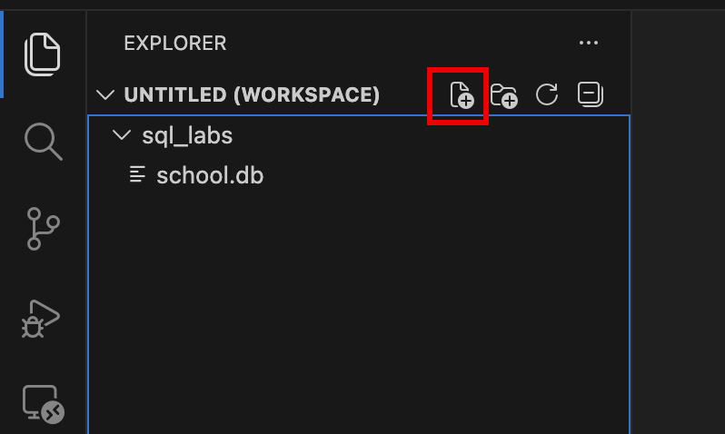
Name it: queries.sql
Copy the following to the file and run the queries:
SELECT * FROM students;
SELECT name FROM students;
SELECT * FROM students WHERE major = 'Business';
Highlight ONE query (for example):
SELECT * FROM students;
Right-click and select
Run Selected Query
Add a screenshot of your outputs (There will be 3 screenshots for 3 queries):
