Assignment Documentation – Deploying Movie Analyzer App on EKS with ALB & Custom Domain
1. Domain Purchase & DNS Setup
- Purchased domain from Namecheap: kmc-info.online
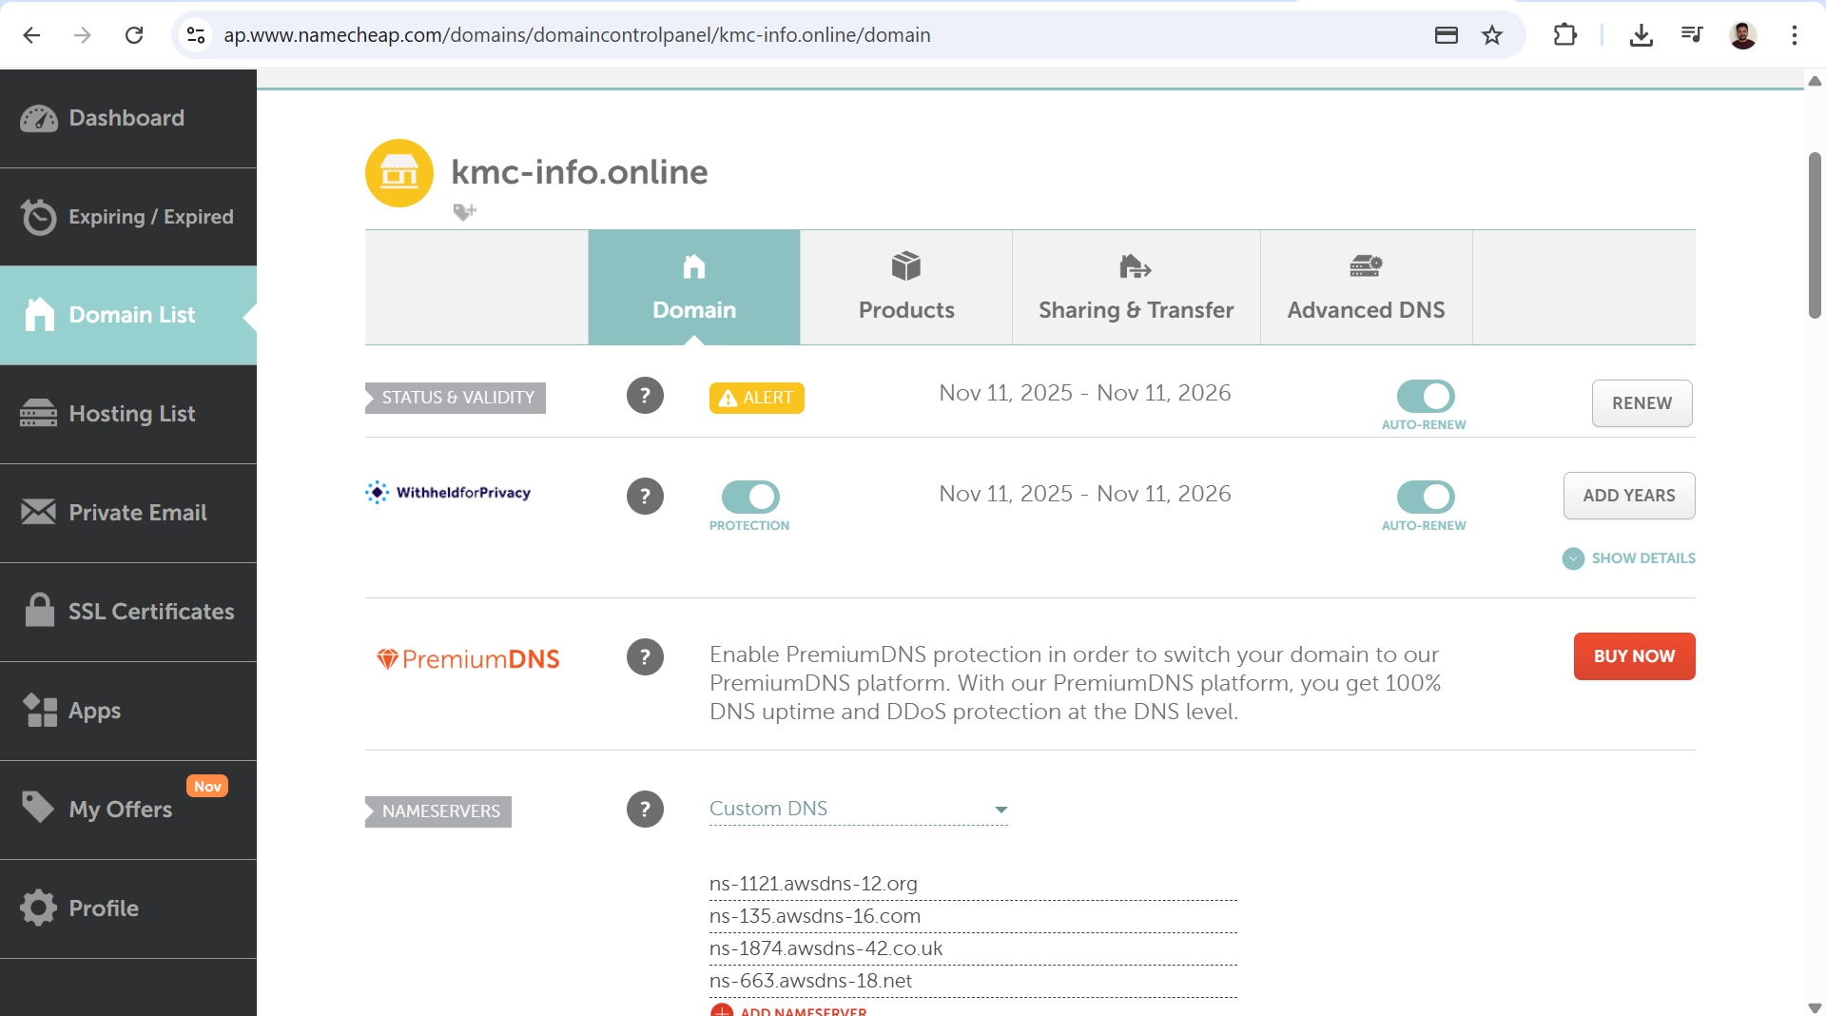
- In AWS Route53 → Hosted Zones → Created Public Hosted Zone for kmc-info.online
- NS & SOA records created automatically
- Updated Namecheap domain settings → Custom DNS → Added 4 AWS NS records:
ns-663.awsdns-18.net
ns-1121.awsdns-12.org
ns-135.awsdns-16.com
ns-1874.awsdns-42.co.uk
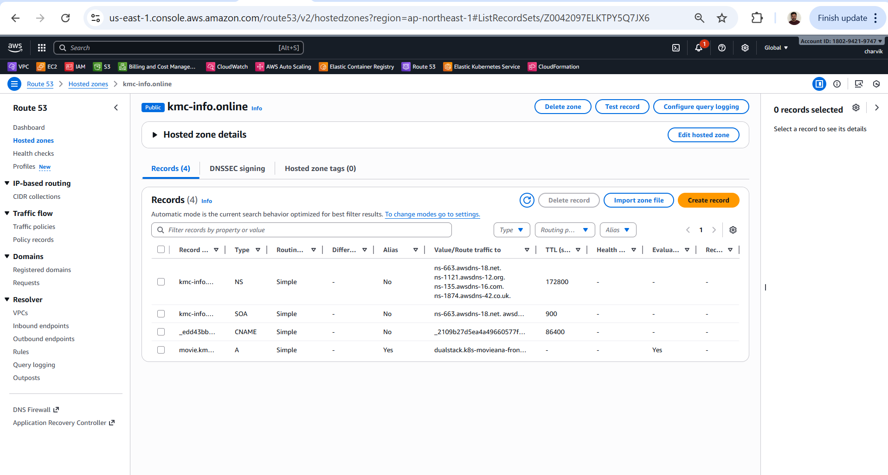

2. EKS Cluster Creation
Executed via PowerShell:
eksctl create cluster --name eks-cluster --version 1.33 --with-oidc --nodegroup-name worker --region ap-northeast-1 --node-type t2.medium --ssh-access --ssh-public-key k8s-tokyo
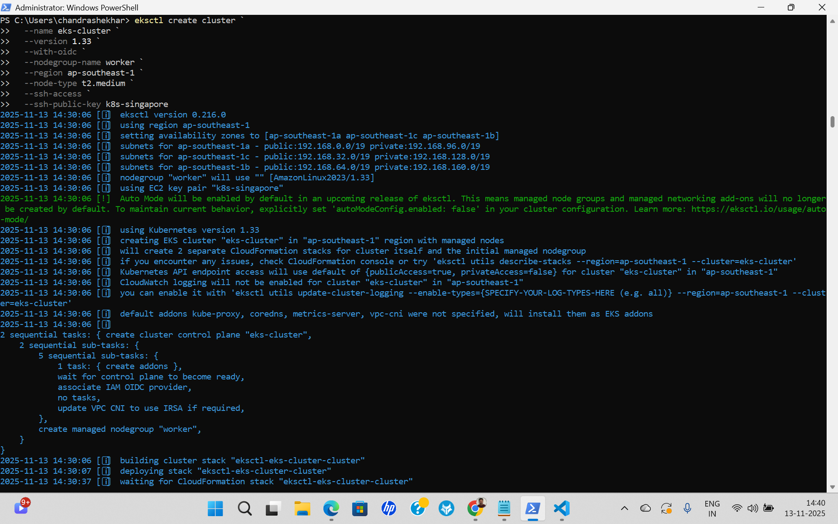
Updated kubeconfig:
aws eks update-kubeconfig --name eks-cluster --region ap-northeast-1
Verified:
kubectl get nodes
kubectl get pods -A
3. IAM Service Account for ALB Controller
Created service account:
eksctl create iamserviceaccount --cluster eks-cluster --namespace alb --name aws-load-balancer-controller --attach-policy-arn arn:aws:iam::180294219747:policy/AWSLoadBalancerControllerIAMPolicy --override-existing-serviceaccounts --approve --region ap-northeast-1
Verified:
kubectl get sa -n alb
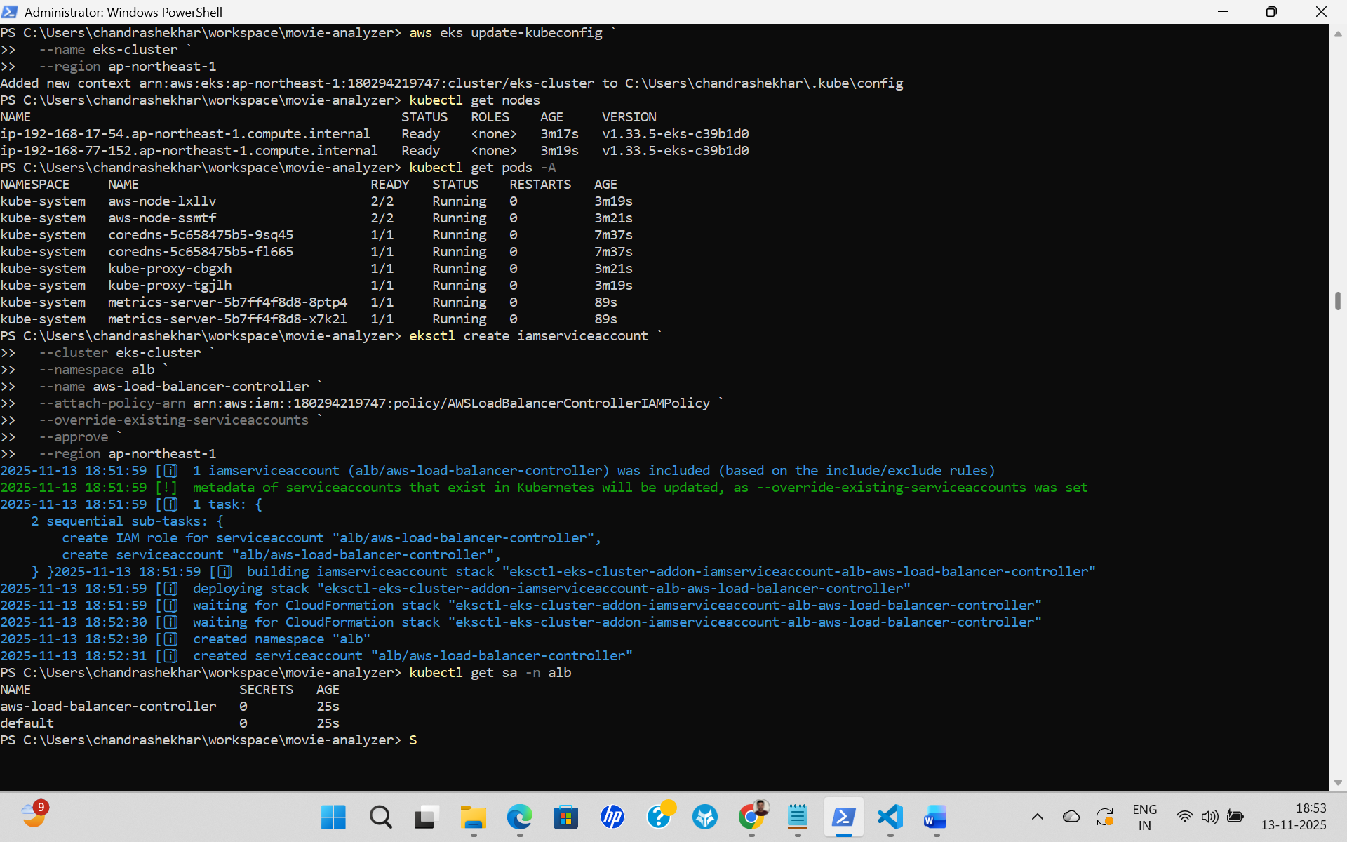
4. Subnet Tagging for ALB
Tagged public subnets:
aws ec2 create-tags --resources subnet-020b0d07249f5cf56 subnet-034f292727cbcaf12 subnet-03770518e79d24fc7 --tags Key=kubernetes.io/cluster/eks-cluster,Value=shared

Tagged private subnets:
aws ec2 create-tags --resources subnet-0ddaf173a64bf42a2 subnet-0eee2d3120db7d48b subnet-08e0626f8d389199e --tags Key=kubernetes.io/cluster/eks-cluster,Value=shared

Verified:
aws ec2 describe-subnets --subnet-ids subnet-020b0d07249f5cf56 --query 'Subnets[].Tags'

5. SSL Certificate Creation (ACM)
Requested certificate for:
*.kmc-info.online
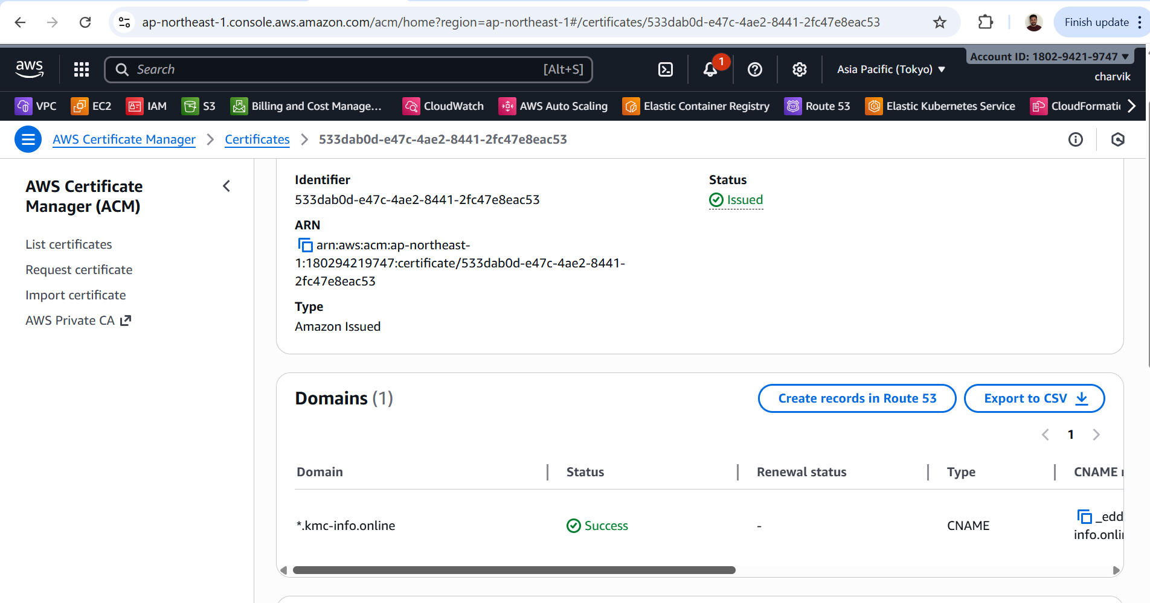
Added CNAME in Route53:
_edd43bb3bc0465b3ddce05b4af36d9ce.kmc-info.online → ACM validation CNAME

6. Updating Ingress Annotations in values.yaml
Added:
alb.ingress.kubernetes.io/certificate-arn: arn:aws:acm:ap-northeast-1:180294219747:certificate/533dab0d-e47c-4ae2-8441-2fc47e8eac53
alb.ingress.kubernetes.io/listen-ports: '[{"HTTP":80},{"HTTPS":443}]'
alb.ingress.kubernetes.io/ssl-redirect: "443"
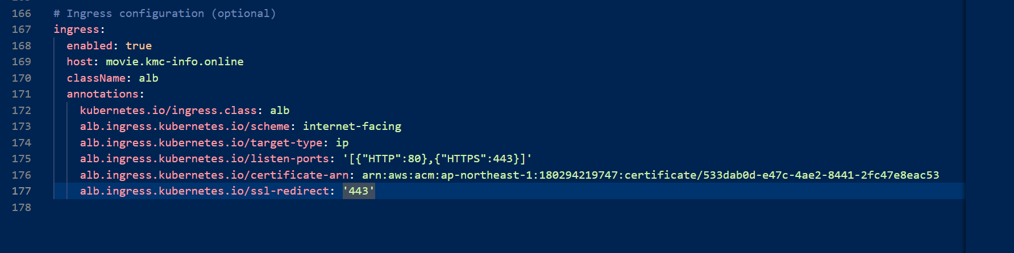

7. Deploying AWS Load Balancer Controller (Helm)
helm install aws-load-balancer-controller eks/aws-load-balancer-controller -n alb --create-namespace --set clusterName=eks-cluster --set serviceAccount.create=false --set vpcId=vpc-039d5a5002baade01 --set region=ap-northeast-1 --set serviceAccount.name=aws-load-balancer-controller
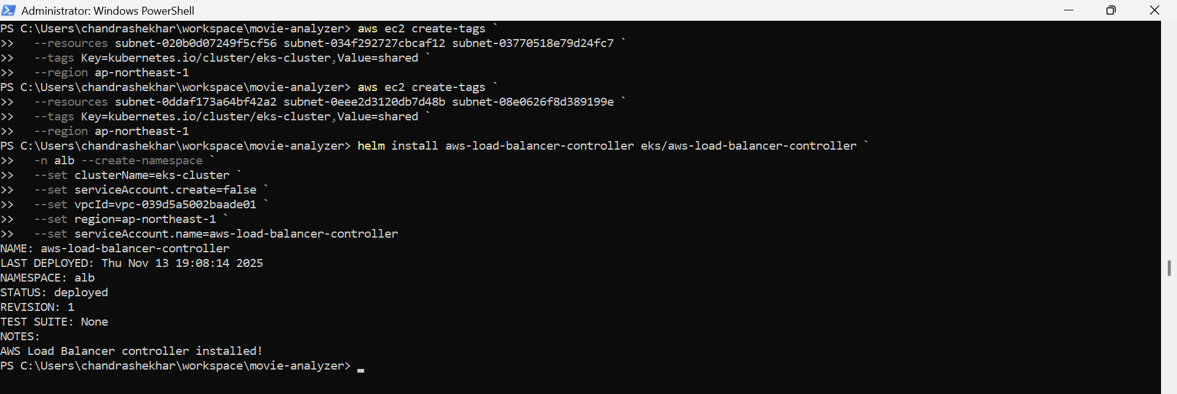
Verified ALB created in AWS Console.
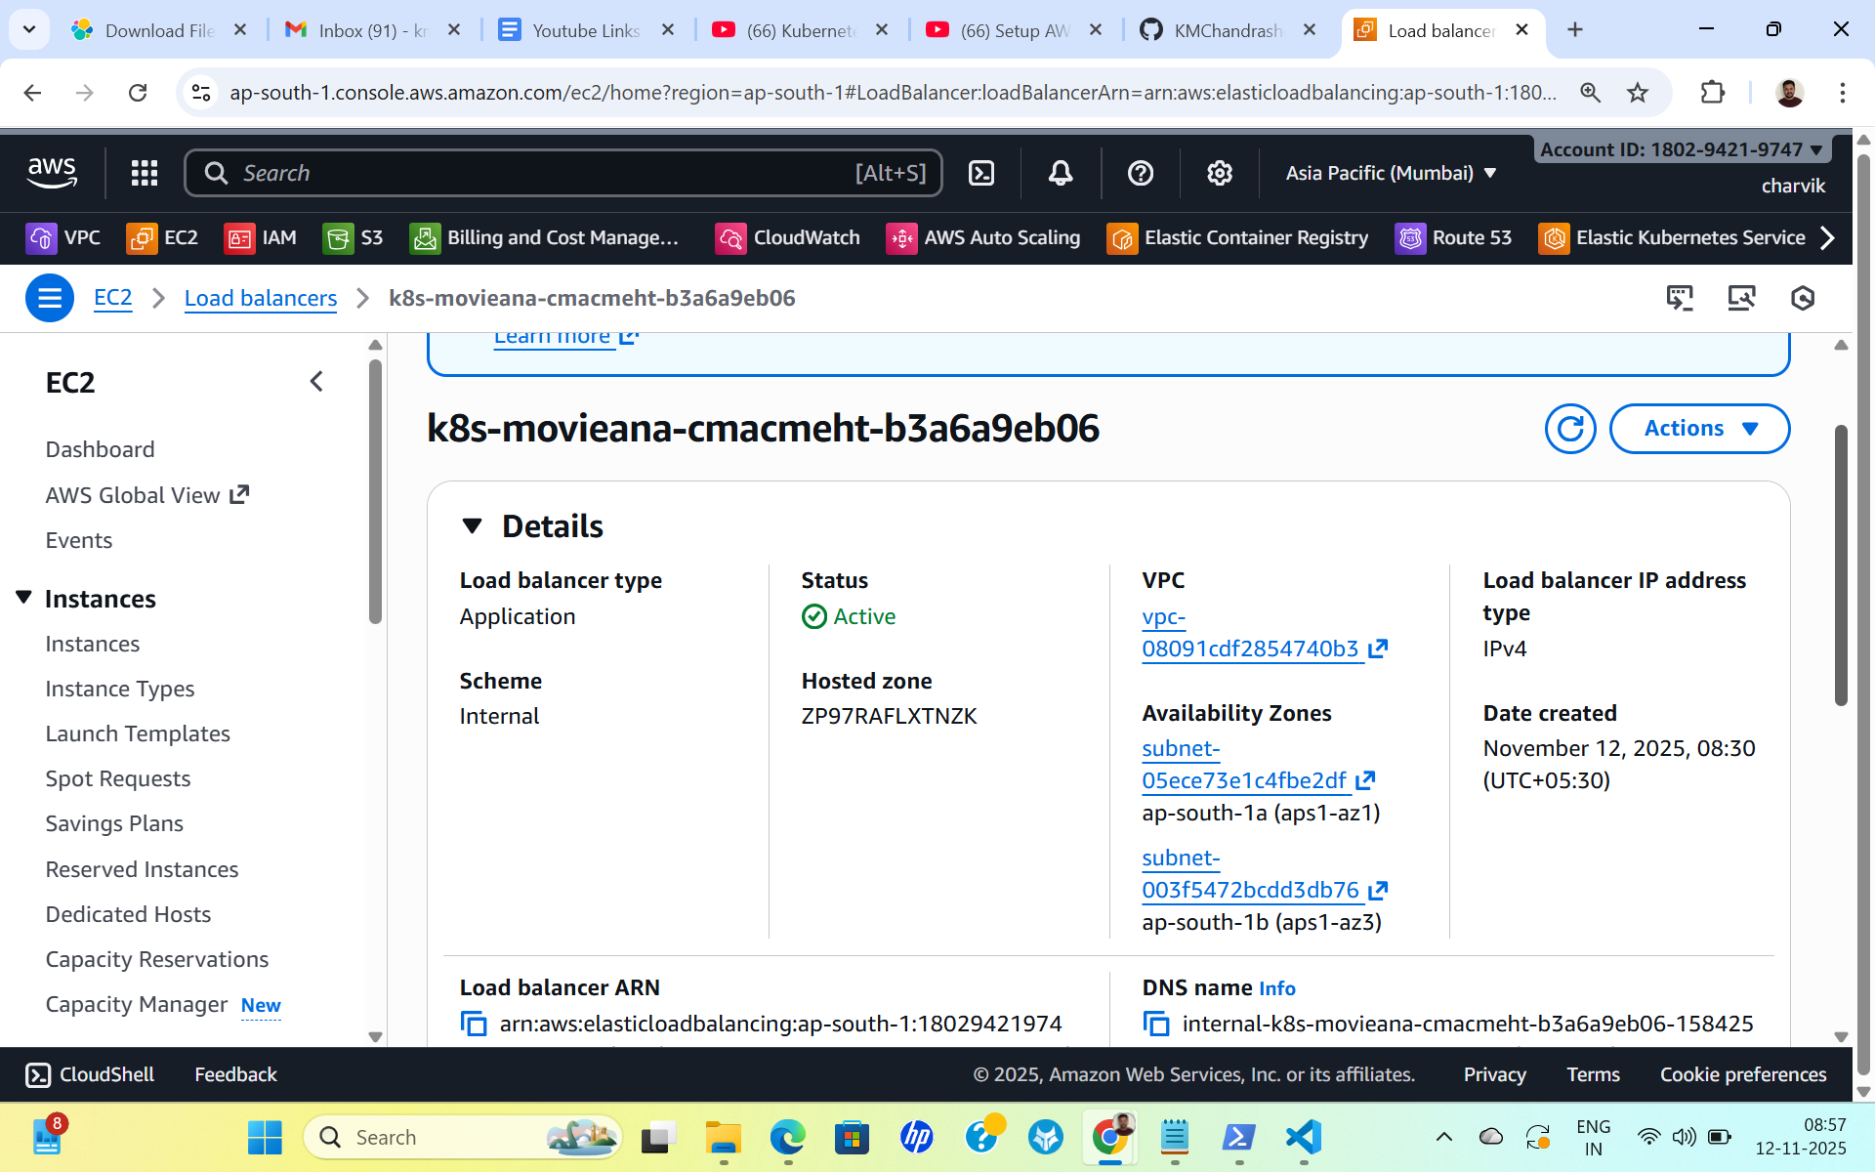
8. Deploying the Application
Steps:
git clone https://github.com/KMChandrashekhar/movie-analyzer.git
cd movie-analyzer/deploy/helm
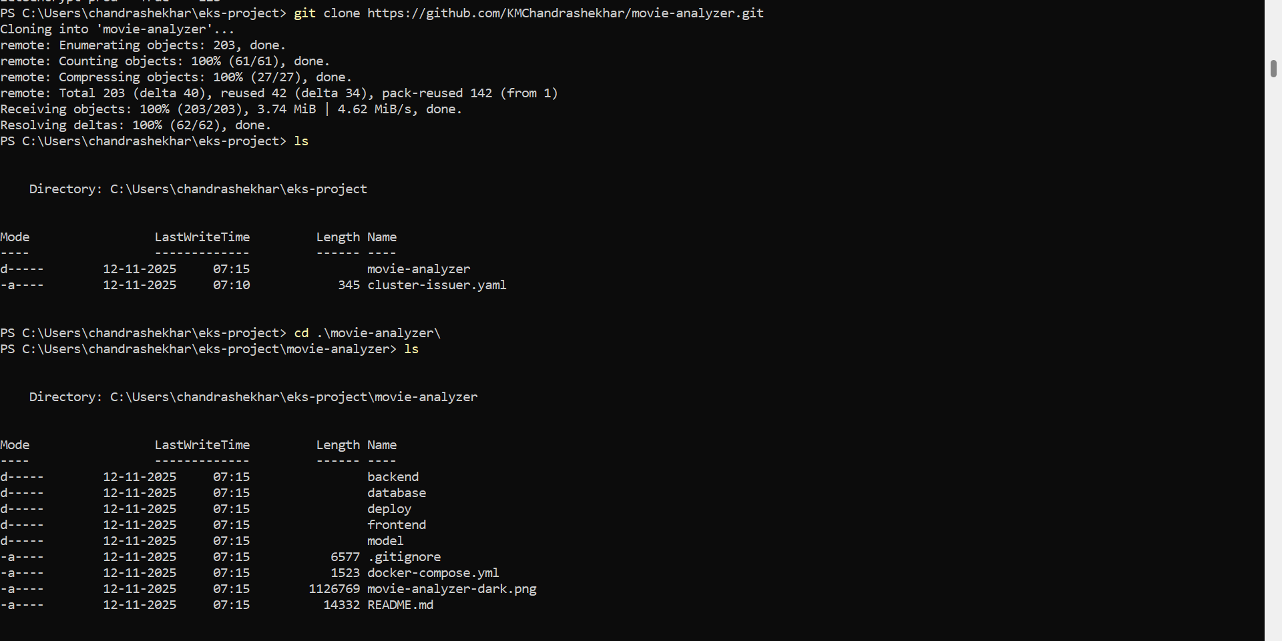
helm install movie-analyzer .
Verified:
kubectl get all -n movie-analyzer
kubectl get ingress -A
9. DNS Mapping for Application
Created A record:
Record name: movie.kmc-info.online
Type: A (Alias)
Alias → Application Load Balancer
10. Final Output
The website is now fully functional:
https://movie.kmc-info.online
