Movie Analyzer Application Deployment on Amazon EKS
A Complete Professional Deployment Report

1. Introduction
This report provides a complete end-to-end deployment documentation of the Movie Analyzer application on Amazon Elastic Kubernetes Service (EKS). The deployment includes Route53 DNS setup, ACM SSL certificate integration, AWS Load Balancer Controller, Kubernetes Ingress, Helm deployment, and a fully configured Application Load Balancer (ALB) serving a custom HTTPS domain movie.kmc-info.online.

2. System Architecture
Below is the full architecture diagram:
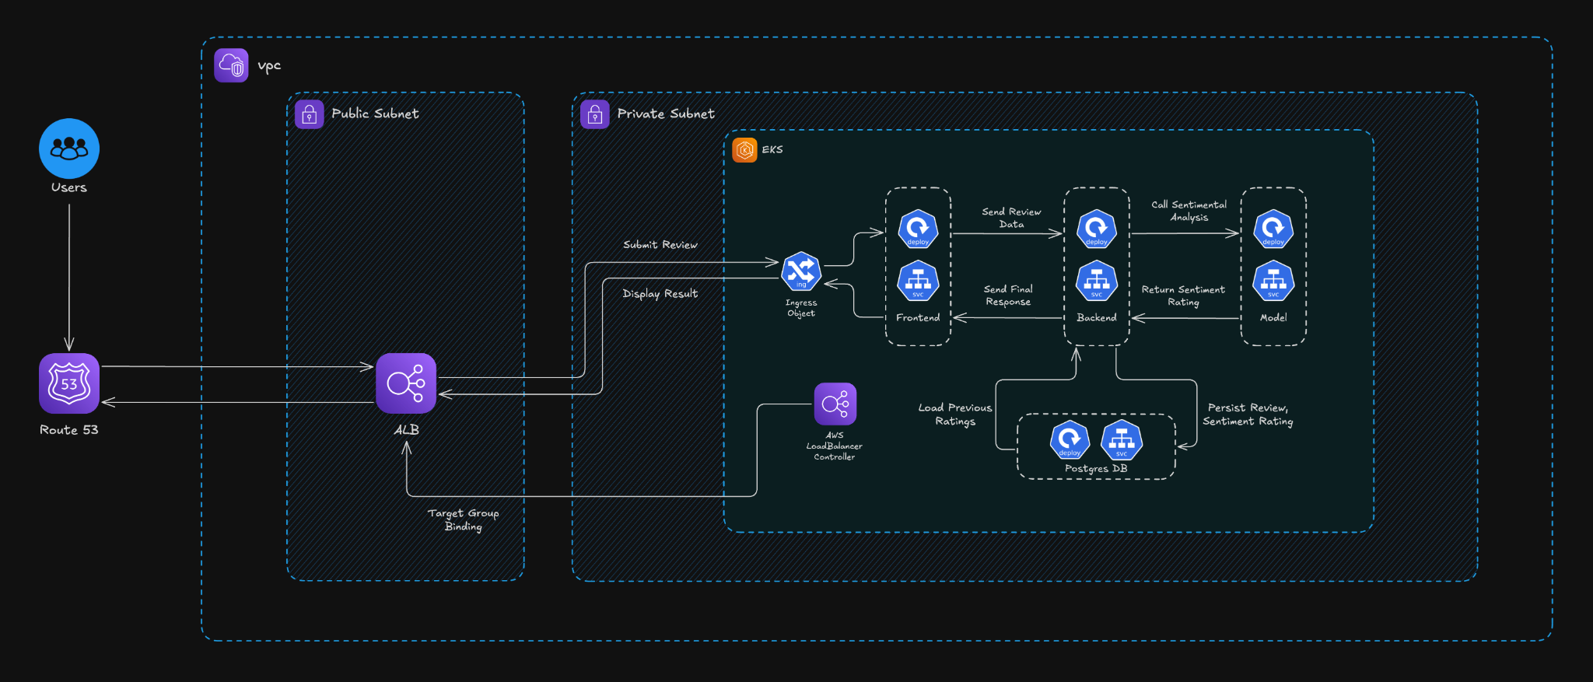

3. Application User Interface
Below is the screenshot of the deployed Movie Analyzer application:
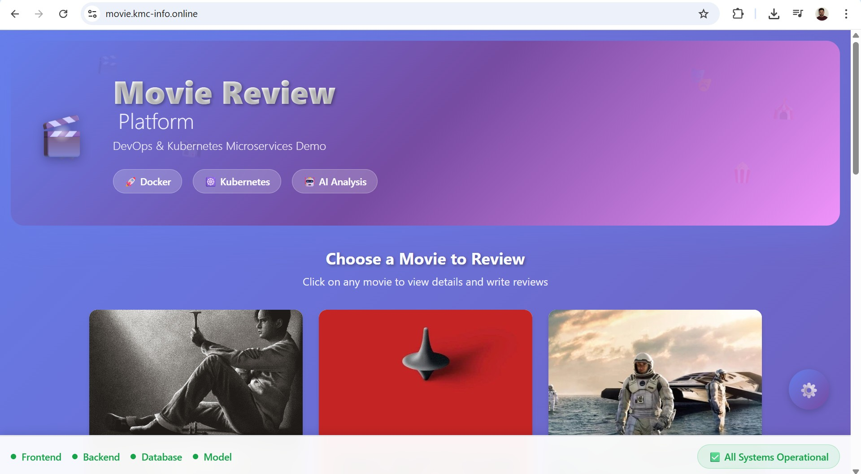

4. Detailed Deployment Steps

Step 1: Domain Purchase
Purchased kmc-info.online from Namecheap and prepared it for AWS DNS hosting.

Step 2: Configure Route53
Created a Public Hosted Zone for kmc-info.online and updated Namecheap with NS records.

Step 3: Create EKS Cluster
Executed eksctl create cluster with OIDC enabled, nodegroup t2.medium, region ap-northeast-1.

Step 4: Update Kubeconfig
aws eks update-kubeconfig was executed to connect kubectl to the new cluster.

Step 5: Verify Cluster
kubectl get nodes and kubectl get pods -A were used for verification.

Step 6: IAM Setup for ALB Controller
IAM policy created and IAM service account deployed using eksctl create iamserviceaccount.

Step 7: Subnet Tagging
Tagged both public and private subnets with kubernetes.io/cluster/eks-cluster=shared so ALB controller can detect them.

Step 8: Install AWS Load Balancer Controller
Installed using Helm with correct settings for VPC ID, region, and service account.

Step 9: Create SSL Certificate (ACM)
Requested wildcard certificate (*.kmc-info.online) and added CNAME to Route53 for validation.

Step 10: Configure Ingress
Updated values.yaml with ALB annotations including certificate ARN, redirect rules, and host.

Step 11: Deploy Application
Cloned GitHub repo, ran helm install movie-analyzer, verified pods and ingress.

Step 12: Create Route53 A Record
Created an alias A record movie.kmc-info.online pointing to ALB.

Step 13: Final Validation
Accessed https://movie.kmc-info.online successfully and verified frontend, backend, and API interactions.

