HashiCorp Vault with Kubernetes - Secret Injection Lab
This document explains the steps to configure HashiCorp Vault on Kubernetes, store secrets inside Vault, and inject them into a Kubernetes Pod using Vault Agent Injector.

1. Create Namespace
Create a dedicated namespace for Vault:
- kubectl create namespace vault

2. Install Vault using Helm
Add the HashiCorp Helm repository and install Vault in Dev mode:
- helm repo add hashicorp https://helm.releases.hashicorp.com
helm install vault hashicorp/vault \
--set="server.dev.enabled=true" \
--set="ui.enabled=true" \
--set="ui.serviceType=NodePort" \
--namespace vault

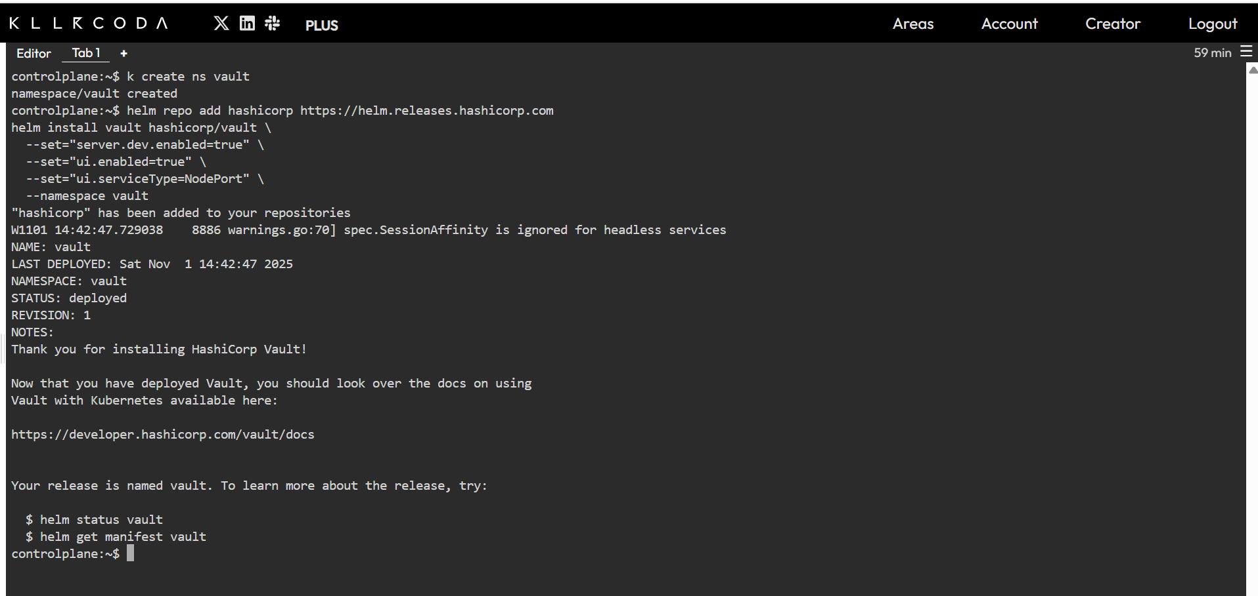

3. Configure Vault inside Pod
Enter the Vault pod shell:
- kubectl exec -it vault-0 -n vault -- /bin/sh

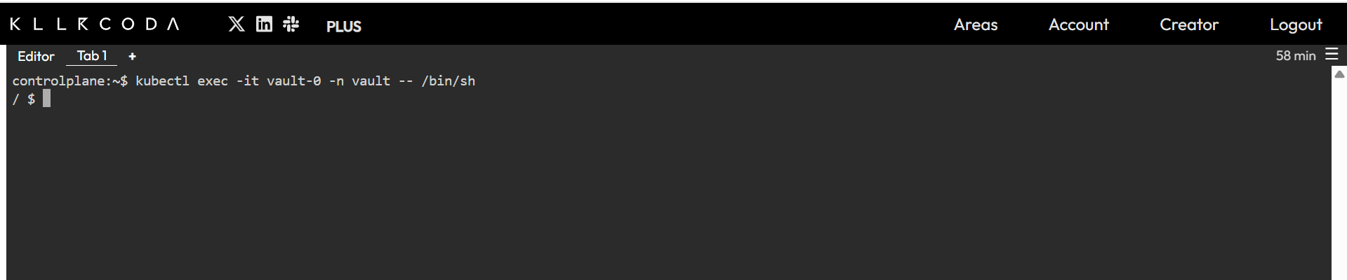

4. Create Policy for Reading Secrets
Create a read-policy file and upload it to Vault:
- cat <<EOF > /home/vault/read-policy.hcl
path "secret/*" {
capabilities = ["read"]
}
EOF
vault policy write read-policy /home/vault/read-policy.hcl

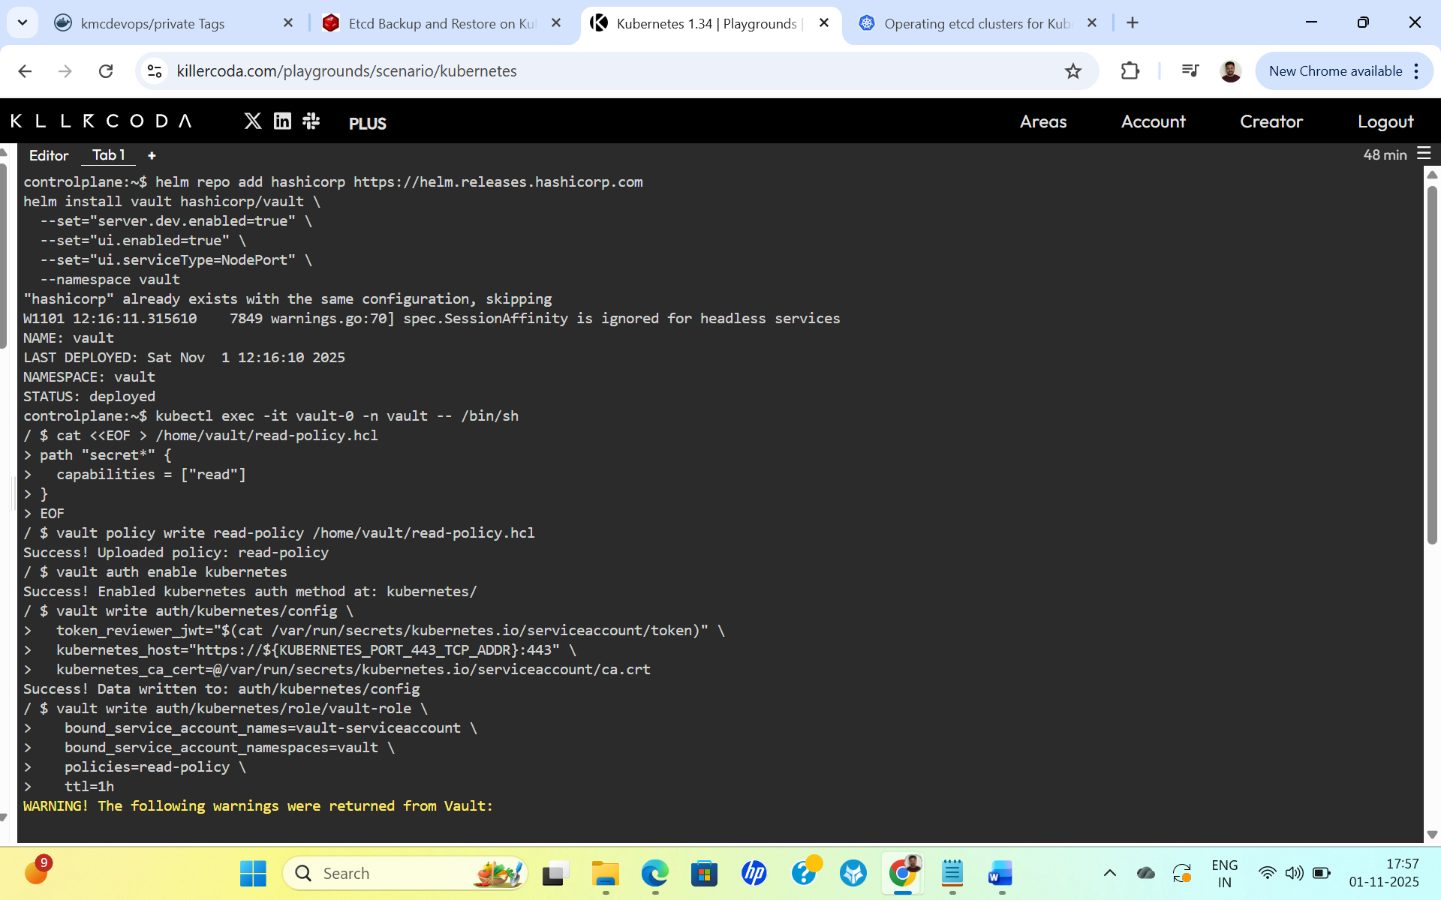

5. Enable Kubernetes Authentication
Enable and configure the Kubernetes authentication method:
- vault auth enable kubernetes
vault write auth/kubernetes/config \
token_reviewer_jwt="$(cat /var/run/secrets/kubernetes.io/serviceaccount/token)" \
kubernetes_host="https://${KUBERNETES_PORT_443_TCP_ADDR}:443" \
kubernetes_ca_cert=@/var/run/secrets/kubernetes.io/serviceaccount/ca.crt

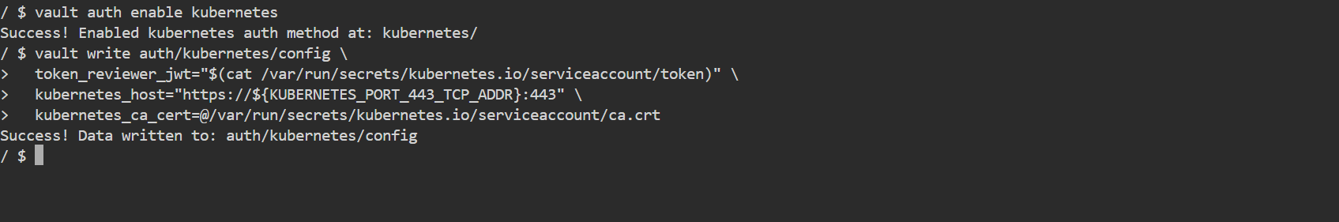

6. Create Role for Service Account
- vault write auth/kubernetes/role/vault-role \
bound_service_account_names=vault-serviceaccount \
bound_service_account_namespaces=vault \
policies=read-policy \
ttl=1h \
audience="vault"

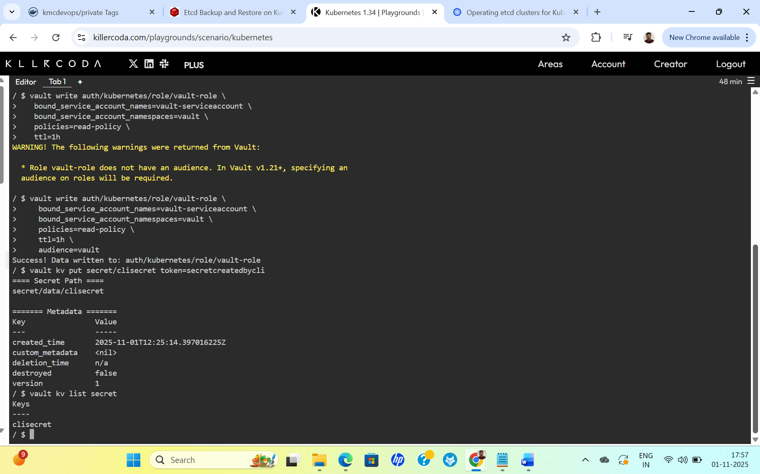

7. Create Secrets in Vault
- vault kv put secret/clisecret token=secretcreatedbycli
vault kv put secret/uisecret username=admin password=admin123

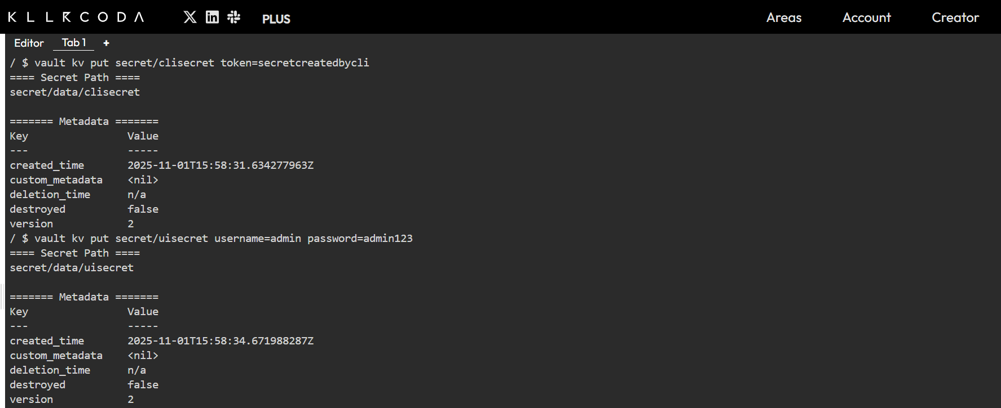

Verify secrets:
- vault kv list secret
vault kv get secret/clisecret
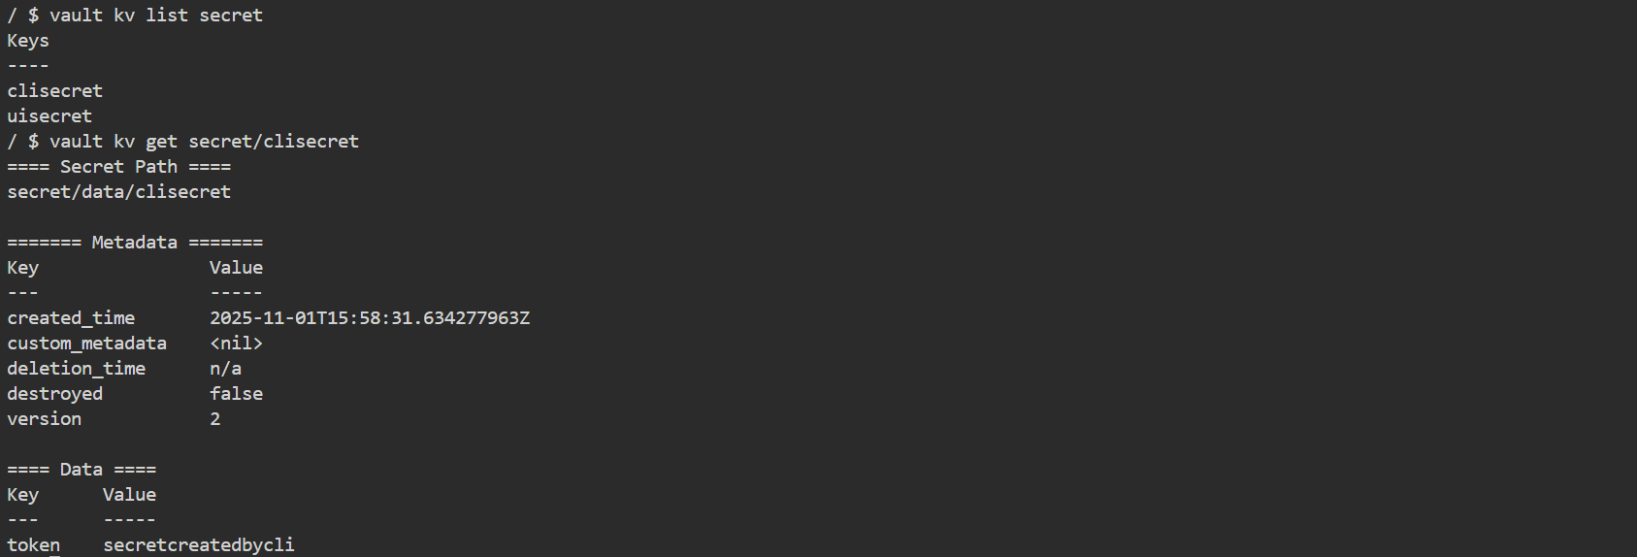

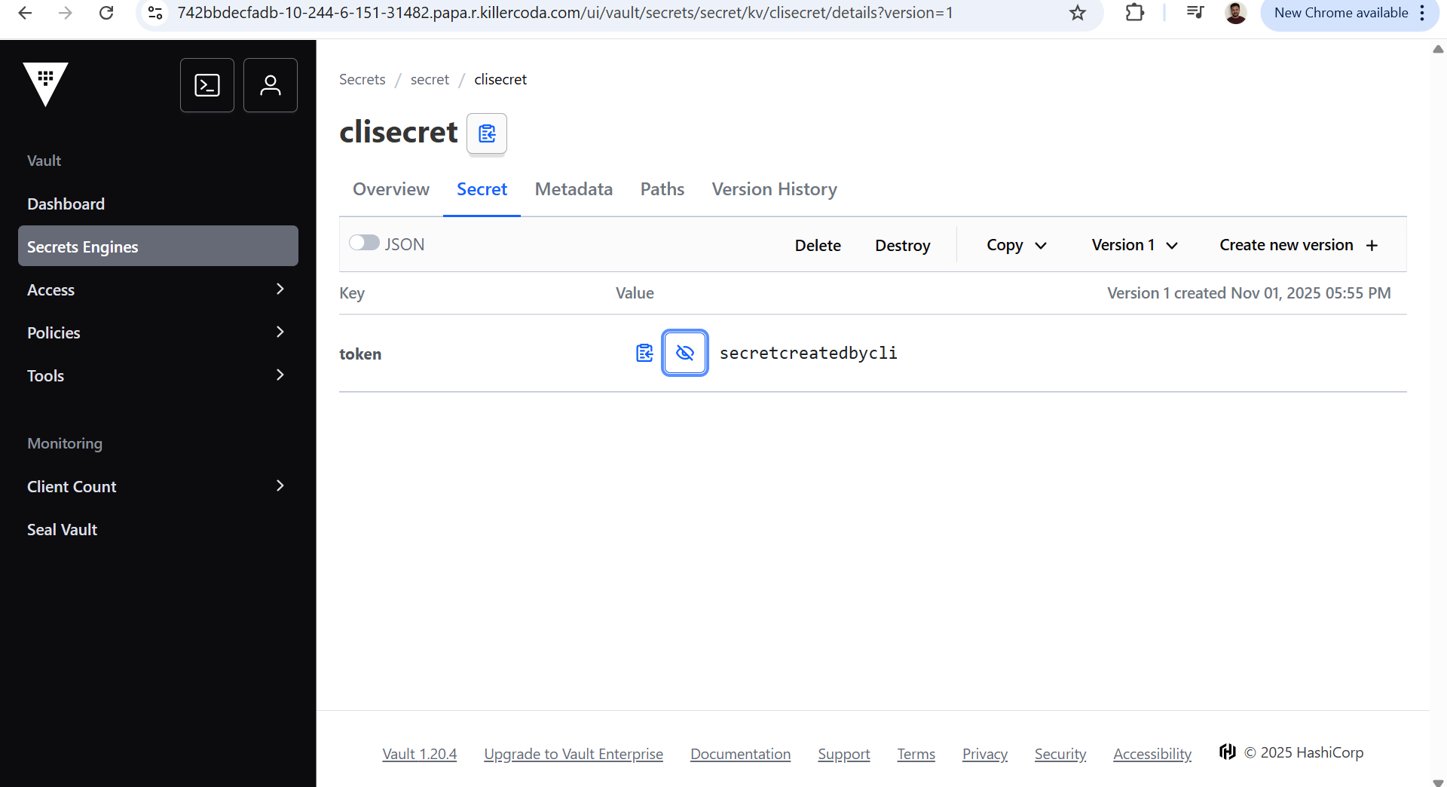

8. Create Service Account (sa.yaml)
- apiVersion: v1
kind: ServiceAccount
metadata:
name: vault-serviceaccount
namespace: vault
labels:
app: read-vault-secret

9. Create Deployment (deployment-test.yaml)
- apiVersion: apps/v1
kind: Deployment
metadata:
name: vault-test
namespace: vault
labels:
app: read-vault-secret
spec:
replicas: 1
selector:
matchLabels:
app: read-vault-secret
template:
metadata:
annotations:
vault.hashicorp.com/agent-inject: "true"
vault.hashicorp.com/agent-inject-status: "update"
vault.hashicorp.com/role: "vault-role"
vault.hashicorp.com/agent-inject-secret-clisecret: "secret/clisecret"
vault.hashicorp.com/agent-inject-template-clisecret: |
{{- with secret "secret/clisecret" -}}
pattoken={{ .Data.data.token }}
{{- end }}
vault.hashicorp.com/agent-inject-secret-uisecret: "secret/uisecret"
vault.hashicorp.com/agent-inject-template-uisecret: |
{{- with secret "secret/uisecret" -}}
username={{ .Data.data.username }}
password={{ .Data.data.password }}
{{- end }}
labels:
app: read-vault-secret
spec:
serviceAccountName: vault-serviceaccount
containers:
- name: nginx
image: nginx
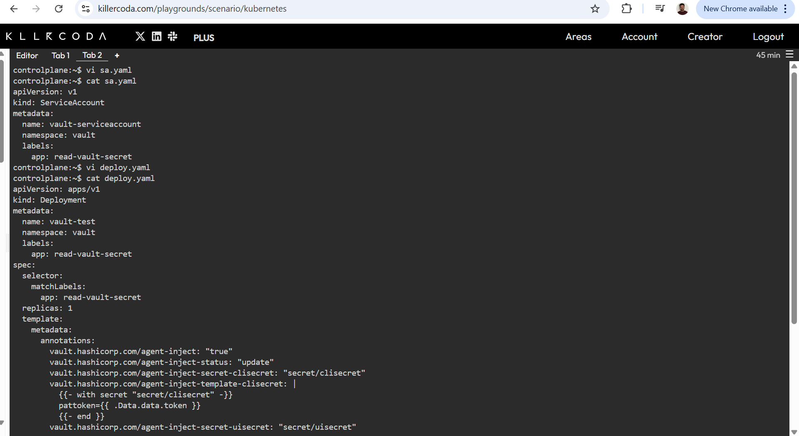

10. Apply Configurations
- kubectl apply -f sa.yaml
kubectl apply -f deployment-test.yaml

11. Verify Secret Injection
- kubectl get pods -n vault
kubectl exec -it <pod-name> -n vault -- ls /vault/secrets/
kubectl exec -it <pod-name> -n vault -- cat /vault/secrets/clisecret
kubectl exec -it <pod-name> -n vault -- cat /vault/secrets/uisecret

