1.Set up a Java (Spring Boot) application on AWS using: Auto Scaling Group (2–4 EC2 instances) with Launch Template. Application Load Balancer to distribute traffic. CloudWatch Alarms to scale out when CPU > 70% (2 min) and scale in when CPU < 30% (5 min). User Data script to install Java, download .jar from S3, and run the app. Test by generating CPU load and verifying scale-in/scale-out in CloudWatch and ASG history.
2.Deploy a JAR file in a Docker container using an Ubuntu base image—by starting the container interactively, entering it, and manually installing Git and Maven, building the JAR from a Git repository, and running the application
3.Create a image from the above running container(which we created in the above question) and run the application from the image. how to achieve this
Ans:
1st I installed Java from official website : Adoptium Temurin (Recommended) → https://adoptium.net in my CMD
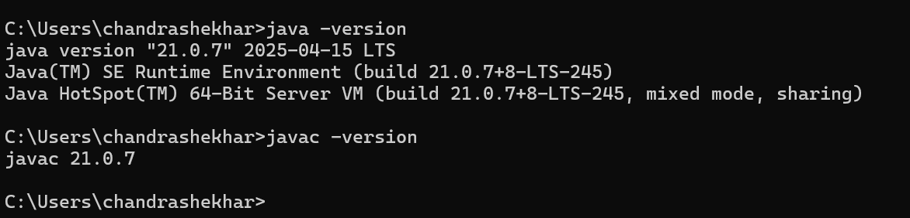
2nd I Install Maven (to download dependencies & build JAR)
Maven is a build tool that downloads Spring Boot dependencies and builds your .jar.
- Download Maven → https://maven.apache.org/download.cgi
- Extract it and add bin folder to PATH.
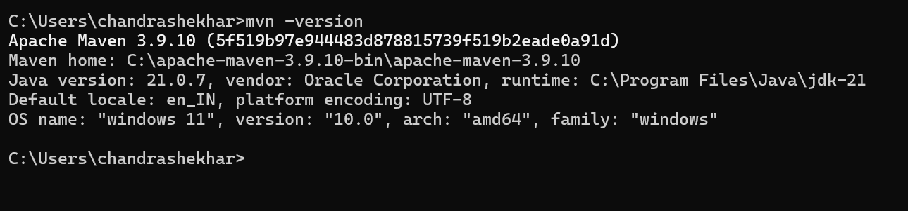
Get Spring Boot Starter Project
Spring Boot provides a website to generate your starter project with dependencies:
https://start.spring.io
- Choose Project: Maven
- Choose Language: Java
- Choose Spring Boot version: Stable one (e.g., 3.x)
- Add dependencies (like Spring Web, Spring Data JPA, etc.)
- Click Generate → It downloads a ZIP file.
Unzip it → Open the folder → This has a pom.xml file (for Maven).
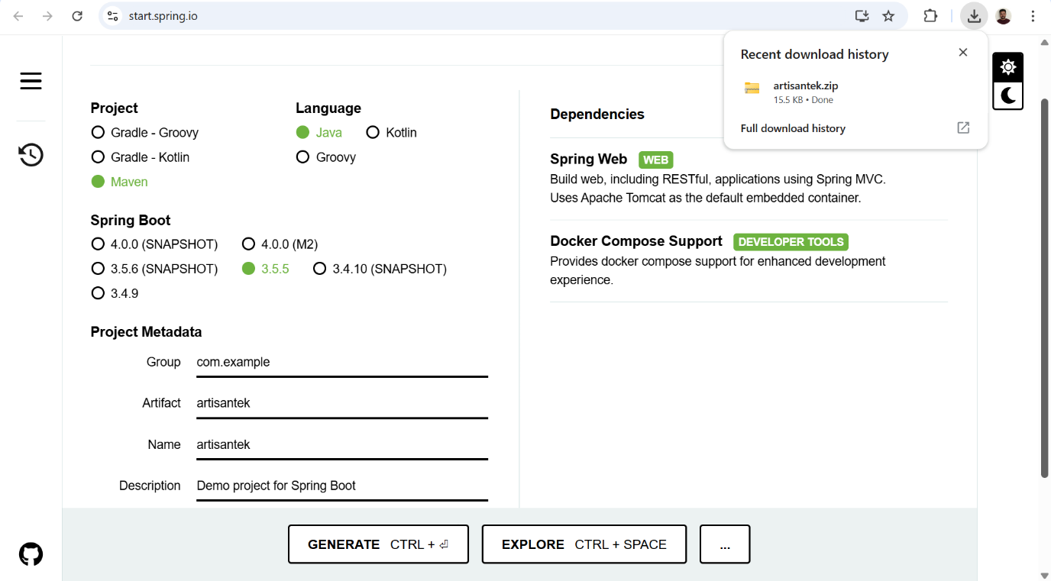
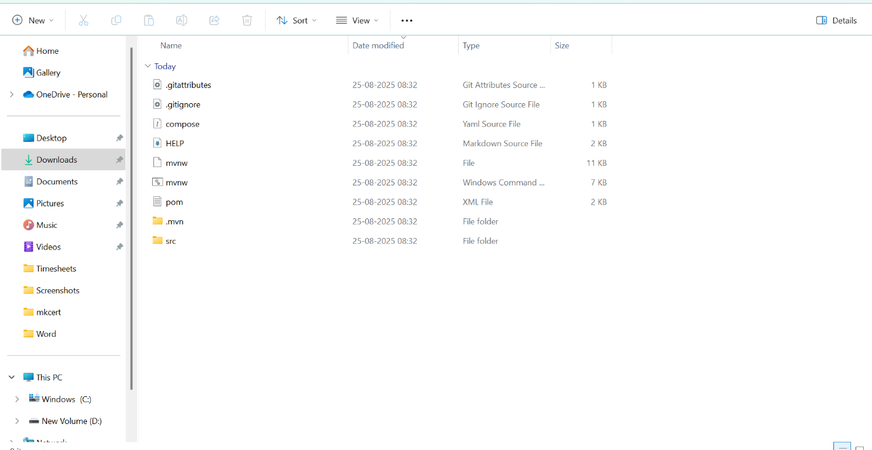
Build Spring Boot Application (Download dependencies + JAR)
In CMD, go to the project folder (where pom.xml is):
C:\Users\chandrashekhar\Downloads\artisantek\artisantek> mvn clean package
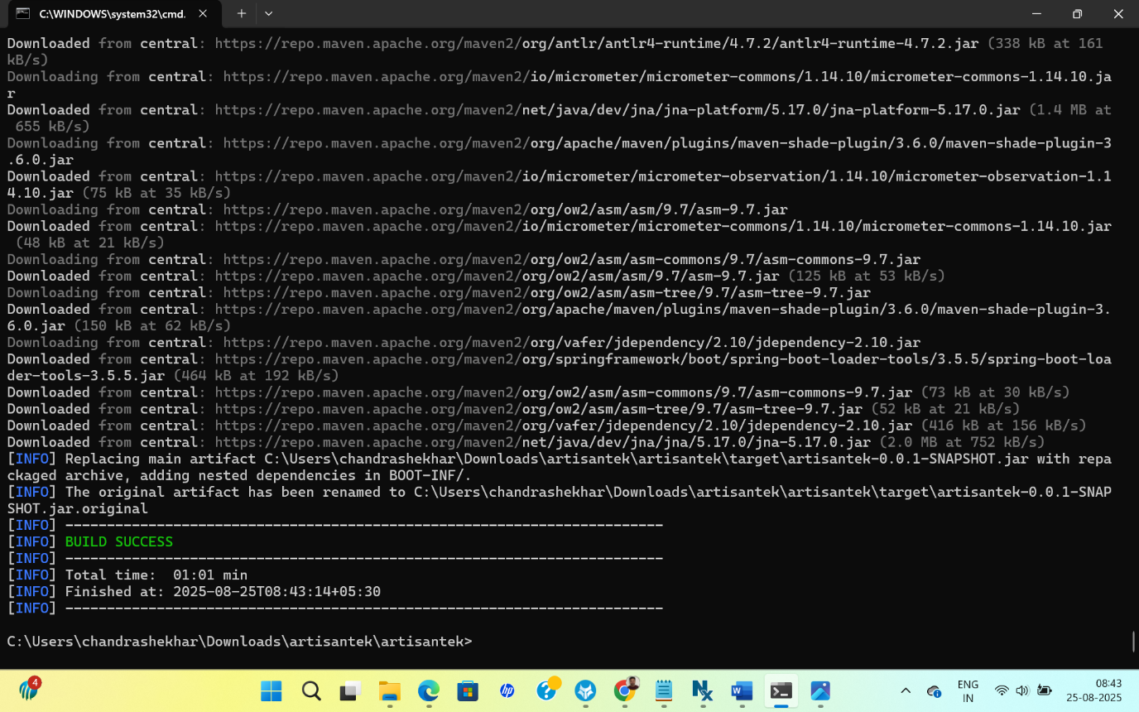
What happens:
- Maven downloads all dependencies from the internet (first time takes time).
- It compiles your code.
- Creates a JAR under target/ folder → e.g., yourapp-0.0.1-SNAPSHOT.jar.

Run the JAR
C:\Users\chandrashekhar\Downloads\artisantek\artisantek\target>java -jar artisantek-0.0.1-SNAPSHOT.jar
Spring Boot app will start.
Summary:
- Download Java (JDK) → Adoptium/Oracle (not from Spring Boot website).
- Download Maven → To build and fetch dependencies.
- Use Spring Initializr (start.spring.io) → To create Spring Boot project with dependencies.
- Run mvn clean package → Builds JAR.
- Run java -jar target/xxx.jar → Starts app.
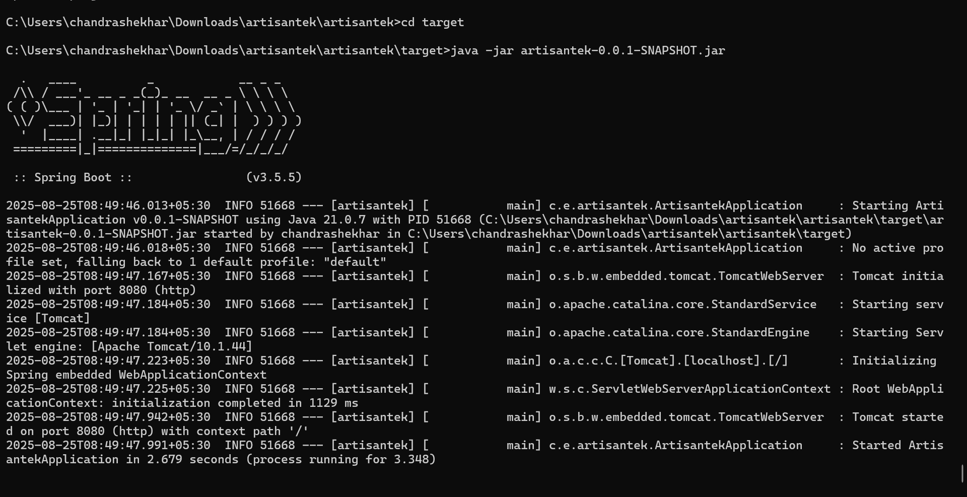

Installed AWS CLI to my CMD
Step 1: Install & Configure AWS CLI
If not already done:
Install AWS CLI
  - Windows: Download installer
  - Linux (Ubuntu):
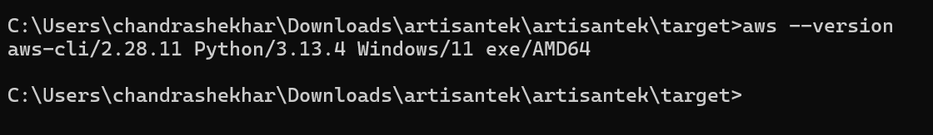
Installed AWS-Cli by using commands
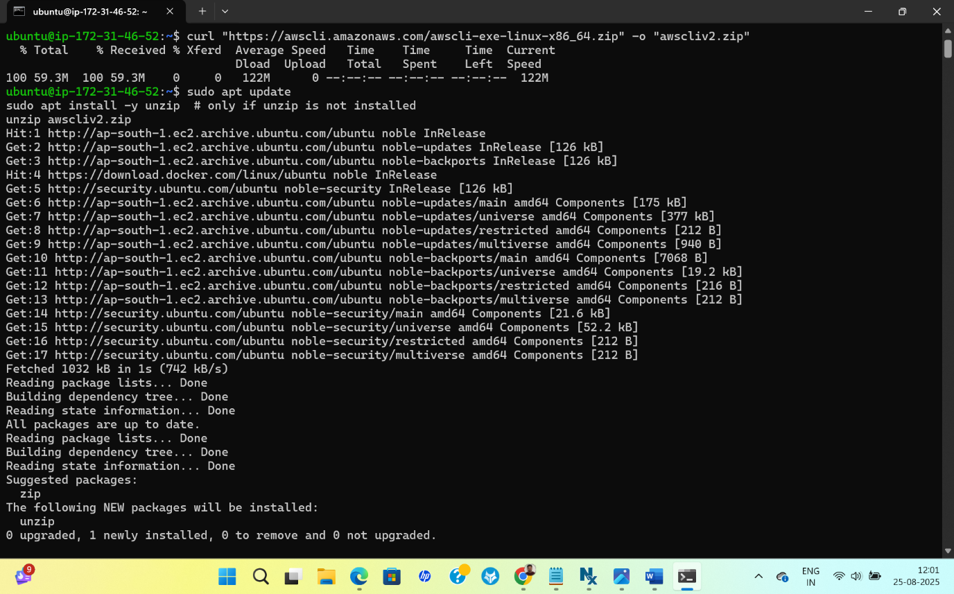
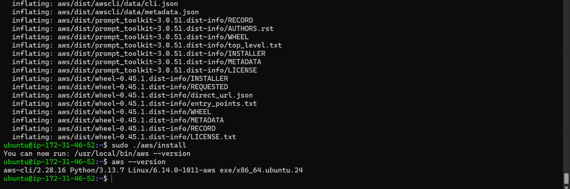

Created S3 Bucket
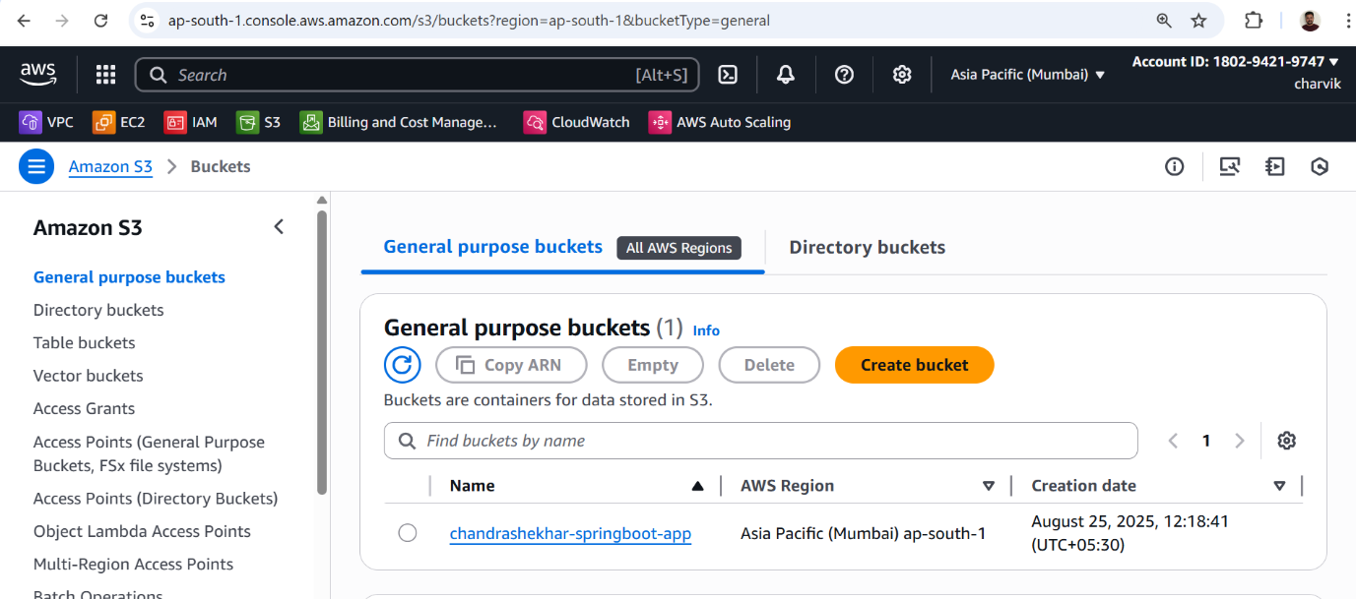

Then used command : aws configure
It will ask four things, Enter your Access Key ID, Secret Access Key, Region (e.g., ap-south-1), and output format (json).

Upload from your local Windows machine directly
If you have AWS CLI installed on Windows:
- Open Windows CMD or PowerShell.
- Run: aws s3 cp "C:\Users\chandrashekhar\Downloads\artisantek\artisantek\target\artisantek-0.0.1-SNAPSHOT.jar" s3://chandrashekhar-springboot-app/app.jar

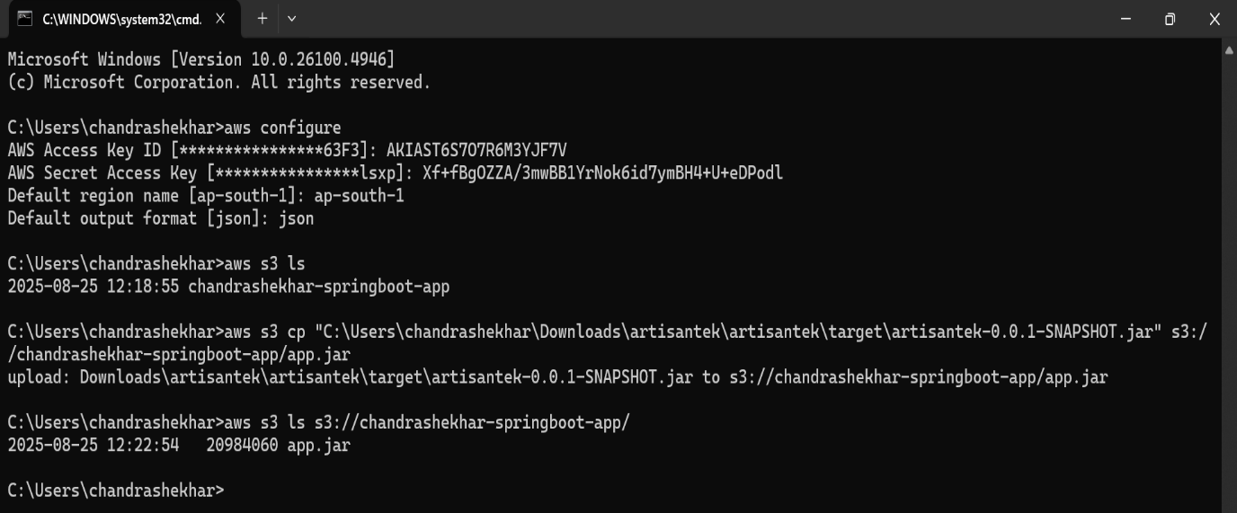

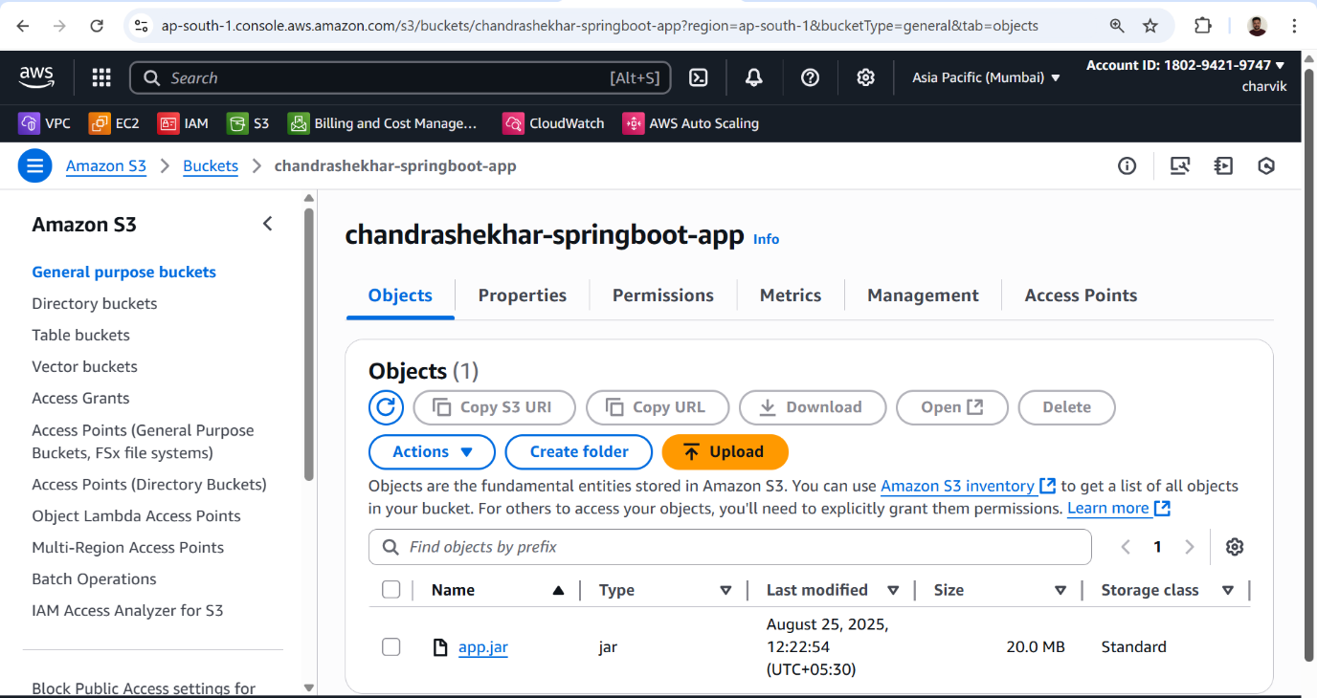

Launch Template for your Spring Boot app with User Data script .
Since I already uploaded JAR to S3, the script will download it to the EC2 instance and run it automatically.
Launch Template Basics
- AMI: Ubuntu 22.04 LTS selected since I used Ubuntu for AWS CLI and Java,
- Instance Type: t2.micro (free tier)
- Key Pair: Your EC2 key for SSH access
- Security Group:
  - Allow SSH (22) → for admin access
  - Allow HTTP (80) → if your Spring Boot app exposes a web interface
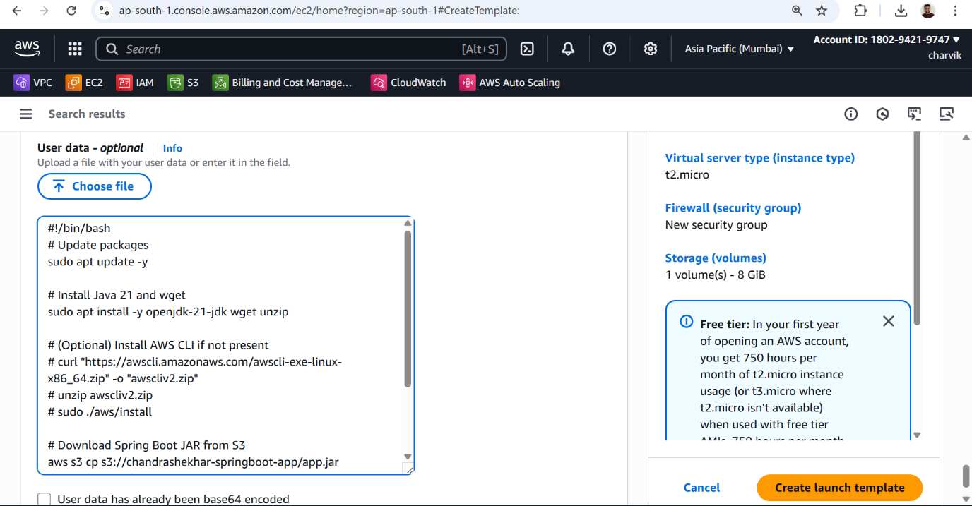

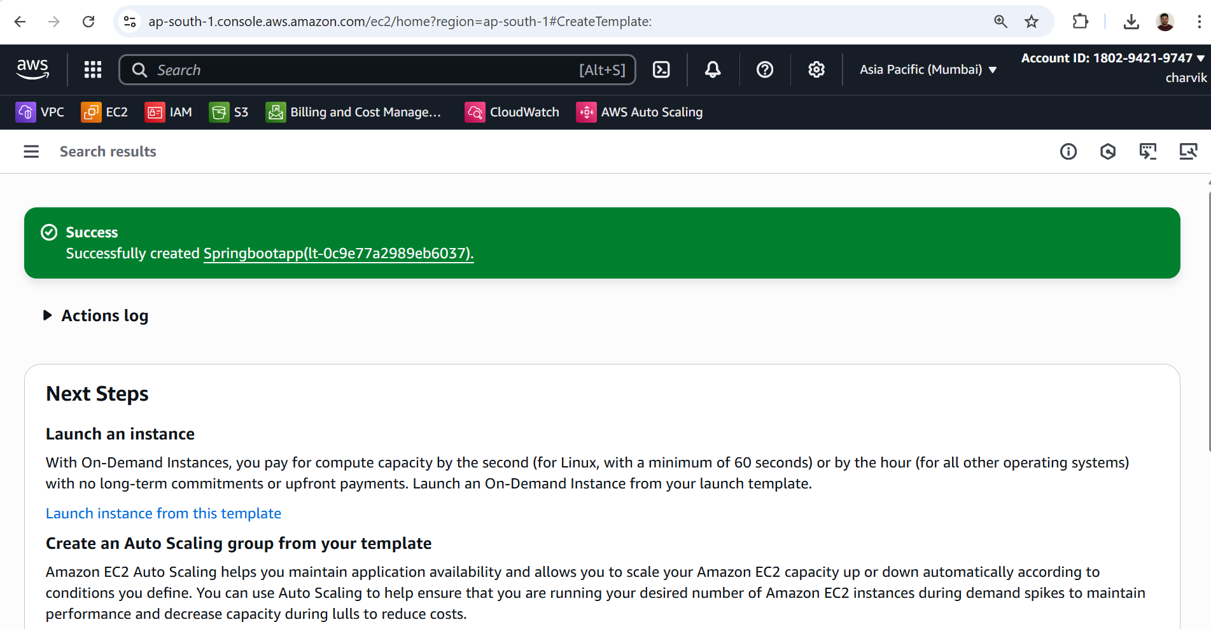

Based on Launch Templete I created Instance by selecting Launch Templete

