Jenkins Zero-Downtime Upgrade – Assignment Report

1. Introduction
This assignment demonstrates how to upgrade a Jenkins server without downtime using a Blue-Green deployment approach. The method ensures production remains available while the new version is prepared, tested, and switched seamlessly.

2. Objective
Upgrade Jenkins from version 2.528.2 (Blue instance) to 2.540 (Green instance) with:
- No downtime
- Safe rollback option
- Verified functionality post-upgrade

3. Environment Used
The following environment was used:
- WSL on Windows Laptop
- Docker & Docker Compose
- Nginx reverse proxy for traffic switching
- Jenkins Blue (Old version) on port 8080
- Jenkins Green (New version) on port 8081
- Jenkins accessed via http://localhost through Nginx

4. Architecture Diagram (Description)
Blue-Green setup:
• Blue Jenkins (Old version: 2.528.2)
• Green Jenkins (Upgraded version: 2.540)
• Nginx routing traffic to either Blue or Green.
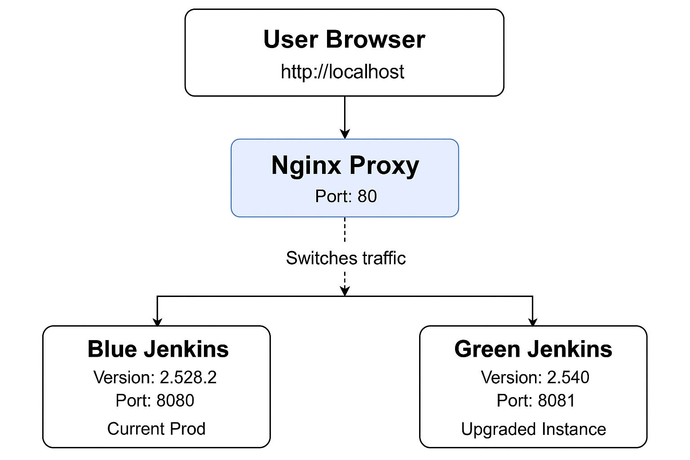

5. Steps Performed with Explanation
Below are the complete steps performed during the upgrade:

Step 1: Create Project Directory
Purpose: To organize all Jenkins and Nginx configuration files.
Command:
mkdir -p ~/jenkins-bluegreen && cd ~/jenkins-bluegreen
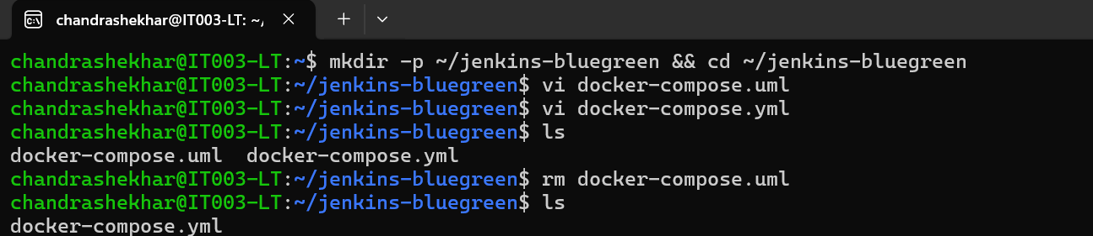

Step 2: Create docker-compose.yml
Purpose: Define Blue Jenkins, Green Jenkins, and Nginx reverse proxy.
Blue runs old version, Green will run upgraded version.
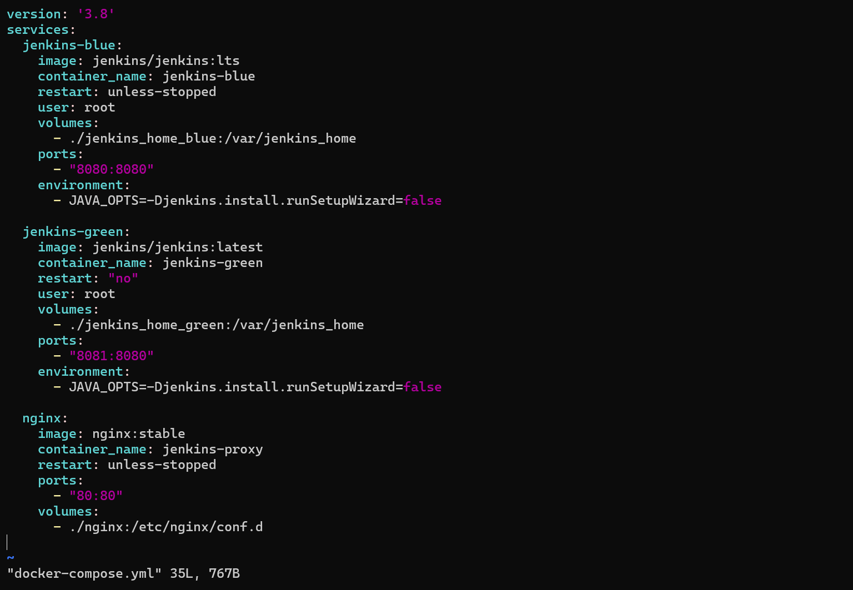

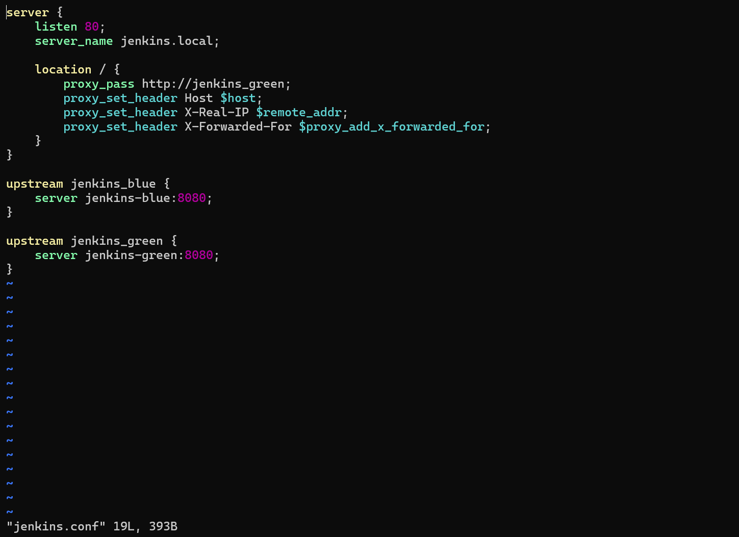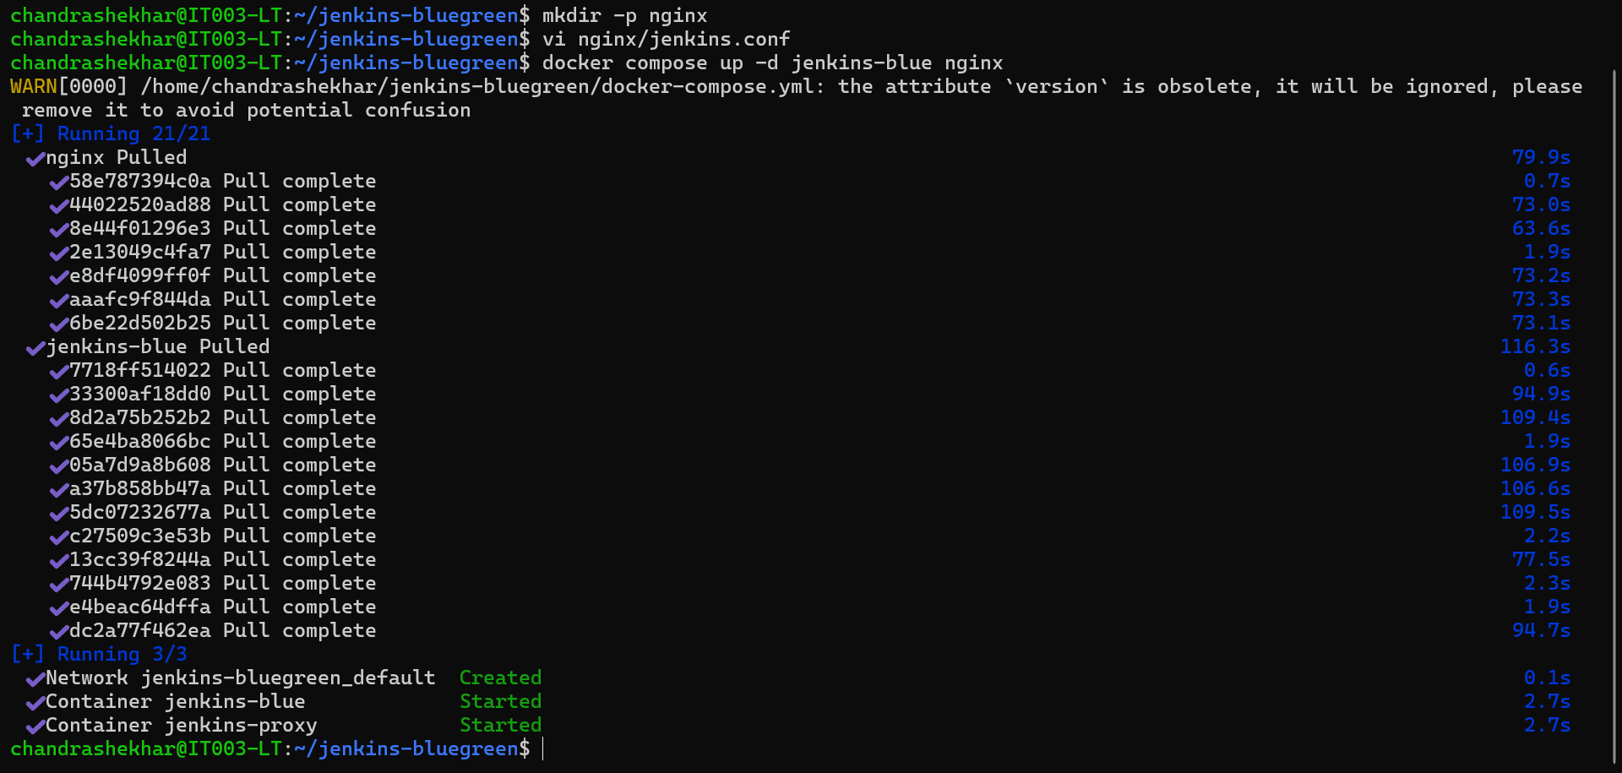

Step 3: Start Blue Jenkins
Purpose: Launch the existing stable version (2.528.2) and validate functionality.
Command:
docker compose up -d jenkins-blue nginx
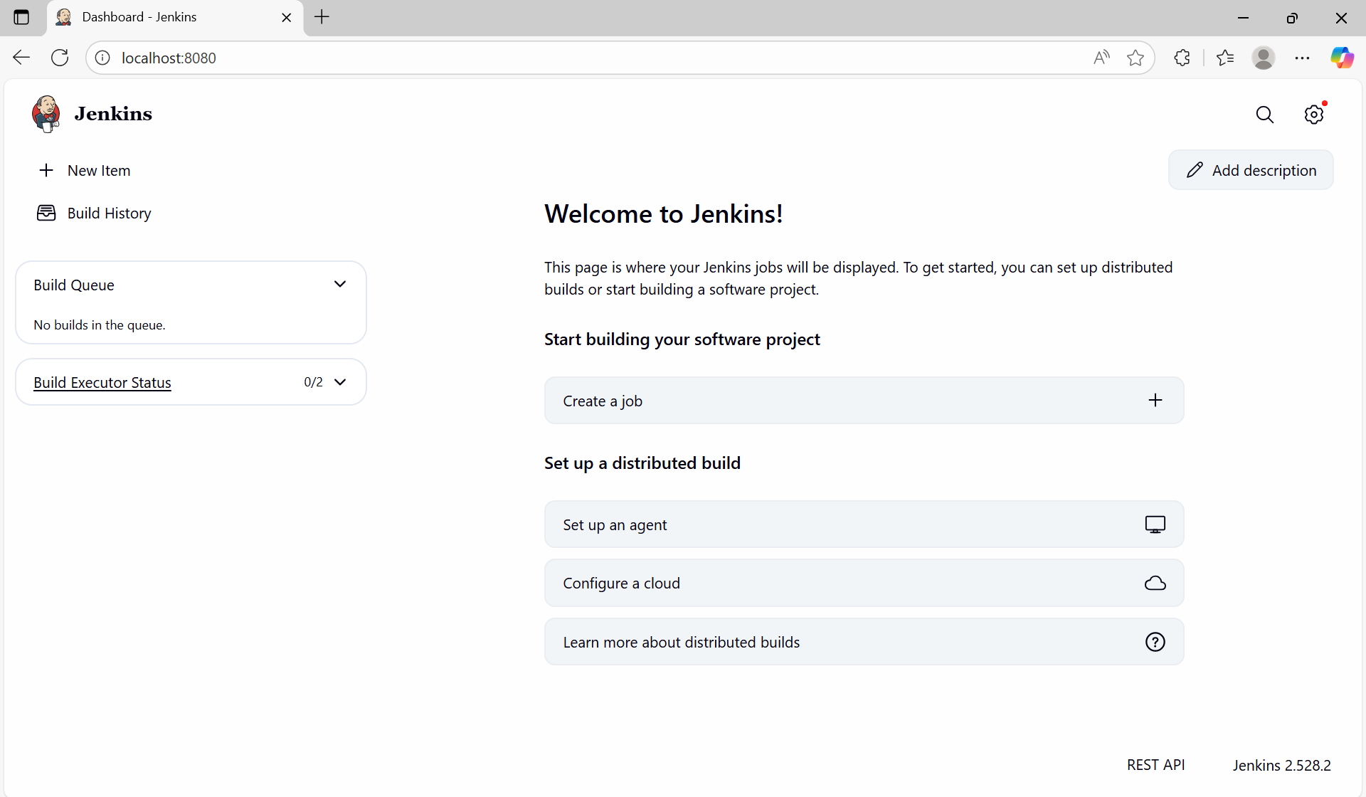
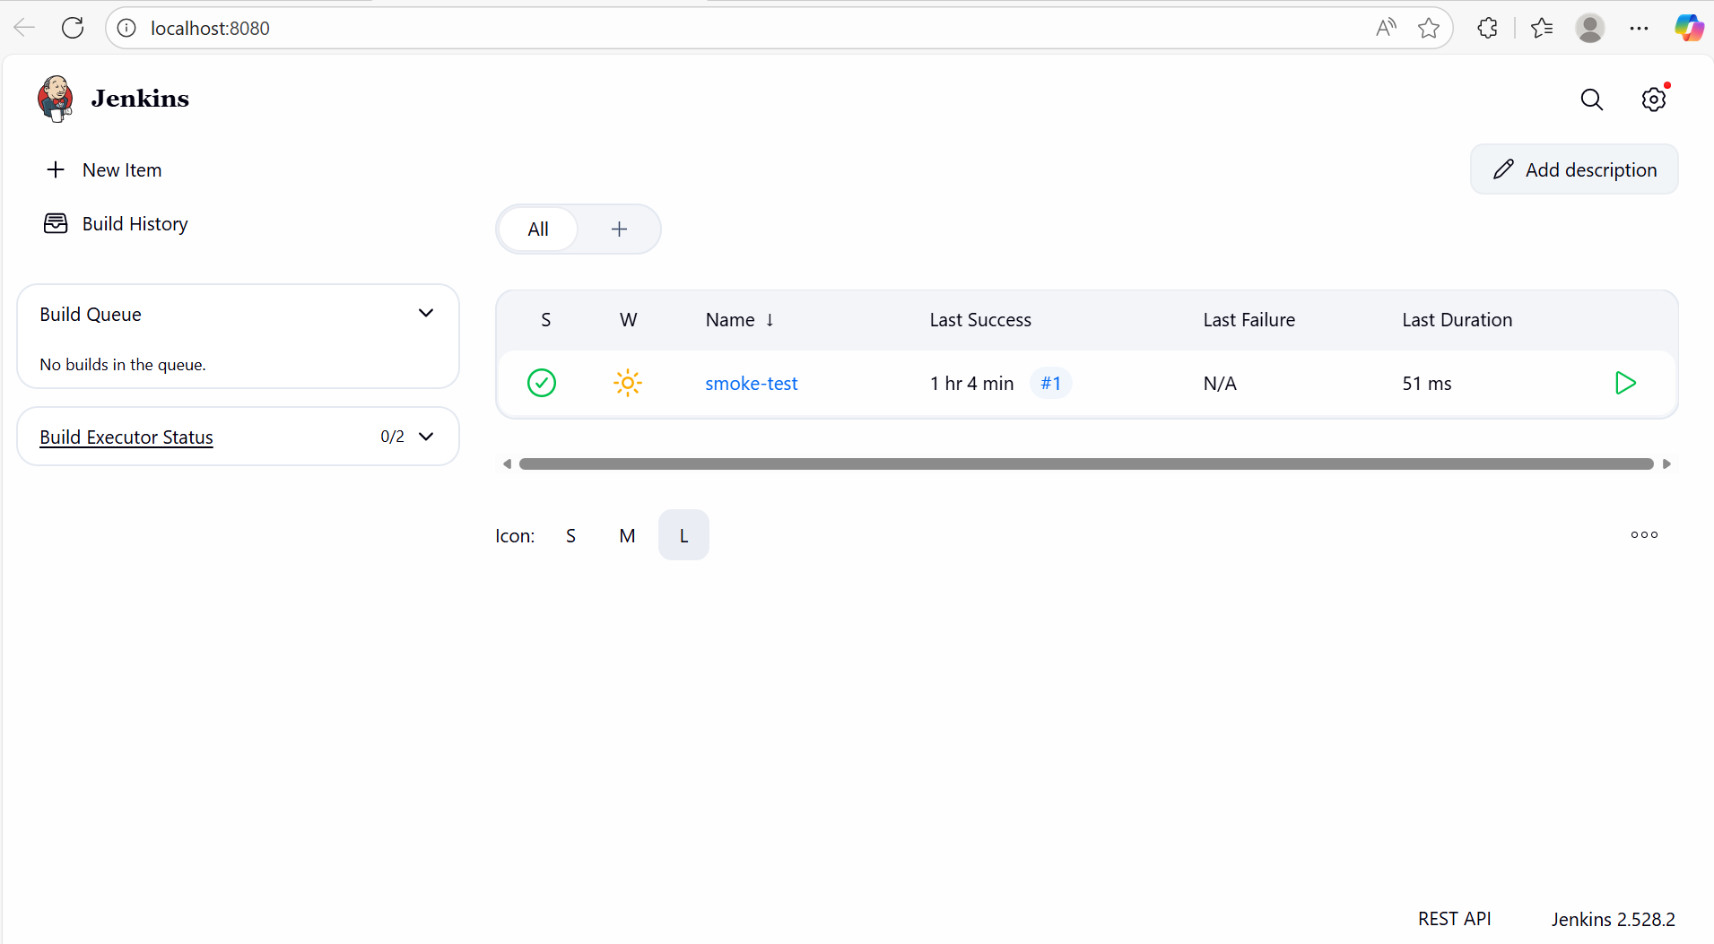

Step 4: Backup JENKINS_HOME
Purpose: Ensure rollback safety and backup job configuration, credentials, plugins.
Command:
sudo tar -czf backup.tgz -C jenkins_home_blue .

Step 5: Copy Blue Jenkins Data to Green
Purpose: Clone jobs, plugins, and Jenkins configuration to new upgraded instance.
Command:
sudo rsync -av --delete jenkins_home_blue/ jenkins_home_green/
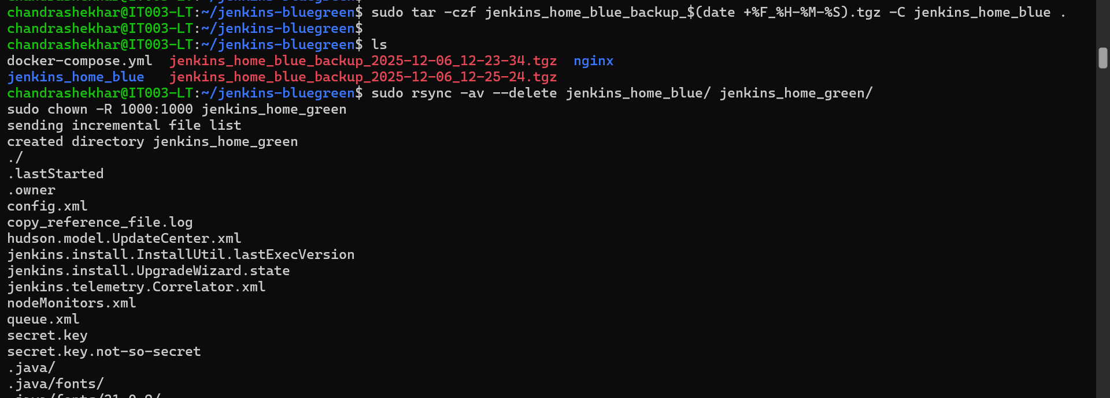

Step 6: Upgrade Green Jenkins Version
Purpose: Run upgraded Jenkins version (2.540) safely on a separate container.
Edited docker-compose.yml to:
image: jenkins/jenkins:2.540
Command:
docker compose up -d jenkins-green
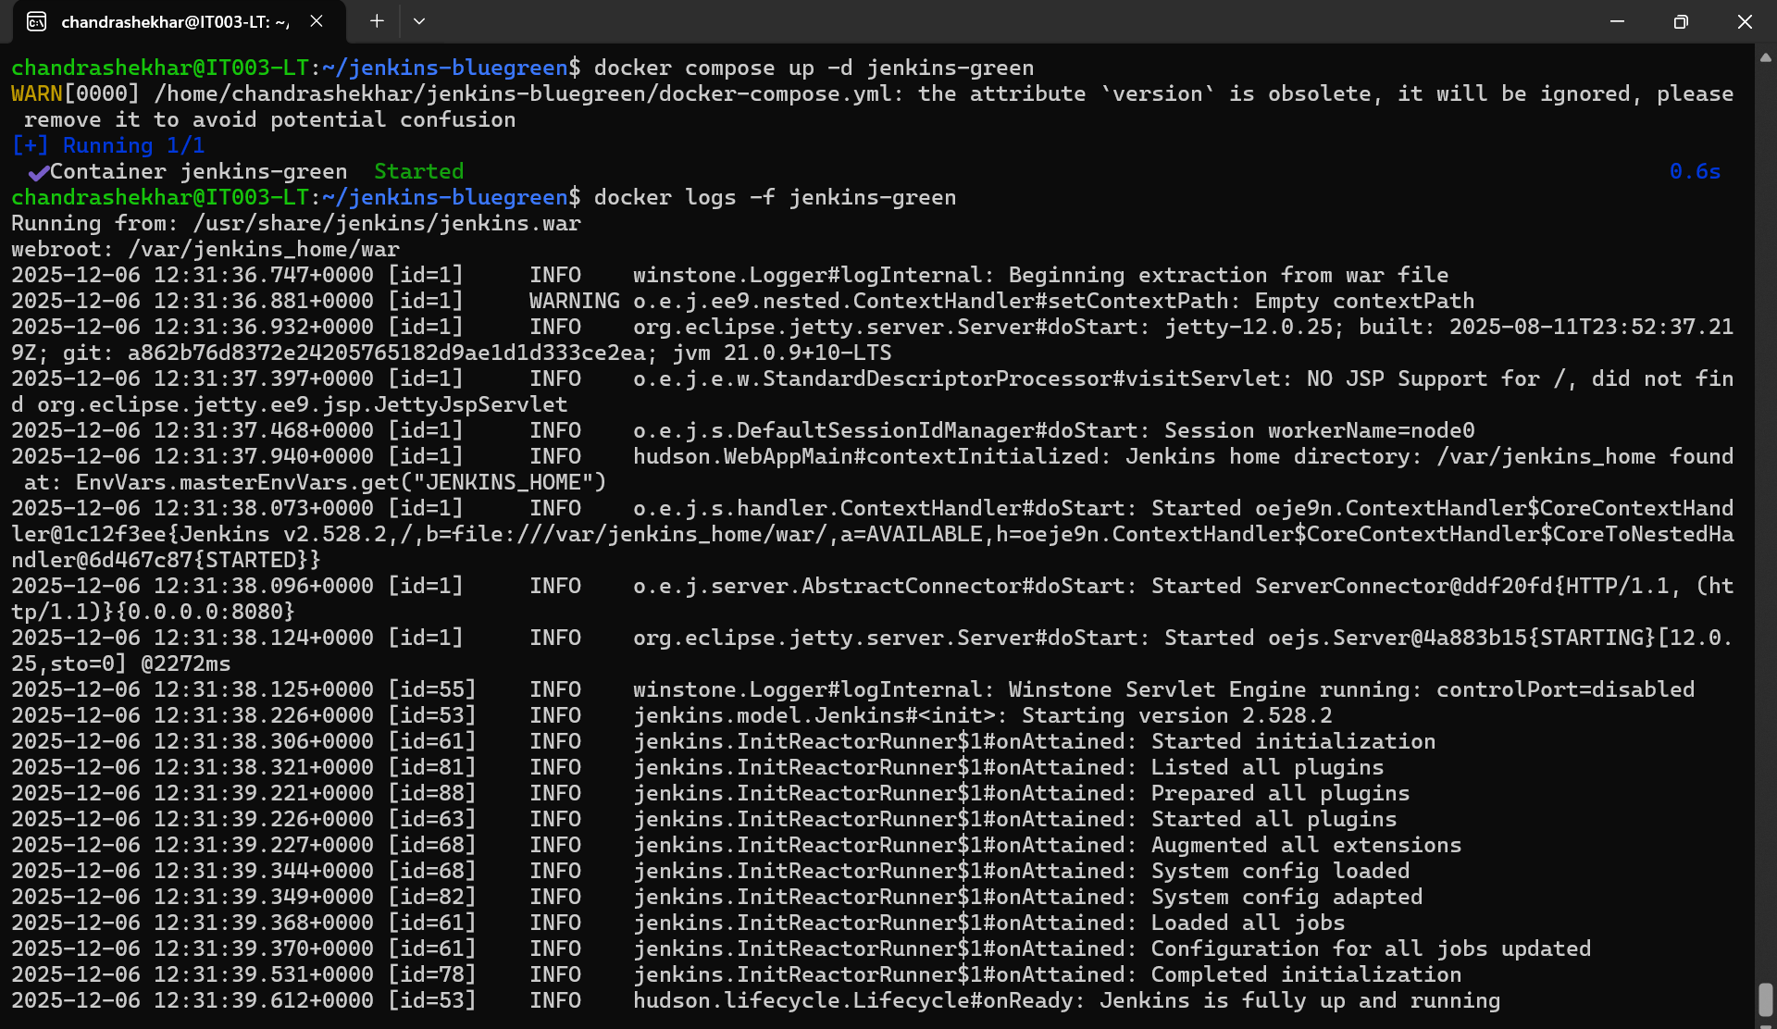

Step 7: Switch Traffic Using Nginx
Purpose: Make the upgraded Jenkins live without downtime.
Command:
docker exec jenkins-proxy nginx -s reload

Step 8: Validate Upgrade
Purpose: Ensure jobs, plugins, UI, and builds work after upgrade.
Validation checks:
- Jenkins version shows 2.540
- Jobs loaded successfully
- No plugin errors
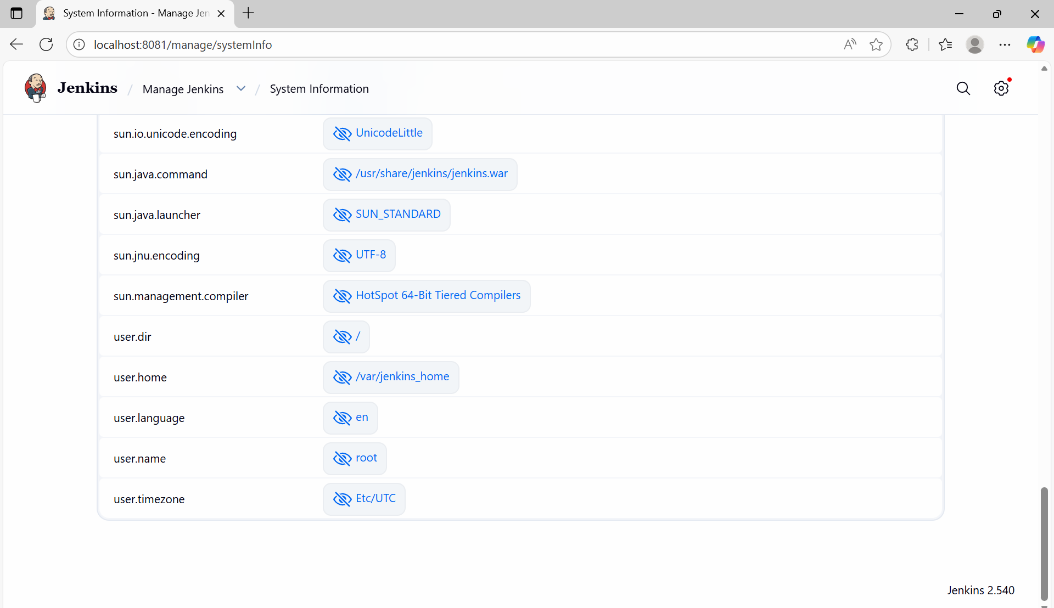

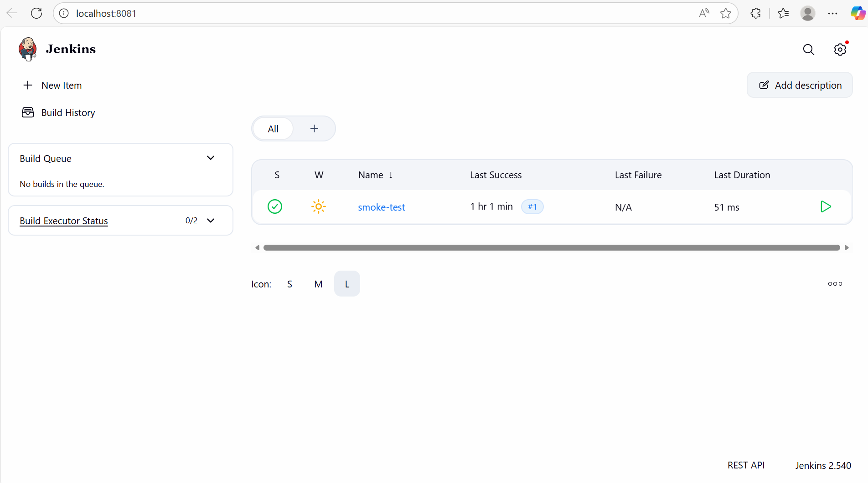

Step 9: Rollback Option (If Needed)
Purpose: Ability to instantly switch back to old version if issues arise.
Rollback required only modifying Nginx config and reloading.

10. Final Result
The upgrade was successfully completed with zero downtime.
Final Versions:
- Blue Jenkins: 2.528.2 (Standby)
- Green Jenkins: 2.540 (Production)
Traffic successfully routed via Nginx.
System stable after upgrade.
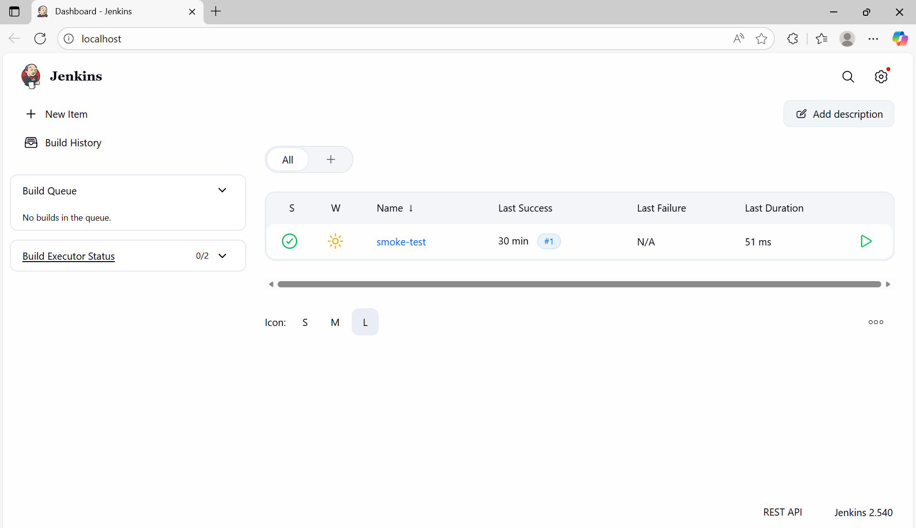

11. Conclusion
This assignment demonstrated a professional zero-downtime Jenkins upgrade using Blue-Green deployment. This method is used in real production environments because it provides safety, rollback capability, and uninterrupted CI/CD services.

