Voting App — Assignment Submission

1. Objective
Set up and run the Voting App (Flask frontend, Kafka, Spring worker, PostgreSQL, Node results) on an AWS EC2 Ubuntu instance using Docker Compose

2. Project Overview
Architecture / Flow:
1. User submits vote via the Vote UI (Flask).
2. Vote messages are published to Kafka topic "votes".
3. Worker (Spring Boot) consumes from Kafka and writes votes to PostgreSQL.
4. Result UI (Node/Express) reads tallies from PostgreSQL and displays them.

3. Prerequisites
AWS account with EC2
Recommended EC2 configuration: Ubuntu 22.04 LTS, t2.medium (2 vCPU, 4 GB RAM), 20 GB EBS.
Security Group inbound rules (minimum):
- SSH (TCP 22) from your IP
- Vote UI (TCP 5000) from required IPs (open to 0.0.0.0/0 if allowed)
- Result UI (TCP 5001) from required IPs

4. EC2 Launch & Server Setup (Step-by-step)
Follow these steps on the AWS Console:
1. Launch EC2 → Choose Ubuntu 22.04 LTS AMI.
2. Choose instance type: t2.medium.
3. Configure storage: 20 GB or more.
4. Create or choose an existing key pair (.pem) for SSH.
5. Security group: add inbound rules for ports 22, 5000, 5001.
After the instance is running, connect from your terminal:
ssh -i your-key.pem ubuntu@<EC2-PUBLIC-IP>

5. System update & Package installation (commands)
Run these commands on the EC2 instance (copy-paste):
sudo apt-get update && sudo apt-get upgrade -y
sudo apt-get install -y docker.io
sudo systemctl start docker
sudo systemctl enable docker
sudo usermod -aG docker $USER # optional: allows docker without sudo
newgrp docker # apply docker group membership for current session
sudo apt-get install -y docker-compose-plugin
sudo apt-get install -y git
sudo apt-get install -y postgresql-client # optional, for psql queries

6. Clone repository & run the stack
Replace YOUR_USERNAME with your GitHub username if you have a fork; otherwise use the original repo URL.
git clone https://github.com/YOUR_USERNAME/voting-app-project.git
cd voting-app-project
docker compose up -d –build

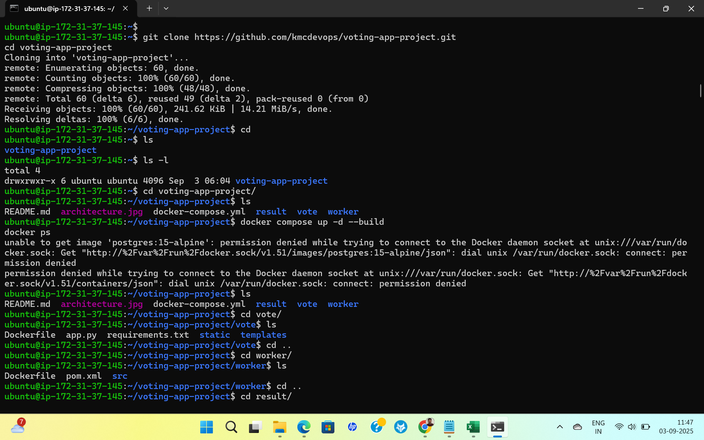
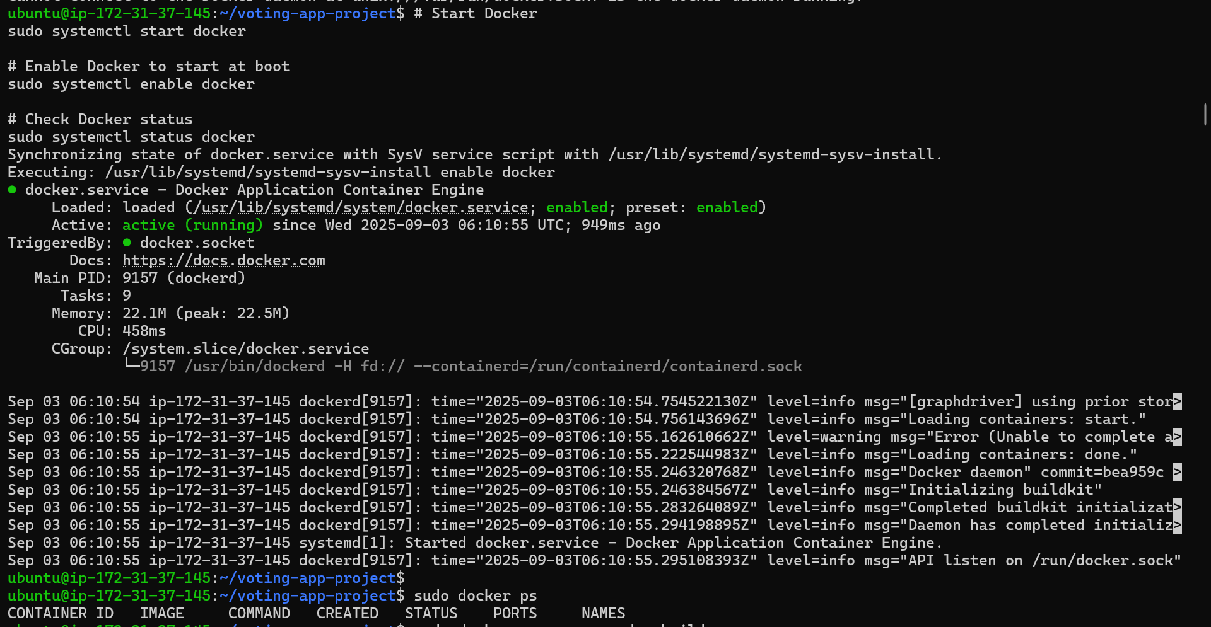
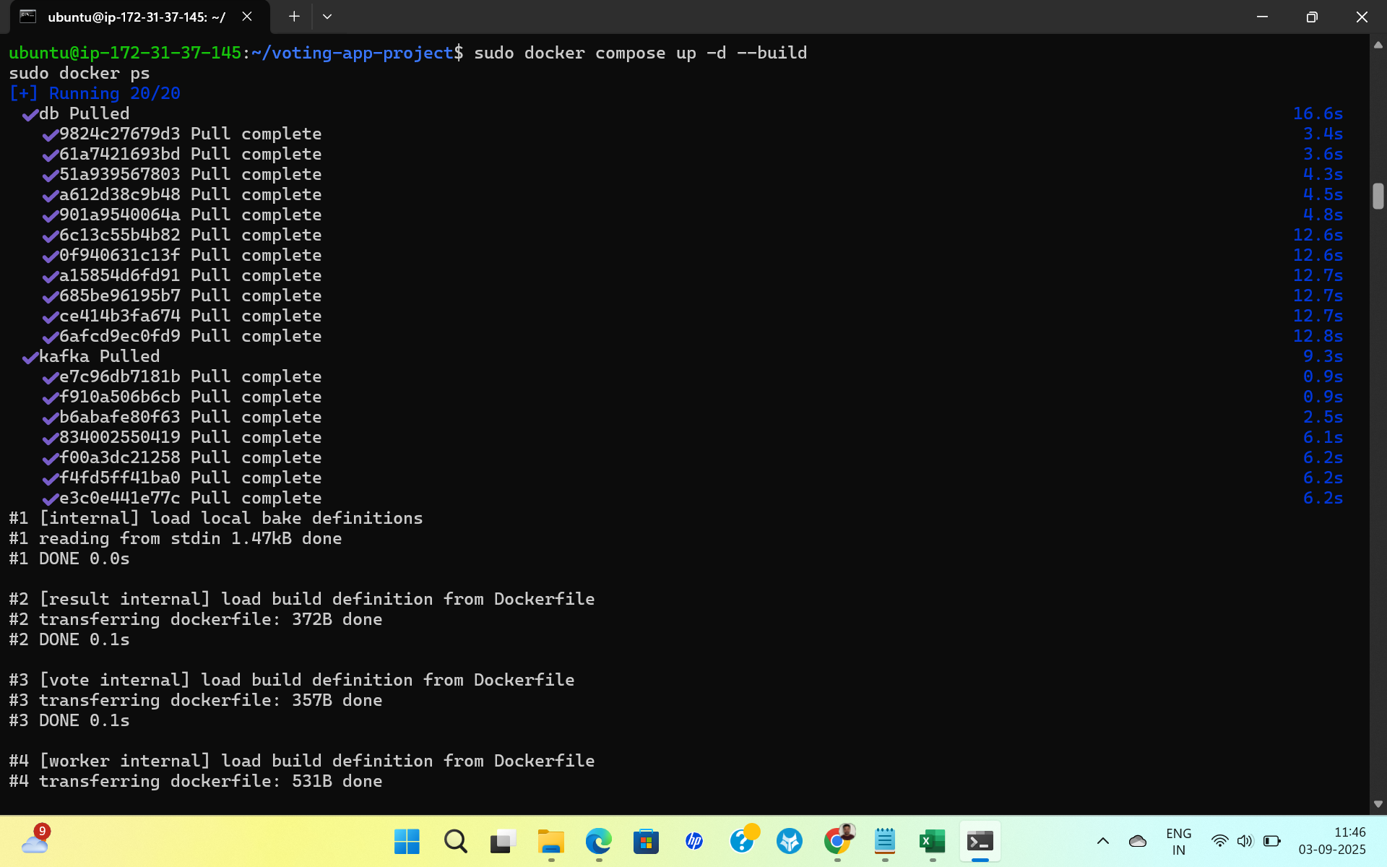
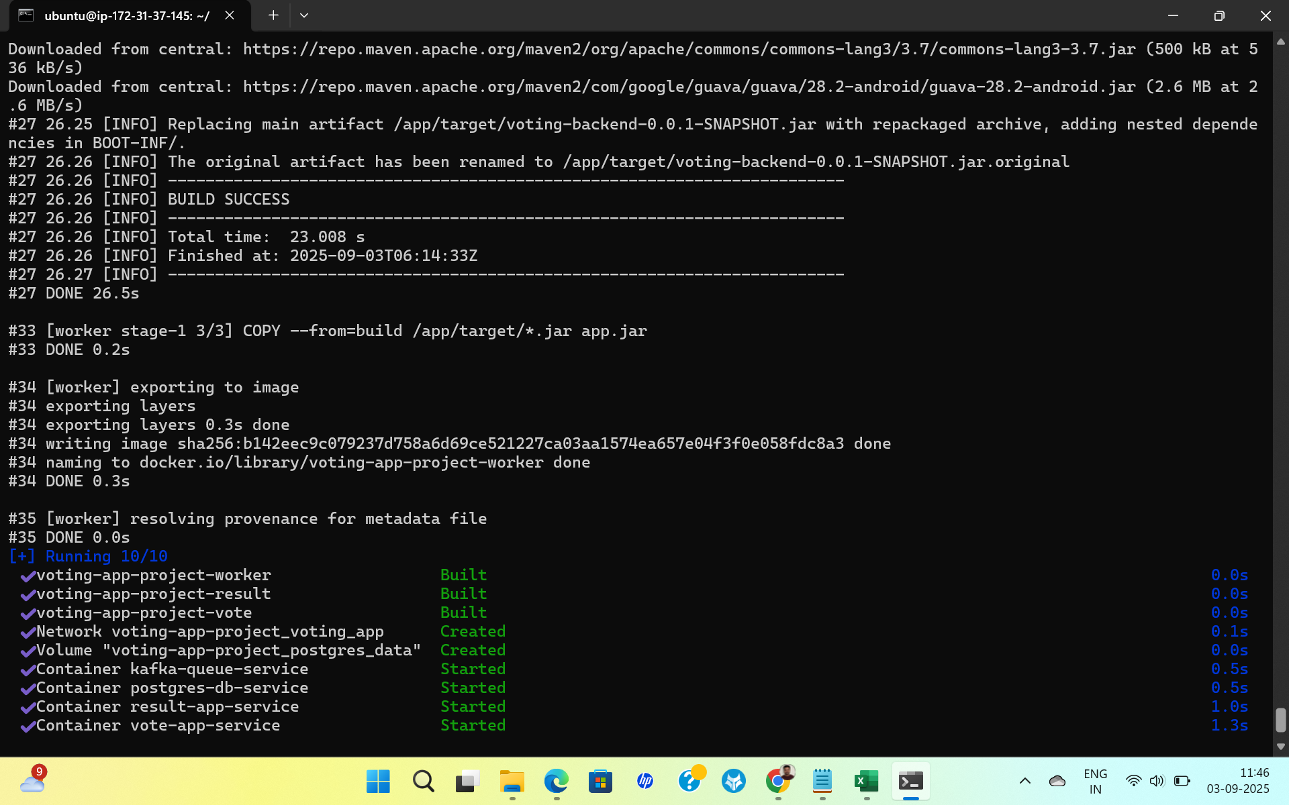

7. Verification & Testing
Check running containers:
docker ps
You should see these containers
- vote-app-service (Flask frontend)
- result-app-service (Node results frontend)
- worker-service (Spring Boot)
- postgres-db-service (Postgres)
- kafka-queue-service (Kafka)
Open in a browser:
- Vote UI: http://<EC2-PUBLIC-IP>:5000
- Results UI: http://<EC2-PUBLIC-IP>:5001
