Create a Custom Docker Image using Dockerfile that Clones a Java Repository and generates a jar/war file using maven
Ans: Created Dockerfile inside docker file installed maven java and git packages. Cloned the repository from github then build the package by using mvn clean package inside the dockerfile after that I build the Jar and run java -jar without entering into container.
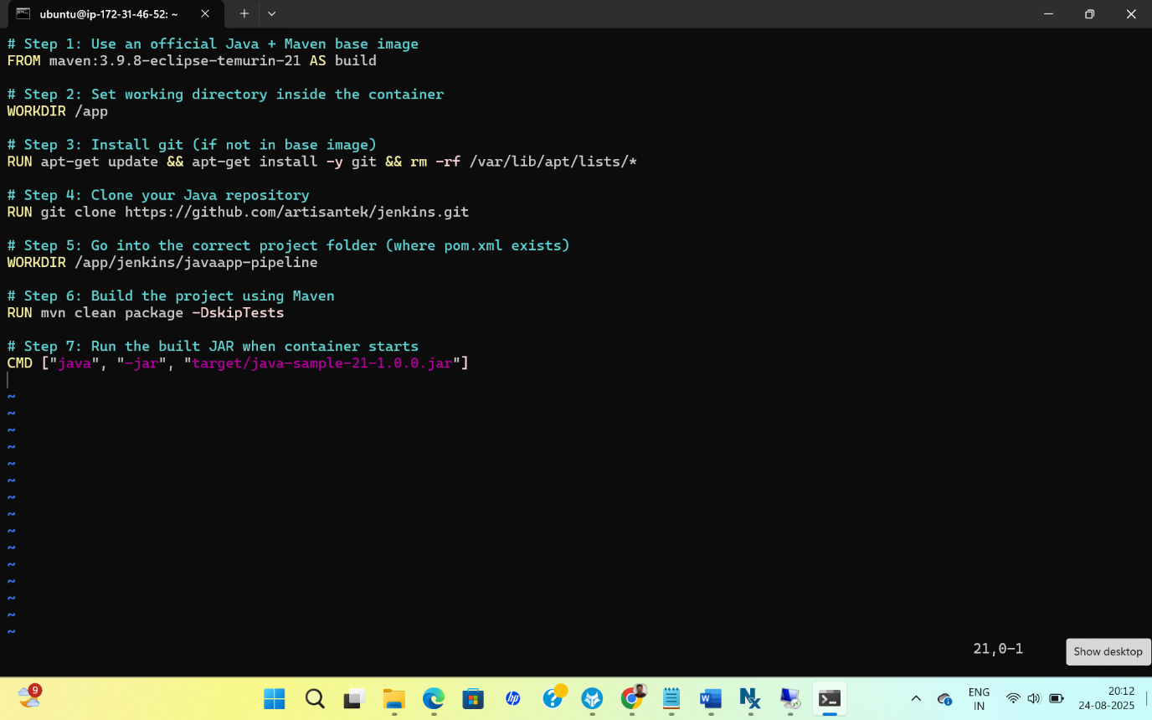
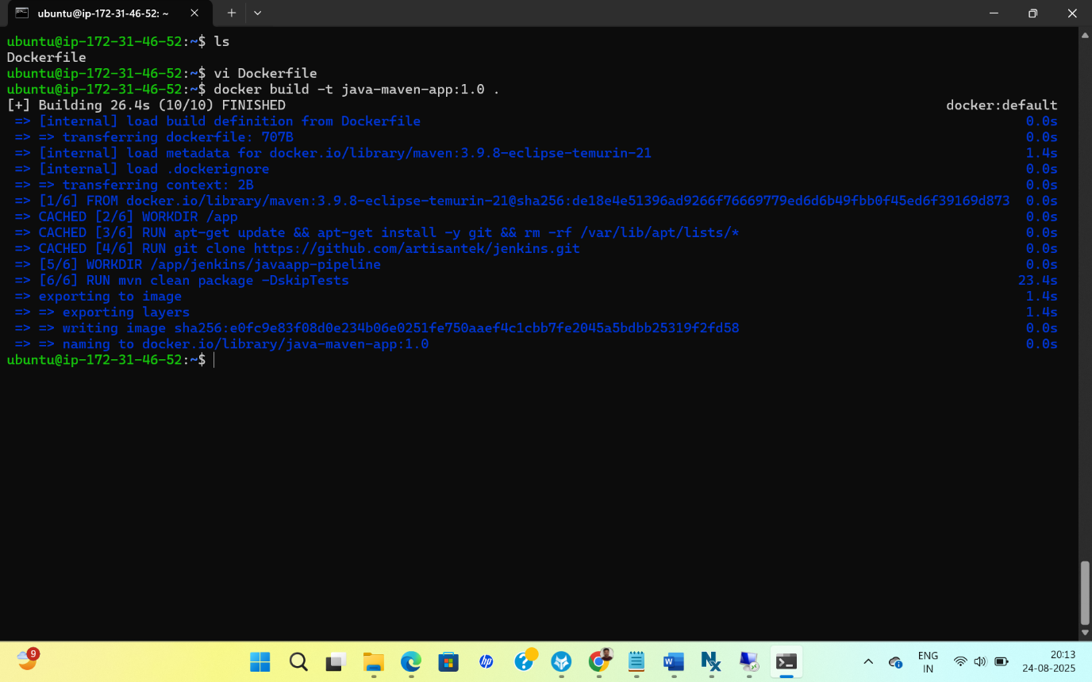
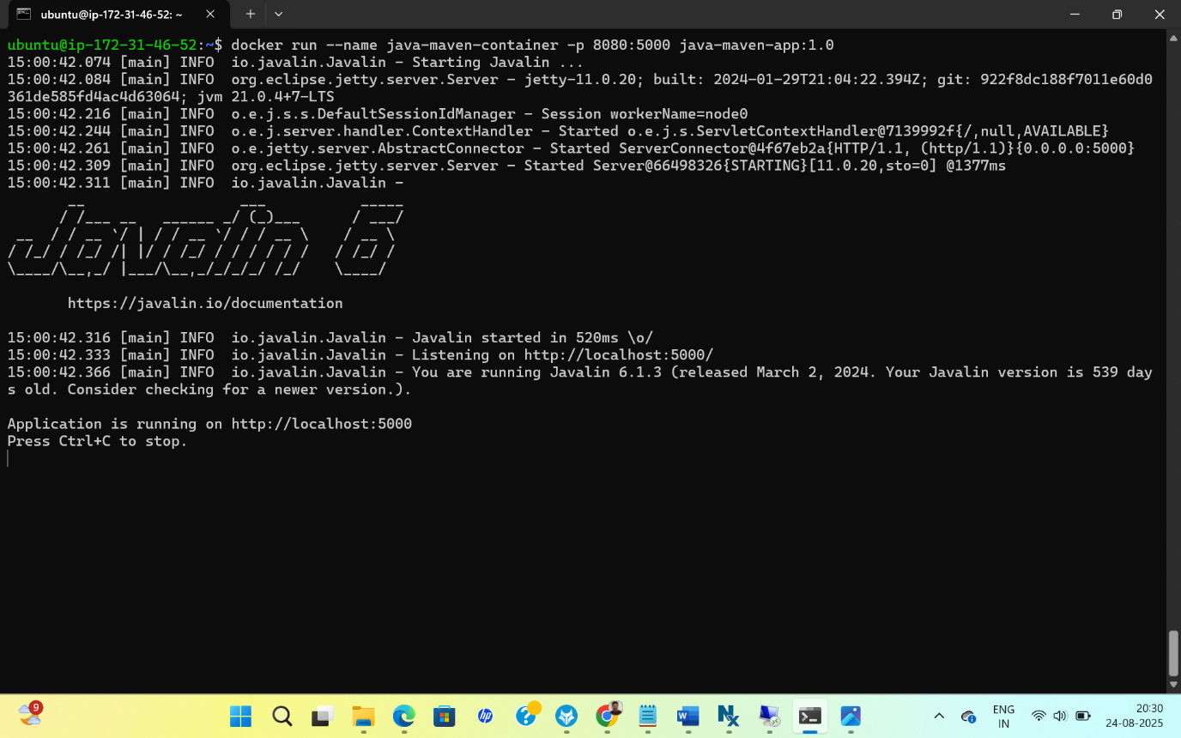
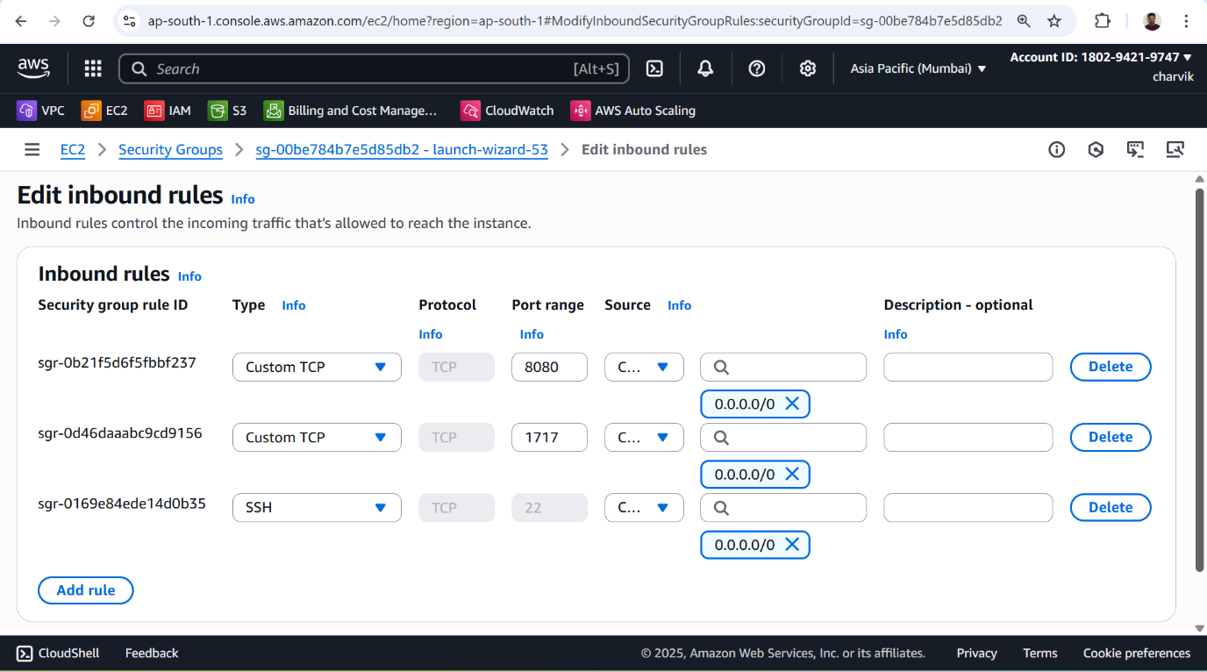
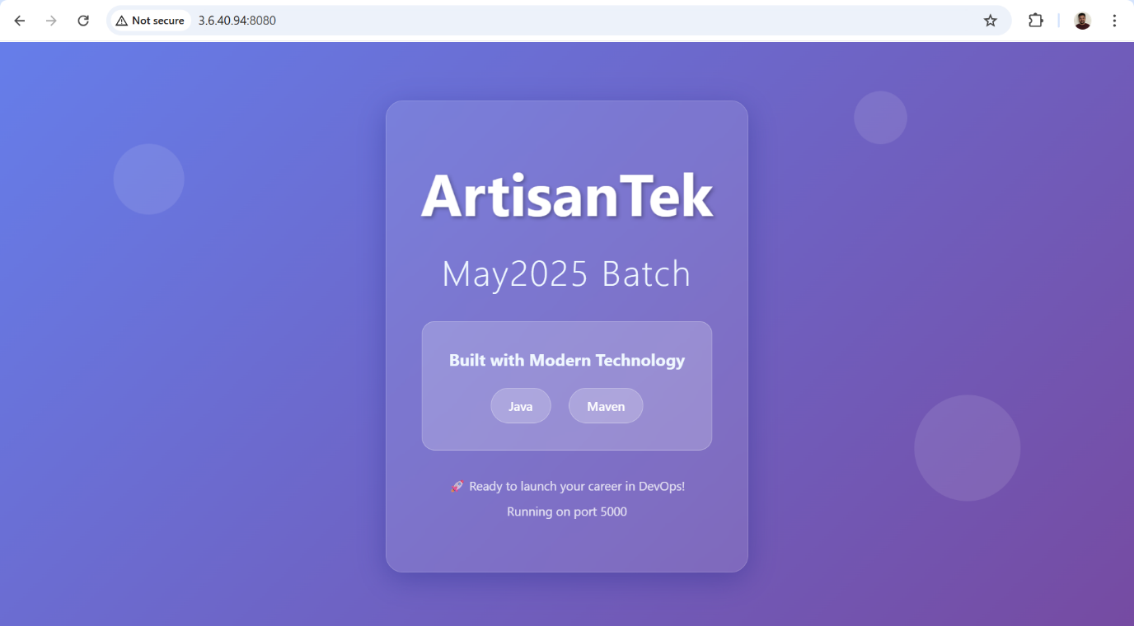
If I want to run the container (Auto Run) without entering inside the container
docker run -d --name java-maven-container -p 8080:5000 java-maven-app:1.0
docker run - This tells Docker to create and start a new container from an image.
-d - Detached mode: runs the container in the background.
- Docker won’t attach your terminal to the container’s output.
--name java-maven-container
- Assigns a custom name to your container (java-maven-container).
- Without --name, Docker generates a random name like jolly_morse.
-p 8080:5000
- Port mapping between host and container.
- Syntax: host_port:container_port
  - Host port (8080) → the port you access from your machine or browser.
  - Container port (5000) → the port your app is listening to inside the container.
- Example: If your app inside container listens on port 5000, you can access it via http://localhost:8080.
java-maven-app:1.0
- This is the Docker image name and tag:
  - java-maven-app → the image name
  - 1.0 → the image tag/version
    - If no tag is provided, Docker uses latest by default.
SUMMARY
Part | Meaning
docker run | Start a container
-d | Detached mode (runs in background)
--name java-maven-container | Custom name for the container
-p 8080:5000 | Map host port 8080 to container port 5000
java-maven-app:1.0 | Image name and tag to run

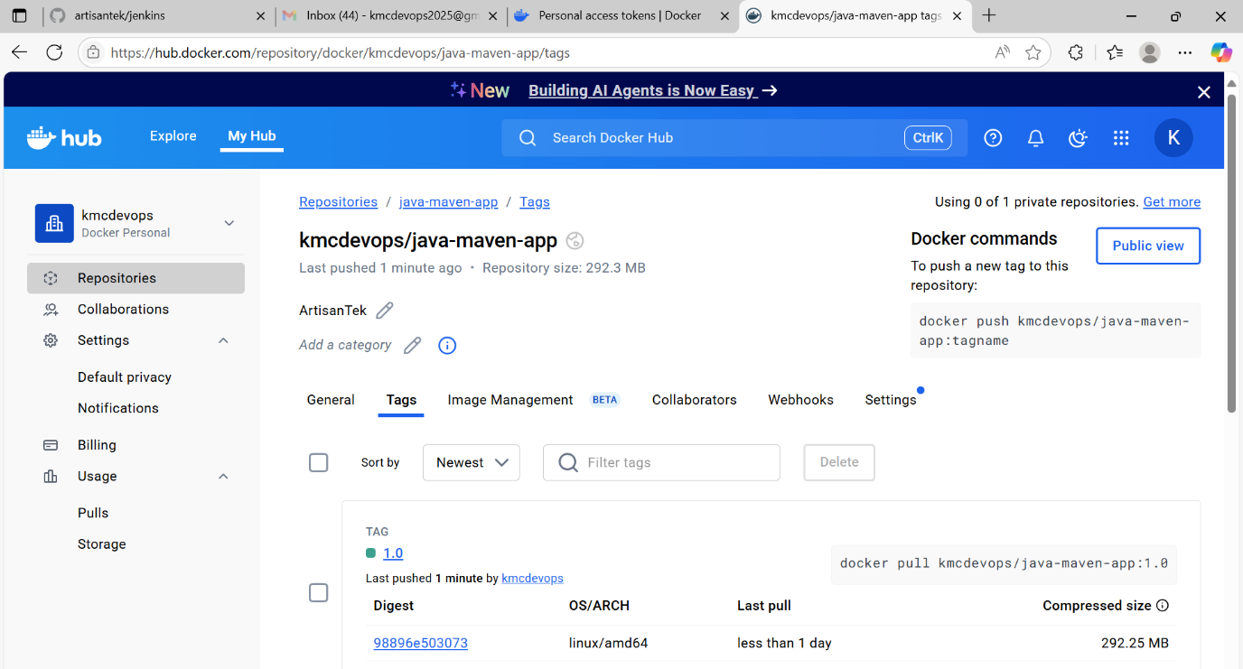

docker build -f Dockerfile -t java-sample-app:1.0 .
docker run -d --name java-sample-container -p 9090:5000 java-sample-app:1.0

