**[Lab worksheet 2: Numerical Data File](https://ekel.kln.ac.lk/mod/resource/view.php?id=444337)**

**Q1. Code:**

|  |
| --- |
| ***import java.util.Scanner;***  ***import static java.lang.Math.pow;***  ***public class Q1 {***  ***public static void main(String[] args) {***  ***Scanner S1 = new Scanner(System.in);***  ***// Getting A***  ***System.out.print("Enter A :");***  ***double A = S1.nextDouble();***  ***// Getting B***  ***System.out.print("Enter B number :");***  ***double B = S1.nextDouble();***  ***// Getting C***  ***System.out.print("Enter C number :");***  ***double C = S1.nextDouble();***  ***double result = Math.sqrt(Math.pow(B, 2) + (4 * A * C));***  ***/* Display the result */***  ***System.out.println("The result of (B^2 + 4AC) is: " + result);***  ***// Getting X***  ***System.out.print("Enter X :");***  ***double Y = S1.nextDouble();***  ***// Getting Y***  ***System.out.print("Enter Y number :");***  ***double X = S1.nextDouble();***  ***double result1 = Math.sqrt(X+4*(Math.cbrt(Y)));***  ***// Display the result***  ***System.out.println("The result of (X+4Y^3) is: " + result1);***  ***// Get radius input from the user***  ***System.out.print("Enter the radius of the circle: ");***  ***double radius = S1.nextDouble();***  ***// Calculate the area***  ***double area = Math.PI * Math.pow(radius, 2);***  ***// Display the result***  ***System.out.println("The area of the circle is: " + area);***  ***S1.close();***  ***}***  ***}*** |

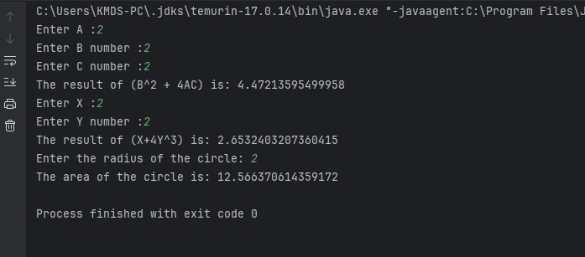

**Output:**

**Q2. Code:**

|  |
| --- |
| ***import java.util.Scanner;***  ***public class Q2 {***  ***public static void main(String[] args) {***  ***Scanner S2 = new Scanner(System.in);***  ***// Get input from the user***  ***System.out.print("Enter length in centimeters: ");***  ***double CM = S2.nextDouble();***  ***// Conversion***  ***double inches = CM / 2.54; // 1 inch = 2.54 cm***  ***double Feet = inches/12;***  ***double rest_feet = inches%12;***  ***// Display the result***  ***System.out.println(CM + "cm convert to " + Feet + " feet and " + rest_feet +" inches");***  ***S2.close();***  ***}***  ***}*** |

**Output:**

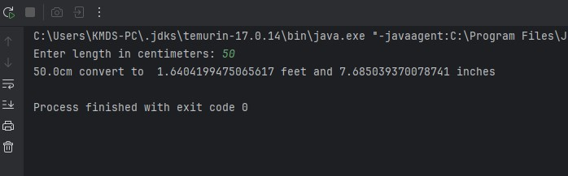

**Q3. Code:**

|  |
| --- |
| ***import java.util.Scanner;***  ***public class Q3{***  ***public static void main(String[] args) {***  ***Scanner S3 = new Scanner(System.in);***  ***// Get temperature input from the user***  ***System.out.print("Enter temperature in Celsius: ");***  ***double celsius = S3.nextDouble();***  ***// Convert to Fahrenheit***  ***double fahrenheit = (1.8 * celsius) + 32;***  ***// Display the result***  ***System.out.println(celsius + "°C is equal to " + fahrenheit + "°F");***  ***S3.close();***  ***}***  ***}*** |

**Output:**

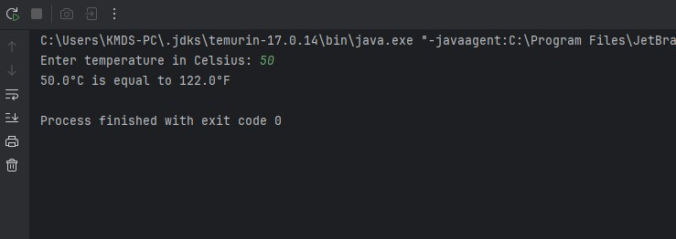

**Q4. Code:**

|  |
| --- |
| ***import java.util.Scanner;***  ***public class Q4 {***  ***public static void main(String[] args) {***  ***Scanner S4 = new Scanner(System.in);***  ***// Get weight input from the user***  ***System.out.print("Enter your weight : ");***  ***double bodyWeight = S4.nextDouble();***  ***// Calculate daily calorie needs***  ***double calories = bodyWeight * 19;***  ***// Display the result***  ***System.out.println("Your Weight is " + bodyWeight);***  ***System.out.println("You need approximately " + calories + " calories per day.");***  ***S4.close();***  ***}***  ***}*** |

**Output:**

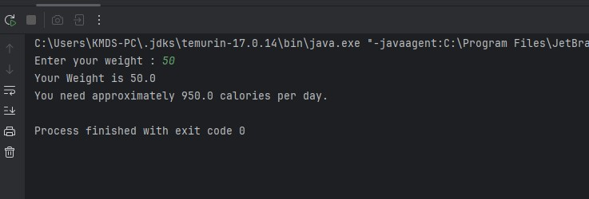

**Q5. Code:**

|  |
| --- |
| ***import java.util.Scanner;***  ***public class Q5 {***  ***public static void main(String[] args) {***  ***Scanner S5 = new Scanner(System.in);***  ***// Get temperature input from the user***  ***System.out.print("Enter temperature in Fahrenheit: ");***  ***double fahrenheit = S5.nextDouble();***  ***// Convert to Celsius***  ***double celsius = (5.0 / 9) * (fahrenheit - 32);***  ***// Display the result***  ***System.out.println(fahrenheit + "°F is equal to " + celsius + "°C");***  ***S5.close();***  ***}***  ***}*** |

**Output:**

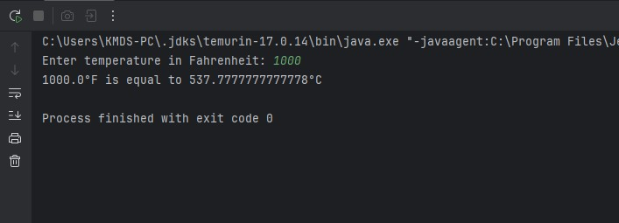

**Q6.** **Code:**

|  |
| --- |
| ***import java.util.GregorianCalendar;***  ***import java.util.Scanner;***  ***public class Q6 {***  ***public static void main(String[] args) {***  ***// Today***  ***GregorianCalendar today = new GregorianCalendar();***  ***System.out.println(today.getTime());***  ***int currentYear = today.get(GregorianCalendar.YEAR);***  ***// User bron day***  ***Scanner S6 = new Scanner(System.in);***  ***System.out.print("Enter the year you were born: ");***  ***int birthYear = S6.nextInt();***  ***int age = currentYear - birthYear;***  ***System.out.println("You were born in " + birthYear + " and will be " + age + " this year.");***  ***S6.close();***  ***}***  ***}*** |

**Output:**

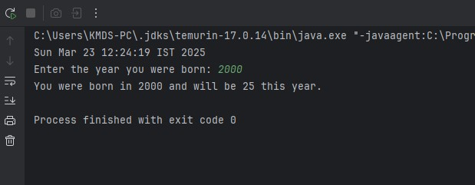

**Q7. Code:**

|  |
| --- |
| ***import java.util.Scanner;***  ***public class Q7 {***  ***public static void main(String[] args) {***  ***// Create Scanner object for user input***  ***Scanner S7 = new Scanner(System.in);***  ***// Get weight***  ***System.out.print("Enter your weight in kilograms: ");***  ***double weight = S7.nextDouble();***  ***// Get height***  ***System.out.print("Enter your height in centimeters: ");***  ***double height = S7.nextDouble();***  ***double heightM = height / 100.0;***  ***// Calculate BMI using the formula***  ***double bmi = weight / Math.pow(heightM ,2);***  ***// Display the result***  ***System.out.println("Your Body Mass Index (BMI) is: " + bmi);***  ***if (bmi >= 20 && bmi <= 25) {***  ***System.out.println("You are underweight.");***  ***} else if (bmi >= 25) {***  ***System.out.println("You are overweight.");***  ***}***  ***S7.close();***  ***}***  ***}*** |

**Output:**

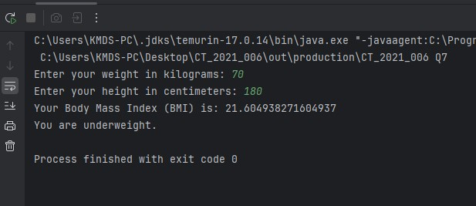

**Q8. Code:**

|  |
| --- |
| ***import java.util.Scanner;***  ***public class Q8 {***  ***public static void main(String[] args) {***  ***// user input***  ***Scanner S8 = new Scanner(System.in);***  ***// Get the radius***  ***System.out.print("Enter the radius of the sphere: ");***  ***double radius = S8.nextDouble();***  ***// Pi***  ***final double PI = 3.14;***  ***// Calculation***  ***double volume = (4.0 / 3.0) * PI * Math.pow(radius, 3);***  ***// Display the result***  ***System.out.println("The volume of the sphere is: " + volume);***  ***S8.close();***  ***}***  ***}*** |

**Output:**

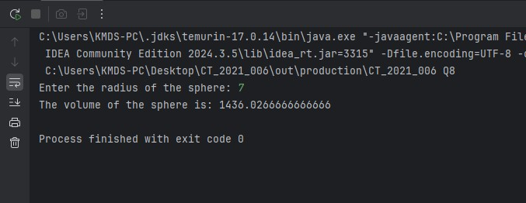

**Q9. Code:**

|  |
| --- |
| ***import java.util.Scanner;***  ***public class Q9 {***  ***public static void main(String[] args) {***  ***// Create Scanner object for user input***  ***Scanner S9 = new Scanner(System.in);***  ***// Get amount***  ***System.out.print("Enter the amount : ");***  ***double P = S9.nextDouble();***  ***// Get interest rate***  ***System.out.print("Enter the annual interest rate in percentage: ");***  ***double R = S9.nextDouble();***  ***// Get the number of years***  ***System.out.print("Enter the number of years : ");***  ***int N = S9.nextInt();***  ***// Calculate the amount after N years***  ***double amount = P * Math.pow(1 + (R / 100), N);***  ***// Calculate the money earned***  ***double money = amount - P;***  ***// Display the results***  ***System.out.println("Amount after " + N + " years: " + "Rs " + amount);***  ***System.out.println("Money earned after " + N + " years: " + "Rs "+ money);***    ***S9.close();***  ***}***  ***}*** |

***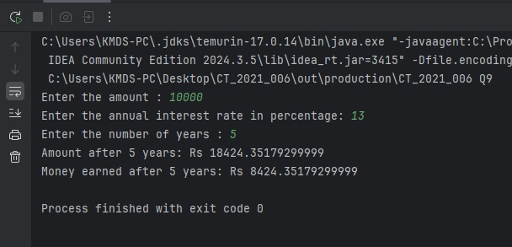*Output:**

**Q10. Code:**

|  |
| --- |
| ***import java.util.Scanner;***  ***public class Q10 {***  ***public static void main(String[] args) {***  ***// Create Scanner object for user input***  ***Scanner S10 = new Scanner(System.in);***  ***// Get loan amount***  ***System.out.print("Enter the amount : ");***  ***double loan = S10.nextDouble();***  ***// Get loan period***  ***System.out.print("Enter the loan period (years) : ");***  ***double loanPeriod = S10.nextDouble();***  ***// Get interest rate***  ***System.out.print("Enter the annual interest rate in percentage: ");***  ***double annualInterestRate = S10.nextDouble();***  ***final double MONTHS_IN_YEAR = 12;***  ***//monthly interest rate***  ***double monthlyInterestRate = (annualInterestRate / 100.0) / MONTHS_IN_YEAR;***  ***//no of payments***  ***double numberOfPayments = loanPeriod * MONTHS_IN_YEAR;***  ***//monthly payment***  ***double monthlyPayment = (loan * monthlyInterestRate) / (1 - Math.pow(1 / (1 + monthlyInterestRate), numberOfPayments));***  ***//total payments***  ***double totalPayment = monthlyPayment * numberOfPayments;***  ***// Display the results***  ***System.out.println("Monthly payment: Rs " + "Rs " + monthlyPayment);***  ***System.out.println("Total payment after " + loanPeriod + " years: Rs " + totalPayment);***  ***S10.close();***  ***}***  ***}*** |

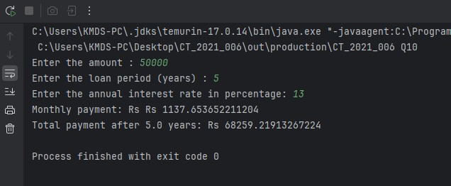

**Output:**