Operating Systems — Week 2 Notes

1. Process Scheduling
The scheduler decides which process runs next. Critical concept: context switching has a cost.
Common algorithms:
- Round Robin
- Shortest Job First
- Multi-level Feedback Queue

1.1 Comparison
Algorithm | Preemptive
Round Robin | Yes
SJF | Sometimes
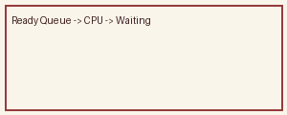

2. Deadlocks
Four necessary conditions must hold simultaneously.

