

ДОКУМЕНТАЦИЯТА Е ОТ СОФИЯ
TABLE OF CONTENTS
1. About our team.....................................................
2. Resume.................................................................
3. Parts of the project...............................................
4. What programs and languages we used................
5. Idea......................................................................
6. Workflow..............................................................
7. Conclusion............................................................


1. ABOUT OUR TEAM
ClassQuest is a group of 5 dedicated people, with
Juliana Stoykova, 9V as SCRUM TRAINER; Kristian Dinev, 9B as BACKEND DEVELOPER; Sofya Chapkina, 9V as BACKEND DEVELOPER; Simona Subeva, 9V as DESIGNER; Nikoleta Georgieva, 9A as QUALITY ENGINEER.

2. RESUME
As a small group of dedicated young programmers brought together by our love for coding, we are here to complete our project task for which we decided to write a program that helps students learn remotely from school, with out focus on Biology, Chemistry and Physics which are the subjects we love most.
After registering, each user has the access to study plans, homework assignments and tests. Their test result date is stored and they can view it at any time as a statistic.


3. PARTS OF THE PROJECT
FRONTEND – the overall look of the program as we see it. BACKEND – log-in system, statistic system and data saving

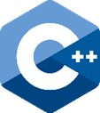
4. PROGRAMS AND LANGUAGES USED
C++
The primary programming language.

Visual Studio 2022


Used for programming.
MS Word and MS PowerPoint
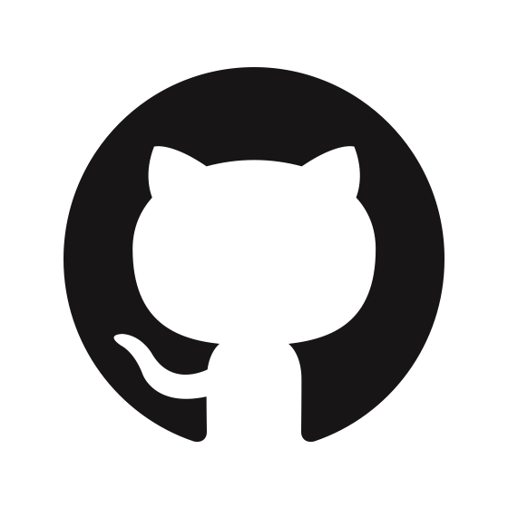

Used to make the documentation and the presentation for our project.
Git and GitHub

The primary collaboration tools.
MS Teams
Used to communicate with eachother.

5. IDEA
Our primary focus was to learn and explore the boundaries of C++. We experimented with, and discovered for ourselves, many new possibilities to use the coding language and found out how to work with various new features we had never ever used before.

6. WORKFLOW
Week 1
Assigning roles, brainstorming and sharing ideas for what we want as the final product, rough draft of our code.
Week 2
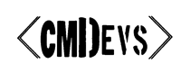
Developing the base code of the program, a lot of experimenting with the features of C++.
Week 3
Adding final touch-ups and documenting the project.



7. CONCLUSION
During our time developing the project, our team has naturally encountered bugs and imperfections, as well as minor difficulties communicating.
Despite this, all of the troubles we came across have been overcome and now we are proud to present our program to you.



