***Daily Grind Game Rule Set***

**Overview (why I made the game):** This game is a simulation card game meant to represent the difficulties of completing day to day activities when you are suffering from depression. At least 350 million people live with depression, and it is the leading cause of disability worldwide. 50% of the people suffering from depression do not seek medical help and 75% with mental illness have reported experiencing stigma. This game is designed to increase awareness for depression and start a meaningful dialogue about the disease to hopefully reduce societal stigma about depression.

**Goal**: Players take turns drawing activity, tasks, symptom, and treatment cards during their turns in order to complete as many tasks cards as possible. Completed task cards will give the player points in order to win the game. Player with highest points after round 15 will win the game. In order to simulate the difficulty of completing day to day tasks when suffering depression players will experience a sliding scale of severity from mild to severe to crippling. The higher on the scale a player is the harder it becomes to “stay active” and complete tasks.

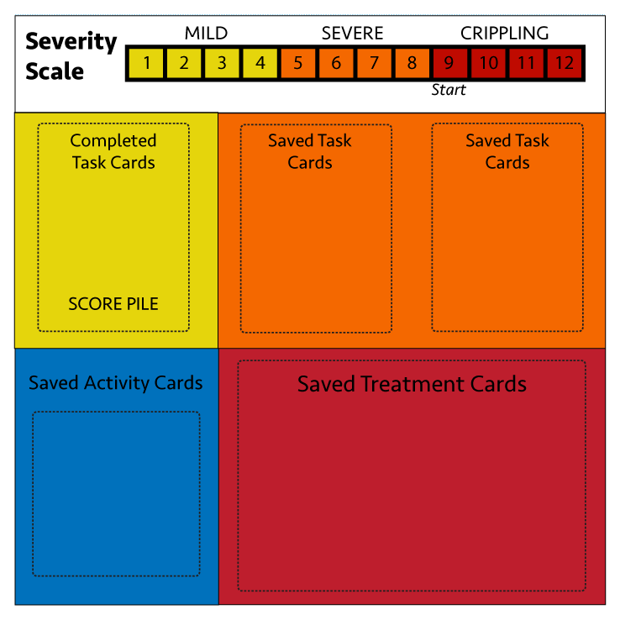

**Game Materials**

* **Task Cards**
* **Activity Cards** (divided into 3 levels of “severity” ***mild, severe, crippling***\*)
* **Symptom Cards**
* **Treatment Cards**
* **Game Sheets** (shown)
* **Scale marker** (pawn)
* **Dice**

**Setup**

1. Separate all the decks of cards and lay them out so that everyone can easily see and access them. Keep the **Activity Cards** near each other in piles for mild, severe, and crippling.
2. Make sure all decks of cards are shuffled.
3. Each player draws 3 task cards each.
4. Youngest player will start first round by drawing an **Activity Card (from the crippling pile)** and begin the game.

**Task Cards**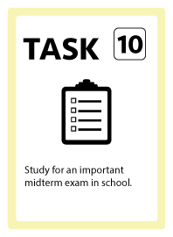

* Task Cards represent “tasks” that players want to complete during their rounds to score points. To complete a task players need the amount of Activity Points (See Activity Cards) that are listed on the top right of the task card (ex. 10). Once completed, player can put card in “Completed Task Pile” on game sheet and those 10 task points will go to their ending score.
  + *\*Each leftover task card at the end of the game will cost a player -2 points on their score for each card!*
  + *To draw more task cards it will cost 2 Activity Points each draw.*

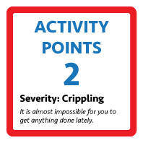

**Activity Cards**

* Activity Cards include a value in the middle of the card which is the players activity points for that round. To do any actions in the game players need to use these activity points.
  + ***Actions Players can do with Activity Points:*** 
    - **Complete Task Cards** (You must complete tasks in full, and cannot keep “extra” activity points left over from a turn.)
    - **Draw Treatment Cards** = 2 Activity Points
    - **Complete a Treatment** (cost value on Treatment Card)
    - **Draw another Task Card** = 2 Activity Points

**Chance Cards**

* Activity Cards include a few chance cards that change the players choices for that turn. Follow what the card says if a Chance Card is pulled.

**Symptom Cards**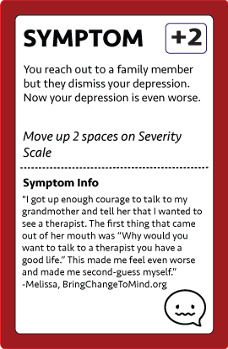

* Symptom cards are drawn at the **end of each turn** (unless a treatment card was completed) and their values represent player movement on the severity scale. Cards **values** (**“+2” on severity scale)** are listed on the top right corner of the card.

**Treatment Cards**

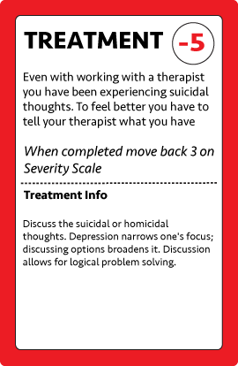

* In order to reduce the players score on the Severity Scale, they need to complete Treatments. Treatment cards have an initial cost of **2 activity points** for the first draw, and then to complete them they each have different values listed on the top left of the card under “cost.”
  + *If you complete a Treatment card during your turn, the you DO NOT PULL A SYMPTOM CARD.*
  + *Reducing your score on the Severity Scale will give you greater odds of getting more Activity Points.*

**GAMEPLAY ELEMENTS**

**Player Game Sheet:** the game sheet is meant to keep the players cards in order and help keep track of where they are on the Severity Scale. Includes space for:

* Completed Task Cards (players score at the end of the game)
* Non-Completed Task Cards (“Saved Tasks”)
* Saved Activity Cards
* Saved Treatment Cards
* Severity Scale Markers

**Severity Score:** the severity score is a player’s sliding scale to measure the “severity” of their depression at that time of the game. The scale has values from 0-12 with mild, severe, and crippling stages. The scale is shown on the top of the Game Sheet.

* Mild = 0-4
* Severe = 5-8
* Crippling = 9-12

Players **start at value 9** just entering the crippling stage (labeled start). In order to make completing tasks easier players will need to try to **reduce severity score by completing treatment cards** (see treatment cards).

**Turn Basics**

**START OF EACH TURN**

* **Pull an Activity card** from the pile that represents your severity level (i.e. value 6 on severity = Severe level so draw from Severe card pile)
  1. *The value on the Activity Card is the amount of Activity Points you have for that turn.*

***PLAYER CHOICES PER TURN***

1. You may choose to keep that activity card for next round if you do not use any of its point values. IF YOU DO THIS YOU STILL DRAW A SYMPTOM CARD.
2. Use Activity Points:
   1. *Complete a Task*
   2. *Draw more Task Cards (cost 2 points)*
   3. *Draw a Treatment Card (cost 2 points)*
   4. *Complete a Treatment*

**END OF EACH TURN = DRAW SYMPTOM CARD** and move on the severity scale

* *DO NOT* draw symptom card if you have **completed** a treatment that turn

**Sample Turn**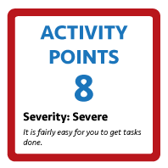

1. **Player 1 draws Activity Card** with value 8 from the severe pile.
2. **Player 1** already has task cards of 4, 9, and 10
3. Player 1 chooses to **complete task with value 4.** 
   1. Remaining 4 points
4. Player 1 cannot finish anymore of their task cards so he/she chooses to **draw a Treatment Card** costing 2 more points.
   1. Treatment card is value 4 (so cannot finish it this turn)
   2. Remaining 2 points
5. Player uses **last 2 points to draw another Task Card** (value 7).
   1. Remaining points 0
6. **Finishes turn by DRAWING SYMPTOM CARD** (because no treatment was completed).
   1. Symptom Card has value +2 so Player 1 moves up 2 spaces on Severity Scale.
7. End Turn. Next Player goes.

**GAME WINNER**

**Game ends -** after 15 rounds (1 round is all players completing their turn). For each non-completed task card players subtract 2 points from their total score. Player with highest score after deductions for non-completed tasks wins!

**QUICK CARD REFERENCES**

**Tasks:** value listed on card. Want to complete these using activity points to get a score.

**Activity Cards** = value listed on the card (mild, severe, crippling piles). Used to complete tasks.

**More Task Cards** = cost 2 activity points

**Initial Treatment Card draw** = cost 2 activity points

**Complete a treatment** = cost is value listed on top right of card

**Symptom Card Values** = shows the amount to move on severity scale in top right

**End of Game Tasks not Completed** = -2 from score for each task card not completed

**QUICK TURN GUIDE**

1. Draw Activity Card from severity pile
2. Complete any actions with activity points (tasks, treatments)
3. “Buy” more tasks or treatment cards for 2 activity points each (if needed)
4. Draw Symptom Card (if no treatment was completed)





**GAME WINNER**

**Game ends -** after **15 rounds** (1 round is all players completing their turn). For each **non-completed task card players subtract 2 points from their total score**. Player with highest score after deductions for non-completed tasks wins!