6/26/2017

Kasun Madusanka

IT15116420

Distributed Systems

Assignment 02 Report

**High Level Architectural Diagram of the System**

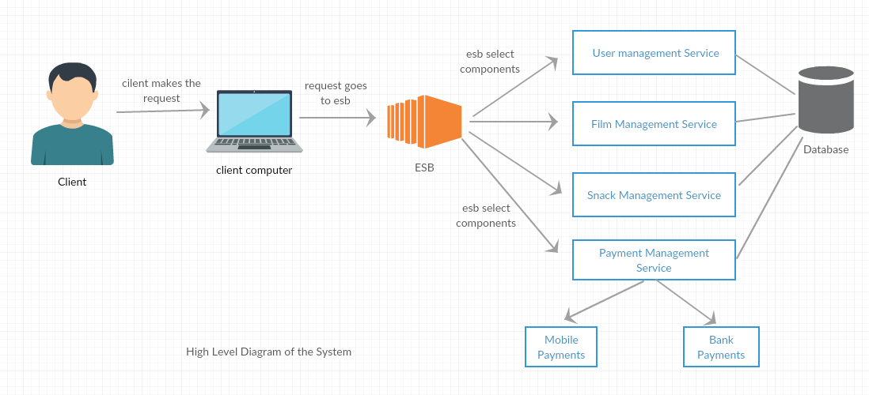

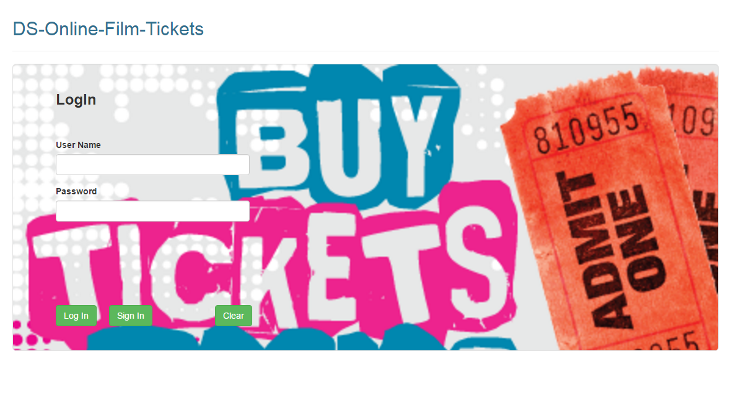**Login Page**

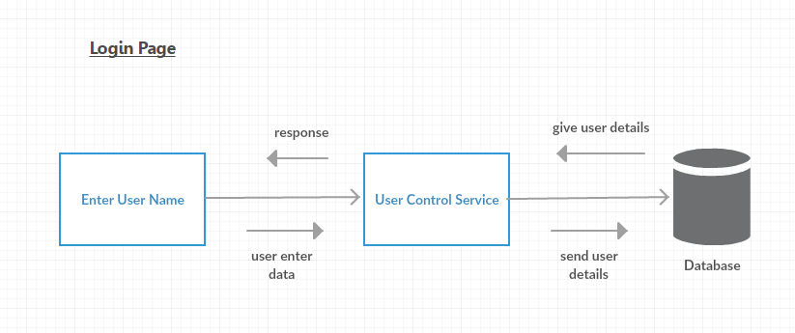

User enters the login details to the login page.

Once the user hit the login button the request will be sent to the database.

The request will be send to the database through User Control Service.

Once the database finished initializing the login details of the user it will send response notification to the login interface.

The login status of the user will be displayed to the user.

**User Registration Page**

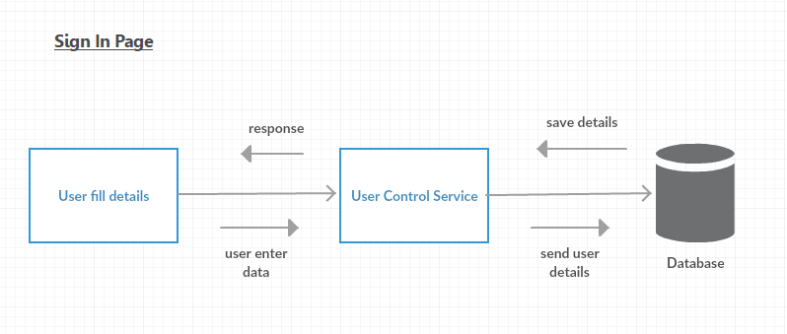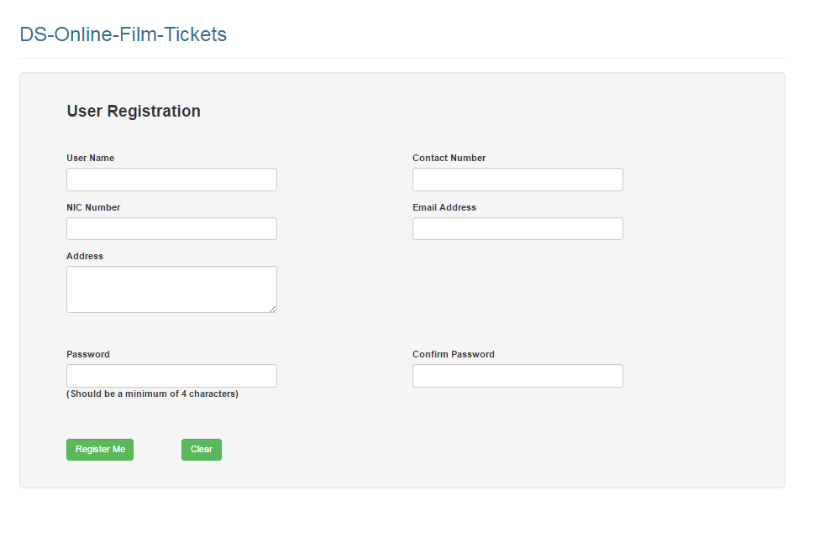

User enter the details and hit the register me button.

The data will be send to the database and save the data.

Once the data is saved a notification will be send to the Sign in interface.

The sign in status will be displayed to the user.

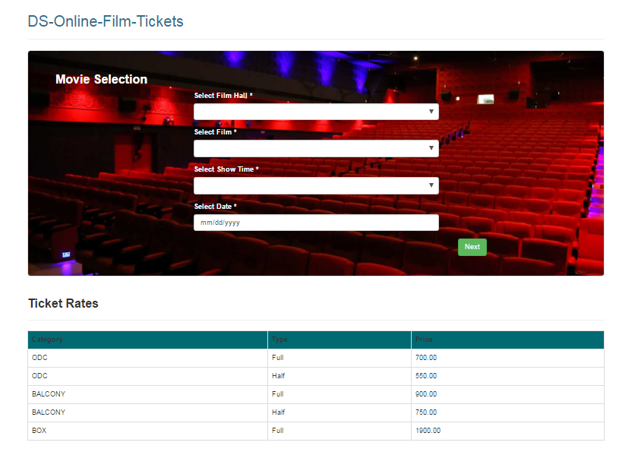**Movie and Snack Selection Page**

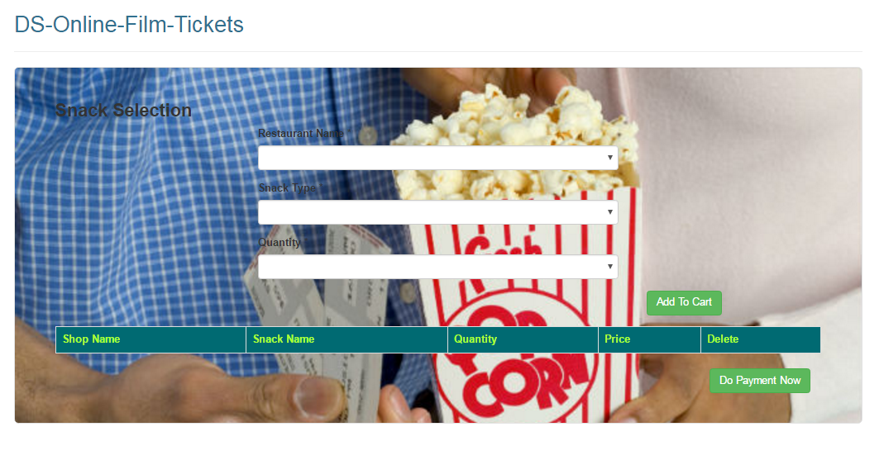

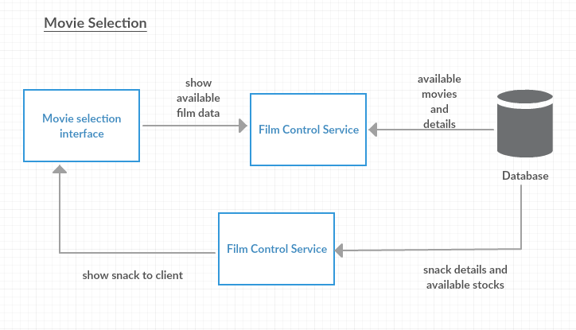

Movie selection page has two sections.

They are snack selection and movie selection.

Both sections will get data from the database and show the data to the user.

Once a registered user selects the snack and the film, the request will be send to the database and check the availability of the items that has been selected.

And the response will be send to the user interface and the user will get notified.

Once the purchasing is confirmed, the details will be stored temporarily in a cached memory and pass it to payment gateway.

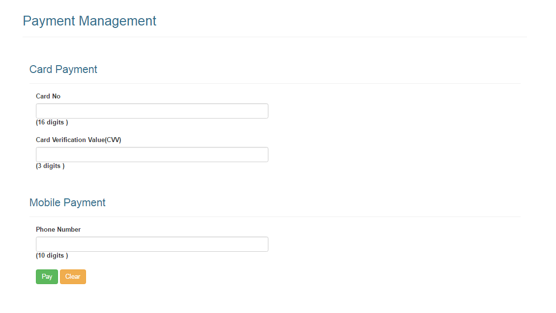**Payment Page**

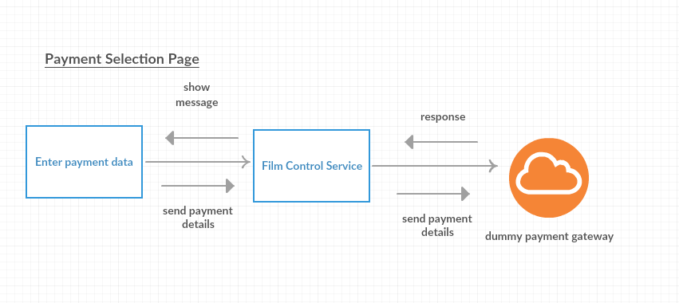

Once the user enters the payment details and confirmed the purchasing the items ordered, the details will be send to the payment gateway.

In this project, we have created a dummy interface for the Payment Gateway.

After the payment is done the status of the payment will be sent to the user immediately whether the payment is done successfully or unsuccessfully.

The user will be notified.