The Open University of Sri Lanka
Department of Electrical and Computer Engineering
Bachelor of Software Engineering Honors
EEX5362 – Performance Modelling
Academic Year - 2024/2025

Mini Project

OPD Patient Flow & Queue Management – Sri Lanka

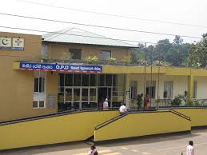

K.M.Lokuge
621429591
S92069591

Table of Content

1. Introduction 3
2. Performance Objectives 4
3. Modeling Techniques 4
4. Data Description 5
5. Detailed Analysis and Findings 7
6. Visualization 11
7. Limitations and Future Extensions 13
8. References 13

Introduction

The Outpatient Department (OPD) in Sri Lankan government hospitals is a major point of access to primary medical services. All patients in this department come without an appointment or pre-registration, especially in the morning and during peak hours when a large number of patients arrive at the same time
Since the number of doctors, support staff and consultation rooms providing the necessary medical services is limited, patients often have to wait for long periods. This situation increases patient dissatisfaction, and it seems that the efficiency of doctors and overall clinic productivity have decreased.
The OPD system can be described as a complex system that combines many frequency patterns, variable service durations and resource constraints (rooms, doctors). Therefore, there is a need to analyze performance metrics such as bottlenecks, waiting time, queue length, throughput and resource utilization.
By analyzing this system, actions can be identified to reduce waiting times, maximize physician utilization, identify queue bottlenecks, and increase clinic throughput. The aim of this project is to achieve greater efficiency, increase patient satisfaction, and provide high-level service delivery standards.

OPD System Performance (Key Points)
- Patient Arrival Rate
  - No appointments in government hospitals
  - Varies by time of day (peak hours in morning 8.50am -10.20am)
- Doctor Availability
  - Number of doctors available for consultation directly affects patient flow
  - Limited doctors → longer waiting times
- Service Time per Patient
  - Includes registration and consultation
  - Variable per patient depending on complexity of case

- Queuing System Modeling
  - Multiple doctors → M/M/c queue

- Performance Metrics to Measure
  - Average patient waiting time – time patients spend waiting before consultation
  - Queue length – number of patients waiting at any given time
  - Doctor utilization – percentage of time doctors are actively consulting

- Analysis & Optimization
  - Identify bottlenecks in patient flow
  - Test interventions:
    - Adding more doctors
    - Increasing registration counters
  - Optimize overall patient throughput and clinic productivity

Performance Objectives

- Minimizing Patient Waiting Time :-
  - The long waiting time can overload the patient count. Minimizing patient waiting time can mitigate delays. The time every patient spends waiting before being seen by the doctor should be minimized to improve satisfaction and service quality.

- Maximizing Doctor Utilization :-
  - The hospital system can increase the doctor count to mitigate patient overloading. Ensure that available doctors are engaged throughout the clinic hours, without too much work overload or idle time.

- Controlling Queue Length :-
  - Keep the number of patients in the waiting area manageable by keeping arrival and service rates balanced.

- Increasing Patient Throughput :-
  - Improve the total number of patients who can be served effectively in any one session without compromising the quality of service.

- Identifying Performance Bottlenecks :-
  - Identify points of delay: such as registration counters, consultation time variation, availability of doctors.

- Optimizing Resource Allocation :-
  - Determine how changing the number of doctors, staff, or registration counters would impact system performance with the objective of best utilizing the hospital resources.

Modeling Techniques

To analyze this OPD Queue system I use two modeling techniques.
- M/M/1 queue model: Used to represent scenarios where a single doctor is available for consultation (in some days, there is an one doctor in a room).
- M/M/c queue model: Used to analyze scenarios involving multiple doctors working in parallel. Hence of this model, service times are distributed among few doctors. (like 3 doctors)

Justification:
- OPD follows the First-Come, First-Served (FCFS) system
- This dataset shows random arrivals and service times according to the peek time.
- Patients arrivals are unplanned and random
- Less doctor count ( When I went, there were 3 doctors in that room. Some days it was even less.)

Assumptions:
- Patient arrivals average rate (λ)
- Consultation times mean service rate (μ)
- Queue capacity is assumed to be infinite
- All patients wait until called their numbers by number color (red numbers, yellow numbers, pink numbers, blue numbers, orange numbers like that)
- Doctors serve patients independently and at equal service rates
- The system is assumed to be stable (λ < cμ)
(c = Number of servers in the system (doctor count) )

Data Description

The dataset used in this analysis, OPD_Data.xlsx (collected 25 patient datas), consists of simulated arrival and service times of patients who visited the OPD during a 90-minute peak session at a Sri Lankan government hospital. Each record contains the arrival time for a single patient and the time taken for his or her consultation. In this data, two important parameters can be estimated: the mean arrival rate and the mean service rate used in the queuing model to calculate key performance measures such as average waiting time, queue length, and doctor utilization. By using this data, the system's behavior for various conditions say, adding doctors or reducing service time-can be assessed for any bottlenecks and thereby enhance the efficiency of the flow of patients.

Venue: District General Hospital – Matale

Morning session (08:50–10:20)
- 25 patient records
- High-frequency arrivals (peek load)
- Arrival times and service durations recorded in minutes from session start

Afternoon session (14:00–15:30)
- 10 patient records
- Lower arrival frequency (non peek)

Each dataset contains the following fields:
- Patient_ID: Unique identifier for each patient
- Arrival_Time: Time at which the patient arrives at the OPD
- Service_Time: Duration of consultation with the doctor

Required things for Queue Model & Simulation:
- arrival rate (λ)
- service rate – consultation time (μ)

Methodology:
- System Mapping
  - Patients are considered customers, and doctors are treated as servers.
  - The system operates a First-Come, First-Served (FCFS) system.

Queuing Model Selection:
- The M/M/c queue is applied to model the three doctors in the OPD room. Because there are 3 doctors in that OPD room.

Simulation Implementation:
- SimPy is used to implement the patient flow in OPD
- Each patient arrives according to the dataset schedule and waits if all doctors are busy (3 doctors in a room)
- Metrics recorded include main topics according waiting time, service start time and departure time
- Simulations are run for different numbers of doctors (3 (current in a room) , 4, 5) to recognize the system flow.

Performance Metrics Calculation:
- Average waiting time
- Maximum waiting time
- Minimum waiting time

The starting time of the morning OPD standard is 8.00 am-12 noon
The starting time of the afternoon OPD standard is 2.00 pm-4.00 pm
 | District General Hospital - Matale
 | Morning | Afternoon
Mean waiting time | 46 min | 27 min

Morning session peek time (08:50–10:20 snapshot of 90 minutes)
Patient_ID | Arrival_Time_Min | Service_Time_Min
M001 | 0 | 10
M002 | 2 | 9
M003 | 3 | 11
M004 | 5 | 8
M005 | 6 | 12
M006 | 8 | 10
M007 | 10 | 9
M008 | 12 | 11
M009 | 14 | 10
M010 | 16 | 8
M011 | 19 | 12
M012 | 22 | 9
M013 | 25 | 11
M014 | 28 | 10
M015 | 31 | 12
M016 | 35 | 9
M017 | 40 | 11
M018 | 45 | 10
M019 | 50 | 12
M020 | 56 | 9
M021 | 62 | 11
M022 | 69 | 10
M023 | 76 | 12
M024 | 84 | 9
M025 | 92 | 11

Afternoon session (14:00–15:30 snapshot of 90 minutes)
Patient_ID | Arrival_Time_Min | Service_Time_Min
A001 | 0 | 9
A002 | 6 | 8
A003 | 12 | 7
A004 | 20 | 9
A005 | 28 | 8
A006 | 36 | 7
A007 | 45 | 9
A008 | 55 | 8
A009 | 65 | 7
A010 | 76 | 8

Detailed Analysis and Findings

Morning_dataset Analysis:
- Patient_ID – Unique identifier for each patient.
- Arrival – Patient arrival time in minutes from session start.
- Service – Duration of service required by the patient in minutes.

Patient Process Analysis:
- Waits until arrival time their time
- Requests a doctor from the available room
- Records service start time, waiting time, and departure time (for my report)
- Waits for the service duration to complete

Doctor Resource Analysis:
- 3 doctors in a room
- Increase doctors 4 to 5

Throughput Analysis:
- Total throughput consists of 25 patient records
- We can give faster service by increasing performance

Queue Formation:
- The primary bottleneck is limitation of doctors’ availability
- Queues occur when several patients arrive in a short period of time
- To reduce queue times and waiting times, can increase the count of doctors

Key Findings:
- Doctor count is mainly affected to the queue
- Resource bottlenecks occur during peak arrival time

Simulation Analysis:
- Morning session Patient table: Arrival, service start, wait, service, and departure times
- Performance summary: Number of patients served, Average waiting time, Maximum waiting time and Minimum waiting time

Output:
Show the table patient service events

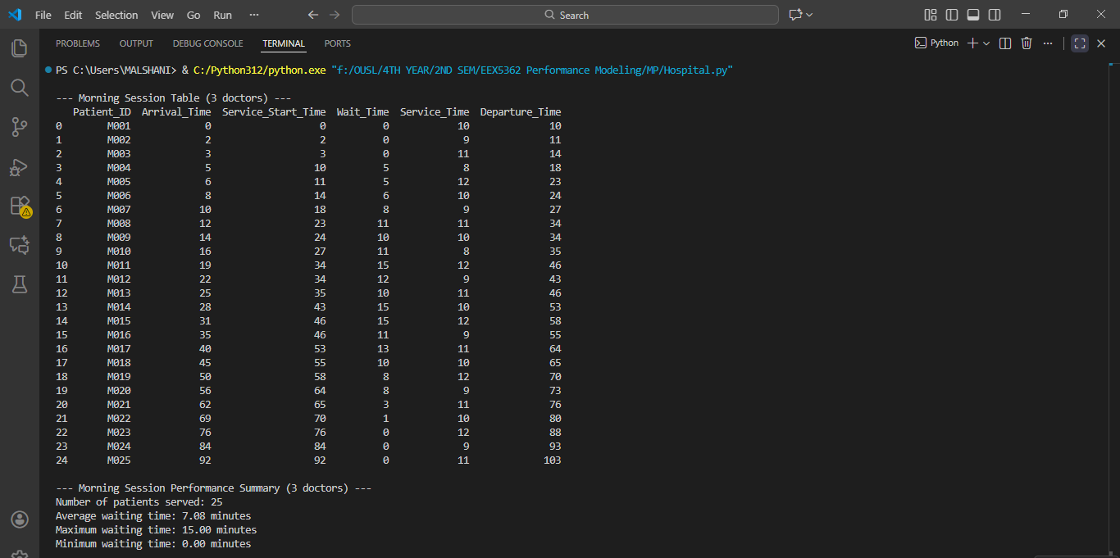
Figure 1: doctor count 3

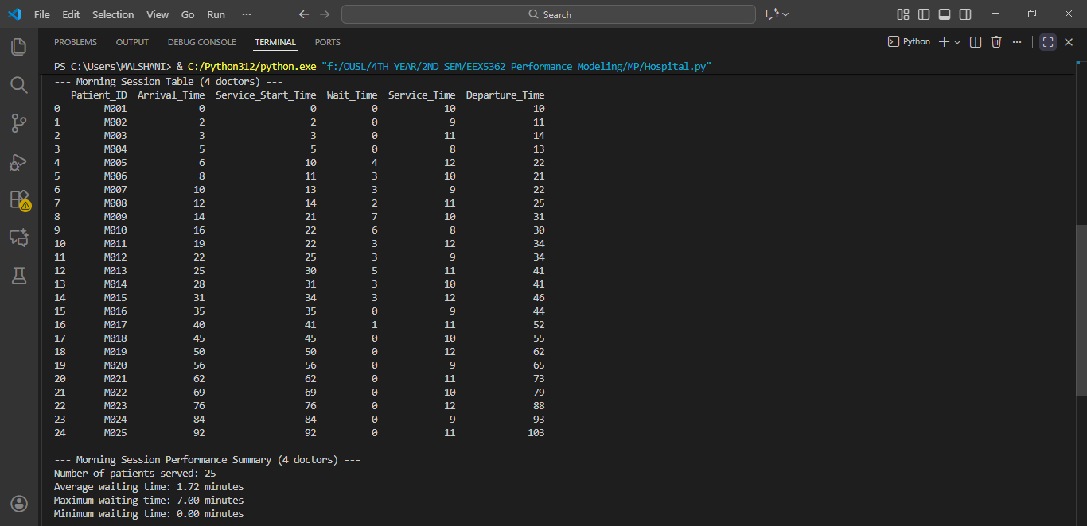
Figure 2: Doctor count increased as 4

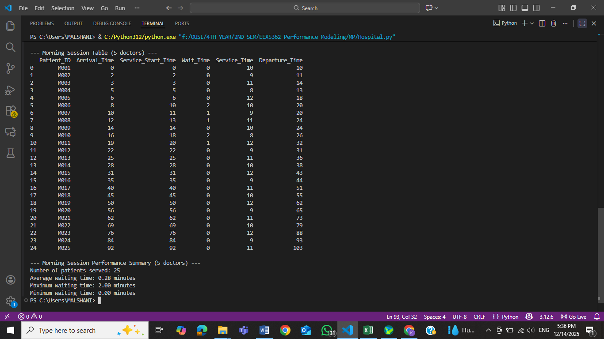
Figure 3: Doctor count increased as 5

Code:
import simpy
import pandas as pd

# Morning session dataset based on Matale General Hospital

morning_data = [
{"Patient_ID": "M001", "Arrival": 0, "Service": 10},
{"Patient_ID": "M002", "Arrival": 2, "Service": 9},
{"Patient_ID": "M003", "Arrival": 3, "Service": 11},
{"Patient_ID": "M004", "Arrival": 5, "Service": 8},
{"Patient_ID": "M005", "Arrival": 6, "Service": 12},
{"Patient_ID": "M006", "Arrival": 8, "Service": 10},
{"Patient_ID": "M007", "Arrival": 10, "Service": 9},
{"Patient_ID": "M008", "Arrival": 12, "Service": 11},
{"Patient_ID": "M009", "Arrival": 14, "Service": 10},
{"Patient_ID": "M010", "Arrival": 16, "Service": 8},
{"Patient_ID": "M011", "Arrival": 19, "Service": 12},
{"Patient_ID": "M012", "Arrival": 22, "Service": 9},
{"Patient_ID": "M013", "Arrival": 25, "Service": 11},
{"Patient_ID": "M014", "Arrival": 28, "Service": 10},
{"Patient_ID": "M015", "Arrival": 31, "Service": 12},
{"Patient_ID": "M016", "Arrival": 35, "Service": 9},
{"Patient_ID": "M017", "Arrival": 40, "Service": 11},
{"Patient_ID": "M018", "Arrival": 45, "Service": 10},
{"Patient_ID": "M019", "Arrival": 50, "Service": 12},
{"Patient_ID": "M020", "Arrival": 56, "Service": 9},
{"Patient_ID": "M021", "Arrival": 62, "Service": 11},
{"Patient_ID": "M022", "Arrival": 69, "Service": 10},
{"Patient_ID": "M023", "Arrival": 76, "Service": 12},
{"Patient_ID": "M024", "Arrival": 84, "Service": 9},
{"Patient_ID": "M025", "Arrival": 92, "Service": 11},
]

# Patient waiting process

def patient_process(env, patient, doctors, records):
arrival = patient["Arrival"]
service_time = patient["Service"]

# Wait until patient arrives
yield env.timeout(arrival - env.now)

with doctors.request() as request:
yield request
start_time = env.now
wait_time = start_time - arrival
yield env.timeout(service_time)
departure = env.now

records.append({
"Patient_ID": patient["Patient_ID"],
"Arrival_Time": arrival,
"Service_Start_Time": round(start_time, 2),
"Wait_Time": round(wait_time, 2),
"Service_Time": service_time,
"Departure_Time": round(departure, 2)
})

# Run simulation with flexible doctor count

# current doctor count in an OPD room is 3

def run_morning_session(patient_data, num_doctors=3):
env = simpy.Environment()
doctors = simpy.Resource(env, capacity=num_doctors)
records = []

for patient in patient_data:
env.process(patient_process(env, patient, doctors, records))

env.run()

df = pd.DataFrame(records).sort_values("Arrival_Time").reset_index(drop=True)
print(f"\n--- Morning Session Table ({num_doctors} doctors) ---")
print(df)

print(f"\n--- Morning Session Performance Summary ({num_doctors} doctors) ---")
print(f"Number of patients served: {len(df)}")
print(f"Average waiting time: {df['Wait_Time'].mean():.2f} minutes")
print(f"Maximum waiting time: {df['Wait_Time'].max():.2f} minutes")
print(f"Minimum waiting time: {df['Wait_Time'].min():.2f} minutes")

# Example usage: change number of doctors here

# increase doctor count to 4 and 5

for doctors_count in [3, 4, 5]:
run_morning_session(morning_data, num_doctors=doctors_count)

Visualization

Graph 1: Average waiting time & maximum waiting time

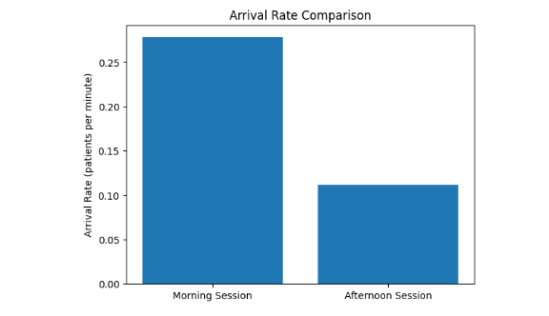
Graph 2: Average rate comparison

Graph 3: Morning session peek time (08:50–10:20 snapshot of 90 minutes)

Limitations and Future Extensions

Limitations:
- No emergency prioritization
- All patients came only morning time
- No take account the complexity of the patient

Future Extentions:
- Increase the OPD operation time
- Increase the doctor count
- Increase the OPD room count

References

- P. A. D. Dilrukshi, H. D. I. M. Nirmanamali, G. H. J. Lanel, and M. A. S. C. Samarakoon, “A Strategy to Reduce the Waiting Time at the Outpatient Department of the National Hospital in Sri Lanka,” International Journal of Scientific and Research Publications (IJSRP) , vol. 6, no. 2, Feb. 2016. [Online]. Available: https://www.ijsrp.org/research-paper-0216/ijsrp-p5044.pdf

- D. B. A. S. Jayawardena, “Patients waiting time at Out Patient’s Department at the National Hospital Sri Lanka,” Journal of Community Medicine & Public Health*, vol. 1, p. 113, Nov. 2017. [Online]. (Accessed: Dec. 14, 2025) Available:
https://www.gavinpublishers.com/article/view/patients-waiting-time-at-out-patients-department-at-the-national-hospital-sriLanka

