@WeRateDogs – INSIGHTS

Contents

Twitter Posting Trend 2

Dog’s Rating Insights 2

Tweet Source 3

Udacity – Dog Image Prediction Conflicts 4

TOP 3 Favorite DOG Stages 4

FINALLY Some WORD CLOUD FUN 4

# Twitter Posting Trend

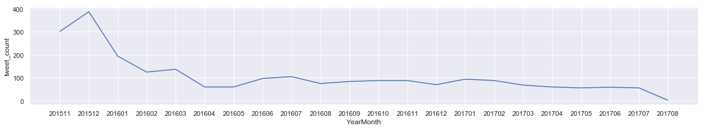

Looking at the above chart (which shows tweet count by month), @WeRateDogs have been posting about 200-400 tweets in first 3 months. After that, the account tweeting activities have been reduced significantly. After April 2016, the account has less than 100 tweets per month.

# Dog’s Rating Insights

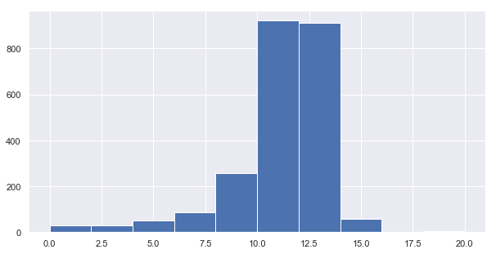

|  |  |
| --- | --- |
| **Rating Value** | **Count** |
| 12 | 560 |
| 11 | 467 |
| 10 | 454 |
| 13 | 352 |
| 9 | 158 |
| 8 | 101 |
| 14 | 56 |
| 7 | 54 |
| 5 | 35 |
| 6 | 32 |
| 0 | 23 |
| 3 | 19 |
| 4 | 15 |
| 2 | 11 |
| 1 | 8 |
| 20 | 5 |
| 15 | 2 |
| 17 | 1 |

Of all 2356 Tweets, 80% tweets have been rated greater than or equal to 10.0. This shows rating folks really like dogs 😊.

# Tweet Source

From the below graph, we can see that, more than 95% of the tweets originated from iPhone device compared to tweets from ‘Tweet Deck’, ‘Vine’, ‘Twitter Web Client’. Looks like all dog lovers loves Apple Devices.

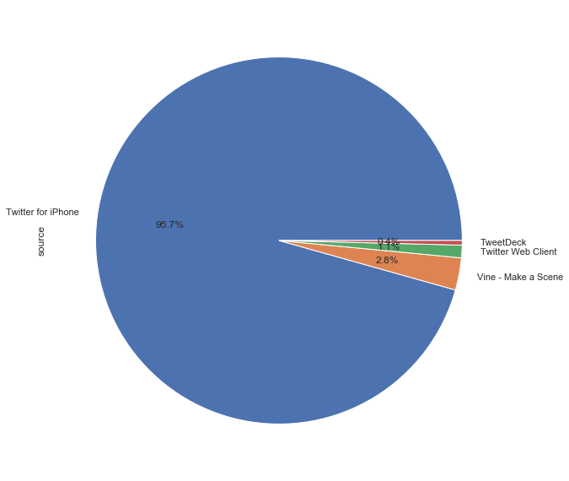

# Udacity – Dog Image Prediction Conflicts

From the Image prediction results provided, we have given whether a prediction is a dog or not for top 3 predictions. Here we identified about 75% of the predictions have predictions of either dog or some other animal/object. About 25% of have conflicts, some predictions says it’s a dog and some says its not a dog.

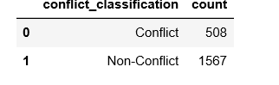

# TOP 3 Favorite DOG Stages

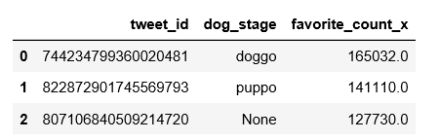

Doggo – Is the favorite dog stage, as it has the maximum favorite count (> 165K). Runner up is ‘puppo’.

# FINALLY Some WORD CLOUD FUN

