Kaung Myat Soe

Web Developer

Able to develop Web Application from ground up: requirement gathering, planning, design and development, testing, deployment to maintenance.

: kaungmyatsoe.m192@gmail.com : kaung-myat-soe

: 09 - 771981407 : https://github.com/KMSoe

: Tamwe Township, Yangon






Objective

Seeking an opportunity to extend my skills and willing to get more experience in the industry

Passionate in Software Development

Education

Computer Engineering & Information Technology at Mandalay Technological University

Programming Basic at Code 2 Training in 2017

Stock Manager App

CS50: Introduction to Computer Science ( Harvard University Online Course ) in 2020

Problem Solving (with many problem sets)

E-commerce Website Home Page

Finance App (Web)

Skills

HTML5, CSS3, JavaScript ( ES6 & modern features ), Bootstrap( 4, 5 )

Linux (Ubuntu, Mint) & Git , Github, Database Design with MySQL

PHP, OOP, MVC with pure PHP, Understanding SOLID and Essential Design patterns

Laravel, RESTFUL API design, Vue, Vuex, React, Redux

Familiar with Laravel mix, Data Table, PHPUnit, laravel-debugbar, Laravel Dusk, Developers tools, Webpack, Nodejs, Mongodb, jQuery, Axios, Domain & Hosting.

Personal Projects

Budget app design with HTML, CSS, Bootstrap ( https://butget.netlify.app/ )

Todo with Laravel and vanilla JavaScript ajax ( https://github.com/KMSoe/todo.git )

Finance ( Budget Tracker ) app

With pure PHP, OOP, MVC Architecture, MySQL using Singleton, Facade Design patterns ( https://github.com/KMSoe/Budget-app-MVC-with-Pure-PHP-.git )

With Laravel ( https://github.com/KMSoe/Budget-App-with-laravel.git )

API design using laravel passport( https://github.com/KMSoe/budget-app-server-api.git )

Client Side App with Vue, Vuex ( https://github.com/KMSoe/budget-app-client.git )

My Media app with Laravel + Vue

POS app with Laravel, adminLTE, react (processing…)

Team Experience

Store app with nodejs

My role is adding categories feature to the project.

( https://github.com/SaiPha454/POS.git )

Blog app with Laravel + react, redux

Laravel backend is done by me. ( https://github.com/KMSoe/blog.git )

React frontend is implemented with a junior. Processing … ( https://github.com/KMSoe/simple-social-app.git )

Language

English ( Intermediate )

Certification

CS50: Introduction to Computer Science
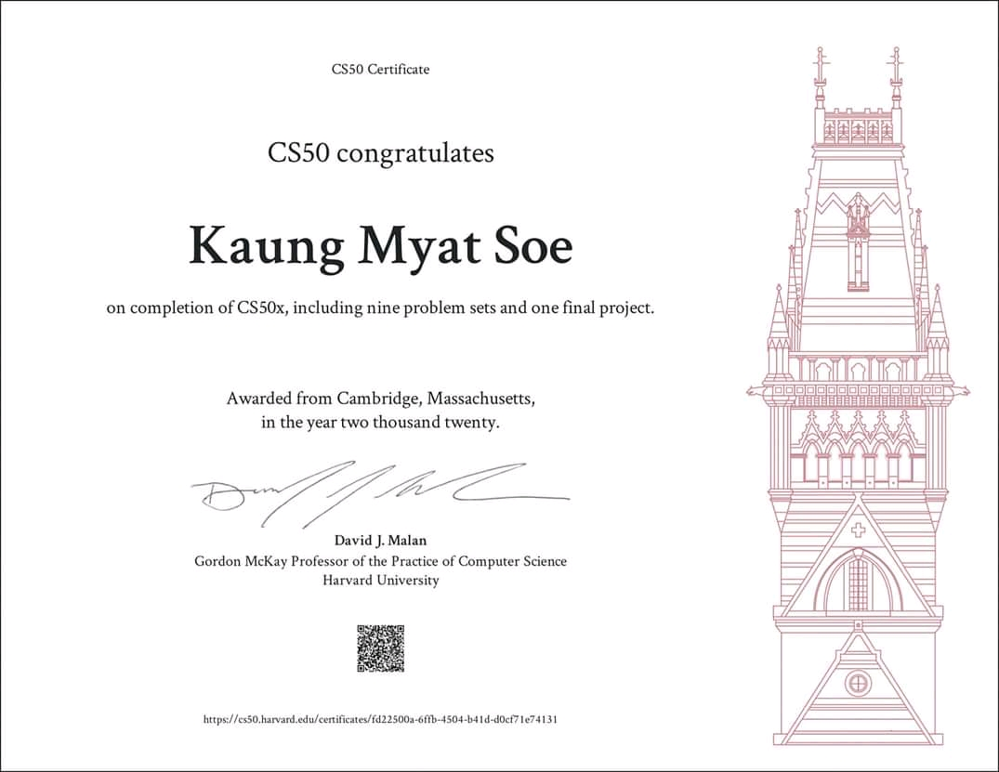

Personal Information

Name : Mg Kaung Myat Soe

Father’s Name : U Tin Aung Win

NRC No. : ၅/စကန(နိုင်) ၂၉၇၈၀၃

Date of Birth : 08 - 11 – 1999

Gender : Male

Nationality : Myanmar

Religion : Buddhism

Marital Status : Single

Address : Thin Ga Ha Street, Kyauk Myaung Ward, Tamwe

Township, Yangon

