* Remove Footer section

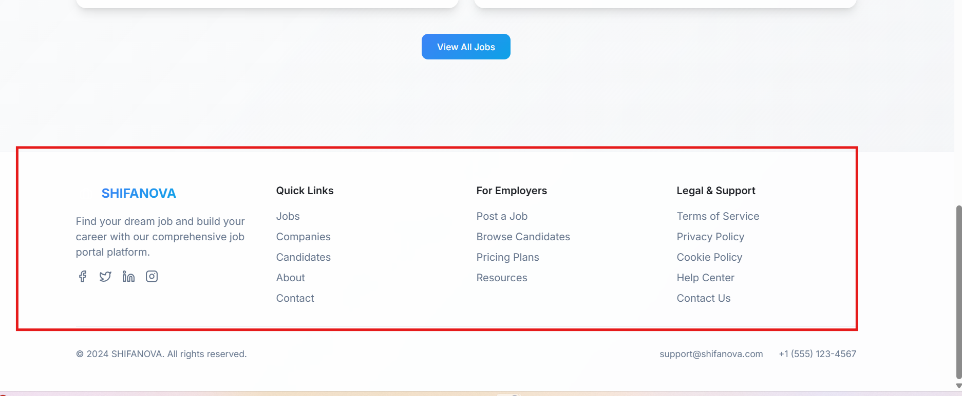

* Just copyright is okay
* Remove save button

