**Lab 05 – ML**

**IT20088514**

**Activity**

1. **Adult Census Income Binary Classification Dataset**
3. **age**

**education-num**

**occupation**

**work-class**

**hours-per-week**

**native-country**

1. **work-class**

**occupation**

**native-country**

**Drop row technique.**

1. **work-class**

**occupation**

**native-country**

1. **age**

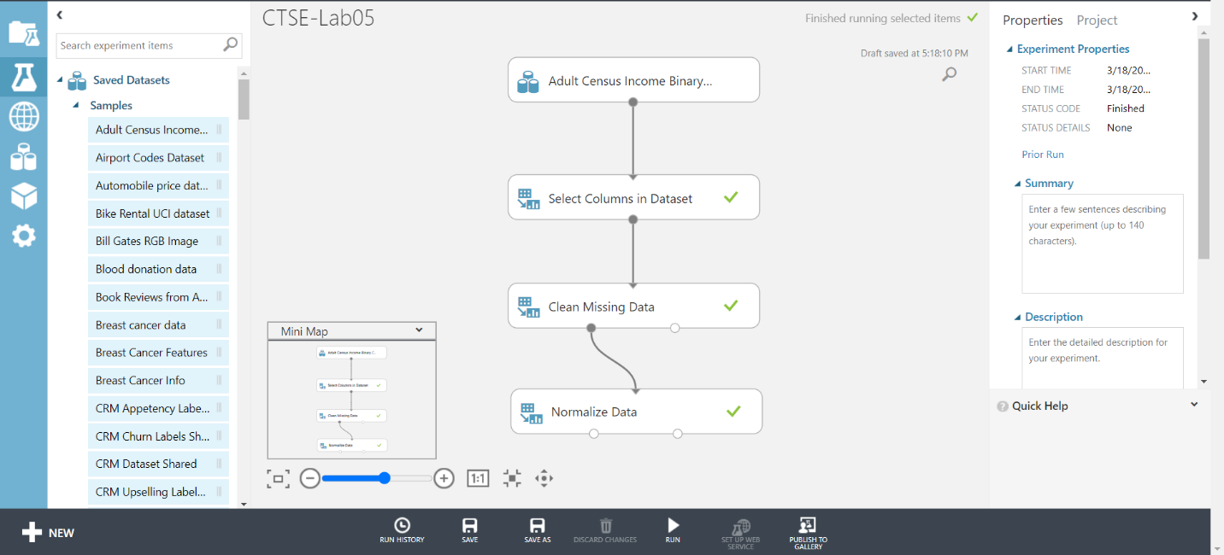**hours-per-week**

