**Multiple Year Stock Data Analysis**

This program utilizes VBA programming script within Excel to loop through multiple years of stock data within the worksheet and return the following information for analysis:

* Per ticker, per year
  + Yearly change from opening price at the beginning of the year to the closing price at the end of the year
  + The percent change for the same period
  + The total volume of the stock
  + Conditional formatting highlights positive percent change in green and negative percent change in red
* Summary data, per ticker per year
  + Greatest percent increase
  + Greatest percent decrease
  + Greatest total volume

2016 Stock Analysis Results Preview

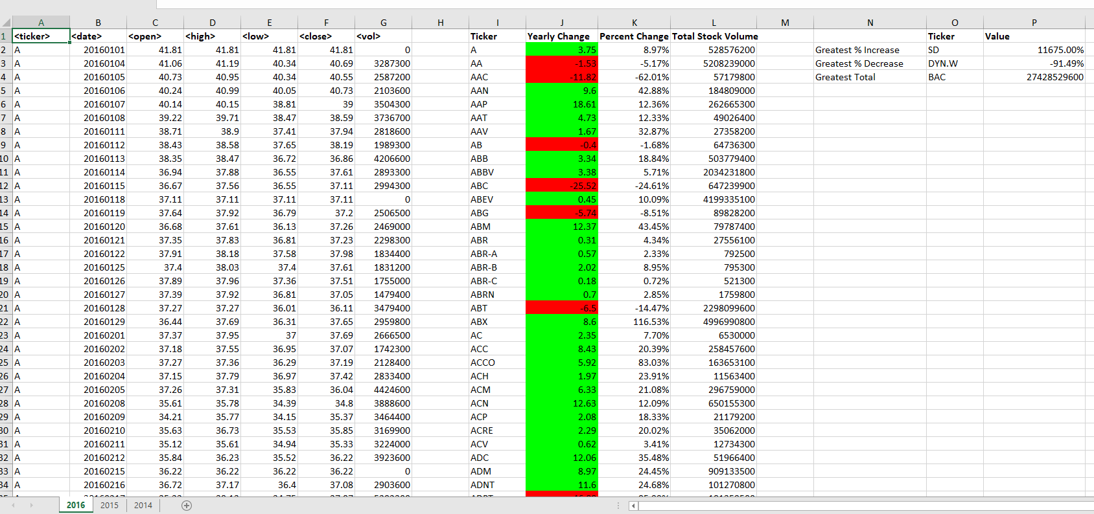

2015 Stock Analysis Results Preview

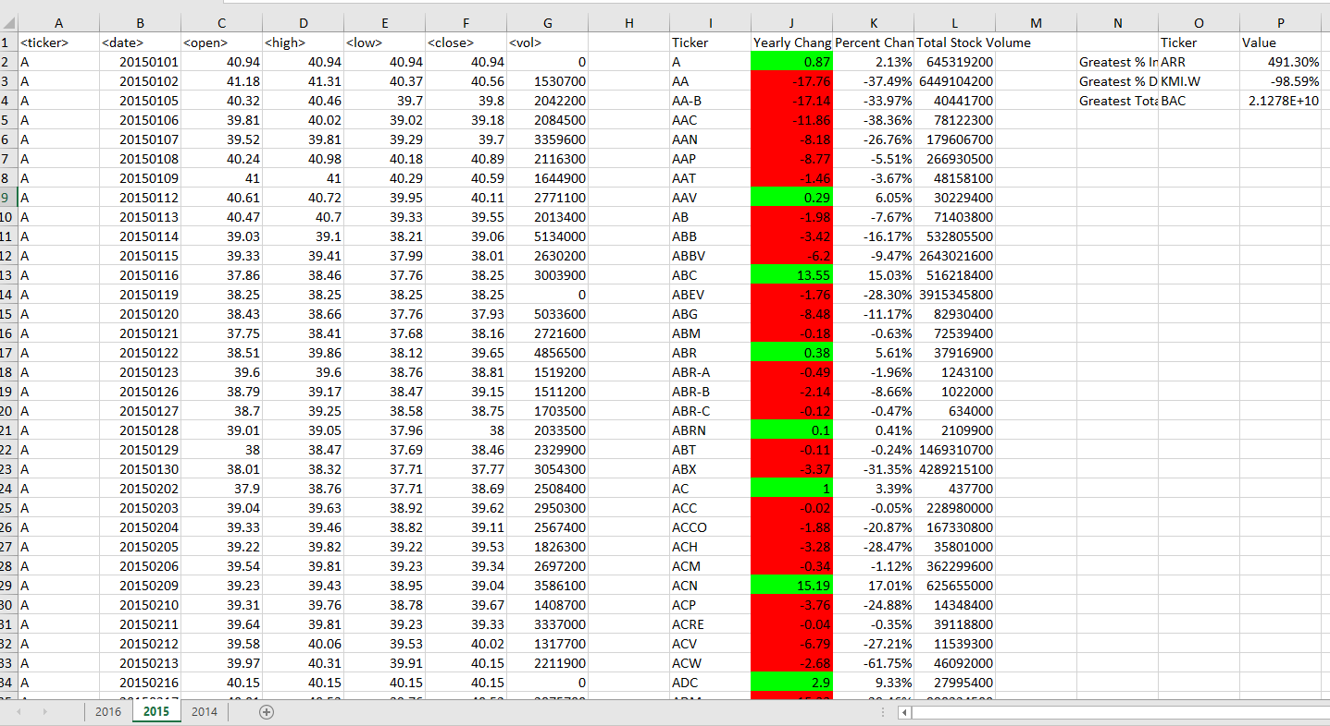

2014 Stock Analysis Results Preview

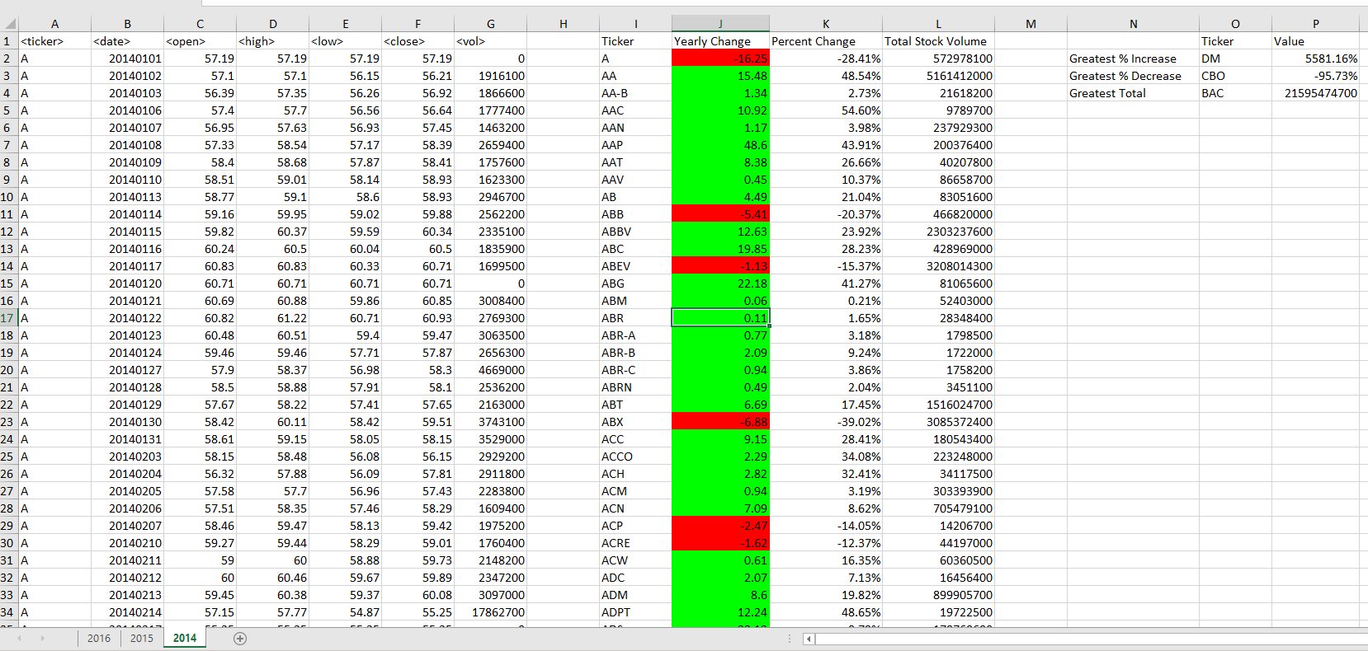

Files:

[Test Data](Resources/alphabetical_testing.xlsx)

[Stock Data](Resources/Multiple_year_stock_data.xlsx)