1.Feladat
A.Feladat
SELECT nev, osztaly, SUM(mennyiseg) / 100 AS Kg
FROM tanulok INNER JOIN leadasok ON tazon = tanulo
GROUP BY nev
ORDER BY Kg DESC
LIMIT 3;

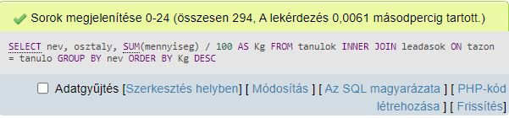

B.Feladat

SELECT nev, COUNT(tanulo) AS "Leadások száma"
FROM tanulok INNER JOIN leadasok ON tazon = tanulo
GROUP BY nev
HAVING COUNT(tanulo) >= '6'
ORDER BY COUNT(tanulo) DESC;

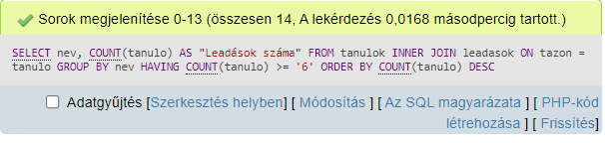

C.Feladat
SELECT nev
FROM tanulok
ORDER BY nev;

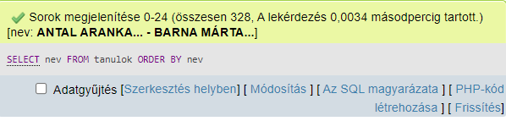

D.Feladat

SELECT osztaly, SUM(mennyiseg) AS Eredmény
FROM tanulok INNER JOIN leadasok ON tazon = tanulo
GROUP BY osztaly
HAVIG SUM(mennyiseg) >= 120000
ORDER BY Eredmény DESC;

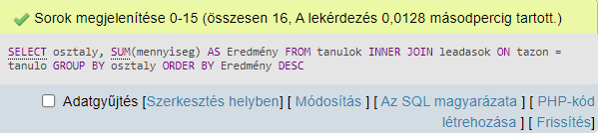

E.Feladat

SELECT idopont, SUM(mennyiseg) / 10000 AS Eredmény
FROM leadasok
GROUP BY idopont
ORDER BY Eredmény DESC
LIMIT 5;
