Results Experiment 5

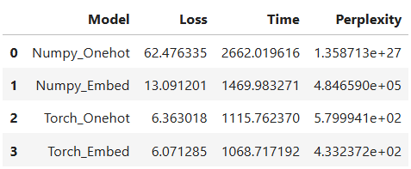
In text generation using RNNs, words must be converted into numerical form before being processed by the model.
One-hot encoding represents each word as a vector whose length equals the size of the vocabulary, with a single “1” and the rest zeros. This method is simple and easy to implement, but it produces very high-dimensional and sparse vectors. Because it does not capture any semantic relationship between words, the RNN must learn all similarities from scratch, which increases the number of parameters and training time, especially for large vocabularies.
Word embeddings, on the other hand, represent words as dense, low-dimensional vectors that capture semantic meaning. Methods such as Word2Vec and GloVe learn word representations where similar words have similar vectors. This makes training more efficient and helps the RNN generate more coherent and contextually meaningful text. However, embeddings require additional training or pretrained models, may suffer from out-of-vocabulary issues, and can inherit biases from the training data. Overall, embeddings are generally preferred over one-hot encoding in modern text generation systems.

