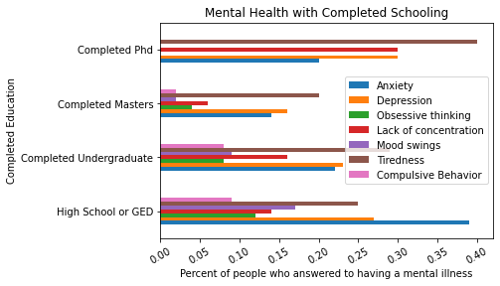

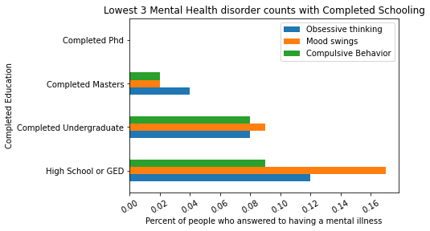

**Survey results of employment status**

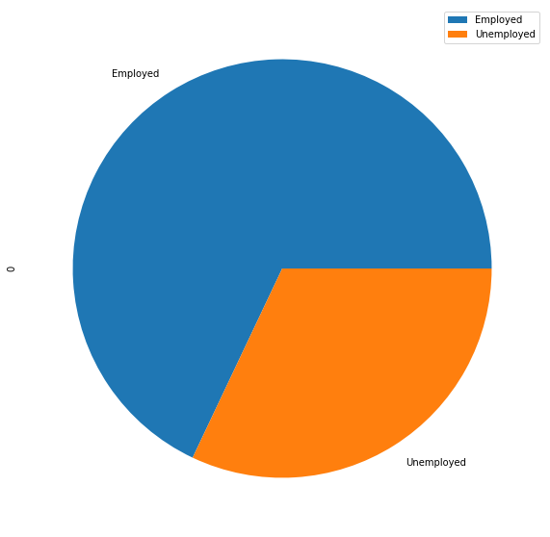

**Survey results of the mental health illnesses accounted for that were Employed**



