

**Web Development:**

**Advanced Web Scripting Concepts**

**HL9W 35**

**Assessment**

**LO 2,3**

|  |  |  |  |  |  |  |  |  |
| --- | --- | --- | --- | --- | --- | --- | --- | --- |
| **Student** | |  | Kamil Milej | |  | | | |
| **I.D.** | |  | 2264629 | |  | | | |
| **Date** | |  | 16/05/2025 | |  | | | |
|  | **Pass** | |  | **Fail** |  | **Remediation** |  |  |
| **Tutor** | |  |  | |  | | | |

© Fife College

These materials may not be reproduced without the copyright holder’s permission.

***Design Document***

1. Site Structure Diagram

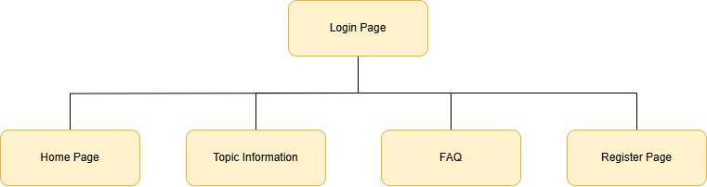  
  
This diagram shows the structure of my website, which includes the following:

* The login page is the first page the user sees.
* From the login page, the only available action is to navigate to the registration page.
* After logging in, the navigation bar displays the remaining page options along with a Logout button.

1. Wireframe design for each screen

