WigglyPaint by Umm..
Karitt Thanawan 6730057621
Kaokanya Kokirdpanich 6730051821
1. Overview

WigglePaint is a JavaFX-based pixel-art drawing application designed around two main ideas: Ultra-simple retro painting workflow using pixel brushes, marker pens, highlighters, spray tools, and erasers. A unique “wiggle effect” rendering system that animates drawings by alternating between two visual states, giving the entire canvas a hand-drawn, shaky aesthetic (similar to old cartoons or wiggly-line animations).
The app uses a layered canvas architecture, custom brushes built on a Paintable interface, a CanvasData pixel array for crisp pixel-level drawing, and a dynamic theme system that recolors brush icons and UI elements.

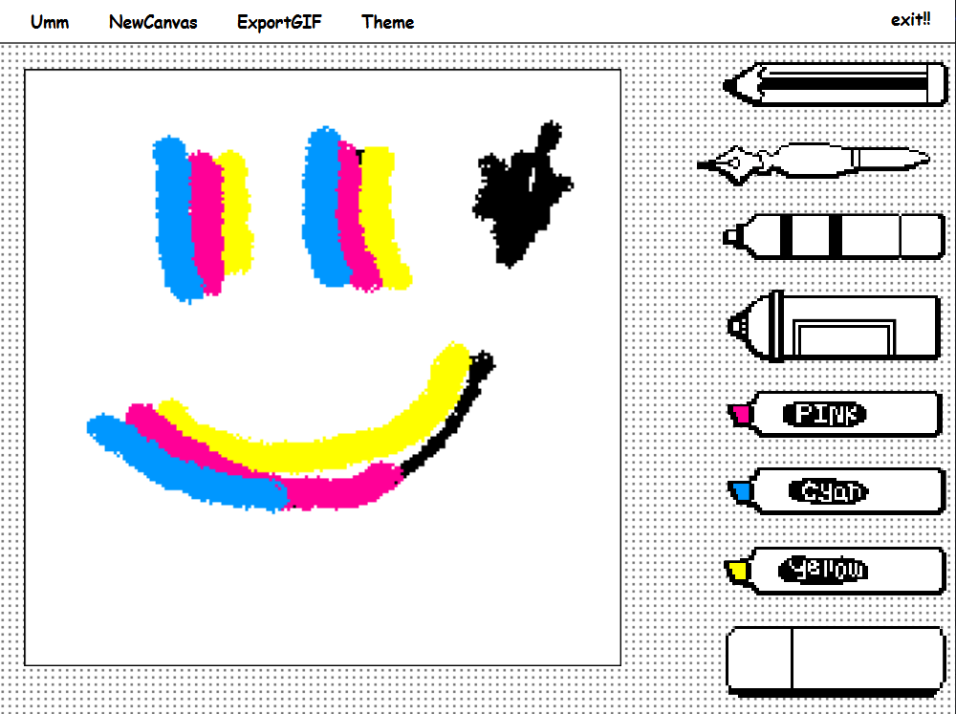

2. Features
2.1 Drawing Tools
- Pencil Brush — Hard pixel brush with 1px size.
- Marker Pen — Adds jitter and soft edges to emulate a marker stroke.
- Fountain Brush — Pressure-like effect using speed scaling.
- Highlighters — Colorful strokes in 3 main colors; pink, cyan, and yellow.
- Spray Brush — Particle-style dot spraying within a radius.
- Eraser — Removes pixels from any layer.
2.2 GIF Exporting
WigglePaint includes a built-in Export to GIF feature that transforms the app’s signature wiggle animation into a lightweight animated GIF. The app internally maintains two drawing frames (Frame A and Frame B) that alternate to create the hand-drawn wiggly effect.
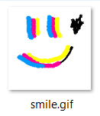
2.3 Theme System
WigglePaint allows the entire application—UI, background, and brush icons—to adapt instantly to different visual styles using a unified color palette. Each theme defines five colors: Foreground, Background, Primary, Secondary, and Accent. Instead of storing multiple icon sets, WigglePaint uses a smart recoloring engine (ImageThemeRender) that maps specific source colors in each PNG icon to the active theme colors, ensuring all tools match the selected palette while preserving clean pixel edges. When a theme is changed, the UI refreshes immediately: the menu bar, dot-pattern background, canvas grid, and icons all update together to create a coherent, consistent aesthetic. This system makes it easy to support classic, paste, etc.

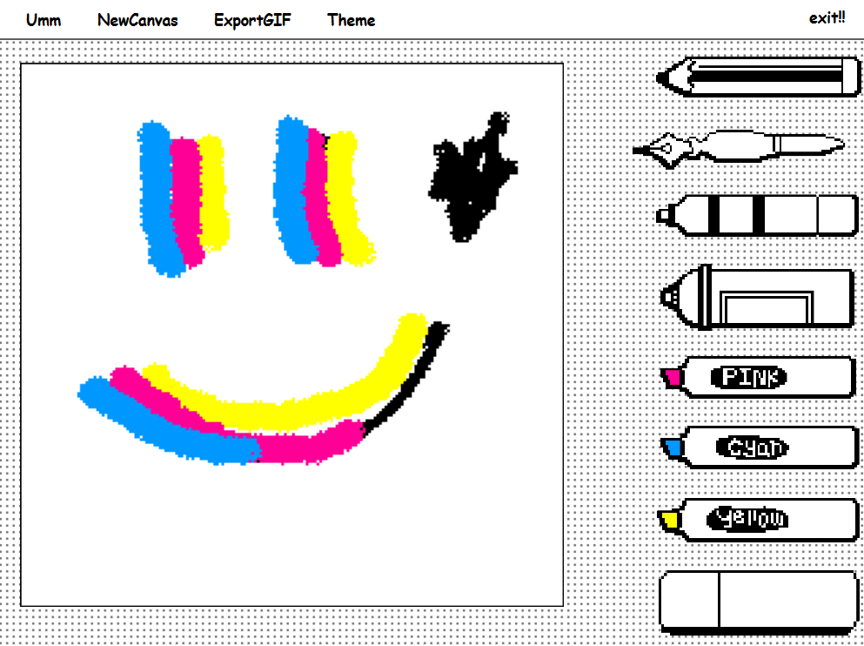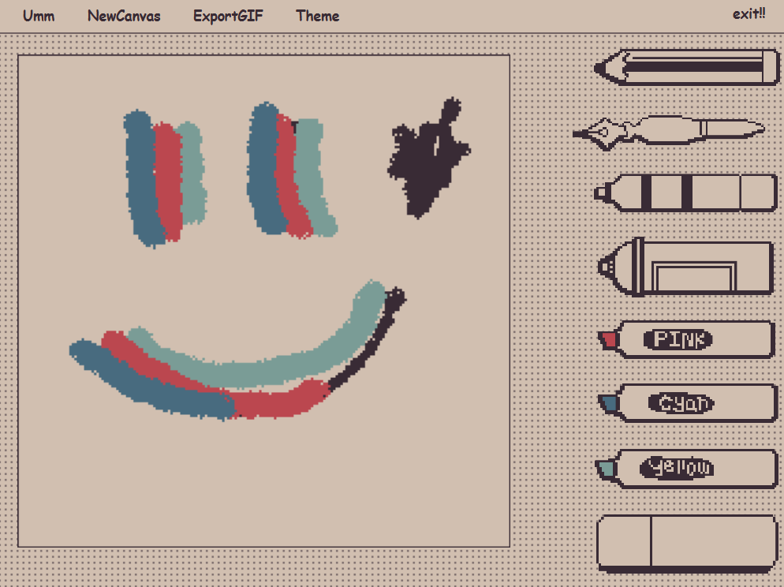
Theme: classic Theme: pastel

JavaDoc: https://perkiepai.github.io/project-cp-2025-1-umm-docs/

3. Project Structure

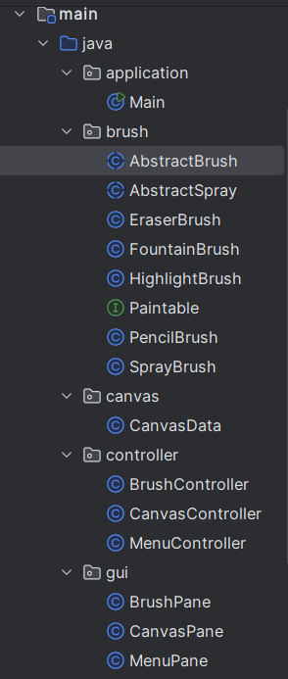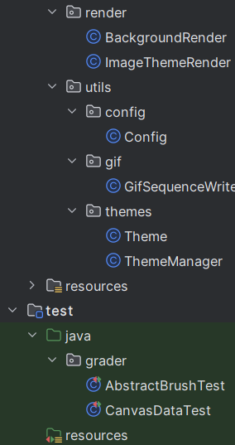

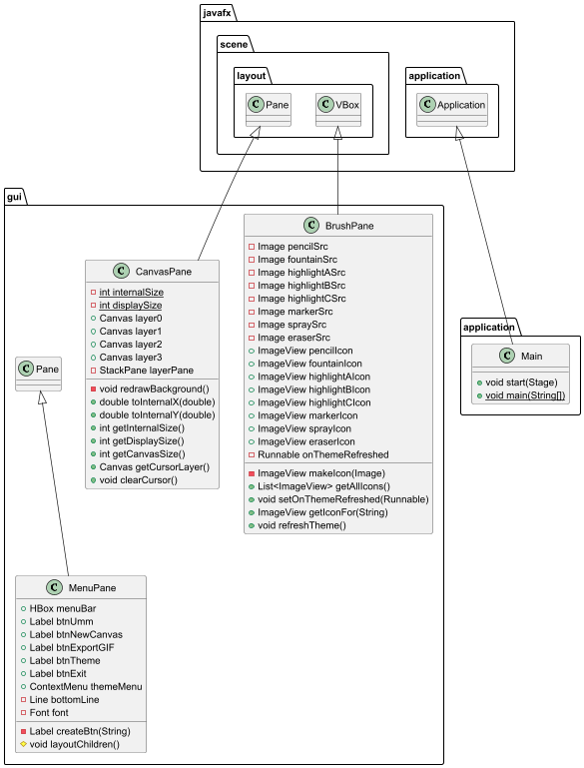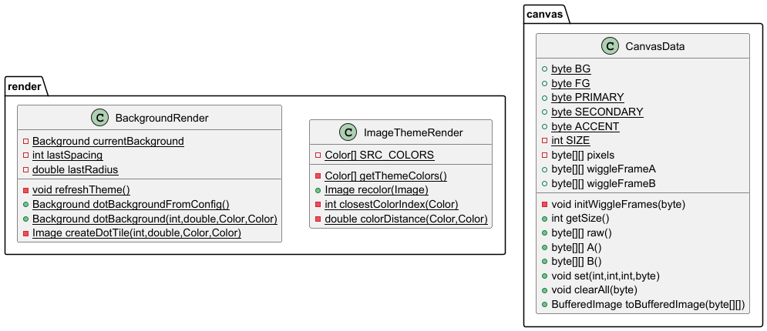

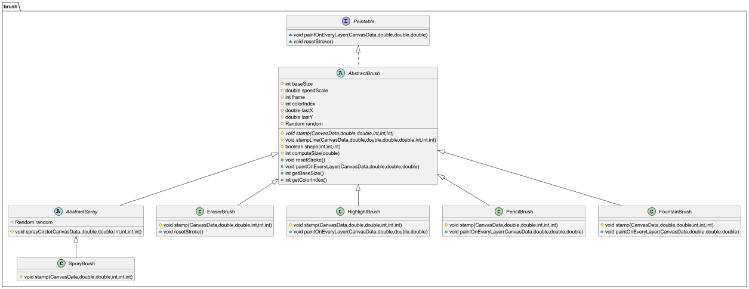
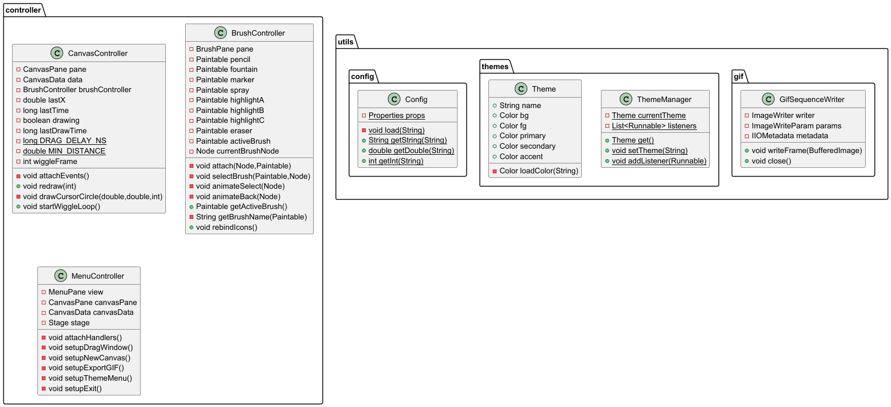
1. package application
1.1 class Main extends Application
This class is the main entry point of the program. It initializes the main window, layout, canvas, menu, brush panel, controllers, and starts the application.

Methods
Method | Description
+ void start(Stage primaryStage) | Initializes the main UI layout, controllers, and shows the application window.
+ static void main(String[] args) | Launches the JavaFX application.

2. package brush
2.1 class Abstract AbstractBrush implements Paintable
This class represents a base brush used for drawing on the canvas and is inherited by all specific brush types.

Fields
Field | Description
# int baseSize | Base size of the brush.
# double speedScale | Scale factor used to adjust brush size based on speed.
# int colorIndex | Color index used for drawing.
# double lastX | Last X position for continuous stroke drawing.
# double lastY | Last Y position for continuous stroke drawing.
# final Random random | Random generator used for spray particle distribution.

Methods
Method | Description
+ AbstractBrush(int baseSize) | Constructor that sets the base brush size.
+ AbstractBrush(int baseSize, double speedScale) | Constructor that sets base size and speed scale.
+ AbstractBrush(int baseSize, int colorIndex, double speedScale) | Constructor that sets base size, color index, and speed scale.
# abstract void stamp(CanvasData canvas, double x, double y, int size, int colorIndex, int layer) | Abstract method used to draw a single brush stamp.
# void stampLine(CanvasData canvas, double x0, double y0, double x1, double y1, int size, int colorIndex, int layer) | Draws a continuous line between two points using multiple stamps.
# boolean shape(int dx, int dy, int r) | Determines brush shape pattern using random styles.
# int computeSize(double speed) | Computes brush size based on drawing speed.
+ void resetStroke() | Resets the current stroke position.
+ void paintOnEveryLayer(CanvasData canvas, double x, double y, double speed) | Draws the brush on all layers of the canvas.
+ getter/setter

2.2 class AbstractSpray extends AbstractBrush
This class represents an abstract spray brush that extends AbstractBrush. It provides a common spray behavior by randomly scattering particles inside a circular area. This class cannot be directly instantiated and must be inherited by specific spray brush implementations.

Methods
Method | Description
+ AbstractSpray(int baseSize, double speedScale) | Constructor that initializes the base brush size and speed scale.
# void sprayCircle(CanvasData canvas, double x, double y, int radius, int colorIndex, int layer, int particles) | Draws a spray effect by randomly scattering particles inside a circular area.

2.3 class EraserBrush extends AbstractBrush
This class represents an eraser brush used to remove drawings from the canvas. It erases pixels by drawing over them with the background color. The eraser size does not depend on drawing speed.

Methods
Method | Description
+ EraserBrush(int baseSize) | Constructor that initializes the eraser with a fixed base size and background color.
# void stamp(CanvasData canvas, double x, double y, int size, int colorIndex, int layer) | Erases pixels in a circular area by setting them to the background color.
+ void resetStroke() | Resets the stroke position while keeping continuous erase behavior.

2.4 class FountainBrush extends AbstractBrush
This class represents a fountain brush used for smooth and continuous drawing. It applies a slight random jitter to create a natural ink flow effect.

Methods
Method | Description
+ FountainBrush(int baseSize, double speedScale) | Constructor that initializes the brush with base size and speed scale.
# void stamp(CanvasData canvas, double x, double y, int size, int colorIndex, int layer) | Draws a circular stamp with slight random jitter to simulate fountain pen effect.
+ void paintOnEveryLayer(CanvasData canvas, double x, double y, double speed) | Draws continuously on every layer without broken stroke effect.

2.5 Class HighlightBrush extends AbstractBrush

This class represents a highlight brush used for marking or emphasizing areas on the canvas. It applies a light jitter effect to simulate a hand-drawn highlighting style.

Methods
Method | Description
+ HighlightBrush(int baseSize, int colorIndex, double speedScale) | Constructor that initializes the highlight brush with base size, color, and speed scale.
# void stamp(CanvasData canvas, double x, double y, int size, int colorIndex, int layer) | Draws a highlighted circular area with slight random jitter.
+ void paintOnEveryLayer(CanvasData canvas, double x, double y, double speed) | Draws the highlight continuously on every layer.

2.6 class PencilBrush extends AbstractBrush
This class represents a pencil brush used for natural hand-drawn style drawing. It applies a slight random jitter to simulate the texture of a real pencil.

Methods
Method | Description
+ PencilBrush(int baseSize) | Constructor that initializes the pencil brush with a base size.
# void stamp(CanvasData canvas, double x, double y, int size, int colorIndex, int layer) | Draws a circular pencil stroke with slight random jitter.
+ void paintOnEveryLayer(CanvasData canvas, double x, double y, double speed) | Draws continuously on every layer using the base brush behavior.

2.7 class SprayBrush extends AbstractSpray
This class represents a spray brush that scatters paint particles randomly within a circular area. The density of particles depends on the brush size.

Methods
Method | Description
+ SprayBrush(int baseSize, double speedScale) | Constructor that initializes the spray brush with base size and speed scale.
# void stamp(CanvasData canvas, double x, double y, int size, int colorIndex, int layer) | Applies a spray effect by scattering particles inside a circular area using the inherited spray algorithm.

2.8 interface Paintable
This interface defines the basic behavior for all drawable tools in the application. Any class that implements this interface must support continuous drawing and stroke resetting.

Methods
Method | Description
+ void paintOnEveryLayer(CanvasData canvas, double x, double y, double speed) | Called continuously while the mouse or finger is moving to draw on all canvas layers.
+ void resetStroke() | Resets the current stroke position for a new drawing action.

3. package canvas
3.1 CanvasData
This class represents the core pixel buffer of the canvas. It stores all pixel data for the base layer and the two wiggle animation frames, and provides methods for pixel access, clearing, and image export.

Fields
FIeld | Description
+ static final byte BG | Background color index.
+ static final byte FG | Foreground color index.
+ static final byte PRIMARY | Primary theme color index.
+ static final byte SECONDARY | Secondary theme color index.
+ static final byte ACCENT | Accent theme color index.
- static final int SIZE | Canvas size (200 × 200 pixels).
- final byte[][] pixels | Base pixel layer.
+ final byte[][] wiggleFrameA | First wiggle animation frame.
+ final byte[][] wiggleFrameB | Second wiggle animation frame.

Methods
Method | Description
+ CanvasData() | Constructor that initializes the wiggle frames with background color.
- initWiggleFrames(byte color) | Initializes all pixels in both wiggle frames with the given background color.
+ int getSize() | Returns the canvas size.
+ byte[][] raw() | Returns the base pixel layer.
+ byte[][] A() | Returns the first wiggle frame.
+ byte[][] B() | Returns the second wiggle frame.
+ void set(int layeridx, int x, int y, byte index) | Sets a pixel value in the specified layer.
+ void clearAll(byte color) | Clears all layers using the given color.
+ BufferedImage toBufferedImage(byte[][] frame) | Converts a frame buffer into a BufferedImage for export or screenshot.

4. package controller
4.1 class BrushController
This class controls the selection and behavior of all brushes in the application. It binds brush tools to their corresponding icons, handles brush switching, and manages selection animations.

Fields
Field | Description
- final BrushPane pane | Reference to the brush panel UI.
- final Paintable pencil | Pencil brush object.
- final Paintable fountain | Fountain brush object.
- final Paintable marker | Marker brush object.
- final Paintable spray | Spray brush object.
- final Paintable highlightA | Highlight brush A.
- final Paintable highlightB | Highlight brush B.
- final Paintable highlightC | Highlight brush C.
- final Paintable eraser | Eraser brush object.
- Paintable activeBrush | Currently selected brush.
- Node currentBrushNode | Currently selected brush icon node.

Methods
Method | Description
+ BrushController(BrushPane pane) | Constructs the controller and binds all brush icons with their brushes.
- void attach(Node icon, Paintable brush) | Attaches a mouse click event to an icon for selecting a brush.
- void selectBrush(Paintable brush, Node icon) | Sets the active brush and updates the UI selection animation.
- void animateSelect(Node node) | Plays the selection animation on the selected brush icon.
- void animateBack(Node node) | Resets the animation of the previously selected brush icon.
+ Paintable getActiveBrush() | Returns the currently selected brush.
- String getBrushName(Paintable b) | Returns the name of a brush as a string.
+ void rebindIcons() | Rebinds all brush icons after a theme change and restores the active brush state.

4.2 class CanvasController
This class controls all user interactions with the canvas. It handles mouse input for drawing, manages rendering of all canvas layers, displays the eraser cursor preview, and controls the wiggle animation.

Fields
Field | Description
- final CanvasPane pane | Reference to the canvas UI pane.
- final CanvasData data | Reference to the canvas pixel buffer.
- final BrushController brushController | Reference to the brush controller.
- double lastX, lastY | Last mouse position for stroke tracking.
- long lastTime | Last timestamp for speed calculation.
- boolean drawing | Indicates whether the user is currently drawing.
- long lastDrawTime | Timestamp for draw throttling.
- static final long DRAG_DELAY_NS | Minimum delay between draw updates.
- static final double MIN_DISTANCE | Minimum distance between stroke points.
- int wiggleFrame | Current wiggle animation frame index.

Methods
Method | Description
+ CanvasController(CanvasPane pane, CanvasData data, BrushController brushController) | Constructs the controller, attaches mouse events, pre-renders wiggle frames, and registers theme refresh behavior.
- void attachEvents() | Attaches mouse press, drag, release, move, and exit events to the canvas input layer.
- void redraw(int layerIndex) | Renders the specified canvas layer to the screen.
- void drawCursorCircle(double x, double y, int radius) | Draws the eraser cursor preview as a circular outline.
+ void startWiggleLoop() | Starts the timeline loop that alternates between wiggle animation frames.

4.3 class MenuController
This class controls all menu-related actions in the application. It handles window dragging, new canvas creation, GIF exporting, theme switching, and application exit.

Fields
Field | Description
- final MenuPane view | Reference to the menu UI.
- final CanvasPane canvasPane | Reference to the canvas pane.
- final CanvasData canvasData | Reference to the canvas pixel data.
- final Stage stage | Reference to the main application stage.

Methods
Method | Description
+ MenuController(MenuPane view, CanvasPane canvasPane, CanvasData canvasData, Stage stage) | Constructs the controller and attaches all menu event handlers.
- void attachHandlers() | Attaches all menu-related event handlers.
- void setupDragWindow() | Enables dragging of the application window using the menu bar.
- void setupNewCanvas() | Clears all layers and resets the canvas to a new blank state.
- void setupExportGIF() | Exports the current wiggle animation as a GIF file.
- void setupThemeMenu() | Handles switching between available application themes.
- void setupExit() | Closes the application when the exit button is clicked.

5. package gui
5.1 class BrushPane extends VBox
This class represents the brush selection panel on the right side of the application. It displays all brush icons, handles theme-based recoloring of icons, and provides access to individual brush icons.

Fields
Field | Description
- Image pencilSrc | Original image source for the pencil icon.
- Image fountainSrc | Original image source for the fountain icon.
- Image highlightASrc | Original image source for highlight A icon.
- Image highlightBSrc | Original image source for highlight B icon.
- Image highlightCSrc | Original image source for highlight C icon.
- Image markerSrc | Original image source for the marker icon.
- Image spraySrc | Original image source for the spray icon.
- Image eraserSrc | Original image source for the eraser icon.
+ ImageView pencilIcon | Themed pencil icon displayed on the UI.
+ ImageView fountainIcon | Themed fountain icon displayed on the UI.
+ ImageView highlightAIcon | Themed highlight A icon displayed on the UI.
+ ImageView highlightBIcon | Themed highlight B icon displayed on the UI.
+ ImageView highlightCIcon | Themed highlight C icon displayed on the UI.
+ ImageView markerIcon | Themed marker icon displayed on the UI.
+ ImageView sprayIcon | Themed spray icon displayed on the UI.
+ ImageView eraserIcon | Themed eraser icon displayed on the UI.
- Runnable onThemeRefreshed | Callback triggered when the theme is refreshed.

Methods
Method | Description
+ BrushPane() | Constructs the brush panel, loads all icons, creates themed icons, and registers a theme change listener.
- ImageView makeIcon(Image raw) | Creates a theme-colored ImageView from a raw source image.
+ List<ImageView> getAllIcons() | Returns a list of all brush icons in the panel.
+ void setOnThemeRefreshed(Runnable callback) | Sets a callback to be executed after the theme is refreshed.
+ ImageView getIconFor(String name) | Returns the corresponding brush icon based on the given brush name.
+ void refreshTheme() | Rebuilds all brush icons using the updated theme and notifies the brush controller.

5.2 class CanvasPane extends Pane
This class represents the main drawing canvas area of the application. It manages multiple layered canvases for background, wiggle animation frames, and cursor input, and handles scaling between internal and display sizes.

Fields
Field | Description
- static final int internalSize | Logical pixel resolution of the canvas (200 × 200).
- static final int displaySize | Display size of the canvas on screen (500 × 500).
+ final Canvas layer0 | Background layer (theme-colored).
+ final Canvas layer1 | Wiggle animation frame A.
+ final Canvas layer2 | Wiggle animation frame B.
+ final Canvas layer3 | Cursor and input interaction layer.
- final StackPane layerPane | Container that stacks all canvas layers.

Methods
Method | Description
+ CanvasPane() | Constructs the canvas pane, sets up layered canvases, applies scaling, draws the initial background, and registers a theme refresh listener.
- void redrawBackground() | Redraws the canvas background and border based on the current theme.
+ double toInternalX(double x) | Converts a display X coordinate to an internal canvas coordinate.
+ double toInternalY(double y) | Converts a display Y coordinate to an internal canvas coordinate.
+ int getInternalSize() | Returns the logical internal canvas size.
+ int getDisplaySize() | Returns the display size of the canvas.
+ int getCanvasSize() | Returns the internal canvas size.
+ Canvas getCursorLayer() | Returns the cursor/input layer canvas.
+ void clearCursor() | Clears all drawings from the cursor layer.

5.3 class MenuPane extends Pane
This class represents the top menu bar of the application. It provides user interface controls for creating a new canvas, exporting GIF files, switching themes, and exiting the program. It also handles dynamic theme updates.

Fields
Field | Description
+ final HBox menuBar | Container for all menu buttons.
+ final Label btnUmm | Label button for the main menu title.
+ final Label btnNewCanvas | Label button for creating a new canvas.
+ final Label btnExportGIF | Label button for exporting the canvas as a GIF.
+ final Label btnTheme | Label button for opening the theme menu.
+ final Label btnExit | Label button for exiting the application.
+ final ContextMenu themeMenu | Context menu for selecting application themes.
- final Line bottomLine | Divider line below the menu bar.
- final Font font | Font used for all menu text.

Methods
Method | Description
+ MenuPane() | Constructs the menu bar UI, initializes all buttons, sets up the theme menu, and registers theme update listeners.
- Label createBtn(String text) | Helper method for creating a styled menu button.
# void layoutChildren() | Arranges the menu bar and bottom divider line within the pane.

6. package render
6.1 Class BackgroundRender
This class is responsible for generating and caching the dotted background pattern used in the application. It dynamically updates the background based on theme and configuration settings.

Fields
Field | Description
- static Background currentBackground | Cached background pattern.
- static int lastSpacing | Last used dot spacing value.
- static double lastRadius | Last used dot radius value.

Methods
Method | Description
- static void refreshTheme() | Clears the cached background when the theme changes.
+ static Background dotBackgroundFromConfig() | Returns a dotted background based on configuration and theme values, using cache when possible.
+ static Background dotBackground(int spacing, double dotRadius, Color dotColor, Color bgColor) | Generates a repeating dotted background pattern.
- static Image createDotTile(int size, double dotRadius, Color dotColor, Color bgColor) | Creates a single tile image containing one centered dot.

6.2 Class ImageThemeRender
This class is responsible for recoloring pixel-art icons by mapping predefined source colors to the current theme colors. It ensures that all icons automatically adapt to theme changes.

Fields
Field | Description
- static final Color[] SRC_COLORS | Reference color palette used for matching original pixel colors.

Methods
Method | Description
+ static Color[] getThemeColors() | Returns the current theme color palette from the ThemeManager.
+ static Image recolor(Image src) | Recolors an input image by mapping each pixel to the nearest theme color.
- static int closestColorIndex(Color c) | Finds the nearest reference color index for a given pixel color.
- static double colorDistance(Color a, Color b) | Computes the Euclidean distance between two RGB colors.

7. package utils.config
7.1 class Config
This class manages application configuration values by loading data from .properties files at startup and providing static access methods to retrieve configuration values.

Fields
Field | Description
- static final Properties props | Container that stores all configuration key–value pairs loaded from property files.

Methods
Method | Description
- static void load(String fileName) | Loads a .properties file into the configuration container.
+ static String getString(String key) | Returns a configuration value as a String.
+ static double getDouble(String key) | Returns a configuration value as a double.
+ static int getInt(String key) | Returns a configuration value as an int.

8. package utils.gif
8.1 Class GifSequenceWriter
This class is responsible for creating and writing animated GIF files. It handles GIF metadata configuration, frame delays, looping behavior, and sequential frame writing.

Fields
Field | Description
- final ImageWriter writer | GIF image writer used for output generation.
- final ImageWriteParam params | Parameters used for writing GIF images.
- final IIOMetadata metadata | Metadata used for configuring GIF animation properties.

Methods
Method | Description
+ GifSequenceWriter(ImageOutputStream out, int imageType, int delayMS, boolean loopForever) | Constructs the GIF writer, configures metadata, frame delay, and looping behavior.
+ void writeFrame(BufferedImage img) | Writes a single frame to the GIF sequence.
+ void close() | Finalizes and closes the GIF writing process.

9. package utils.themes
9.1 class Theme
This class represents a color theme of the application. It loads and stores all theme colors from the configuration files based on a given theme name.

Fields
Field | Description
+ final String name | Name of the theme.
+ final Color bg | Background color of the theme.
+ final Color fg | Foreground color of the theme.
+ final Color primary | Primary color of the theme.
+ final Color secondary | Secondary color of the theme.
+ final Color accent | Accent color of the theme.

Methods
Method | Description
+ Theme(String name) | Constructs a theme object and loads all theme colors from configuration files using the given theme name.
- Color loadColor(String key) | Loads a single color value from the configuration file and converts it into a Color object.

9.2 class ThemeManager
This class manages the current theme of the application. It allows switching between themes and notifies all registered listeners to update the user interface when the theme changes.

Fields
Field | Description
- static Theme currentTheme | Current active theme of the application.
- static final List<Runnable> listeners | List of UI listeners that are notified when the theme changes.

Methods
Method | Description
+ static Theme get() | Returns the current active theme.
+ static void setTheme(String name) | Sets a new theme based on the given name and notifies all registered listeners.
+ static void addListener(Runnable uiRefresher) | Registers a UI refresh listener that will be called when the theme changes.

