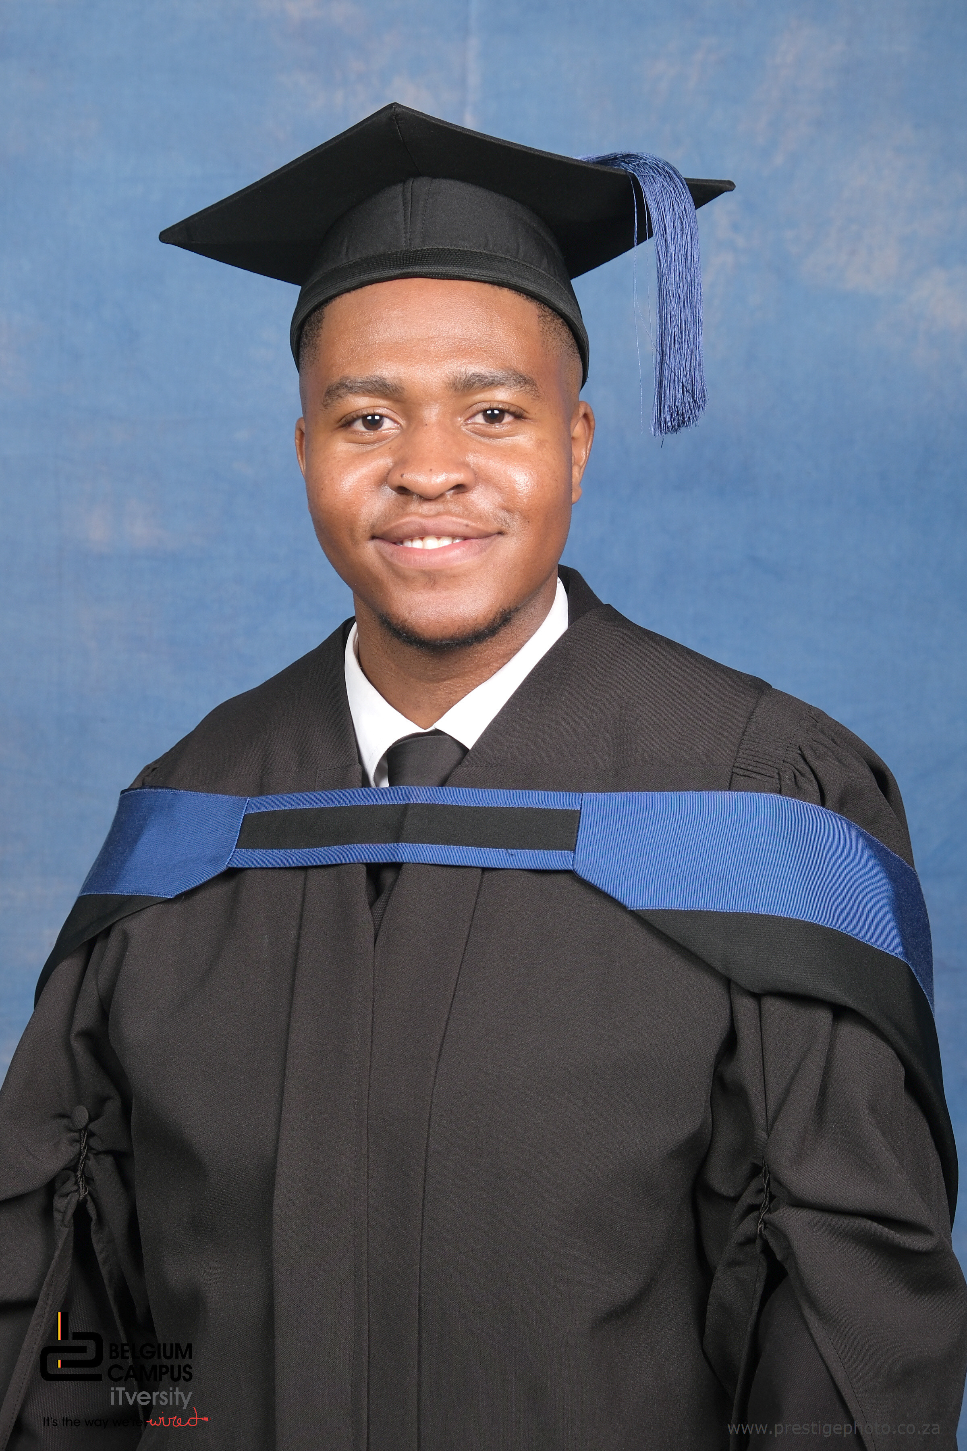  PROFILE  Recent BComp Software Engineering graduate (NQF8, Cum Laude) from Belgium Campus iTversity, passionate about building scalable software solutions. Experienced in full-stack development with Angular, .NET, and microservices architecture.  CONTACT  EMAIL:  mkramatsui@icloud.com  keneilwempho15@gmail.com  LANGUAGES  ENGLISH : 100%  SEPEDI : 100%  AFRIKAANS : 50%  SPANISH : 10% | KENEILWE MPHO RAMATSUI  PROFESSIONAL CV  EDUCATION  LYTTELTON MANOR HIGH SCHOOL  2016 – 2020  • 1st Team Chess Player from 2017–2020  • Chess Captain from 2019–2020  BELGIUM CAMPUS iTversity  2022 – 2025  • BComp: Software Engineering (NQF8) — Cum Laude  SKILLS AND ABILITIES  • Proficient in C#, .NET, Angular, TypeScript, JavaScript, HTML, CSS, PostgreSQL, Docker  • Excellent communication skills  • Goal-driven professional who thrives and delivers  CERTIFICATIONS  Microservices on .NET 8  ASP.NET Web API, Docker, MassTransit, Yarp Gateway, Redis & SQL Server  Udemy · 2025  HOBBIES  • Exercising and healthcare  • Chess (1st Team, Captain 2019–2020) & Soccer  • Solve a Rubik's Cube  • Tutor students  • Learn different languages  • Develop my coding skills  PROFILE  LinkedIn: linkedin.com/in/keneilwe-mpho-ramatsui  GitHub: github.com/KMphoR

