

Final Year Project Report-MID PRESENTATION
AIXAM: Smart Exam Preparation and Teaching Assistance Platform

Hashir Ali

Ghulam Hamza

Mubeen Khan

Supervisor : Sir Waqas Ali

Chapter 1: Introduction

Overview
The modern educational environment presents a significant challenge: students must process vast
amounts of study material from textbooks, slides, and notes, while teachers spend considerable time creating assignments, quizzes, and managing classroom communications. Traditional exam preparation methods require students to manually extract key concepts and create revision materials a time- consuming process that often lacks efficiency and personalization. Similarly, educators invest substantial effort in content creation and administrative tasks, diverting attention from core instructional responsibilities.
AIXAM (Smart Exam Preparation and Teaching Assistance Platform) addresses these challenges through intelligent automation and artificial intelligence. The platform transforms traditional academic workflows by automatically processing uploaded study materials and generating interactive learning resources.
Students can upload documents in PDF, PowerPoint, or Word formats, which the system converts into chapter-wise and topic-wise flashcards for efficient revision. The platform provides comprehensive mock tests in both multiple-choice and descriptive formats, enabling learners to assess understanding and identify knowledge gaps without repeatedly reviewing lengthy content.
For educators, AIXAM functions as an intelligent teaching assistant. Teachers can upload course content to automatically generate assignments, quizzes, and lecture slides, significantly reducing preparation time. The platform integrates a smart chatbot with Google Classroom, enabling teachers to post assignments, distribute quizzes, and make announcements through simple voice or text commands. The system automates assignment evaluation by tracking submission deadlines, recording student work, and automatically marking unsubmitted assignments as zero, ensuring transparent and efficient grading processes.
A distinguishing feature of AIXAM is its machine learning-driven analytics module. The platform continuously collects student performance data from quizzes, mock tests, and assignments, analyzing patterns to identify strengths and weaknesses. Students access a personalized analytics dashboard highlighting specific subjects, chapters, or topics requiring additional focus, enabling data-driven study strategies and optimized time allocation.
AIXAM's architecture is designed for scalability and extensibility. The modular structure separates study material processing, flashcard generation, assessment creation, teacher assistance, and classroom integration into distinct components. This design ensures new features can be added without disrupting existing functionality while accommodating growing user bases and evolving educational requirements. By combining digital flashcards, automated test generation, assignment management, and intelligent classroom integration, AIXAM serves as both a reliable study companion for students and a
comprehensive teaching assistant for educators, ultimately enhancing learning efficiency and academic productivity.

Project Motivation
The motivation for AIXAM emerges from critical inefficiencies affecting both students and educators in contemporary academic settings. These challenges have intensified as educational content expands while time for processing and teaching remains constrained.

Student Challenges:

Students face overwhelming exam preparation demands, managing multiple courses with extensive
materials spread across textbooks, lecture slides, and supplementary resources. The traditional approach requires manually consolidating fragmented information into coherent, reviewable formats a process that is time-intensive and often incomplete. Students struggle to identify essential concepts, leading to inefficient study sessions focusing on less critical details while overlooking important material. The lack of adequate practice opportunities means students often enter examinations without understanding their knowledge gaps or areas needing attention.
The psychological burden is significant. Exam preparation stress is exacerbated by poor time management and inefficient strategies. Students spending hours creating basic study materials have less
time for actual learning and practice, creating cycles where preparation becomes a race against time rather than thoughtful knowledge acquisition. This situation is particularly acute for students managing multiple courses simultaneously, where the cumulative burden of material organization becomes nearly unmanageable. Furthermore, not all students have access to expensive tutoring services or comprehensive study guides, creating educational inequities based on resource availability.

Teacher Challenges:

Educators face equally significant challenges manifesting differently. Teachers invest substantial time creating educational content and managing administrative tasks that draw attention from direct student interaction and pedagogical innovation. Designing assignments requires careful consideration of learning objectives, appropriate difficulty levels, and fair assessment criteria. Creating quizzes involves generating quality questions, formulating plausible distractors for multiple-choice items, and ensuring
comprehensive content coverage. Developing lecture materials demands organizing information logically and engagingly to facilitate understanding. Each task, performed manually, represents hours of work repeated for every course each semester.
Beyond content creation, teachers face classroom management and communication challenges. With
platforms like Google Classroom becoming standard for assignment distribution and submission tracking, teachers navigate multiple interfaces and workflows. Posting assignments, making announcements, tracking submissions, and managing deadlines across different classes creates overwhelming
administrative burdens. The evaluation process adds complexity, particularly with large class sizes. Manually grading assignments, especially descriptive work, is time-consuming and mentally demanding. Ensuring timely feedback while maintaining consistent evaluation standards becomes increasingly difficult as workloads increase.

The Need for Intelligent Solutions:

Traditional methods lack scalability, interactivity, and personalization. As class sizes grow and content expands, manual approaches become unsustainable. Static study materials and conventional testing fail to engage modern learners accustomed to interactive, personalized digital experiences. While artificial
intelligence and machine learning have demonstrated capabilities in natural language processing, content generation, and pattern recognition, these technologies have not been fully leveraged to address specific academic pain points. AIXAM is motivated by the recognition that education faces systemic challenges requiring systematic solutions—harnessing modern technology to create more efficient, effective, and equitable educational environments where students learn better and teachers teach better.

Project Vision, Scope, and Glossary

Project Vision
AIXAM envisions transforming educational technology from mere digitization of traditional processes into an intelligent partner augmenting human capabilities in learning and teaching. For students, the vision centers on fundamentally shifting exam preparation from spending hours manually organizing notes to having instant access to intelligently curated study materials tailored to specific needs. The
platform aims to provide flashcards capturing essential concepts precisely, mock tests offering meaningful assessment opportunities, and analytics delivering clear learning progress insights.
For educators, AIXAM envisions functioning as a tireless teaching assistant handling routine tasks reliably, freeing instructors to focus on mentoring students, designing innovative learning experiences, and providing nuanced feedback. Long-term vision includes incorporating spaced repetition algorithms optimizing review timing, peer-to-peer flashcard sharing fostering collaborative learning, adaptive learning pathways adjusting content based on performance, and intelligent recommendation systems guiding students toward relevant resources. Ultimately, AIXAM aims to democratize access to high- quality educational support, ensuring every student and teacher, regardless of background or institutional resources, has access to effective learning tools and instructional assistance.

Project Scope In-Scope Features:
AIXAM will accept study materials in PDF, PowerPoint (PPTX), and Word (DOCX) formats, processing documents to extract text and identify structural elements including chapters, sections, and topics. The flashcard generation module will automatically create question-answer pairs organized hierarchically by identified chapters and topics, with functionality for users to generate flashcards for entire documents or specific sections, and review, edit, and organize generated content.
Mock test functionality encompasses multiple choice questions and descriptive questions , with configurable parametere including question count , time duration , question type distribution , and content scope. Automated evaluation with instant scoring applies to MCQ based tests, with performance tracking and result storage for analysis.
Teacher features include generating customized assignments from selected content, creating quizzes with configurable grading schemes, producing lecture slide outlines, and managing assignment evaluation with deadline tracking and automatic zero-marking for late submissions. Google Classroom integration through the smart chatbot enables OAuth 2.0 authentication, allowing teachers to post assignments, quizzes, and announcements through conversational commands while answering submission status queries.
The personalized analytics module collects comprehensive performance data from all student interactions, employing machine learning to identify mastery and weakness patterns. Students access dedicated
analytics dashboards displaying performance metrics, highlighted weak areas, and actionable improvement recommendations. Supporting features include user authentication, role-based access control, secure document storage with encryption, and responsive web interfaces.

Out-of-Scope Features:

Real-time collaborative features, advanced gamification elements beyond basic progress tracking, video content processing, audio recording, integration with learning management systems other than Google Classroom, advanced proctoring features, mobile native applications (though web interfaces will be responsive), offline functionality, social networking features, and multilingual support are explicitly excluded from current scope to ensure focused development within time and resource constraints.

Glossary
AIXAM: AI-powered Exam Preparation - Smart Exam Preparation and Teaching Assistance Platform.
Analytics Dashboard: Interface displaying student performance metrics and personalized recommendations.
Auto-Zero Marking: Automatic assignment of zero score for late submissions with timestamp recording.
Flashcard: Question-answer study aid generated from source material , organized by chapter/topic.
Chatbot: Conversational agent integrated with Google Classroom processing natural language commands.
Mock Test: Practice examination configurable by question count, duration, and type.
MCQ: Multiple Choice Question presenting prompt with answer options.
OAuth 2.0: Authorization framework for secure third-party application authentication.
Performance Data: Quantitative information from student quiz, test, and assignment interactions.
RBAC: Role-Based Access Control restricting system access by user role.
Assignment: Teacher generated task with deadlines and evaluation criteria.

Objectives

Objective 1: Develop a Platform for Automated Flashcard Generation

The first objective addresses the core student need for efficient revision tools by creating a system automatically generating chapter-wise and topic-wise flashcards from uploaded study material. The platform must implement sophisticated text processing algorithms extracting meaningful content from various document formats, identifying key concepts, definitions, relationships, and important facts, then formulating effective question-answer pairs. Hierarchical organization ensures flashcards are structured logically according to source material organization,

maintaining chapter and topic boundaries enabling
systematic revision. Success requires processing documents of varying lengths and structures, generating flashcards accurately representing source content, organizing them in navigable hierarchies reflecting document structure, and providing users control over which sections to process for targeted flashcard generation.

Objective 2: Provide Structured Mock Tests for Self-Assessment

This objective focuses on assessment capabilities, recognizing effective learning requires content review and opportunities to test understanding and identify knowledge gaps. Mock test functionality must support multiple question types multiple-choice questions testing recognition and factual recall with automated grading advantage, and descriptive questions assessing deeper understanding requiring articulated explanations. Configuration flexibility enables students to customize test parameters including question numbers, time duration, difficulty level, and content scope, creating practice sessions matching specific needs. Automated evaluation for MCQ tests provides immediate feedback, enabling quick
mistake identification and correct answer understanding. Success metrics include generating high-quality questions with appropriate difficulty, plausible MCQ distractors testing understanding, accurate automated scoring, and meaningful feedback helping students learn from mistakes.

Objective 3: Enable Teachers to Auto-Generate Educational Content

This objective addresses educator needs by creating tools streamlining content creation processes, recognizing teachers spend substantial time developing assignments, quizzes, and presentation materials. Assignment generation allows teachers to select relevant content portions and automatically transform them into structured assignments requiring students to demonstrate comprehension and concept application. Quiz generation produces assessments aligned with learning objectives, ensuring appropriate difficulty distribution, comprehensive content coverage, and clear wording. Lecture slide generation
creates structured outlines or draft slides teachers can customize, providing starting points significantly reducing preparation time. Success requires maintaining quality while automating production generated content must be

pedagogically sound, grammatically correct, and appropriately aligned with educational standards, viewed as reliable assistants producing work requiring only minor refinement.

Objective 4: Integrate a Chatbot with Google Classroom for Automated Communication

This objective streamlines classroom management and communication through intelligent automation, recognizing academic administration posting assignments, making announcements, tracking
submissions—consumes significant teacher time while adding little educational value. Chatbot integration serves as natural language interface between teachers and Google Classroom, eliminating manual navigation through multiple menus and forms. Teachers issue simple commands like "post this quiz to period 3" and the chatbot executes actions reliably. OAuth 2.0 authentication ensures security while maintaining convenience, securely accessing classroom data and performing actions without compromising account security or privacy. Beyond posting, the chatbot provides status information,
answering queries about submission counts, pending evaluations, or upcoming deadlines. For students, it functions as contextual help, answering questions about active study material. Success requires reliable command execution, seamless natural integration, and robust error handling managing edge cases or
ambiguous commands.

Objective 5: Automate Assignment Evaluation and Deadline Management

The fifth objective addresses time-consuming assignment management and grading, reducing
administrative burden while ensuring fair, consistent evaluation practices. Automated tracking monitors assignment submissions against specified deadlines, maintaining accurate records of submission details and timing. Auto-zero marking ensures consistent late policy application, uniformly applying rules with timestamp documentation for dispute resolution. The evaluation interface presents submitted work clearly, provides grading and feedback tools,

and maintains assessment records. For descriptive
assignments requiring subjective evaluation, the system facilitates without replacing human judgment, ensuring

teachers retain grading control while benefiting from organizational support. Success metrics include accurate deadline tracking, reliable submission recording, clear student work presentation, and efficient workflow reducing administrative time without compromising evaluation quality.

Tools and Technologies

Frontend Technologies:

The user interface utilizes Next.js, a React-based framework offering server-side rendering, static site generation, and optimal performance through automatic code splitting and image optimization. Next.js
aligns perfectly with AIXAM's modular design, providing file-based routing and API routes for seamless frontend-backend integration. TypeScript provides static typing, catching development errors and improving code maintainability across the application. Tailwind CSS offers utility-first styling accelerating UI development while maintaining consistency, with mobile-first methodology ensuring
seamless functionality across desktop, tablet, and mobile browsers. For frontend testing, Jest and React Testing Library ensure comprehensive component testing and user interaction validation.

Backend and Database:

Server-side development employs Django, a high-level Python web framework following the model-
view-template (MVT) architecture. Django's built-in features including ORM, authentication system, and admin interface accelerate development while ensuring security and scalability. Django handles core application logic, user management, document processing, and business workflows. PostgreSQL serves as the primary relational

database management system, providing robustness, ACID compliance, and complex query support for storing user data, document metadata, flashcard content, test results, and
performance analytics. Redis provides high-performance in-memory caching for frequently accessed data like user sessions and recent content. Backend testing utilizes pytest and Django's testing framework
for comprehensive API endpoint validation and business logic verification.

API Layer and ML Communication:

FastAPI serves as the high-performance API layer facilitating communication between the chatbot,
analytics dashboard, and machine learning models. FastAPI's asynchronous capabilities and automatic API documentation generation make it ideal for handling real-time chatbot interactions and analytics model predictions. This architecture separates concerns, with Django managing core application logic
while FastAPI handles computationally intensive ML operations and chatbot responses, ensuring optimal performance and scalability.

Chatbot Development:

The intelligent chatbot is built using Python with LangChain framework, which provides powerful tools for building context-aware language model applications. LangChain enables sophisticated conversation flows, memory management, and agent-based reasoning for understanding teacher commands and student queries. The chatbot integrates Google's Gemini API for advanced natural language understanding and generation, providing accurate, contextually appropriate responses. LangChain's integration capabilities
facilitate seamless connection with Google Classroom API and document processing pipelines, enabling the chatbot to execute commands reliably and provide intelligent assistance.

NLP and Machine Learning:

Document text extraction utilizes PyPDF2 or pdfplumber for PDFs, python-pptx for PowerPoint, and python-docx for Word documents. Natural language processing employs spaCy for text analysis, entity recognition, and sentence tokenization, enabling key concept identification and structural element recognition. The Gemini API handles sophisticated language understanding for flashcard generation, question formulation, and content summarization, producing grammatically correct and contextually
appropriate educational materials. Personalized analytics uses scikit-learn for machine learning model development, providing algorithms for classification, clustering, and pattern recognition in student
performance data.

Authentication and Security:

Security implements OAuth 2.0 for Google Classroom integration, which inherently handles password hashing and secure authentication flows. Django's built-in authentication system, combined with OAuth 2.0, ensures robust user authentication and authorization. SSL/TLS certificates from AWS Certificate Manager secure data transmission, meeting encryption requirements for data in transit and at rest.

Cloud Deployment and Infrastructure:

Deployment leverages Amazon Web Services (AWS) infrastructure for scalability and reliability. EC2 instances host the Django application and FastAPI services, S3 provides secure document storage with encryption, RDS for PostgreSQL manages the relational database with automated backups, and
ElastiCache for Redis handles caching layer. AWS Lambda can be utilized for serverless processing of specific tasks such as triggered document processing workflows.

CI/CD and Development Tools:

Version control uses Git with GitHub for collaborative development following Agile Scrum methodology. Docker containers ensure consistent development and deployment environments across local development, testing, and production. The CI/CD pipeline employs GitHub Actions for automated testing and deployment workflows. Upon code commits, GitHub Actions triggers automated test suites (Jest for frontend, pytest for backend), runs code quality checks, builds Docker images, and deploys to AWS infrastructure when all tests pass. This ensures continuous integration and reliable deployment
processes while maintaining code quality standards throughout development.

Chapter 2: Background Study/Literature Review

2.1 Related Work

2.1.1 Introduction
The development of AIXAM is grounded in extensive research and analysis of existing educational technologies, learning methodologies, and artificial intelligence applications in education. This literature review examines the current state of educational technology across multiple dimensions relevant to AIXAM's objectives: flashcard generation and spaced repetition systems, automated question generation, learning management systems, AI-powered educational assistants, learning analytics, and document processing technologies. By analyzing existing solutions, their capabilities, and their limitations, this review establishes the context for AIXAM's innovation and identifies the gaps in current educational technology that motivate this

project. The review draws from both academic research and commercial educational platforms to provide a comprehensive understanding of the field and to position AIXAM within the broader landscape of educational technology development.

2.1.2 Flashcard Generation and Spaced Repetition Systems
Digital flashcard systems have gained popularity as tools for learning and retention, using cognitive science principles to optimize study. Spaced repetition underpins many flashcard applications. Research [1] showed that retrieval practice via flashcards produces better long-term retention than repeated studying, a finding confirmed across diverse subjects.
Anki is a sophisticated spaced repetition system, using the SuperMemo SM-2 algorithm to schedule reviews based on user performance. It supports multimedia cards and hierarchical organization, but all flashcards must be manually created, limiting accessibility. Community-shared decks exist but may lack alignment with course material.
Quizlet, widely used in K-12 and undergraduate education with over 60 million monthly users, offers multiple study modes and social features for collaborative deck creation. Quizlet Learn adapts study plans to user performance, but manual flashcard creation remains necessary. Recent AI features suggest definitions but do not automatically generate full flashcard sets from documents.
Brainscape uses a confidence-based repetition system, adjusting review frequency based on user-rated confidence. This metacognitive approach can improve retention compared to traditional spaced repetition. Curated content is available, but automated flashcard generation is lacking, requiring significant upfront effort from users.
Research validates flashcard effectiveness. Research [2] found practice testing and distributed practice highly effective, and some more research [3] showed spaced retrieval improves long-term retention. Despite this, no system automatically generates high-quality flashcards from study materials, creating a barrier for students and limiting the efficiency of existing spaced repetition platforms.

2.1.3 Automated Question Generation Systems
Automated question generation has emerged as a significant research area within natural language processing and educational technology, with substantial advances driven by deep learning approaches. The field addresses the challenge of creating assessment items automatically from source texts, potentially reducing teacher workload while providing students with unlimited practice opportunities.
Early approaches to automated question generation relied on template-based methods and syntactic transformation rules. Some researchers [4] developed one of the first comprehensive systems for generating questions from declarative sentences using syntactic tree transformations and hand-crafted rules. Their system could identify suitable sentences and transform them into wh-questions through grammatical manipulations. While these rule-based systems could produce grammatically correct questions, they often lacked semantic sophistication and struggled with complex texts or domain-specific content, producing questions that were syntactically valid but pedagogically questionable.
The advent of neural sequence-to-sequence models revolutionized question generation capabilities. Some researchers [5] applied attention-based encoder-decoder networks to question generation, demonstrating that neural models could learn to generate more diverse and contextually appropriate questions than rule-based systems. Their work showed particular promise for generating questions that required understanding of document context rather than simple syntactic transformation. The attention mechanism allowed models to focus on relevant portions of input text when generating each word of the question.
Recent transformer-based models have pushed capabilities significantly further. Research [6] demonstrated that fine-tuned BERT models could generate high-quality multiple-choice questions with plausible distractors by leveraging the model's understanding of semantic similarity and contextual relationships. Their system could identify key concepts in text and generate questions testing understanding of those concepts, with distractors that reflected common misconceptions rather than randomly selected wrong answers. This represented a significant advance in generating pedagogically valuable assessment items.

Several commercial and research systems have implemented automated question generation with varying approaches. Querium uses AI to generate STEM questions with step-by-step solutions, focusing on procedural knowledge in mathematics and science. The platform can create practice problems that guide students through solution processes. Century Tech employs machine learning to generate adaptive assessments based on curriculum standards and student performance data. These systems demonstrate the technical feasibility of automated question generation but typically operate within narrow domains or require extensive training data specific to particular subjects.
Research has also addressed the challenge of evaluating automatically generated questions, which is crucial for ensuring quality [7]. They identified key quality dimensions including grammaticality, answerability, relevance, and difficulty. While automatic metrics can assess grammatical correctness and some aspects of semantic coherence, human evaluation remains necessary to judge pedagogical quality and alignment with learning objectives. This evaluation challenge remains a significant barrier to widespread deployment of automated question generation systems.
Despite these advances, significant limitations persist in existing question generation systems. Most systems focus exclusively on question generation without integration into broader educational workflows, existing as standalone tools requiring manual export and import of content. Generated questions often lack the context of specific courses or textbooks, requiring substantial teacher review and modification before use in actual assessments. The quality of generated distractors for multiple-choice questions remains inconsistent, often producing options that are either too obviously wrong or confusingly similar to correct answers. Furthermore, few systems effectively address the generation of higher-order thinking questions that require analysis, synthesis, or evaluation rather than simple recall of facts.

2.1.4 Learning Management Systems and Classroom Integration
Learning Management Systems (LMS) have become fundamental infrastructure in modern education, providing centralized platforms for course management, content delivery, and communication.

Google Classroom, launched in 2014, has achieved remarkable adoption with over 150 million users globally. Its integration with Google Workspace provides seamless workflows for assignment creation and distribution. Teachers can create assignments, attach materials, set due dates, and distribute to multiple classes efficiently. The platform's API enables third-party integration. However, Google Classroom focuses primarily on workflow management rather than content creation, requiring teachers to develop all instructional materials externally.
Canvas LMS has become dominant in higher education with over 30 million users. Canvas distinguishes itself through sophisticated features including outcomes-based grading, detailed analytics dashboards, and extensive customization. The SpeedGrader tool streamlines assignment evaluation, while Canvas Analytics provides engagement insights. Despite these capabilities, Canvas requires significant institutional investment and training.
Moodle, as an open-source LMS, powers millions of courses worldwide. Its plugin architecture allows extensive customization, and its quiz module provides sophisticated assessment capabilities. However, Moodle's interface is often criticized as less intuitive, and it requires technical expertise for installation and maintenance.
Microsoft Teams for Education leverages its collaboration platform for educational purposes, integrating with Microsoft 365 applications. The platform gained adoption during the COVID-19 pandemic due to video conferencing capabilities. However, its educational features remain less mature than dedicated LMS platforms.
Research on LMS effectiveness has produced mixed results. Research [8] found that while LMS platforms increased administrative efficiency, they often replicated traditional approaches digitally. Several reports [9] demonstrated that adoption success depends on institutional support and teacher training.
A critical limitation across LMS platforms is their passive nature regarding content creation. While they excel at organizing and distributing materials, they provide minimal assistance in creating content. Teachers must still invest substantial time developing assignments and quizzes outside the LMS. Additionally, most platforms offer limited personalization based on individual student needs.

2.1.5 AI-Powered Educational Assistants and Chatbots
Conversational AI has emerged as a promising application in education, with chatbots and virtual assistants offering potential to provide personalized support, answer student questions, and automate routine administrative tasks. The field has evolved from simple rule-based systems to sophisticated natural language understanding platforms leveraging large language models.
Early educational chatbots relied on pattern matching and decision trees to respond to student queries. ALICE (Artificial Linguistic Internet Computer Entity), developed in the 1990s using AIML (Artificial Intelligence Markup Language), represented an early attempt at conversational agents in education. While ALICE could maintain basic conversations, its responses were limited to predefined patterns, making it unsuitable for open-ended educational dialogue or complex question answering. These limitations highlighted the need for more sophisticated natural language understanding capabilities.
Watson Assistant from IBM has been deployed in various educational contexts, including university admissions support and student services. Watson's natural language understanding capabilities, trained on domain-specific data, enable it to handle diverse query types and provide contextually relevant responses. Georgia State University deployed a Watson-based chatbot named "Pounce" to assist with admissions queries, reportedly answering thousands of questions and contributing to improved enrollment rates by providing immediate responses to prospective students. However, Watson Assistant requires substantial configuration, training data collection, and ongoing maintenance, limiting its accessibility for individual teachers or smaller institutions without dedicated technical resources.
Duolingo has successfully integrated conversational AI into language learning through its chatbot feature, allowing learners to practice conversations with AI-powered characters. The chatbot adapts to learner proficiency levels and provides immediate feedback on language use, helping students practice in a low-stakes environment. This represents one of the most successful applications of conversational AI in education, demonstrating the potential for AI assistants to facilitate practice and provide personalized feedback. However, Duolingo's chatbot is narrowly focused on language practice rather than broader educational support or administrative task automation.

Recent developments in large language models have dramatically expanded chatbot capabilities. ChatGPT and similar systems demonstrate remarkable ability to answer questions, explain concepts, and engage in educational dialogue across diverse subjects. Research [10] examined ChatGPT's potential in education, identifying both opportunities (personalized tutoring, writing assistance, content generation) and challenges (accuracy concerns, potential for academic dishonesty, equity issues). While these general-purpose language models show impressive capabilities, they lack integration with specific educational platforms and workflows, limiting their utility for structured educational tasks like assignment management or grade tracking.
Dialogflow (formerly API.AI), Google's conversational AI platform, provides tools for building custom chatbots with natural language understanding, intent recognition, and context management. Educational institutions and ed-tech companies have used Dialogflow to create domain-specific educational assistants for various purposes. However, building effective educational chatbots with Dialogflow requires significant development effort, training data collection, and ongoing refinement of intents and responses to handle the diversity of student queries.
Rasa, an open-source conversational AI framework, offers greater control and customization than cloud-based alternatives. Rasa's machine learning-based approach to natural language understanding and dialogue management enables sophisticated conversational flows and context-aware responses. Several educational projects have utilized Rasa to build campus information systems, course recommendation assistants, and study support chatbots. However, Rasa requires substantial technical expertise in machine learning and software development, along with computational resources for training and deployment.
Research on educational chatbot effectiveness reveals mixed outcomes. Some researchers [11] conducted a systematic literature review finding that chatbots can effectively support learning when properly designed, particularly for factual knowledge domains and procedural skills. However, they identified limitations in handling complex reasoning, providing nuanced explanations, and adapting to diverse learning styles. Student satisfaction with chatbots depends heavily on response quality and conversational naturalness.
Despite advances in conversational AI, significant gaps remain in educational applications. Most educational chatbots focus on student-facing interactions (answering questions, providing tutoring) rather than teacher-facing automation (creating assignments,

managing classroom tasks). Few systems integrate deeply with existing educational platforms to automate workflows rather than simply answering queries. The potential for chatbots to serve as intelligent teaching assistants that understand context, execute complex tasks, and learn from user interactions remains largely unrealized in current implementations.

2.1.6 Learning Analytics and Personalized Learning
Learning analytics represents the measurement, collection, analysis, and reporting of data about learners for understanding and optimizing learning environments. The field has grown substantially with increased digitization of education.
Khan Academy pioneered personalized learning at scale through its mastery-based approach. The platform tracks student performance across millions of exercises, using data to identify knowledge gaps and recommend appropriate content. Research [12] found that Khan Academy usage correlated with improved mathematics achievement. However, Khan Academy's personalization focuses primarily on mathematics and relies on pre-created content.
Coursera and other MOOC platforms implement analytics to track engagement, predict dropout risk, and personalize recommendations. Coursera processes millions of learner interactions, identifying patterns associated with course completion. Research by [13] used cluster analysis to identify distinct learner engagement patterns. However, MOOC analytics primarily serve course-level improvements rather than individual learning path personalization.
ALEKS (Assessment and Learning in Knowledge Spaces) represents a sophisticated adaptive system for mathematics, using knowledge space theory to create detailed cognitive models. Studies [14] demonstrated learning gains associated with ALEKS usage. However, ALEKS requires extensive expert modeling of knowledge structures, limiting applicability beyond mathematics.
Smart Sparrow provides a platform allowing educators to create adaptive courseware with branching logic based on student responses. The platform's analytics track interactions and adjust content accordingly. However, creating effective adaptive courseware requires significant time investment and instructional design expertise.

Academic research has explored various predictive modeling approaches.Researchers [15] surveyed educational data mining techniques, identifying applications including student modeling and performance prediction.Research [16] emphasized ethical considerations in learning analytics, including privacy concerns and student agency over data.
Despite advances, significant limitations persist. Most analytics focus on quantitative metrics while struggling to capture qualitative learning aspects. Personalization often means adjusting difficulty rather than fundamentally adapting instructional approaches. Furthermore, few analytics systems integrate with content generation tools, meaning insights about weaknesses don't automatically trigger creation of targeted practice materials.

2.1.7 Document Processing and NLP in Education
Advances in natural language processing have opened the door to automating many tasks involving educational documents. Modern NLP can extract, analyze, and summarize information from textbooks, lecture slides, and student work, supporting applications ranging from study material generation to automated grading.
Document processing starts with extracting text from various file formats. Libraries like PyPDF2 and pdfplumber are widely used for PDFs, each handling layouts and metadata differently. python-docx and python-pptx give structured access to text and formatting in Word and PowerPoint files. Although these tools reliably extract raw text, they often struggle with tables, mathematical expressions, unusual formatting, and images, requiring additional cleanup before the text can be analyzed.
Once text is extracted, NLP libraries perform tokenization, tagging, entity recognition, and parsing. spaCy is one of the most popular options because of its speed, modern architecture, and strong pre-trained models. It is well suited for large-scale processing, such as analyzing thousands of student submissions or course documents. NLTK, while historically important and excellent for teaching NLP concepts, is slower and less convenient for production use, making it more of a learning tool than a practical engine for large educational systems.

Text summarization is a major application in education. Extractive summarization methods like TextRank and LexRank select the most important sentences by analyzing sentence similarity networks. These methods work well for factual documents but can produce summaries that feel disjointed. Abstractive summarization powered by transformer models has made significant progress. Research [17] showed that fine-tuned BERT models can generate summaries close to human quality. However, abstractive systems can hallucinate information, which is risky in educational contexts where accuracy is essential.
Key phrase extraction helps identify the core concepts within materials. Algorithms like RAKE and YAKE use statistical cues such as word co-occurrence, frequency, and position. More accurate modern methods like KeyBERT use contextual embeddings from transformer models, producing key phrases that better reflect the meaning of the text. These tools are valuable for generating flashcards, identifying important topics, or supporting concept-based assessments.
More advanced applications include concept extraction and knowledge graph construction. Research [18] demonstrated that prerequisite relations between concepts can be inferred automatically in MOOCs, helping support personalized learning paths. Another line of work by [19] proposed a method for extracting domain-specific concepts and learning prerequisite relation graphs from educational data. These approaches, however, require domain-specific tuning and substantial labeled data.
Readability assessment also benefits from NLP. Traditional formulas like Flesch-Kincaid estimate difficulty using surface-level features, but modern machine learning approaches incorporate syntax, vocabulary, and discourse features. Research [20] showed these models outperform traditional formulas, especially for technical or non-narrative texts common in education.
Despite all these advances, applying NLP to education still has challenges. Educational content often contains technical terminology, equations, and domain-specific structures that general NLP tools struggle with. Extracting pedagogically meaningful information such as learning objectives, prerequisite order, or conceptual dependencies requires deeper understanding than simple text analysis. Most research also focuses on isolated tasks rather than integrated systems capable of supporting entire educational workflows. As a result, there remains a significant gap between what NLP can do in controlled studies and what can be reliably deployed in real learning environments.

2.2 Limitations of Existing Solutions

2.2.1 Introduction
While the previous section demonstrates substantial progress in educational technology across multiple dimensions, a comprehensive analysis reveals significant limitations that persist across existing solutions. These limitations fall into several categories: fragmented solutions that address isolated problems, limited automation requiring substantial manual effort, lack of personalization failing to adapt to individual needs, and poor integration with existing educational ecosystems. Understanding these limitations is crucial for positioning AIXAM's contributions and justifying its integrated, automated approach to educational support.

2.2.2 Fragmented Solutions
Today’s educational technology is scattered across isolated, single-purpose tools that don’t work together. Students jump between platforms Quizlet for flashcards, Khan Academy for practice, Google Classroom for submissions, YouTube for explanations, and separate apps for notes or reminders. Each switch interrupts focus and increases the chance of losing information. Teachers face the same fragmented setup, using different tools for assessments, grading, announcements, and progress tracking. Instead of simplifying work, the ecosystem creates more complexity.
This fragmentation creates three major problems. First, it adds unnecessary mental load. Every tool has its own interface, rules, and terminology. Remembering passwords, navigation patterns, and each platform’s role takes attention away from actual learning or teaching. Cognitive load theory shows that this wasted effort reduces the mental capacity needed for meaningful work, creating constant friction.
Second, these disconnected tools create data silos. Useful insights stay trapped inside individual platforms. If a student struggles with a topic on one tool, that information doesn’t update their flashcards or influence recommendations elsewhere. Late submissions recorded in an LMS don’t adjust study suggestions or difficulty levels in other apps. Because data doesn’t flow across systems, no tool can build a full picture of a learner, limiting the potential for real personalization.

Third, fragmentation causes workflow interruptions and manual effort. Teachers copy assignment details between platforms, repost announcements across multiple channels, and manually sync grades. Students rewrite notes, move information between apps, and lose time switching contexts. These repetitive tasks introduce errors and waste time that could be spent on deeper learning or better teaching.
Despite many tools available, none provide a complete end-to-end workflow from processing content to generating study materials, creating assessments, managing classrooms, and analyzing progress. AIXAM addresses this gap by offering all these capabilities in one integrated system with shared data and consistent interfaces. This unified approach removes fragmentation and allows information to flow smoothly across the entire learning process.

2.2.3 Limited Automation
Despite major advances in AI and language technologies, most educational platforms still depend heavily on manual work from both teachers and students. This limits efficiency, slows workflows, and keeps many tasks far more time-consuming than they need to be. These gaps appear across content creation, grading, administration, and student support.
Content creation is still mostly manual. Teachers spend hours designing assignments, writing quiz questions, building lecture slides, and preparing study guides. Even when tools offer templates or question banks, they rarely match the exact course content or learning goals. Teachers still have to choose which concepts to emphasize, write clear questions, craft distractors that expose common misconceptions, and ensure a balanced spread of difficulty. Students face similar manual work: creating their own flashcards, summarizing readings, and organizing study materials before they can begin studying. These tasks eat up valuable time that could be spent on actual learning or teaching.
Grading remains another major bottleneck. Multiple-choice questions can be auto-graded, but open-ended responses still require extensive human evaluation. Teachers must read each answer carefully, judge correctness and quality, identify strengths and weaknesses, and provide feedback. At scale, this becomes overwhelming. A teacher with 150 students and five written

assignments per semester may have to grade more than 700 submissions, each taking 10–15 minutes. This workload leaves little room for deeper student support, lesson improvement, or meaningful interaction.
Administrative tasks also remain far more manual than necessary. Teachers routinely post announcements, share resources, track submissions, send reminders, and record grades. LMS platforms organize these tasks but still require teachers to navigate menus, fill forms, and repeat the same steps for every update. Most of these actions are routine and highly automatable, yet current systems rarely allow teachers to perform them through simple natural language commands or fully automated workflows.
Student support is another area with limited automation. While some platforms provide forums or basic FAQ tools, students still wait for teachers or peers to respond to questions, which breaks focus and slows learning. AI systems could explain concepts, answer factual questions instantly, or walk students through problem-solving steps, but most educational tools do not use these capabilities meaningfully.
These automation gaps have serious consequences. Teacher workload stays extremely high, contributing to burnout and limiting time for personalized guidance or innovation. Students waste energy on administrative or organizational work rather than learning. And as class sizes grow, it becomes harder to scale high-quality support because almost every task still depends on human labor.
AIXAM directly addresses these issues by automating key parts of the learning workflow. It can generate content from source materials, create assessments with minimal teacher input, handle administrative tasks through conversational commands, and provide intelligent, immediate assistance for student questions. By using modern AI to take over repetitive work, AIXAM reduces routine workload while maintaining quality and giving both teachers and students more time for meaningful learning.

2.2.4 Lack of Personalization
Most educational technology platforms still give every student the same experience. They rarely adapt to different learning styles, prior knowledge, pacing preferences, or skill levels. This uniform approach limits effectiveness, especially when research shows that personalized instruction consistently produces better learning outcomes than standardized, one-size-fits-all methods.

Flashcard apps are a clear example. They handle spaced repetition well, adjusting review timing based on performance, but the content itself is identical for all users. Someone struggling with basic concepts is shown the same advanced cards as a student who already understands the fundamentals. This wastes time, increases frustration, and reduces learning efficiency. The system optimizes when a student reviews material but not what they should review based on their actual needs.
Assessment tools face similar limitations. Most practice tests, quizzes, and mock exams give the same questions to everyone, regardless of demonstrated strengths or weaknesses. A student who has already mastered a concept continues receiving questions on it, while areas where they struggle remain under-tested. While adaptive testing exists, it's mostly used for high-stakes exams and usually focuses only on difficulty adjustments, not on identifying which specific topics require more practice.
Learning analytics platforms collect large amounts of performance data, yet the insights they provide are often shallow or backward-looking. Students might receive a score or see their accuracy by topic, but they rarely get clear, actionable recommendations. They’re not told exactly which concepts need attention, what resources might help, or how to structure their study time. There’s a significant gap between the data collected and the personalized guidance students actually receive.
Study materials show the same pattern. Textbooks, slides, and supplementary content remain static for all students. They do not adjust based on reading level, prior knowledge, or preferred learning style. The potential for adaptive content explaining difficult ideas more thoroughly for those who need it, offering extensions for advanced learners, or adjusting complexity dynamically remains largely unused.
This lack of personalization creates real problems. Students waste time reviewing concepts they already know and don’t get enough reinforcement on the ones they find difficult. Motivation drops when material feels too easy or too hard. Teachers also struggle because platforms provide limited insights, making it difficult to understand each student’s specific learning needs.
AIXAM’s personalized analytics module directly addresses these issues. It gathers detailed performance data from quizzes, mock tests, and assignments, then uses machine learning to identify individual strengths and weaknesses across different topics and skills. Students receive a clear dashboard showing exactly where they need improvement, and the system can automatically

generate targeted practice materials tailored to their gaps instead of generic content. This pushes AIXAM beyond uniform content delivery and toward true personalized learning that adapts to each student, making their study time more efficient and effective.

2.2.5 Poor Integration with Educational Ecosystems
Many educational technology tools exist as isolated applications, failing to integrate with existing platforms and workflows that teachers and students already use. This poor integration creates friction and reduces adoption.
Most educational applications require separate accounts and authentication rather than integrating with institutional identity systems. Students and teachers must manage numerous credentials, and institutional IT cannot centrally manage access. Single sign-on integration remains absent from many tools, creating barriers and security vulnerabilities.
Workflow integration remains particularly limited. Teachers cannot execute actions in external tools directly from their primary environment. Creating content in a specialized tool requires navigating to that tool, creating content there, then manually linking it into the LMS. This context switching creates friction and wasted time.
Mobile integration, while improving, remains inconsistent. Students increasingly access content from smartphones, yet many platforms provide poor mobile experiences, limiting accessibility and convenience.
AIXAM's deep integration with Google Classroom through official APIs and OAuth 2.0, combined with its chatbot interface allowing natural language commands, directly addresses integration limitations. By meeting users within existing workflows rather than requiring platform migration, AIXAM reduces friction while providing seamless access to advanced capabilities.
References
[1] J. D. Karpicke and H. L. Roediger, "The critical importance of retrieval for learning," Science, vol. 319, no. 5865, pp. 966–968, 2008. [Online]. Available: https://www.science.org/doi/10.1126/science.1152408

[2] J. Dunlosky, K. A. Rawson, E. J. Marsh, M. J. Nathan, and D. T. Willingham, "Improving students’ learning with effective learning techniques: Promising directions from cognitive and educational psychology," Psychol. Sci. Public Interest, vol. 14, no. 1, pp. 4–58, 2013. [Online]. Available: https://doi.org/10.1177/1529100612453266
[3] N. Kornell and R. A. Bjork, "Learning concepts and categories: Is spacing the 'enemy of induction'?" Psychol. Sci., vol. 19, no. 6, pp. 585–592, 2008. [Online]. Available: https://doi.org/10.1111/j.1467-9280.2008.02127.x
[4] M. Heilman and N. A. Smith, "Good question! Statistical ranking for question generation," in Proc. North American Chapter of the Assoc. Comput. Linguistics Annual Conf., 2010, pp. 609–617. [Online]. Available: https://www.aclweb.org/anthology/N10-1070.pdf
[5] X. Du, Y. Shao, and C. Cardie, "Learning to ask: Neural question generation for reading comprehension," in Proc. 55th Annual Meeting of the Assoc. Comput. Linguistics, 2017, pp. 1342–1352. [Online]. Available: https://www.aclweb.org/anthology/P17-1121.pdf
[6] B. Das, M. Majumder, S. Phadikar, and A. A. Sekh, "Automatic question generation and answer assessment: a survey," Research and Practice in Technology Enhanced Learning, vol. 16, Art. 5, 2021. [Online]. Available: https://telrp.springeropen.com/articles/10.1186/s41039-021-00151-1
[7] M. Kurdi, P. Barta, and R. Ghani, "Evaluation methods for automatic question generation systems: A systematic review," Int. J. Artif. Intell. Educ., vol. 30, no. 3, pp. 421–445, 2020. [Online]. Available: https://doi.org/10.1007/s40593-020-00212-5
[8] H. Coates, R. James, and G. Baldwin, "A critical examination of the effects of learning management systems on university teaching and learning," Tert. Educ. Manage., vol. 11, no. 1, pp. 19–36, 2005. [Online]. Available: https://doi.org/10.1080/13583883.2005.9967131

[9] G. Naveh, D. Tubin, and N. Pliskin, "Adoption of learning management systems in higher education: The role of organizational factors," Internet High Educ., vol. 13, no. 1-2, pp. 9–18, 2010. [Online]. Available: https://doi.org/10.1016/j.iheduc.2009.09.002
[10] E. Kasneci, J. Bücker, and G. Kasneci, "ChatGPT in education: Opportunities and challenges," Comput. Educ.: Artif. Intell., vol. 5, 100158, 2023. [Online]. Available: https://doi.org/10.1016/j.caeai.2023.100158
[11] R. Winkler and M. Söllner, "Unleashing the potential of chatbots in education: A systematic literature review," Comput. Educ., vol. 126, pp. 15–31, 2018. [Online]. Available: https://doi.org/10.1016/j.compedu.2018.07.013
[12] J. Roschelle, M. Feng, R. Murphy, and C. Mason, "Online mathematics homework increases student achievement," Comput. Educ., vol. 97, pp. 1–14, 2016. [Online]. Available: https://doi.org/10.1016/j.compedu.2016.03.004
[13] R. F. Kizilcec, C. Piech, and E. Schneider, "Deconstructing disengagement: Analyzing learner subpopulations in massive open online courses," in Proc. 3rd Int. Conf. Learn. Analytics & Knowl., 2013, pp. 170–179. [Online]. Available: https://doi.org/10.1145/2460296.2460320
[14] G. Hagerty and S. Smith, “Using the web‑based interactive software ALEKS to enhance college algebra,” Mathematics and Computer Education, vol. 39, no. 3, pp. 183–194, 2005. [Online]. Available: https://files.eric.ed.gov/fulltext/ED516147.pdf
[15] C. Romero and S. Ventura, "Educational data mining: A review of the state of the art," IEEE Trans. Syst., Man, Cybern., Part C (Appl. Rev.), vol. 40, no. 6, pp. 601–618, 2010. [Online]. Available: https://doi.org/10.1109/TSMCC.2010.2053532
[16] P. Prinsloo and S. Slade, "Student privacy and learning analytics: Challenges and opportunities," in Proc. 5th Int. Conf. Learn. Analytics & Knowl., 2015, pp. 133–137. [Online]. Available: https://doi.org/10.1145/2723576.2723593
[17] Y. Liu and M. Lapata, "Text summarization with pretrained encoders," in Proc. Conf. Empirical Methods in Natural Language Processing, 2019, pp. 3730–3740. [Online]. Available: https://www.aclweb.org/anthology/D19-1371.pdf.

[18] L. Pan, C. Li, J. Li, and J. Tang, “Prerequisite Relation Learning for Concepts in MOOCs,” in Proc. 55th Annual Meeting of the Association for Computational Linguistics, Vancouver, Canada, 2017, pp. 1447–1456. [Online]. Available: https://aclanthology.org/P17-1133/
[19] W. Lu, Y. Zhou, J. Yu, and C. Jia, “Concept Extraction and Prerequisite Relation Learning from Educational Data,” in *Proceedings of the AAAI Conference on Artificial Intelligence*, vol. 33, 2019, pp. 9678–9685. https://doi.org/10.1609/aaai.v33i01.33019678
[20] M. Xia, E. Kochmar, and T. Briscoe, "Text readability assessment for second language learners," in Proc. 26th Int. Conf. Comput. Linguistics (COLING 2016), 2016, pp. 1279–1289. [Online]. Available: https://www.aclweb.org/anthology/C16-1118.pdf

Chapter 3: System Requirements,Architecture and Design

- Flow Chart
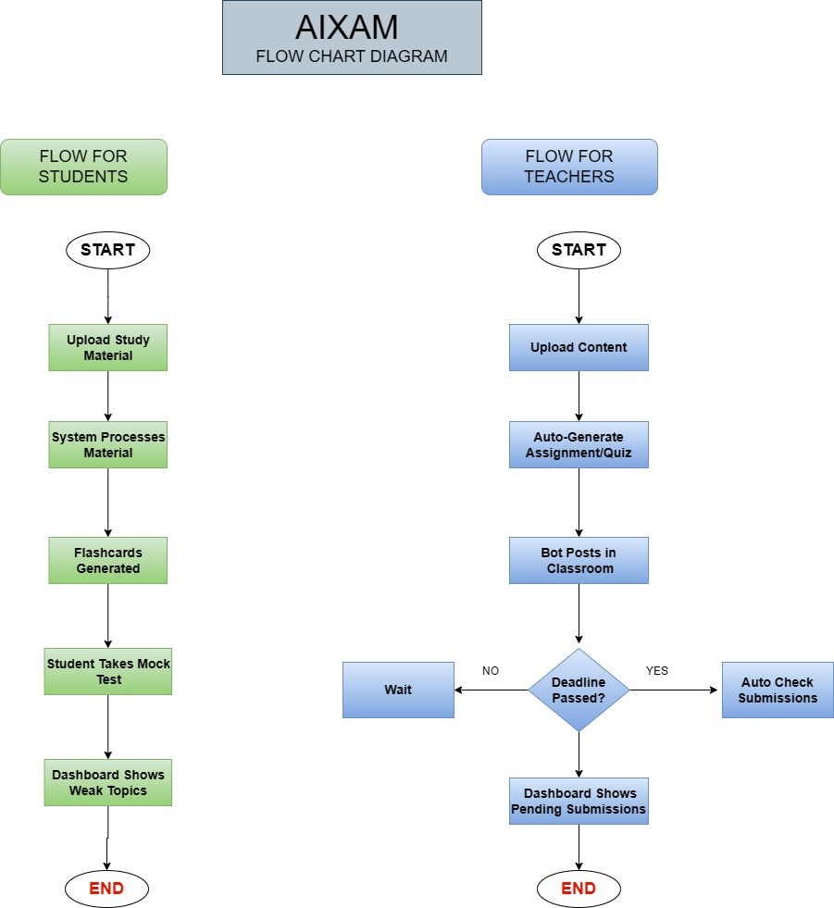

2-Use Case Diagram
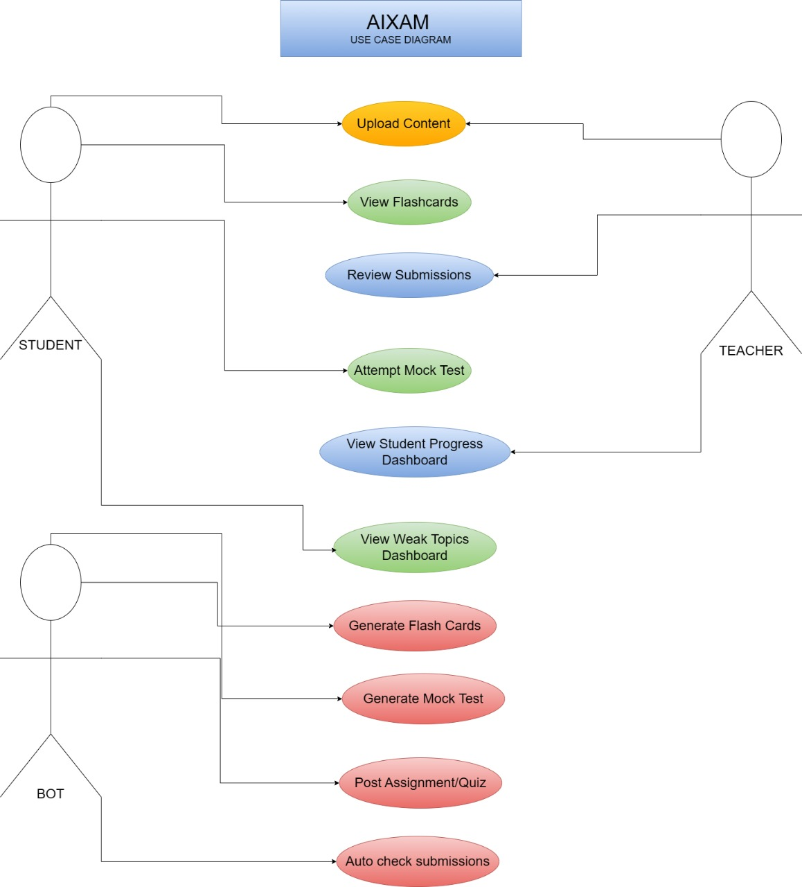

3-Software Development Plan
3.1-The Software Architecture
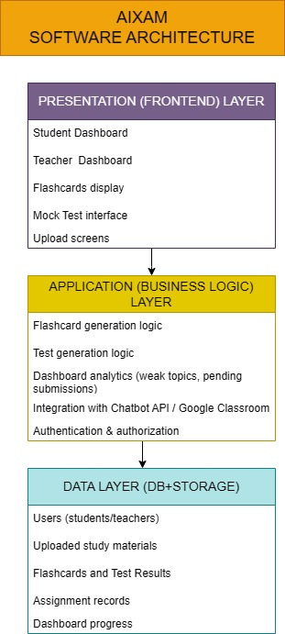

3.2-Number of Iterations:

Iteration 1 — Requirement + Design
Deliverables:
- Requirement gathering
- Use case diagram
- Flow charts
- System architecture
- Database design draft
- Wireframes / UI sketches
Purpose:
To understand the system clearly and finalize the scope.

Iteration 2 — Core Foundation
Deliverables:
- Backend + frontend folder structure
- User authentication module
- File upload API (dummy version)
- Database schema setup
- Basic dashboard layout (UI only, no logic)
- Flashcard extraction demo (sample text only)
Purpose:
Create the base of the system so development can continue smoothly.

- Fully Dressed Use Cases
Here are all possible use cases in Aixam:

Student Use Cases
1 Register / Login
- Upload Study Material
- Generate Flashcards
- View Flashcards (chapter/topic wise)
- Attempt Mock Test (MCQ)
- Attempt Mock Test (Descriptive)
- View Performance Analytics

Teacher Use Cases
- Upload Teaching Material
- Generate Assignments
- Generate Quizzes
- Create Lecture Slides
- Evaluate Assignments
- View Student Submissions

Bot / System Use Cases
- Post Assignment to Google Classroom
- Post Quiz / Announcement
- Track Assignment Deadlines
- Auto-Mark Missing Submissions (0 marks)

Due to the large number of system functionalities, all use cases are initially identified to provide a complete overview of system behavior. However, for detailed analysis, only the most critical and representative use cases are fully documented. These selected use cases cover the core student functionality, teacher automation, and system-level integration, while the remaining use cases follow similar interaction patterns and workflows.

Use Case 1: Generate Flashcards
Primary Actor: Student
Preconditions:
- Student is registered and logged into the system
- Study material is available in PDF or slide format
Postconditions:
- Flashcards are generated and stored in the system
- Flashcards are organized chapter-wise and topic-wise

Main Success Scenario:
- Student uploads study material to the platform
- System validates the file format
- System processes the uploaded content
- System generates chapter-wise and topic-wise flashcards
- Generated flashcards are displayed to the student
Alternate Flow:
- 2a. If the uploaded file format is invalid, the system displays an error message
- 3a. If content processing fails, the system requests the student to re-upload the file

Use Case 2: Create and Evaluate Assignment
Primary Actor: Teacher
Preconditions:
- Teacher is authenticated in the system
- Teaching material is available for upload
Postconditions:
- Assignment is generated and saved in the system
- Student submissions are evaluated and recorded

Main Success Scenario:
- Teacher uploads teaching material
- System confirms successful upload
- Teacher requests assignment generation
- System generates an assignment based on the uploaded content
- Students submit assignments before the deadline
- System evaluates submitted assignments after the deadline
- Evaluation results are stored and made available to the teacher
Alternate Flow:
- 1a. If upload fails, the system prompts the teacher to retry
- 6a. If a student fails to submit the assignment, the system automatically assigns zero marks

Use Case 3: Post Assignment via Chatbot to Google Classroom
Primary Actor: Teacher
Secondary Actor: Google Classroom
Preconditions:
- Teacher is logged into the system
- Google Classroom integration is active
Postconditions:
- Assignment or announcement is posted to the selected classroom
- Posting confirmation is received
Main Success Scenario:
- Teacher issues a command to the chatbot (e.g., post assignment in BSCS Group A)
- System interprets the chatbot command
- System connects to Google Classroom
- Assignment or announcement is posted to the selected class
- Google Classroom confirms successful posting
- System notifies the teacher

Alternate Flow:
- 2a. If the chatbot fails to understand the command, the system requests clarification
- 3a. If Google Classroom connection fails, the system displays an error message

- -System Sequence Diagrams
We have identified the three most important scenarios and make SSDs for them in draw.io

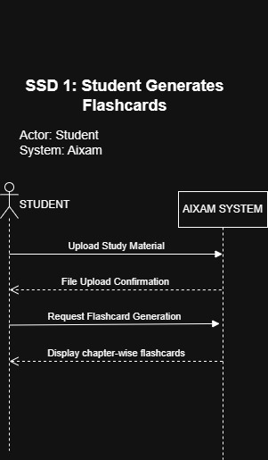
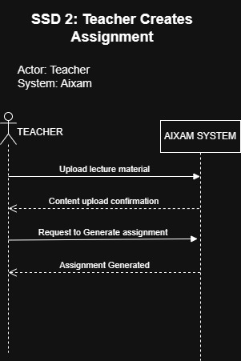

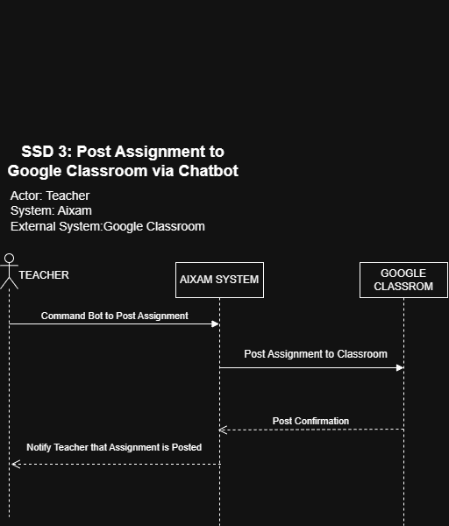

- -Testing Strategy

6.1-Testing Overview
Testing for the proposed system is planned according to an iterative development approach. At the current stage, frontend modules have been implemented and manually validated for functionality and usability. Backend services and AI-based components are scheduled for development in the next semester; therefore, integration and system-level testing will be performed after full implementation. A structured testing strategy has been defined to ensure reliability, correctness, and user satisfaction.

6.2-Testing Levels

Unit Testing
Unit testing focuses on verifying individual components independently. For the current stage, frontend components such as forms, dashboards, and navigation elements have been manually tested. In the next phase, backend modules such as flashcard generation, assignment evaluation logic, and chatbot command processing will undergo unit testing.

Integration Testing
Integration testing ensures proper interaction between different modules. This testing will be conducted once backend services are connected with the frontend. It will verify interactions such as flashcard generation with database storage, assignment creation with chatbot integration, and chatbot communication with Google Classroom.

System Testing
System testing validates the complete system as a whole. After the integration of frontend, backend, and AI components, end-to-end workflows will be tested, including study material upload to flashcard generation, assignment creation to evaluation, and chatbot-based classroom posting.

User Acceptance Testing (UAT)
User Acceptance Testing will be performed with students and teachers to evaluate system usability, performance, and practical effectiveness. Feedback gathered during this phase will help refine system features and improve the user experience.

6.3-Testing Techniques

Black Box Testing
Black box testing focuses on validating system functionality based on inputs and outputs without considering internal implementation. At the current stage, this technique has been applied to test frontend input validation and user interface responses.

White Box Testing
White box testing examines internal logic and code structure. This technique will be applied in later stages to verify backend algorithms such as assignment evaluation rules, chatbot command interpretation, and deadline handling mechanisms.

Functional Testing
Functional testing ensures that each system feature works according to requirements. Frontend features have been partially validated, while complete functional testing will be conducted after backend integration.

Usability Testing
Usability testing evaluates the ease of use and user interaction. The system interface has been designed based on Human-Computer Interaction principles, and informal user feedback has been considered to improve navigation and accessibility.

6.4-Testing Status
At the current development stage, testing is limited to frontend validation and usability checks. Comprehensive testing at unit, integration, and system levels will be performed after backend and AI modules are implemented in the next phase.

- -Software Require Specification Document

