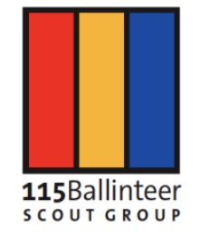

To whom it may concern,

I am writing to confirm our entitlement to register the domain 115ballinteer.ie.

Organization Name: 115th Dublin (Ballinteer) Scout Group Organization Type: Unincorporated Association / Local Youth Group Connection to Ireland: We are an active local unit of Scouting Ireland (Registered Charity Number: 20004347). Our group is based at the Scout Den, Broadford Rise, Ballinteer, Dublin 16 (D16 X9V0).

The domain will be used to provide information to parents, scout members, and the local Ballinteer community regarding our activities, news, and events.

Temp site here for your perusal: https://website-db1306.tiiny.site

Signed,
Karen McLaughlin
MNC Section Leader

