3. Analysis
3.1 Choice of Plot: Bar Plot
Contingency Table is created to obtain the raw count of toss won match, toss lost match. Bar Chart is selected as the main visualization plot because it clearly shows the proportion between two groups whether the team that won toss also won the match (1) or not (0).
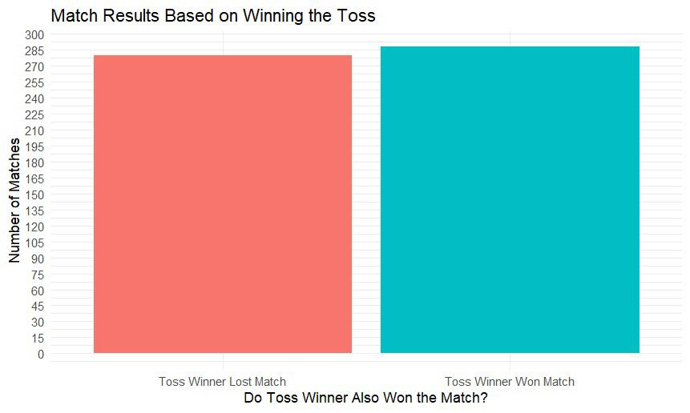
3.3 Useful information relating to understand the data
The Contingency Table simply shows us the raw count of wins and losses by the team that won the toss. Visually, the bar chart shows that the toss winner appears to win slightly more than 50% of the matches. However, this plot doesn't prove anything; it only shows the observed outcome. We need the Chi-squared test to determine if that slight advantage is a real or not.

