**UNIVERSITY OF NAIROBI**

**LOWER KABETE CAMPUS**

**DIS304: Business Applications Development 1 Assignment**

**D33/38037/2016**

**MUSYIMI KENNEDY NZYUKO**

**Wetu Flowchart**

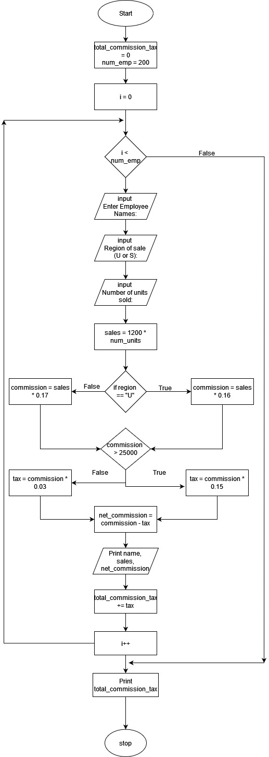

**Swallow Tea Picker’s Flowchart**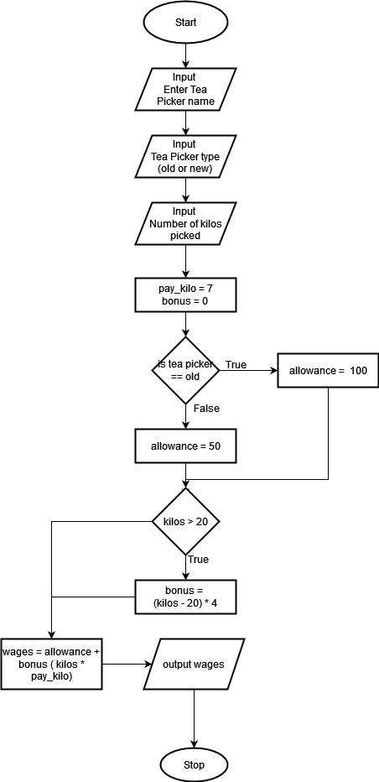

**MaliYao Flowchart**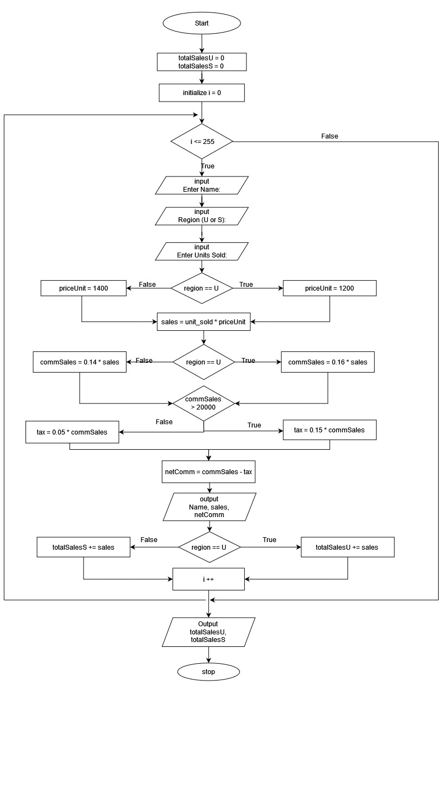

**Cheka Deals C++ Program**

#include <iostream>

#include <string>

using namespace std;

float calcDiscountAmt(float amt, float rate)

{

return amt * rate;

}

int main()

{

string name;

string product;

float purchase;

int units;

float price;

float discount;

float vat;

cout << "Enter customer name: ";

cin >> name;

cout << "\nEnter product (X, Y or Z): ";

cin >> product;

cout << "\nEnter number of units purchased: ";

cin >> units;

if (product == "X")

{

price = 70;

}

else if (product == "Y")

{

price = 85;

}

else if (product == "Z")

{

price = 115;

}

purchase = price * units;

if (product != "Z")

{

if (purchase > 10000)

{

discount = calcDiscountAmt(purchase, 0.10);

}

else

{

discount = calcDiscountAmt(purchase, 0.03);

}

purchase = purchase - discount;

}

if (product == "Y")

{

vat = purchase * 0.16;

purchase = purchase + vat;

}

cout << "\n"<< "SalesPerson: "<< name <<"\nAmount to be paid: "<< purchase<< " Kshs" << endl;

return 0;

}

**Mwambie C++ Program**

#include <iostream>

#include <string>

using namespace std;

float calcGrossPay(float pay, int mileage, float houseAllowance)

{

return pay + mileage + houseAllowance;

}

float calcBasicPay(float wage, int hours)

{

return wage * hours;

}

float calcMileageCost(float rate, float distance)

{

return rate * distance;

}

int main()

{

int payrollNum;

string grade;

int8_t isMarried;

int hoursWorked;

float mileage;

float basicPay;

float grossPay;

float netPay;

float tax = 0;

float distance;

float wageRate;

float houseAllowance = 0;

cout << "Enter employee payroll Number: ";

cin >> payrollNum;

cout << "\nEnter employee grade (A or B must be in capital case): ";

cin >> grade;

if (grade != "A" && grade != "B")

{

cout << "Error";

cout << "\nEnter employee grade (A or B must be in capital case): ";

cin >> grade;

}

cout << "\nEnter marital status (1 for married and 2 not married): ";

cin >> isMarried;

if (isMarried == 1 && isMarried == 2)

{

cout << "Error";

cout << "\nEnter marital status (1 for married and 2 not married): ";

cin >> isMarried;

}

cout << "\nHours worked per month? ";

cin >> hoursWorked;

cout << "\nDistance cover per month from work? ";

cin >> distance;

if (grade == "A")

{

wageRate = 500;

mileage = calcMileageCost(65, distance);

}

else

{

wageRate = 700;

mileage = calcMileageCost(58, distance);

}

if (hoursWorked > 160)

{

wageRate = wageRate * 1.5;

}

basicPay = calcBasicPay(wageRate, hoursWorked);

if (isMarried == 1)

{

houseAllowance = 8000;

}

grossPay = basicPay + mileage + houseAllowance;

if (grossPay > 25000)

{

tax = grossPay * 0.10;

}

netPay = grossPay - tax;

cout << "\n\t\t**********OutPut in (KSHS)**********\n\n";

cout << "\t\t Employee payroll number: " << payrollNum << "\n";

cout << "\t\t Employee gross pay: " << grossPay << "\n";

cout << "\t\t Employee tax deducted: " << tax << "\n";

cout << "\t\t Employee net pay: " << netPay << "\n";

cout << "\n\t\t*****************Final*****************\n\n"

<< endl;

return 0;

}

**BebaSisi Python Program**

def main():

min_fare = 210

distance = int(input("Enter distance traveled: "))

time = int(input("Enter time taken (minutes)): "))

fare = ((distance * 65) + (time * 35)) / 2;

if fare <= min_fare:

fare = 210;

print(fare)

if __name__ == "__main__":

main()

**Sichoki Python Program**

def main():

num_emp = 50

total_sales_x = 0

total_sales_y = 0

total_sales_z = 0

tax = 0

commission = 0

price_unit = 1200

for _ in range(num_emp):

name = input("Enter employee name: ")

region = input("Enter region of sale(X,Y or Z): ").upper()

num_units = int(input("Enter number of units sold: "))

if region != "X" and region != "Y" and region != "Z":

print("Error")

region = input("Enter region of sale(X,Y or Z): ").upper()

sales = price_unit * num_units

if region == "X":

commission = sales * 0.15

elif region == "Y":

commission = sales * 0.18

else:

commission = sales * 0.19

if num_units > 300:

units = num_units - 300

if region == "X":

commission = commission + (10 * units)

elif region == "Y":

commission = commission + (15 * units)

if commission > 25000:

tax = commission * 0.10

net_sales_comm = commission - tax

if region == "X":

total_sales_x += sales

elif region == "Y":

total_sales_y += sales

else:

total_sales_z += sales

print(f"\nEmployee Name: {name} \nSales Value: {sales}\nCommission Earned: {commission} \nTax: {tax}\nNet Commission Earned: {net_sales_comm}\n")

print(f"Regional Sales Total (KSHS)\nRegion X: {total_sales_x}\nRegion Y: {total_sales_y}\nRegion Z: {total_sales_z}")

if __name__ == "__main__":

main()