Group Project Proposal – CSC 4370/6370
Bricks and Stones Recipe Studio

Group Members
- Kothoju Naresh – 002923882
- Sri Krishna Teja Gangina – 002923905
- Sattwik Bhattacharjee – 002960354

Project Summary
- Selected topic track: Track A – Recipe Studio
- Extension pack: Story Pack
- Bonus features: Feature 2 – Recommendation Engine UI, and Feature 5 – AI Ethics & Safety Notice System
Bricks and Stones Recipe Studio is a recipe website for pizza lovers who want to cook at home. Users can look through recipes, pick how many servings they need, save their favorites, and cook along one step at a time. The site is built with HTML and CSS only (no JavaScript and no AI service). It starts from our working prototype (index.html and styles.css), which already has tabbed screens, recipe cards, recipe details, a serving-size selector, favorites, a menu with flip cards and a cart, and a cook-along mode.
Story Pack: The cook-along turns into a short story with five chapters: Prologue, The Dough, Sauce and Cheese, The Bake, and Epilogue. Each chapter has a big chapter number, a story-style paragraph with a drop cap, and a progress bar.
Bonus 1 – Recommendation Engine UI: "Suggested next step" cards change based on what the user did. For example, if the user saves Margherita, the site suggests Pepperoni Classic. Each card shows a confidence label (High, Medium, Low) and a "Why this suggestion?" note. The AI idea shown here is a recommender system with explainable results. It is only a design simulation using fixed rules.
Bonus 2 – AI Ethics & Safety Notice System: Steps and outputs get a Low, Medium, or High risk badge with a short warning and a way to stay safe. For example, the 240 °C oven is High, allergens like gluten and dairy are Medium, and flouring the table is Low. The badges use an icon and words, not only color. The AI idea shown here is risk labeling and transparency.
Why we chose these two: Both fit a recipe site and both sit inside the main flow. Suggestions appear on Home, Favorites, and at the end of cooking. Safety badges appear on the recipe page and in every cooking chapter.
Target audience: Beginner home cooks and college students (ages 18–30) who want simple, clear pizza recipes on their phone or laptop. They need big readable steps, clear safety tips, and an easy way to save recipes. A second audience is people who want to browse a pizza menu and place a simple order.
Scope (14 days): We will build 10 screens, with two full recipes (Margherita and Pepperoni). Two extra recipes are optional and will be dropped first if we run short on time. We will not build real checkout, user accounts, or saved data after a page reload.

Proposed Wireframe

Homepage
The top bar has the logo and links to every screen. Below it, a large hero shows the title, one short sentence, and two buttons: Explore Menu and View Recipes. Next to it is a featured Margherita card. Under that are a story banner ("Begin Chapter 1"), three small link lists (Trending Recipes, Cooking Tools, Suggested Next Step), a row of four photos, and a footer. On phones, everything stacks into one column and the top bar becomes a bottom tab bar.

Screens (10 in total)
- 1. Home (required) – hero, featured recipe, story banner, suggestion card. Purpose: explain the site and start the user quickly.
- 2. Recipes List (required) – a grid of recipe cards with photo, time, difficulty, View Recipe button, and a heart to favorite. Purpose: compare and choose.
- 3. Recipe Detail (required) – photo, prep and cook time, serving selector, ingredient checklist, numbered steps, safety badges, and a Start Cook-Along button. Purpose: the main reading page.
- 4. Cook-Along (Story Mode) – five chapters with a progress bar, timer, and safety note. Purpose: guided cooking.
- 5. Favorites – saved recipes, or a friendly message if none. Purpose: quick access.
- 6. Menu – filter buttons, flip cards with nutrition bars, and a cart. Purpose: browse food items.
- 7. Order – item list, details form, and a thank-you message. Purpose: finish an order.
- 8. Gallery – photo grid. Purpose: inspiration.
- 9. Shopping List – checkable ingredients. Purpose: help the user buy what they need.
- 10. About / Contact (required) – project story, team, contact details, and an explanation of the suggestion and safety features. Purpose: introduce the team and document the bonus ideas.
Layout notes: Recipe Detail shows ingredients on the left and steps on the right on large screens, and stacks them on small screens. The recipe grid shows 3 columns on desktop, 2 on tablet, and 1 on phone. Detailed wireframe sketches will be added to the docs folder of our GitHub repository.

Planned responsive behavior
- Mobile (up to 640 px): one column. The top menu becomes a bottom tab bar with a "More" button. Cards, ingredients, and steps stack. Buttons are at least 44 px tall.
- Tablet (641–1024 px): two-column recipe grid. Ingredients and steps stack, and the hero image sits above the text.
- Desktop (over 1024 px): three-column recipe grid, full top menu, and ingredients next to steps.
- We build mobile first: the base CSS is for phones, and min-width media queries add the larger layouts.

Wireframe sketches
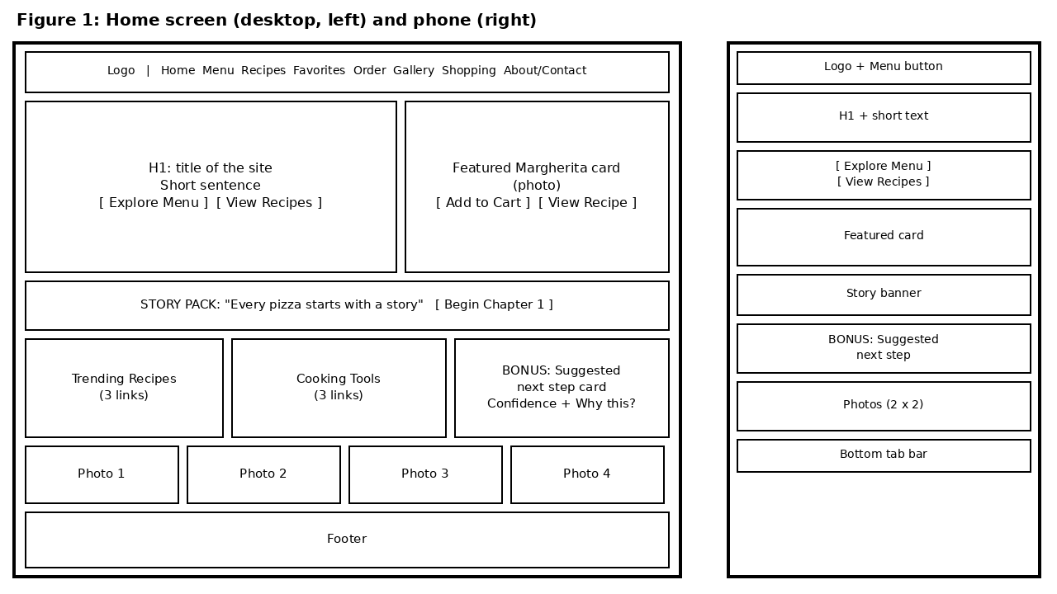
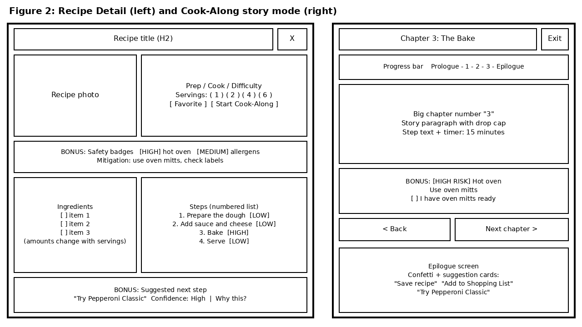

Functionality
Every interaction uses hidden radio buttons and checkboxes. A label acts as the button, and CSS (:checked and sibling selectors) shows or hides the right screen.

Screen-to-screen use cases
- Home → Recipes: user clicks View Recipes.
- Recipes, Home, or Favorites → Recipe Detail: user clicks View Recipe. The detail opens on top of the current screen.
- Recipe Detail → Cook-Along: user clicks Start Cook-Along.
- Chapter → next chapter: user clicks Next or a step dot. The progress bar fills.
- End of cooking → Favorites, Shopping List, or Home: user clicks a suggestion card.
- Any screen → About/Contact through the top bar. Any popup → previous screen with the Close button.

Transitions
- Screens fade in and slide up slightly when opened (about 420 ms).
- Recipe cards lift up and the photo zooms a little on hover or focus.
- Cook-along chapters slide in sideways, and the progress bar width grows smoothly.

Transformations
- Menu cards flip in 3D (rotateY) to show nutrition and the Add to Cart button. They also flip on keyboard focus so touch and keyboard users can use them.
- translateY for hover lift, scale for photo zoom and the heart pop, translateX for chapter slides, and rotate for the "Why this?" arrow.

Animations
- Confetti bounce at the end of the recipe (already in the prototype).
- Chapter title fade-in for the story feel.
- Confidence meter that grows from empty to its value.
- A soft pulse on High-risk badges, which stops for users who turn on reduced motion.

User Experience

Use case for each page
- Home: a new visitor understands the site and reaches a recipe in one click.
- Recipes List: a cook compares recipes by time and difficulty.
- Recipe Detail: a cook picks 4 servings and sees the right amounts.
- Cook-Along: a cook follows the recipe one chapter at a time and sees the oven warning.
- Favorites, Menu, Order, Gallery, Shopping List: save recipes, filter and order items, view photos, and tick off groceries.
- About/Contact: a reviewer finds the team names, contact details, and bonus feature notes.

Accessibility notes
- Focus: every button and link gets a clear visible outline, and a skip link jumps to the main content.
- Contrast: text is checked to meet WCAG AA, and risk levels use icons and words, not only color.
- Reduced motion: flips, bounces, pulses, and slides are turned off when the user asks for less motion.
- Structure: correct heading order, page landmarks, photo descriptions, and big tap targets for phones.

Test Cases
- Usability test: five classmates try four tasks without help: find Pepperoni and set 4 servings, favorite a recipe, finish the cook-along, and find the team contact. We note where they get stuck and ask them to rate clarity and ease from 1 to 5. Goal: at least 80% of tasks done without help.
- Responsive test: check every screen at 360, 390, 768, 1024, and 1440 px wide. There should be no sideways scrolling, and cards should reflow from 3 to 2 to 1 columns.
- Quality checks: use only the keyboard to move through the site, test with reduced motion on, and run the W3C HTML and CSS validators and a Lighthouse accessibility check (goal: 90 or higher).
- Navigation and link check: click every menu link, button, and Close button on all 10 screens to make sure nothing is broken and the user can always go back. Check that images load and have alt text.
- Server check: upload the project to the designated server and confirm it runs the same as on our computers (HTML and CSS only, correct file paths, image names match exactly).
- QA notes: every test result (device size, link check, accessibility finding, and the fix we made) is written in docs/qa-notes.md.
- Recommendation feature (3 checks): (1) layout – cards look the same on Home, Favorites, and the end of cooking; (2) accessibility – "Why this?" works with the keyboard and the confidence label is readable without color; (3) responsive – cards stack neatly at 360 px.
- Safety feature (3 checks): (1) layout – badges and notes do not push content out of place; (2) accessibility – badge text such as "High risk" is read out and still clear in grayscale; (3) responsive – notes stack below the content at 360 px.

Approach to Refine Improvements
We will test early, write down all feedback, and fix the biggest problems first. We will do two feedback rounds: a quick layout check with two peers on Day 6 and the full usability test with five peers on Day 12. We will work on separate GitHub branches, review each other's changes, and use clear commit messages.
Problems we already found in the prototype and will fix: the top menu disappears on phones, there are no visible focus outlines, the Exit Cook Mode button may not close the overlay, the heart icon does not change, and the About page still shows old team names.

14-day plan
- Days 1–2: finalize wireframes, set up GitHub and the Kanban board, split the CSS into files with variables, and clean up the HTML structure. Start the development journal.
- Days 3–4: build Home and Recipes List (Naresh), Recipe Detail and About/Contact (Sri Krishna Teja), and Favorites, Menu, Order, Gallery, and Shopping List (Sattwik).
- Days 5–6: mobile menu, responsive layouts, focus styles, and the first peer check.
- Days 7–8: Story Pack chapters (Sattwik and Naresh) and the Pepperoni recipe story.
- Days 9–10: Recommendation cards (Naresh), safety badges (Sri Krishna Teja), and testing support for both bonus features (Sattwik).
- Day 11: accessibility and reduced-motion check.
- Day 12: full peer usability test and fixes.
- Days 13–14: README (with AI disclosure), screenshots or GIF, QA notes, design reflection, and the links.txt file. Day 14 is final testing on the server, presentation practice, and buffer time.

Project Management and Quality Evidence
- Kanban board: we use a GitHub Projects board with the columns Backlog, In Progress, Review, and Done. Every screen, bonus feature, and fix is a card with an owner. We move cards as work happens and take a screenshot of the board at the end of each week.
- Development journal (docs/dev-journal.md): a short entry after each work session with the date, what we did, one problem we hit, and the decision we made. This shows our problem-solving.
- QA notes (docs/qa-notes.md): a simple log of mobile, tablet, and desktop checks, link checks, keyboard and accessibility checks, and the fixes we made.
- Timeline match: the Kanban cards follow the 14-day plan above, so the finished project matches this proposal.

Delivery and Submission
- GitHub repository: all code, images, and docs, with small, clear commits such as "feat: add recipe grid" or "fix: mobile menu".
- README: what the project is, how to set it up and run it, the folder structure, our design and implementation decisions, the two bonus features (purpose, how it works, trade-offs, tests), screenshots or GIF, and a short reflection.
- AI disclosure: the README will say clearly where AI help was used. AI (Claude) was used to help draft this proposal. If we use AI for code, ideas, or wording later, we will list it.
- links.txt: one text file with the GitHub repository link, the live site link on the designated server, the Kanban board link, and the screenshots or demo link.
- Project type: HTML and CSS only, so it works on the designated server with no build step.

Quality Targets
- Technical: proper landmarks (header, nav, main, section, footer) and one clear heading order; Flexbox and Grid used in real layouts with no overlap or clipping; motion that helps the user (feedback, hierarchy, guidance) with keyframes grouped in one place and timing values stored as CSS variables.
- Design and accessibility: one color palette, one font set, and the same card, button, nav, and spacing styles on every screen; clear contrast, visible focus, keyboard support, and reduced-motion support.
- Documentation: Kanban evidence, journal, QA notes, README, and links.txt as described above.

Presentation Preparation
We will use the Presentation Question Guide and Presentation Guidelines to prepare. Each member will prepare evidence (screenshots, commits, QA notes, and code examples) for at least one answer from each of Q1–Q11, and the whole team will practice the five Q12 defense questions. During the live walkthrough we will answer these questions as we show each screen, and each member will present the parts they built.

Pre-grading checklist
- Project is HTML/CSS only and runs on the designated server.
- Track A and the Story Pack are built as proposed.
- Proposal has audience, wireframes, and responsive plan.
- QA notes cover mobile, tablet, desktop, navigation, and accessibility.
- Two distinct bonus features are chosen (graduate requirement).
- GitHub repo is complete with meaningful commits.
- README includes any AI assistance.
- All required links are in links.txt.

External Assets
- Food photos (16 images in the images folder): free photos from Unsplash or Pexels, or our own photos. We will list the photographer and link for each photo in the README. If a photo is missing, we use a plain color block with alt text.
- Fonts and icons: system fonts and normal emoji only, so nothing external is needed.
- Brand look: the project name is Bricks and Stones Recipe Studio. The red and blue colors come from the prototype and are set as CSS variables, so they are easy to change. The name and logo are our own.

Signed Proposal Statement
We acknowledge the conditions in this proposal, commit to active participation, and understand that individual grades may vary based on contribution and performance.
Name + Signature: Kothoju Naresh (002923882) KN
Name + Signature: Sri Krishna Teja Gangina (002923905) SKTG
Name + Signature: Sattwik Bhattacharjee (002960354) SB

