# Individual Weekly Report for Kristina Chen

### CyberQuest 04.26.24

## **Accomplishments**

* 3 Activities created, 2 for password protection and 1 for phishing
* Wordpress account created, another wireframe created
* Meeting with instructor (2)

## Weekly Activities

| **Activity / Task / Work** | **Hours** | **Status** |
| --- | --- | --- |
| Meeting with Instructor | 1 | **Complete** |
| Password Safety Research | 2 | In-progress |
| Password Activity Brainstorm / Documentation | 5 | In-progress |
| Phishing Training Research (+ Caesar Cipher) | 5 | In-progress |
| Phishing Activity | 3 | In-progress |
|  |  |  |
|  |  |  |
|  |  |  |
|  |  |  |
|  |  |  |
| **Weekly Total** | **16** |  |
| Previous Weekly Cumulative Total (Carry Over) | 46 |  |
| **Current Cumulative Total** | **62** |  |

## **Plans for Next Week**

| **Activity / Task / Work** | **Est Hours** |
| --- | --- |
| Wordpress Website Start | 8 |
| Poster Drafting | 3 |
| Activity brainstorm / documentation | 4 |
|  |  |

## **Response to Feedback**

## “Why don’t you raise the target audience's age?” (Kevin Li)

## After a few weeks I wanted to raise the target audience a bit, however after reevaluating resources available for online safety I think it’s even more important to target the slightly younger audience of 13-15 as this is when they are more heavily beginning their own independent engagement online. In addition I feel it’s important to develop behavioral awareness preemptively. (before they are a more attractive target to fraud/hackers)

## “How did your meeting with your expert change the scope of your project?” (Professor Gregory)

## During my meeting with the professor last week I was very frazzled and frustrated with the path of finishing my capstone on time and ending up in a result I would be satisfied with, however it Professor Lidster made many points to how I should scope down, when presenting these frustrations and talking through what I understood from Professor Lidster to Professor Gregory I was able to formulate my own cohesive idea of what I really wanted to end up finishing this quarter. I want to develop a technical literacy course that could inspire teens to look into cybersecurity. Most importantly however I wanted to make sure I helped develop safe behaviors online and make them aware as upcoming young adults.

## “How will you engage the teens, since lecturing the whole time will not work” (Kevin Li)

## I will engage my class with a variety of activities, something I want to focus on is the connectivity of the entire day with the main ideas of the camp space. Some activities I have brainstormed could include an introduction of the Ceaser Cipher and Industry Phishing examples, made friendly and entertaining to a teen audience. These activities would include references to pop culture to get teens really engaged with the content.

## **Other Reflections**

I feel this week I hadn’t done enough documentation of meetings and preparation for my curriculum which caused my momentum in the project to fall rather flat in terms of vision and scope. The factors I took into consideration in evaluating my own progress was lack of material created despite rescoping my project.

I learned a lot this week about the difficulty it takes in creating a curriculum that know only educates but engages students. In addition I underestimated the work it takes to prepare an educator to teach a course effectively. If I could redo this week and the prior I would have had more time spent researching background information in addition to researching existing concepts that I can connect to prepare students' understanding of information security.

## **Comments, Issues, Notes, Anything Else?**

Thank you for being so quick to rearrange the schedule for the meeting and show & tell times. Are there any specific requirements for our next show & tell online?

## **Evidence of Work**

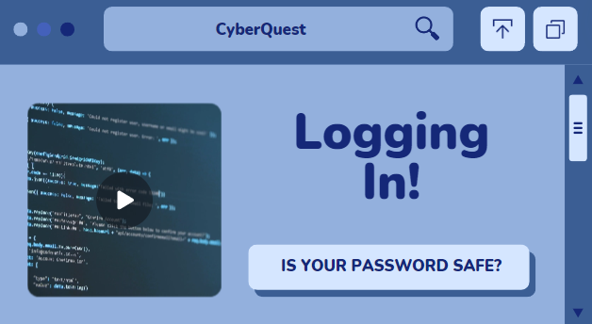

The above photo is the draft start to a lesson I’m creating within the first day centered on password safety. I intend to redo the slide to cater to teens.

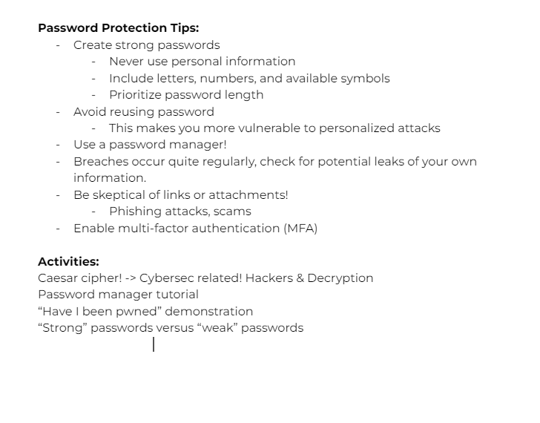

The screenshot above is the decisions I made regarding what to include in password protection. In addition I happened to remember the use of the Ceaser cipher and how that could engage students and they could connect it to hackers and threats these days.