# Individual Weekly Report for Kristina Chen

### CyberQuest 05.03.24

## **Accomplishments**

* Show and Tell #2 Presentation produced
* Phishing Activity Draft mostly completed
* Caesar Cipher Activity instructions accomplished
* Narrative activity flowchart produced

## Weekly Activities

| **Activity / Task / Work** | **Hours** | **Status** |
| --- | --- | --- |
| Curriculum Activity Documentation | 10 | **Complete** |
| Cyberquest Objective Diagrams | 2 | In-progress |
| Show & Tell Preparation + Presentation | 1 | In-progress |
| Wordpress Website Development | 2 | In-progress |
| Weekly Report | 1 | In-progress |
|  |  |  |
|  |  |  |
|  |  |  |
|  |  |  |
|  |  |  |
| **Weekly Total** | **15** |  |
| Previous Weekly Cumulative Total (Carry Over) | 62 |  |
| **Current Cumulative Total** | **77** |  |

## **Plans for Next Week**

| **Activity / Task / Work** | **Est Hours** |
| --- | --- |
| Wordpress Website Development | 5 |
| Narrative Activity Development | 5 |
| Goals + Objectives Diagram Flow | 5 |
|  |  |

## **Response to Feedback**

## “Where will you include and show more about metrics and learning goals, because that is what educators will be interested in?” (Professor Kim)

## I will include details like that in a document specified to educators as well as in the overviews of my educator’s guide to running the classroom. I want to focus a lot on the activities right now as I have my main objectives finalized and the main centerpiece of my capstone will be the actual curriculum and then the educator preparation document.

## **Other Reflections**

This week I was very satisfied with the development of my curriculum as I feel it’s really taken solid footing as I’ve created a narrative that’s helped me direct the direction of my activities and daily theming.

Now I feel like I really need to hone down on the actual activity portion following my narrative flowchart, then I’ll have a mostly working curriculum. However if I were to redo this week I would’ve spent more time after show & tell to create more activity outlines and graphics for the lessons. In addition I feel as if I fell flat on my website development process.

## **Comments, Issues, Notes, Anything Else?**

My only concern as of right now is my ability to develop a cohesive poster/website that really represents the work of my capstone.

## **Evidence of Work**

## 

Above is the narrative flowchart that shows the direction in which I want my story to go and the activities it will correspond to in correlation to the story.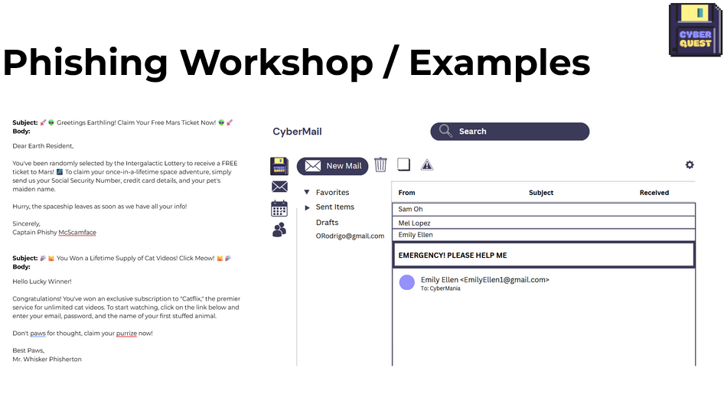

Above on the left are some sample phishing emails I had developed and on the right is an email template I created on canva, in which I intend to insert the emails and have the students deduct and investigate which are phishing emails and which seem to be legitimate.

## 

Above is a screenshot of a Caesar cipher tool and the lesson that will be used to develop a similar tool. The lesson will also include correlation to the act of encryption and decryption.