# Individual Weekly Report for Kristina Chen

### CyberQuest 05.24.24

## **Accomplishments**

* Portfolio Draft Finished
* Website Worked on
* Stakeholder + Weekly Report

## Weekly Activities

| **Activity / Task / Work** | **Hours** | **Status** |
| --- | --- | --- |
| Portfolio Draft | 5 | Ongoing |
| Website Worked On | 3 | Ongoing |
| Poster Draft | 2 | Ongoing |
| Reports | 2 | Finished |
| Monday Class | 2 | Finished |
| Wednesday Class | 2 | Finished |
|  |  |  |
|  |  |  |
|  |  |  |
|  |  |  |
| **Weekly Total** | **16** |  |
| Previous Weekly Cumulative Total (Carry Over) | 104 |  |
| **Current Cumulative Total** | **120** |  |

## **Plans for Next Week**

| **Activity / Task / Work** | **Est Hours** |
| --- | --- |
| Portfolio Revisions | 6 |
| Class time | 4 |
| Poster Design | 5 |
|  |  |

## **Response to Feedback**

## “What is the story in which you are trying to tell?” (CSS 496 Class, Professor Kim)

When reflecting upon this question I believe the story I’m trying to tell is the importance of information security for young teens. The reason I believe they are the best audience for this matter is their ability to adapt and flexibility of perspective. In a time of great technological change they will be the most equipped and vulnerable to future frauds online and they will also be the ones to help their friends/family in need. In the past 50 or so years internet safety and technological literacy education hasn’t changed with the rapid dependency on technologies. This is a big mistake and CyberQuest means to refresh these perspectives and acknowledge the lack of work done on security education online.

## “Why is online safety important? Why do we care?” (Professor Kim)

## Going back to my last response, security is important because it holds so many of our assets such as PII (Personal identifying information), medical records, and financial assets. We care because these are all things we rely on and are judged upon in sectors such as law, health, and finances (especially from a legal perspective).

## **Other Reflections**

As this project comes to a close it really makes me realize how little time there is to create a polished product such as this curriculum especially when accounting how many meetings I should have added, research done, and other axed features I wanted to introduce initially such as the simulations. With an industry so broad such as education combined with the technicalities of STEM, I realize the humongous task CyberQuest is aiming to take a small step towards.

## **Comments, Issues, Notes, Anything Else?**

In future capstones, I would wish for less specific required meetings / formal reports or at least a way to combine the reports into our formalized portfolio.

In addition I would hope for clearer written directions/rubrics/examples for the formal portfolio at the end as it’s been quite confusing what to put/not put on our portfolios and where the different forms of media goes. While I do appreciate the quick response times of our professors it would make this last stretch more easily understandable.

One last note, perhaps a classroom discussion board with Q/A would be helpful so professors need not answer questions over and over and have answers available readily so.

## **Evidence of Work**

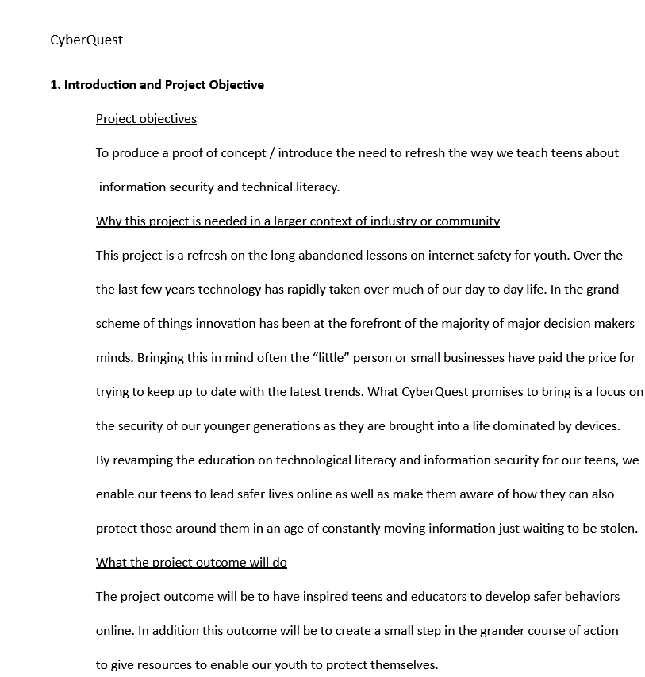

Above is a portion of my draft portfolio 1, this section in particular is section 1 focusing on broad project objectives and outcomes.

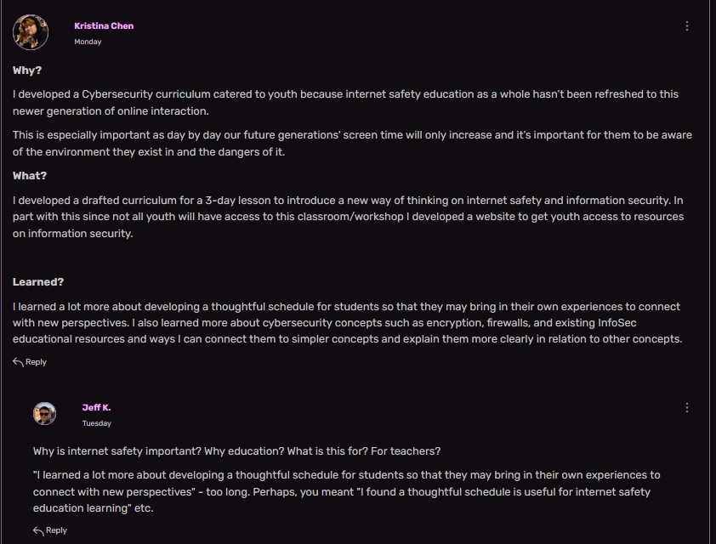

Above is my initial draft for the bullet point assignment in class, this has since then been revamped to include a full narrative and developed set of lessons I learned throughout the project development process.