**Module 5: Option #1**

Lance I. Evans

Colorado State University Global

CSC515-1: Foundations of Computer Vision

Dr. Brian Holbert

25 November 2022

**Summary**

The fingerprint retrieved is already in black and white, there was no need to include a binary code. Additionally, each morphology used a kernel size of (2, 2), delivering as optimally as possible with my knowledge.

Erosion darkened the contours of the fingerprint. The darkening of the lines in the prints can both hurt and help the analysis of fingerprints. It can be hurt through over darkening, while experimenting with these morphologies I increased and decreased kernel size, with erosion specifically, the increased kernel size causes completely obscured prints causing the print to completely unrecognizable. Whereas decreasing kernel size to the minimum returned no changes in the image, but one step above the minimum revealed significant enhancements to the print. This can be of assistance if the prints are complete, it may allow for attaching or connected points that were not meant to be separated. Minutiae were became distorted for this which could cause error in matching prints.

Dilation thinned the contours of the print to reveal a finer lining of the fingerprint. This can be beneficial as well as hurtful in the process of fingerprint analysis. It may be beneficial if the image is far too clustered with the normal lining, dilation will add gaps between each individual line to reveal a more precise print image. Though it may be hurtful in the wrong situation as well, given a lighter fingerprint, this will fade away lines and possibly erase the entirety of sections of fingerprints. Increasing the iterations or kernel size caused the fingerprint to almost completely fade away, while decreasing them to the minimum had no visual changes.

Opening and closing both revealed the best and worst parts of erosion and dilation. They both revealed slightly over clustered areas that would be impossible to decipher, and also over thinned areas that would require more scrutiny. They also created sharper lines than the original image, while being lighter and darker than the erosion and dilation respectively. With closing the lines are almost as sharp as dilation for the most part, with the exception to the portions that became convoluted, while opening revealed sharper lines than erosion, except for the incomplete lines.

Results of mine were similar to a couple academic research results. The first revealed that there are typical results of morphology, broken gaps (Kale et al.). Although the previous research used a more complex algorithm to display how well it can perform against traditional morphology. Another article revealed that “new gaps were created” (Srisombut, 2004), in reference to opening and closing morphology, which is similar to the results I had.

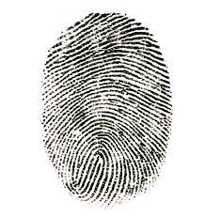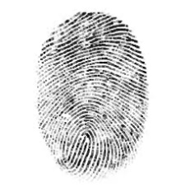

Original Erosion Dilation Opening Closing

`

**References**

Kale, K. V., Manza, R. R., Humbe, V. T., & Deshmukh, P. (n.d.). GSPx2005 Pervasive Signal Processing Conference, CA, USA.

Srisombut, P. (2004, November 4). *Morphological Image Processing* . Graphics.ics.uci.edu. Retrieved November 25, 2022, from http://graphics.ics.uci.edu/CS111/Slides/woodsandgonzalez.pdf