­­­



**DATABASE MANAGEMENT SYSTEM PROJECT REPORT ON**

**“LAUNDRY SERVICE DATABASE”**

**SUBMITTED BY:**

**ROSHAN BADRINATH**

**1NT15CS140**

**GUIDED BY:**

DR.PRITI MISHRA MRS.JAGDEVI N KALSHETTY

(ASSOCIATE PROFESSOR) (ASSISTANT PROFESSOR)

(DEPT.OF CSE) (DEPT.OF CSE)



**DEPARTMENT OF COMPUTER SCIENCE AND ENGINEERING**



**CERTIFICATE**

Certified that the project work entitled STUDENT MANAGEMENT SYSTEM is a bonafied work carried out by Roshan Badrinath[1NT15CS140] of semester V, in partial fulfillment for the award of degree of **bachelor of engineering of Visvesvaraya Technological University, Belgaum** during the year 2017-18. It is certified that all the corrections or suggestions indicated for internal assessment have been incorporated in the report deposited in the department library. The project report has been approved as it satisfies the academic requirements in respect of project work prescribed for bachelor of engineering degree.

**Guide 1 Guide 2 Head of Department**

**__________________ __________________ ___________________**

(Dr. Priti Mishra ( Mrs. Jagdevi N Kalshetty (Dr. Thippeswamy M N

Assoc. Professor Asst. Professor Hod &Professor

Dept Of Cse Dept Of Cse Dept Of Cse

Nmit, Bangalore-64) Nmit, Bangalore-64) Nmit, Bangalore-64)

**External VIVA**

**Name of the Examiners Signature with Date**

1._________________ _________________

**ACKNOWLEDGEMENT**

We are extremely grateful to our HOD, Dr. Thippeswamy who extended his support towards our project.

We remain indebted to our teacher Dr. Priti Mishra for her constant support in the Design, Implementation and Evaluation of the project. We are thankful to her for constructive criticism and valuable suggestions, which benefited us a lot while developing the project.

With candor and pleasure we take this opportunity to thank Mrs. Jagdevi N Kalshetty for the encouragement, co-operation and consent, without which we might not have been able to accomplish this project.

Finally, we gratefully acknowledge the support, encouragement and patience of our friends.

**TABLE OF CONTENTS**

|  |  |  |
| --- | --- | --- |
| **Sl. No.** | **Description** | **Page No.** |
|  | Introduction | 6 |
|  | Requirements | 7 |
|  | Entity Relationship Diagram | 8 |
|  | Implementation | 4 |
|  | Snapshots | 11 |
|  | Conclusion | 13 |
|  | Bibliography | 14 |

**ABSTRACT**

In today’s fast paced busy world, many people don’t have any enough time to wash clothes and iron it. So this is a small project for the implementation of the laundry service.

Laundry processes include washing (usually with water containing detergents or other chemicals), agitation, rinsing, drying, pressing (ironing), and [folding](https://en.wikipedia.org/wiki/Self-service_laundry#Fluff_and_Fold_services). The washing will often be done at a temperature above room temperature to increase the activities of any chemicals used and the solubility of stains, and high temperatures kill micro-organisms that may be present on the fabric.

A self-service laundry, coin laundry, or coin wash is a facility where clothes are washed and dried without much personalized professional help.

This helps us in our eternal quest for work-life balance. So with the help of this we can stop wasting our time doing dirty laundry, instead do something that makes us happy – build our business, or spend some time with our beloved ones.

Our application allows customers to wash different types of clothes such as cotton,nylon,silk,etc..It also provides information on the rates for different types of clothes. This Project helps in managing the customer details who has provided clothes for washing and it also maintains the cost and due dates within which the clothes has to be returned to the customer.

1. **INTRODUCTION**

DATABASE:A database is a collection of related data. Defining a database involves specifying the data type, attributes and constraints for the data to be stored.

Constructing a database is a process of storing itself on some storage medium like disk or tape that can be handled by the DBMS. Manipulating a database includes such functions like querying a database, to retrieve a specific data, updating the database, to reflect the changes in the miniworld and generate reports from the data.

DBMS: It is a collection of programs that enables us to create, maintain and manipulate the database. It is hence the general-purpose software system that facilitates the process of defining, constructing and manipulating databases for various applications.

DATA MODEL: Is a set of concepts that is used to describe the structure of the database.

HIERARCHICAL DATA MODEL:This model represents data hierarchy which has to be maintained.

DATABASE ABSTRACTION: Major objective of databases is to provide the user with an abstract view of the data i.e. the system hides the details about the storage of the database. They include:

* LOW LEVEL ABSTRACTION: it defines how exactly the data is stored in the database. It is a detailed view dealing with the actual constructs used and the storage details of the database.
* CONCEPTUAL LEVEL: The next level of the abstraction defines how exactly the data is stored and the relationship that exists between the data. Implementation of the complex physical storage is hidden from the user.
* VIEW LEVEL: This s the highest level of data abstraction and provides the users wit facility to view the part of the database. This is to exploit the fact that many users will not need the intricate details of the data storage.
  + 1. **2. REQUIREMENTS**

This application is actually a suite of applications developed using:

**Hardware interfaces**

* Memory minimum of 1GB RAM
* Hard disk of 40 GB
* Monitor
* Mouse
* Keyboard
* Printer

**Software interfaces**

* Operating System --------- Linux
* Front End --------- HTML, CSS
* Backend --------- PHP, Apache2 Server, MySQL

**3. ER DIAGRAM OF STUDENT MANAGEMENT SYSTEM**

Cloth_now

Cur_order

Login user

Shirt no.

Saree no.

Pant no.

Jeans no.

Kurta no.

Oid

Cloth

Status

Date

price

**Username**

**password**

profile

Login admin

All_order

Uid

Username

Fname

Lname

Gender

City

email

**Username**

**password**

Oid

Cloth

Status

Date

price

Price cloth

Wash

Shirt

Saree

Pant

jeans

location

Cloth no.

Oid

Street

City

landmark

Shirt no.

Saree no.

Pant no.

Jeans no.

Kurta no.

ku

**Fig 1.1**

**DESCRIPTION OF ER-DIAGRAM**

An Entity Relationship data model is based on a perception of a real world that consists of a set of basic objects called **entities** and of **relationships** among these entities.

The basic features of an ER diagram are:

1.**ENTITY TYPE:**

An entity type defines a collection of entities that have the same attributes .Each entity type in the database is described by its name and attributes.

The entity types used in our ER diagram are: LOGIN USER, LOGIN ADMIN, PRICE CLOTH, CLOTH NO, CURORDER, ALLORDER, PROFILE and LOCATION.

The attributes of the following entity types are:

1. LOGIN USER- username,password.
2. LOGIN ADMIN-username,password
3. PRICE CLOTH- wash,shirt,pant,kurta.
4. CLOTH NO-oid, shirtno, pantno,sareeno,kurtano.
5. CURORDER-oid,uid,status,date,price,cloth.
6. ALLORDER- oid,uid,status,date,price,cloth.
7. CLOTH NOW-oid, shirtno, pantno,sareeno,kurtano.
8. PROFILE-uid,username,fname,lname,gender,city,landmark.
9. LOCATION-oid,street,city,landmark.

**4. SCHEMA’S**

1. **schema for login user**

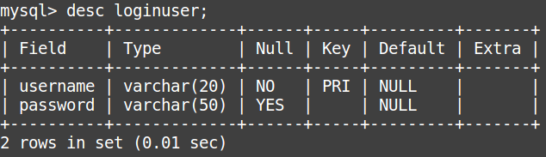

**Fig 4.1**

1. **schema for login admin**

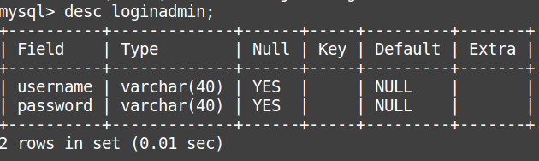

**Fig 4.2**

**3. schema for price cloth**

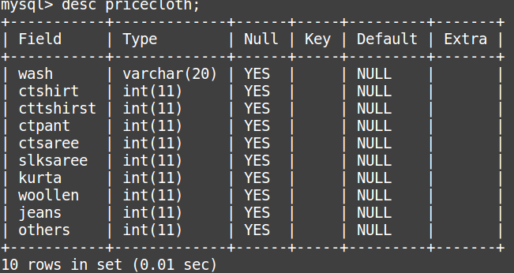

**Fig 4.3**

**4.schema for cloth number**

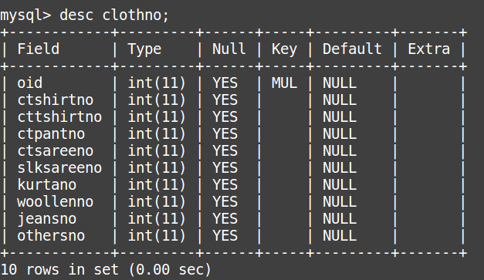

**Fig 4.4**

**5. schema for cloth now**

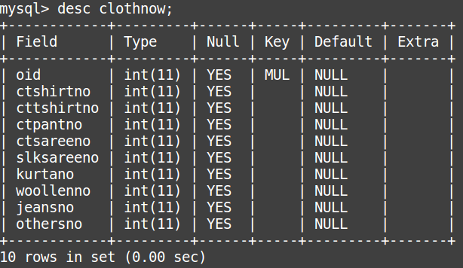

**Fig 4.5**

**6. schema for profile**

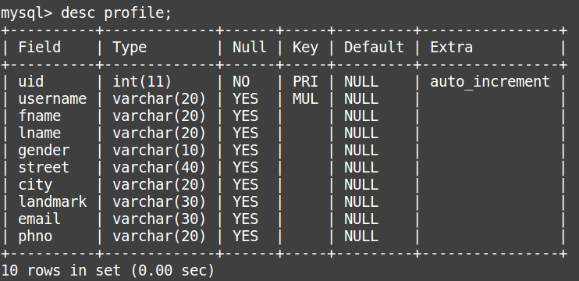

**Fig 4.6**

**7. schema for location**

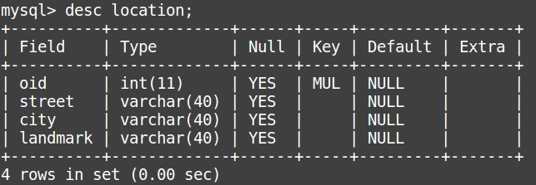

**Fig 4.7**

**8. schema for curorder**

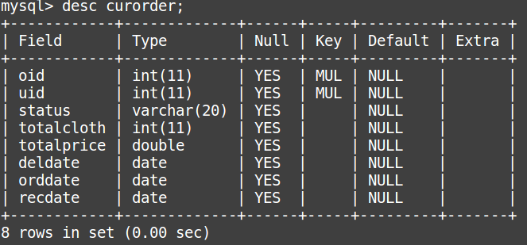

**Fig 4.8**

**9. schema for allorder**

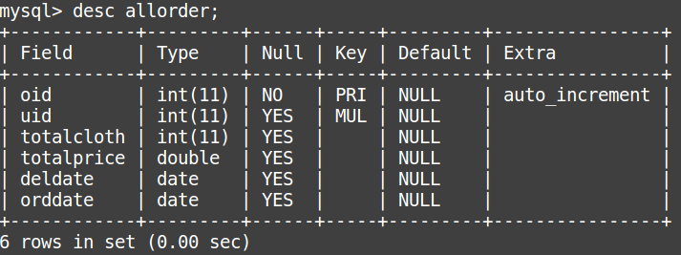

**Fig 4.9**

**5. IMPLEMENTATION CODE**

**5.1)ADMIN:**

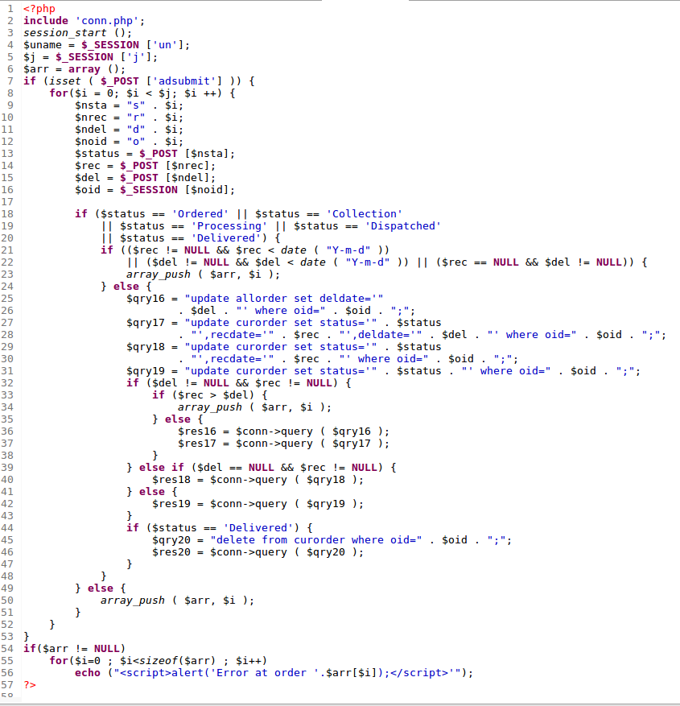**Fig:5.1.1**

**5.2)BILLING:**

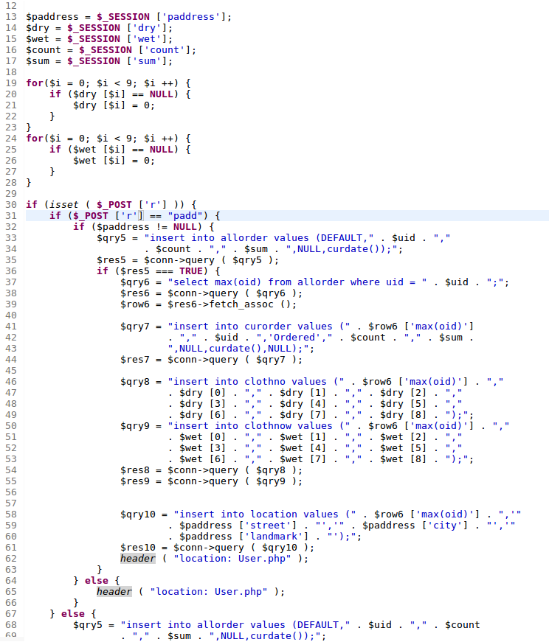

**Fig:5.2.1**

**5.3)CONNECTION:**

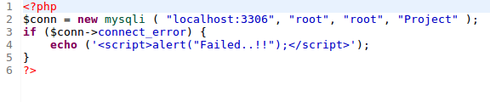

**Fig:5.3.1**

**5.4)USER CONTROL:**

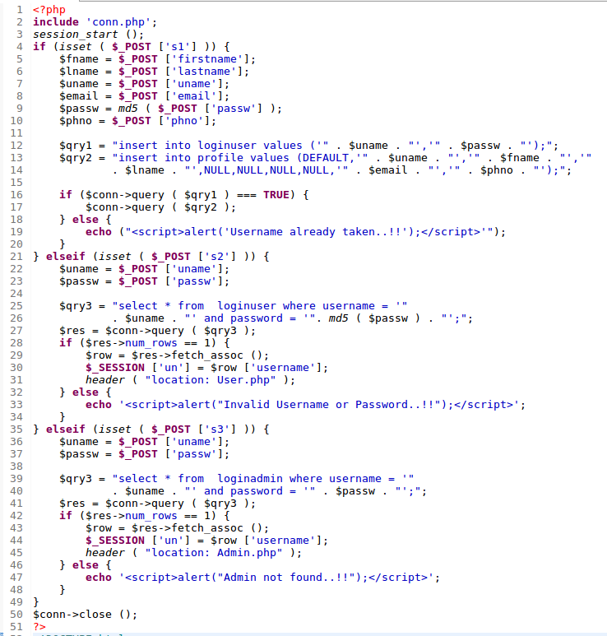

**Fig:5.4.1**

**5.5)LOGOUT:**

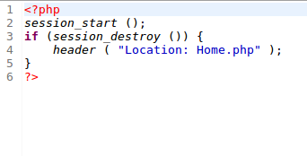

**Fig:5.5.1**

**5.6)USER:**

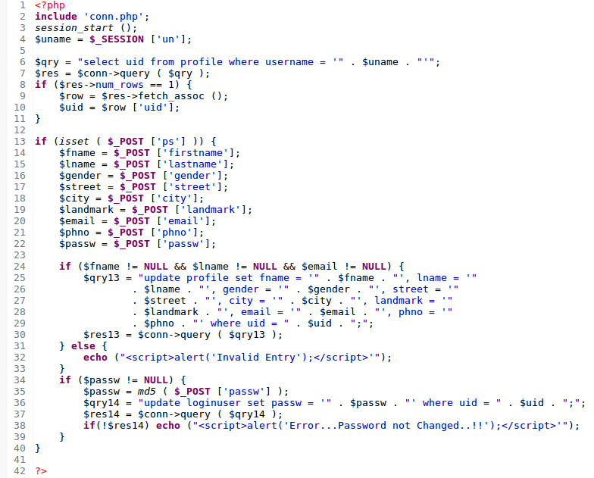

**Fig:5.6.1**

**5.7) ORDER:**

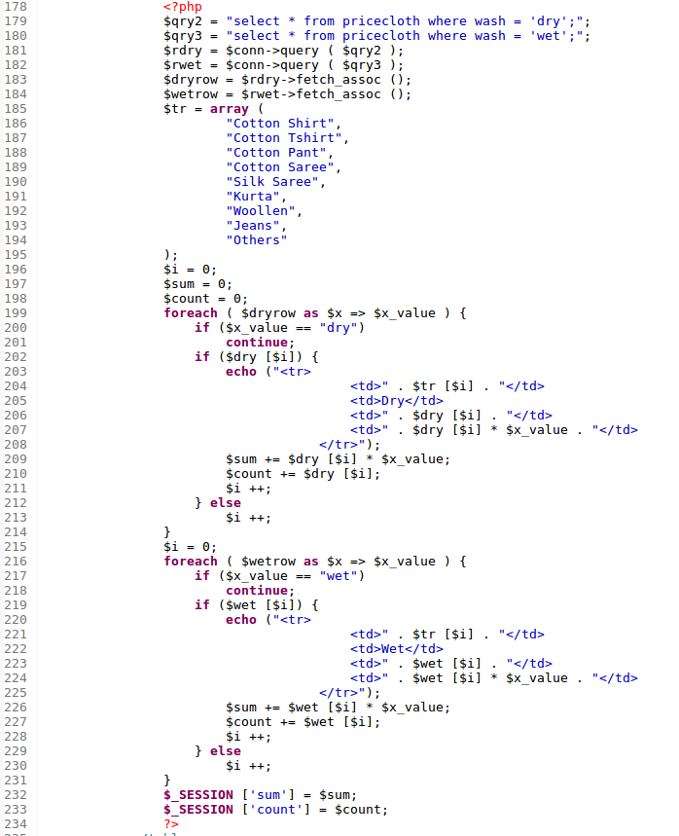

**Fig:5.7.1**

**6)SNAPSHOTS**

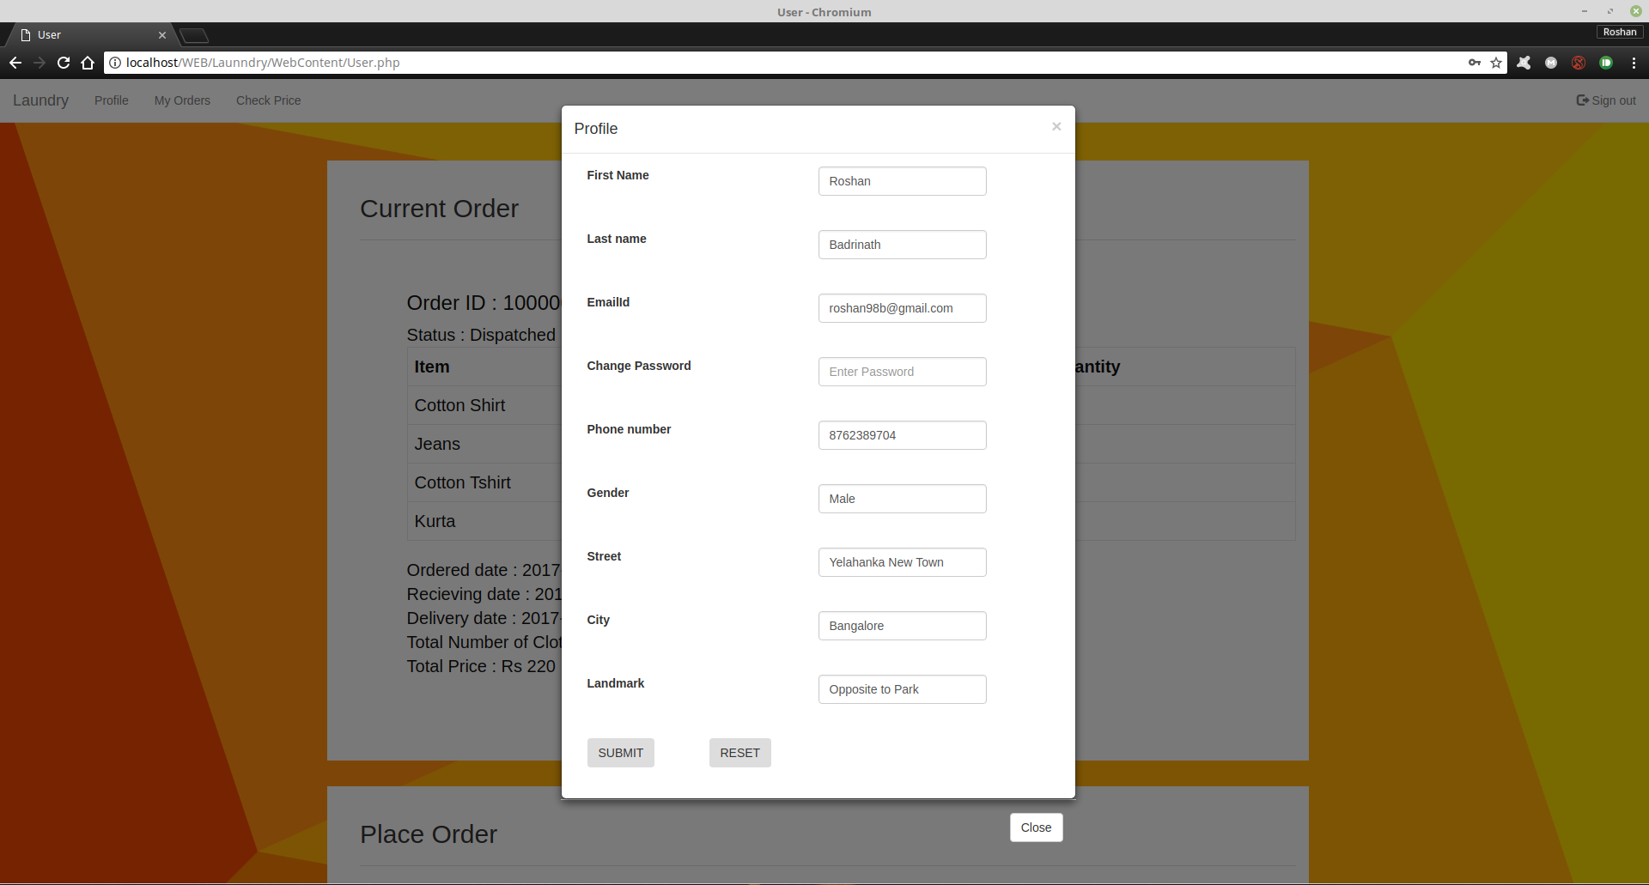

**Fig:6.1 USER PROFILE**

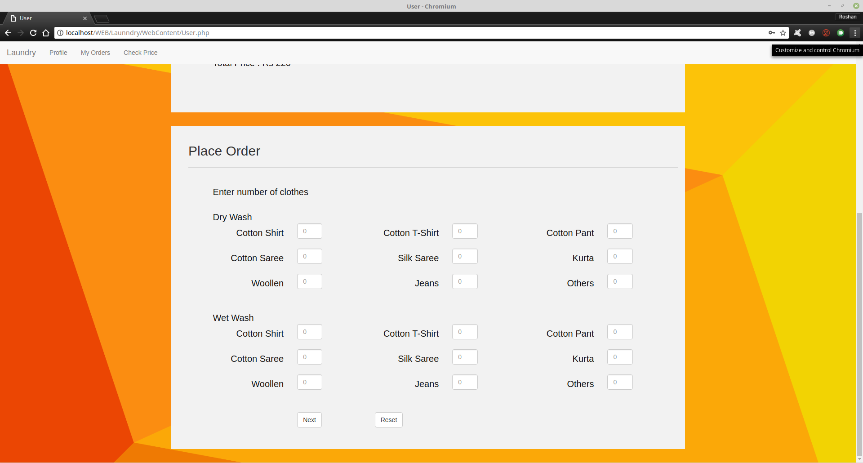

**Fig:6.2 USER ORDER**

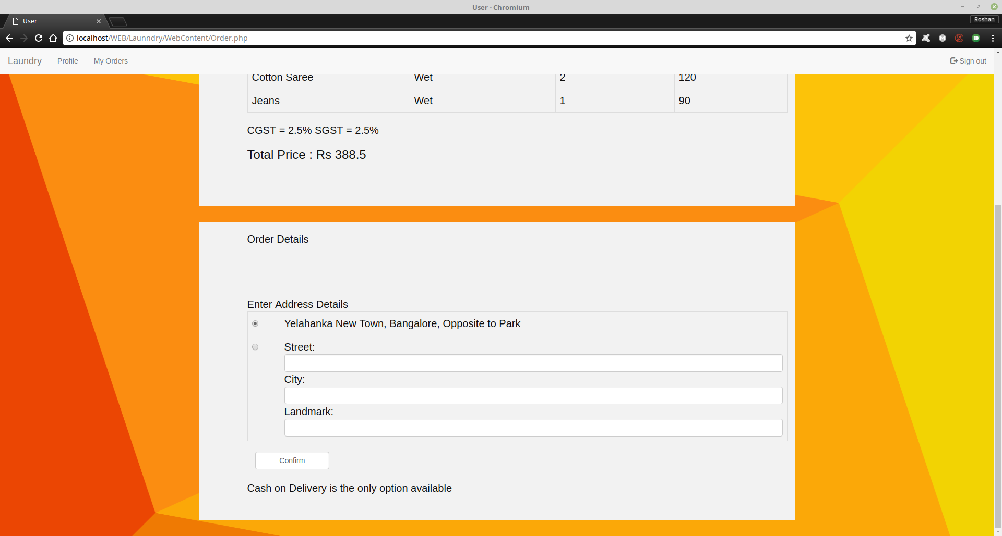

**Fig:6.3 USER DETAILS**

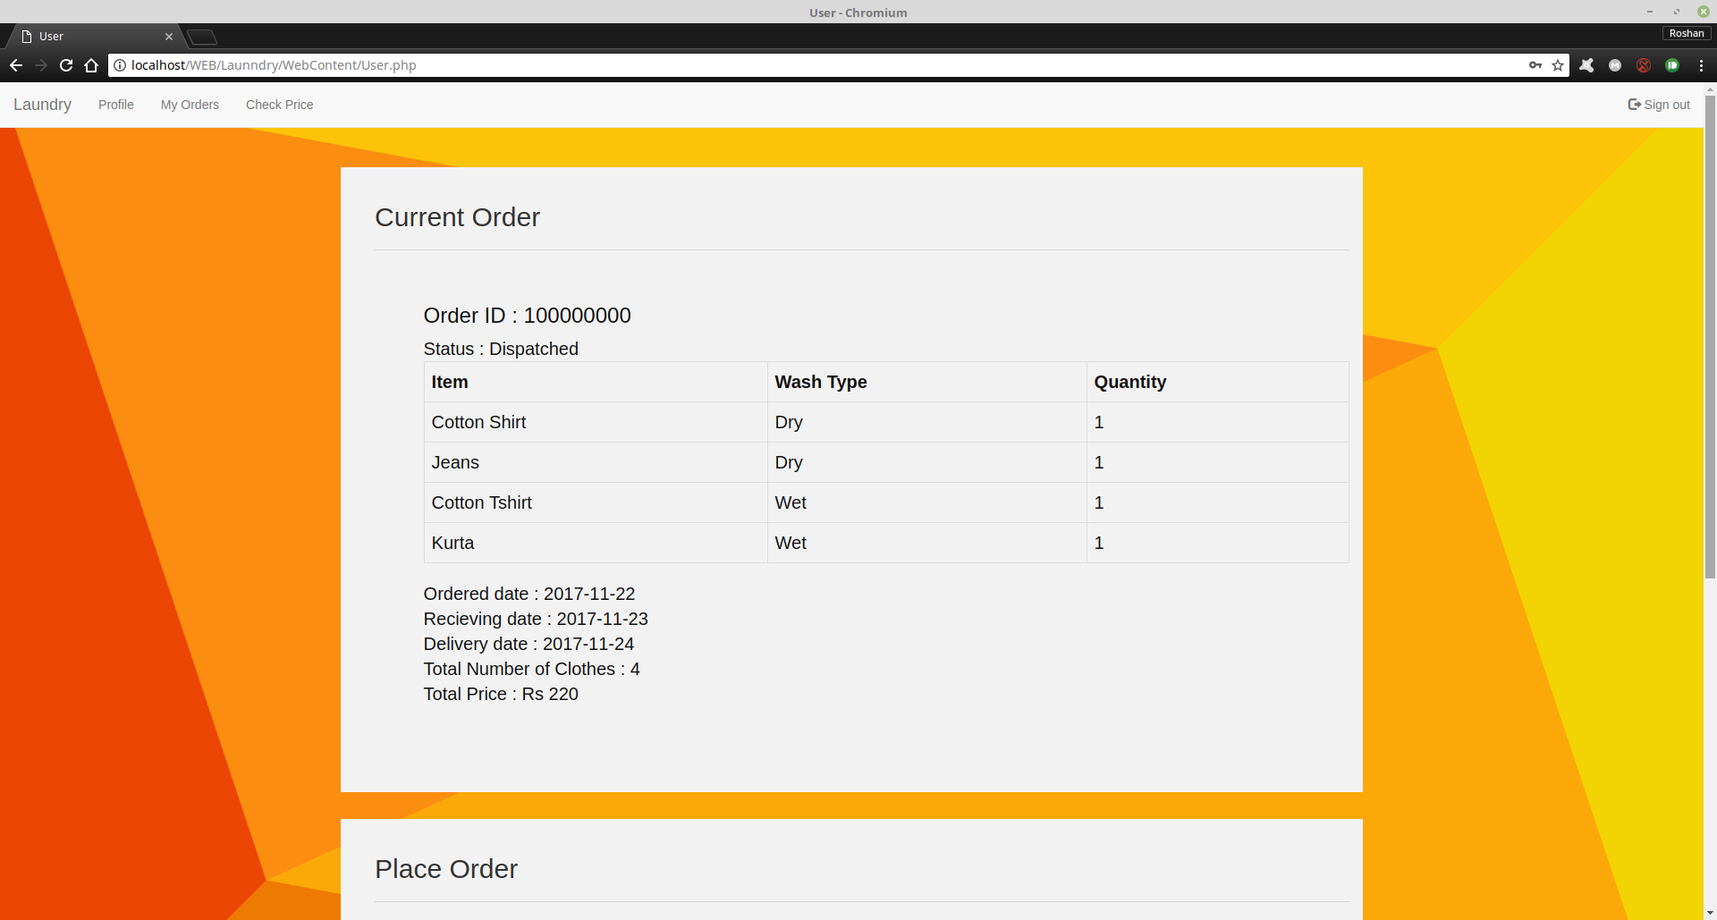

**Fig:6.4 USER CURRENT ORDER**

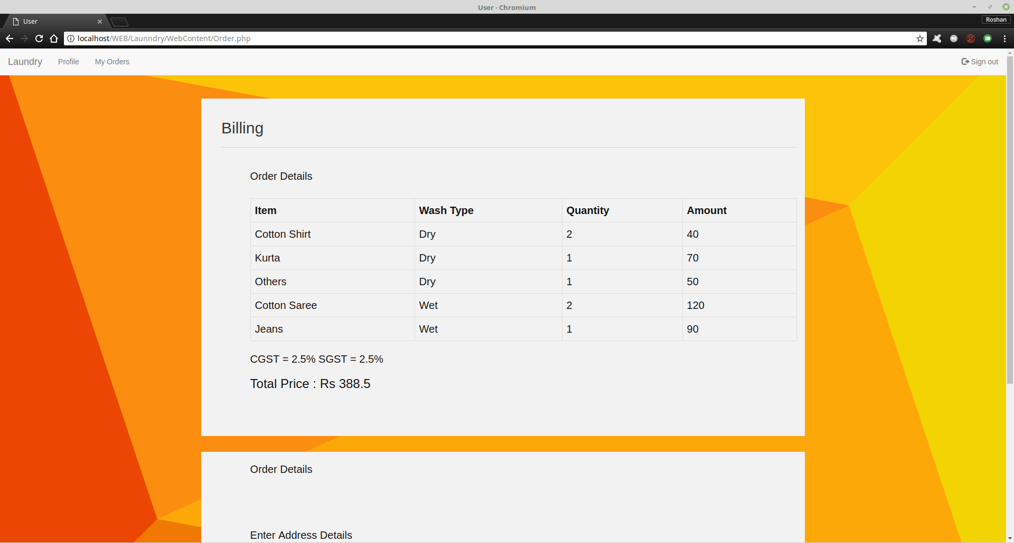

**Fig:6.5 USER BILL**

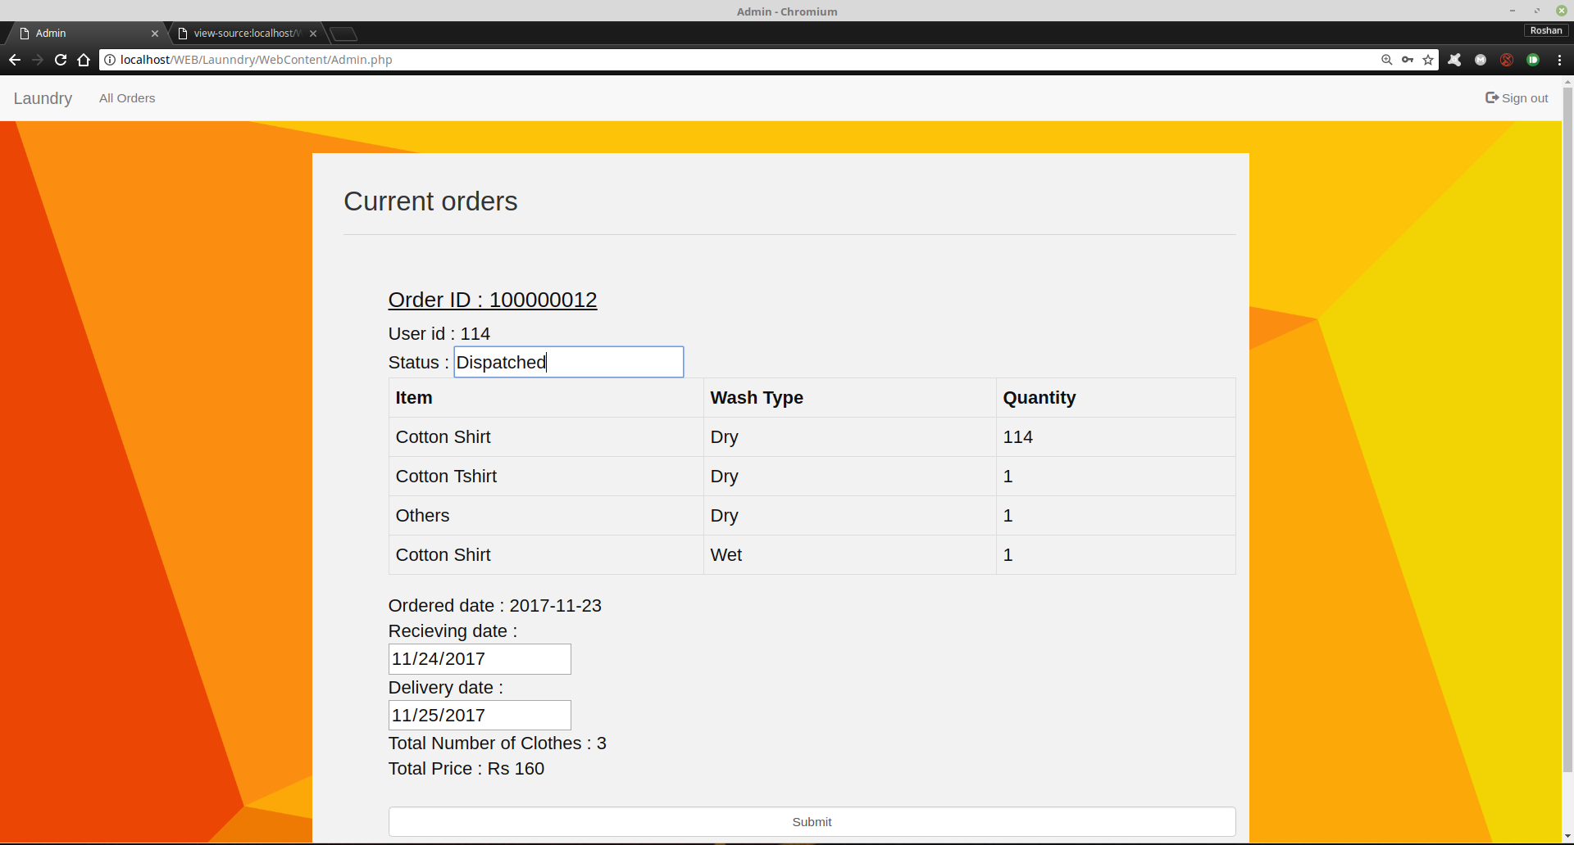

**Fig:6.6 ADMIN CURRENT ORDER**

**7. CONCLUSION**

This project has given us an ample opportunity to design, code, test and implements an application. This has helped in putting into practice of various Software Engineering principles and Database Management concepts like maintaining integrity and consistency of data. Further, this has helped us to learn more about MySQL, HTML, PHP and Personal Web Server applications.

**8. BIBLIOGRAPHY**

* <http://smallbusiness.chron.com>
* <https://www.edx.org/course/introduction-html-javascript-microsoft-dev211-1x-2>.
* <https://play.google.com/store/apps/details?id=com.ocean.phcomguide>.
* <https://www.tutorialspoint.com/>.
* <https://www.w3schools.com>