|  |  |
| --- | --- |
| **World Meteorological Organization &**  **Intergovernmental Oceanographic Commission (of UNESCO)**  **JOINT WMO/IOC TECHNICAL COMMISSION FOR OCEANOGRAPHY AND MARINE METEOROLOGY**  **Ship Observations Team Tenth Session**  Hong Kong, China, 01-04 April 2019 | Image result for ioc logo unesco  **SOT-10/Doc. 10.1.2** |
| Submitted by: Martin Kramp  13.03.2019  **DRAFT 1** |

**AGENDA ITEM 10: CROSS-PANEL-ITEMS**

**AGENDA ITEM 10.1.2: SOT-Identifier**

The meeting reviewed JCOMM-5 decision 32. Members explained their transition plans, with corresponding timelines, requirements and constraints. It was discussed how the transition should be organized with stations/platforms that require actions on board of the vessel (e.g. ID change in electronic logbooks) and how the new ID, which is neither mask nor call sign, should be reflected in new versions of electronic logbooks. In cases where the ID is only mounted after the ship-to-shore transmission (most AWS systems) a bulk change would be possible. It was also discussed, which impact the ID change will have for stations/platforms with identifiers in Read-Only-Memory, e.g. the Canadian AWS. The meeting recalled that all registered SOT stations/platforms already have allocated SOT-IDs inside the new JCOMMOPS system, and that the switch to this ID as main/GTS identifier has been automated and takes place as soon as data with this ID first appears on the GTS (without impact on the station/platform history). It was discussed that the present Pub47 style metadata repository (formerly E-Surfmar) has the capacity to manage masks, and that technically this capacity could be used for an immediate transition (before changes in metadata format) to the new ID in metadata management and GTS submissions. A small number of VOS is already operating this way. The meeting agreed that the use of the Pub47 call sign field should not be used for SOT-IDs or masks, which is presently the case for a growing number of EUCAWS systems. Members, which do not yet have the capacity to handle alternative IDs in their national systems, were urged to develop such a capacity as fast as possible. It was also discussed that accepting call-signs as IDs until the corresponding station/platform is either closed or (per validated decision tree) in a situation with mandatory ID change, would lead to having call-signs on the GTS and in climate archives for many additional years. The meeting agreed that such a situation should be avoided because of the known issues with call-signs and agreed on terminating the use of call-signs by no later than December 2020, per following implementation plan for SOT-IDs across all SOT networks / per an implementation plan that the XX TT should provide by YY.

…...

### B. ACTIONS/DECISIONS/RECOMMENDATIONS REQUIRED:

(a) Adopt draft Action/Decision[1] [0.0.0/1](#_Draft_Decision_X.X.X(X)/1) — Action/Decision *title.*

(b) Adopt draft Recommendation[2] 0.0.0/1 *— Recommendation title.*

# Background / References:

Extract JCOMM-5 Final Report (Appendix 3. Decisions. 32)

<https://www.jcomm.info/index.php?option=com_oe&task=viewDocumentRecord&docID=21580>

Note: Because of inconsistencies/terminology issues in the use of the term “platform” across JCOMM, some changes have been applied and highlighted in yellow.

**Decision 32 (JCOMM-5)**

**SHIP OBSERVATIONS TEAM IDENTIFIER SCHEME**

THE JOINT WMO–IOC TECHNICAL COMMISSION FOR OCEANOGRAPHY AND MARINE METEOROLOGY,

**Noting:**

(1) The report of the ninth session of the Ship Observations Team (SOT-9) (London, United

Kingdom, 27-31 March 2017), where SOT recommended to adopt the SOT identifier

(SOT-ID) scheme for platforms and instrument systems as described in the Annex to this decision,

(2) The report of the eighth session of the Observations Coordination Group (OCG, Qingdao, China, 22-25 May 2017), where OCG concurred with SOT recommendations in this regard,

**Considering** that:

(1) The SOT proposal with regard to SOT-ID would provide unique identifiers for marine platforms and instrument systems / packages on ships as follows:

(a) The SOT-ID list would be maintained by JCOMMOPS and the platform IDs would be issued according to the wider JCOMM ship list within the WIGOS metadata scheme (that is, SOT instrument packages would get IDs assigned by JCOMMOPS),

(b) Instrument packages with SOT-ID are mounted on hosting ships; the hosting ships may also contribute to more than one observing programme such as the Voluntary Observing Ship Scheme (VOS), the Ship-of-Opportunity Programme (SOOP) and

the Automated Shipboard Aerological Programme (ASAP); therefore, all instruments should refer to a shared JCOMM ship list, which SOT proposed should use the ICES code as unique identifier,

(c) VOS, SOOP and ASAP could continue using traditional WMO identifiers for ships, but eventually all could be assigned by JCOMMOPS (on behalf of the Members),

(2) The link between an instrument package with an SOT-ID and hosting ship could be hidden from the public if a ship must be “masked” per national requirement, meaning that all instrument metadata are then available, but not the ship metadata,

**Concurs** with the SOT proposal for new SOT-IDs;

**Requests** GO-SHIP and Global Temperature and Salinity Profile Program (GTSPP) and other observing platforms to consider implementing the SOT-ID system for subsurface oceanographic instrument packages;

**Decides** to adopt the SOT-ID proposal as described in the annex to the present decision and to promote the use of the JCOMM Ship list across all networks.

**Annex to Decision 32 (JCOMM-5)**

**SHIP OBSERVATIONS TEAM IDENTIFIER SCHEME**

**Recommendations from SOT**

SOT-9 recommended to adopt a new scheme that would provide unique identifiers for marine platforms and instrument systems / packages on ships (SOT-ID)s. The Recommendation includes the following:

(a) JCOMMOPS will issue WIGOS Platform Identifiers for marine platforms and instrument systems / packages on ships (hereafter called system(s)) (SOT-ID) with a dedicated

<issuer of identifier> assigned to JCOMMOPS;

(b) The local identifier will be exactly seven characters: n1n2n3n4n5n6n7; n1,n4,n5,n6 will be letters or digits; n2,n3,n7 will be letters. This will also form the SOT-ID;

(c) No information, such as type of platform, link to ship, operator, etc., will be encoded into the SOT-ID;

(d) Changes to the assigned SOT-ID will be governed according to decision trees below

(Figures 1 – 4);

(e) Each ~~platform or~~ ship hosting or deploying instruments shall be assigned a unique hull ~~or platform~~ ID as part of a wider JCOMM station metadata list. The ICES Ship Code should be used for this purpose, with new codes requested when a new platform is recruited.

**The usage of the proposed SOT-ID scheme would mean that:**

With the new ID scheme, every marine platforms and instrument systems / packages on installed on, or deployed from, a specific vessel ~~or platform~~ will be able to be uniquely identified, even when there are several systems installed on that vessel. Changes (e.g. flag, callsign, name of the vessel, etc.,) will not trigger a change of the SOT-ID, therefore the data from that specific system and vessel can always be distinguished from other data by use of the unique SOT-ID. With the new SOT-ID scheme the direct link to the vessel making the

observations can be hidden – effectively acting as a vessel masking scheme. However, the link, between the vessel hosting the system and the system, will be maintained through a separate JCOMM ship metadata list and the hull or platform ID.

**Background information:**

Boundary conditions considered in the new scheme:

(a) IDs in TurboWin allow a maximum of seven characters. Increasing this will increase the cost of transmission;

(b) IDs need to be unique, therefore other ID schemes need to be considered to avoid duplicates. Schemes to be considered:

(i) ITU callsign regulation;

(ii) JCOMM/WMO identifier schemes (such as buoys); (iii) Third-party systems and masking schemes.

(c) Requirements of different SOT panels need to be considered (multiple systems in single ship);

(d) WIGOS identifier scheme:

<WIGOS identifier series>-<issuer of identifier>-<issue number>-<local identifier> JCOMMOPS will issue IDs for marine platforms and instrument systems / packages on ships

with dedicated <issuer of identifier>

Local identifier: n1n2n3n4n5n6n7 (n1,n4,n5,n6: letters or digits, n2,n3,n7: letters)

|  |  |  |
| --- | --- | --- |
| (e) | Deci (i) (ii)  (iii) | sion tree:  Instrumentation moved to different ~~platform~~ ship: new SOT-ID; Change in network operator or recruiting country: new SOT-ID;  Significant instrumentation change (likely to change bias or error characteristics): |
|  |  | new SOT-ID; |
|  | (iv) | Replacement of instruments (like for like, no change to bias or error characteristic):  no new SOT-ID; |
|  | (v) | Change of ~~platform~~ ship owner, flag, callsign, name, etc. but no change of instrumentation: no new SOT-ID; |
|  | (vi) | Additional instrument installed or removal of instrument: no change of SOT-ID. |

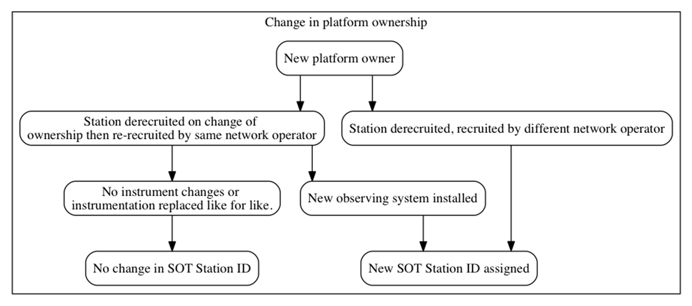

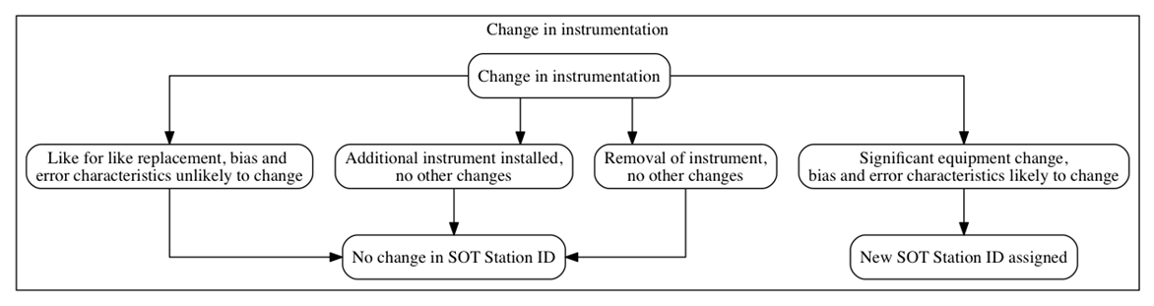**Figure 1. Decision tree governing changes to the SOT-ID when there is a change in ownership of the hosting platform (i.e. ship)**

**Figure 2. As figure 1 but for a change in instrumentation**

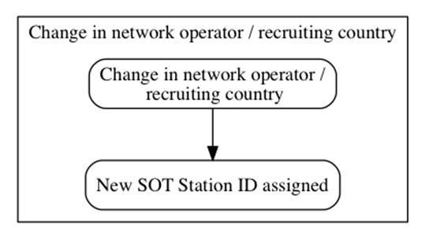

**Figure 3. As Figure 1 but for a change in network operator/recruiting country**

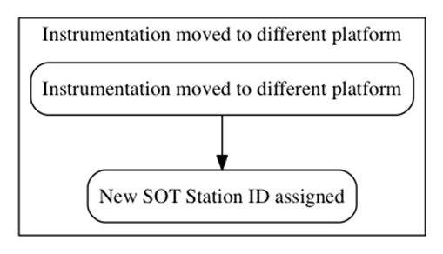

**Figure 4. As Figure 1 but for a change in hosting platform (i.e. ship)**

1. An Action/Decision is an item directly related to SOT and on which SOT can action or decide directly. Details on rational for the action/decision should be included in the Background section.
2. A Recommendation involves proposed action(s)on another body outside of SOT (e.g. DBCP, JCOMM, WMO, IOC, CBS etc.). Rational for the Recommendation should be included in the Draft Recommendation.