**Tài liệu tham khảo**

Asp.net Api: [http://www.asp.net/web-api/](http://www.asp.net/web-api/overview/getting-started-with-aspnet-web-api/tutorial-your-first-web-api)

AngularJS: <https://docs.angularjs.org/tutorial>

Login Facebook:<http://bitoftech.net/2014/08/11/asp-net-web-api-2-external-logins-social-logins-facebook-google-angularjs-app/>

OWin login: <http://bitoftech.net/2015/01/21/asp-net-identity-2-with-asp-net-web-api-2-accounts-management/>

SignalR: <http://vchat.vn/home/>

Host Appharbor: <https://appharbor.com/page/support>

Somee: <https://somee.com/>

Question: <https://stackoverflow.com>

Project: <http://www.dotnetcurry.com/aspnet/1049/crud-database-aspnet-webapi-angularjs>

Project: <http://www.infragistics.com/community/blogs/dhananjay_kumar/archive/2015/06/05/a-step-by-step-guide-to-working-with-the-asp-net-web-api-and-angularjs.aspx>

Project SignalR:

<http://www.asp.net/signalr/overview/getting-started/tutorial-getting-started-with-signalr>

<http://www.codeproject.com/Articles/633378/ASP-NET-SignalR-Basis-Step-by-Step-Part>

<http://www.codeproject.com/Articles/562023/Asp-Net-SignalR-Chat-Room>

**Hình chụp GitHub đóng góp**

**Members:**

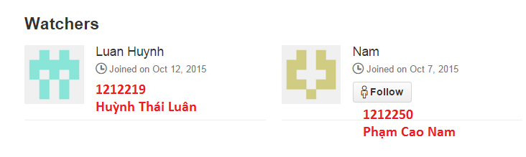

**Contribution:**

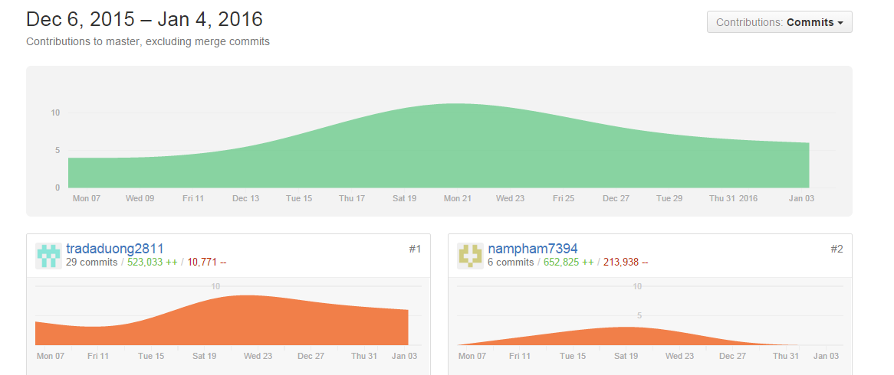

**Traffic:**

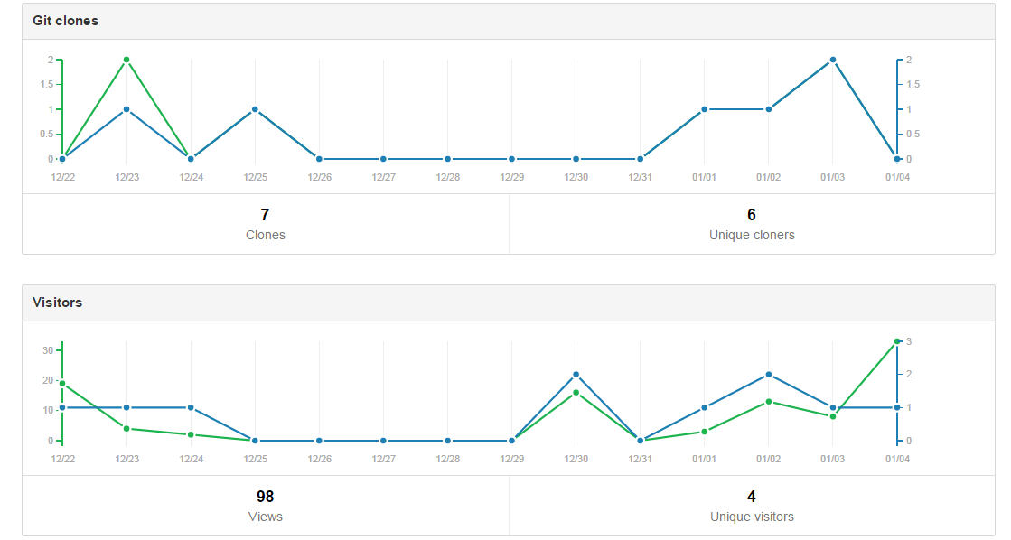

**Code frequency:**

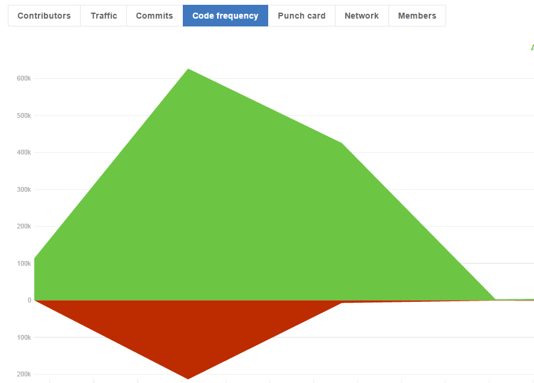

**Commit network:**

