This is a project to evaluate the minimum surrounding rectangle by Amir Hossein Heidari from K.N Toosi University using Java.

It consists of two classes by the name of "SurroundingRectangle" and "Pair".

In the beginning user ought to enter the count of the vertexes which the shape consists of and the coordinates.

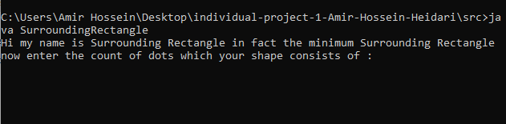

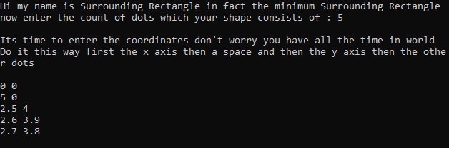



To find the coordinates of this rectangle we need to break the problem into two problems :

1. minimum and maximum on the x axis
2. minimum and maximum on the y axis

To find the min and max we use a divide and conquer practice

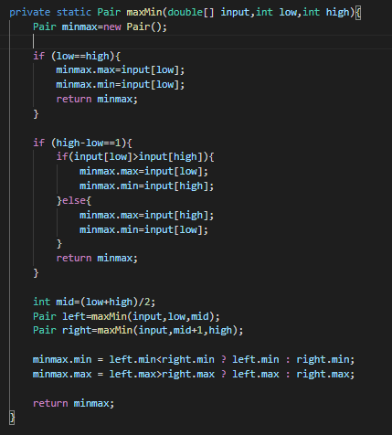

T(n) = T(floor(n/2)) + T(ceil(n/2)) + 2c T(2) = c T(1) = 0

Where c is the duration of a comparison

If n = 2^k

by making it a little simpler we have

T(n) = 2T(n/2) + 2c T(1) = 0 T(2) = c

Thus T(n) = 3n/2 -2