LAPLAP

By GG_Nein

Members

Kridtin Chawalratikool ID : 5931003221

Kantanat Siripipatworakun ID : 5931005521

1 Introduction

LapLap is a music rhythm game developed as a term project of 2110215 Programming Methodology class. It is written entirely with Java language with Javafx library. It uses various crucial aspects of Java language such as Object Oriented Programming (OOP), thread, image and audio integration, and many more. For example, inheritance, polymorphism, access modifier setter/getter are used in this project. This project has begun on 20th November 2017, and with dedication and tremendous endeavour, it was finally completed on 11th December 2017. We hope that it’s fun to play for all adults, children and the instructors as well.

2 User Manual

LapLap is a single player game that player select a mode, song, and then play by pressing any of 3 buttons to match the circle that appear on top and slide downward on the screen. This will happen continuously meanwhile music that player chose is still playing. When players type the button correctly, they get a score.

The game has five scenes, a main menu scene, a select mode scene, a select song scene, an in-game scene, and a game result scene.

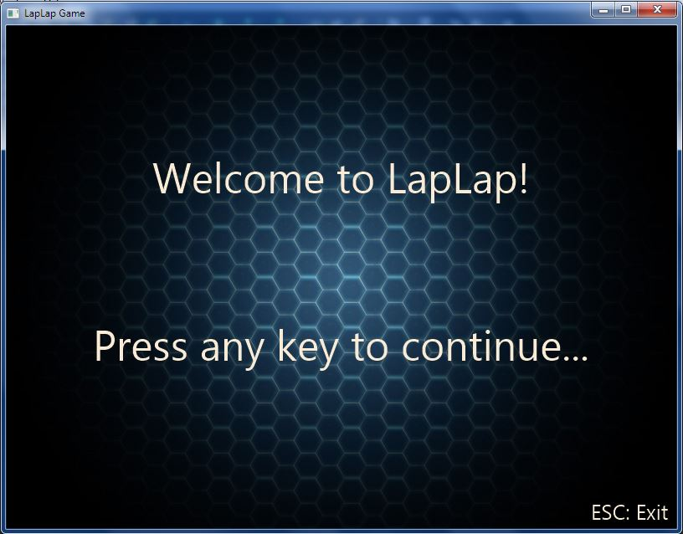

*Figure 1: the main menu scene of the Game*

At the main menu scene, player can:

- Press **ENTER** to go to the select mode scene, or

- Press **ESC** to exit the program.

When player presses **ENTER**, the program’s window switches to the select mode scene as shown in figure 2.

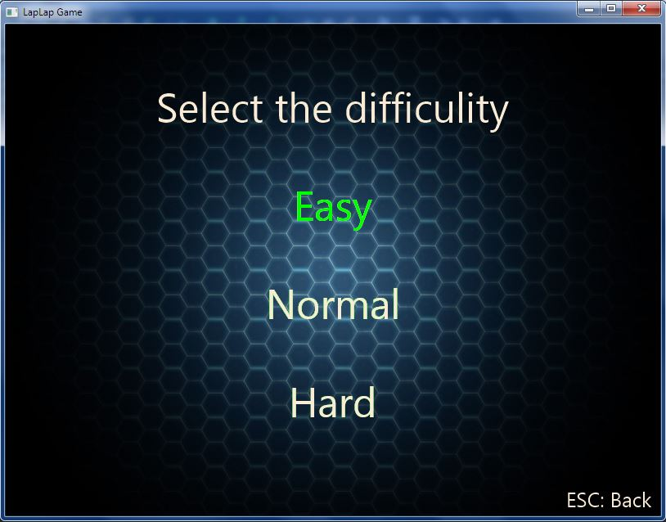

*Figure 2: the Select Mode Scene of the Game*

At the select mode scene, player can:

- Choose difficulty mode with the green highlight text by pressing **UP** or **DOWN**

- And then press **ENTER** to go to the select song scene, or

- Press **ESC** to go back to the main menu scene

When player have chosen difficulty mode and press **ENTER**, the program’s window will switches to the select song scene as shown in figure 3.

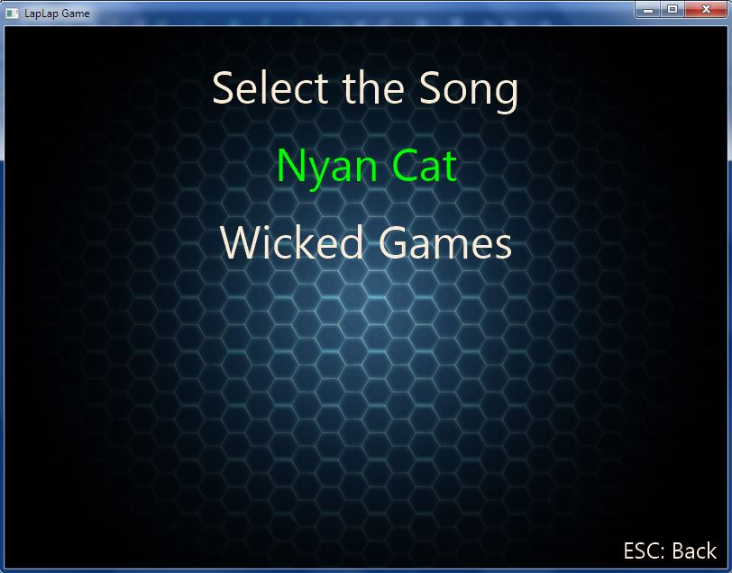

*Figure 3: the Select Song Scene of the Game*

At the select song scene, player can:

- Choose song with the green highlight text by pressing **UP** or **DOWN**

- And then press **ENTER** to play the game, or

- Press **ESC** to go back to the select mode scene

When player have chosen difficulty mode and press **ENTER**, the program’s window will switches to the game scene.

In the game scene, there are 2 screens, the game loading screen as show in figure 4 and the in-game scene as shown in figure 5.

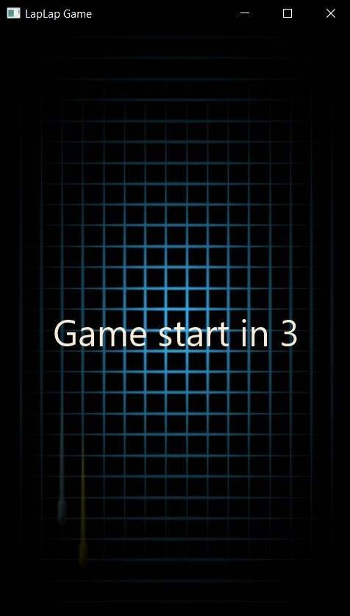

*Figure 4: the game loading screen*

In the game loading screen:

- Will start counting down ‘Game start in 3’ and number 3->2->1

- After that, it will launch the in-game scene

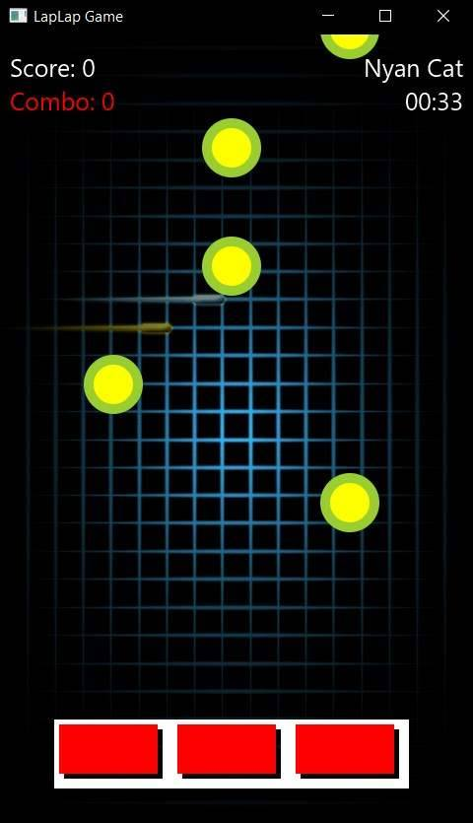

*Figure 5: the in-game scene*

In the in-game scene, it is displaying:

1. Score text at the top-left corner of the screen

2. Combo text at the top-left corner and under the score text

3. A song name chosen by player at the top-right of the screen

4. A time of the song that player choose at the top-right and under the song name

5. A white rectangle that there are 3 red squares inside, at the bottom-center of the screen

6. Many of yellow-in-green circles that moving downwards from top of the screen

And the Song chosen by player will be played

- When the circles move inside the red rectangle, Player can press these three buttons for matching the circle:

- **A** for the left rectangle

- **S** for the middle rectangle

- **D** for the right rectangle

- When player press these buttons, red color will turn to orange color

- If player can match the circle, player will get the score and combo will increase

- If player match circles without any miss, the score and combo will increase much more

- If player press button but not match the circle, player will not get score and combo will reset to 0

When player play game until the song is finished, the program’s window will switches to a game result scene as shown in figure 6.

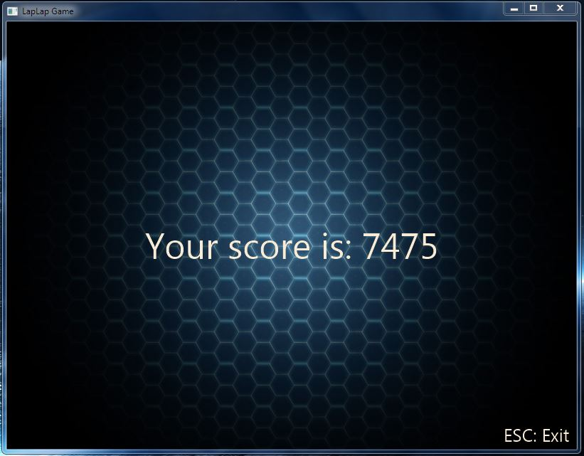

*Figure 6: the Game Result Scene of the Game*

At the game result scene, it will show:

- The Score of player after playing the game

- Player can press **ESC** button to exit the game